# 14/03/2019

There is a VERY good agreement between the data from Gplates and the data from pyGplates.

I wanted to plot the data in seaborn but it didn’t work, I tried to install seaborn but I kept getting an error.

I was too lazy to export the data and plot it in my own environment (meaning outside the Pygplates container)

In the future check this link

<https://chrisalbon.com/python/data_visualization/seaborn_pandas_timeseries_plot/>

dicked around all morning and couldn’t figure out how to do it in seaborn!!!!

All the attempts are in

http://localhost:8888/notebooks/Australia-Antarctica%20spreading%20rates_140319_SM.ipynb#

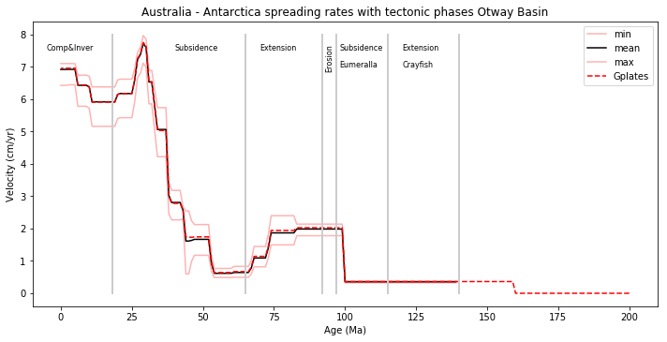

This plot is in agreement with Figure 6 of Brune et al., 2018, there are two



To ask Ben:

Age range not just the max

reconstruction_times = np.arange(0, 100, 1) # Ma #Give age range here

Plate ID = <http://localhost:8888/notebooks/Australia-Antarctica%20spreading%20rates_v2.ipynb>

#Any lat log

points_downunder = np.array([[145.0, -38.0], # Victoria

[133.0, -23.0], # central Australia

[122.0, -16.0]])

npts = points_downunder.shape[0]

# create point features

point_features = []

for lon, lat in points_downunder:

point_feature = pygplates.Feature()

point_feature.set_geometry(pygplates.PointOnSphere(lat, lon))

point_features.append(point_feature)

# lookup plate ID

partitioned_point_features = pygplates.partition_into_plates(static_polygons,

rotation_filename,

point_features)

~~How do I install seaborn?~~

http://localhost:8888/terminals/1

In jupyter notebook created a terminal and typed

pip install seaborn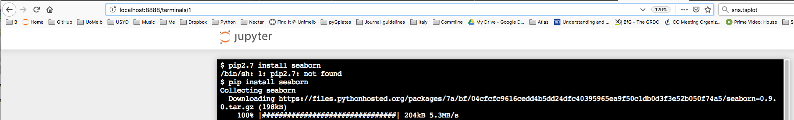

2019 plate model + rotation files 14:20

I changed the files and it didn’t work.

rotation_filename = 'Data/AUSLHR_DeformingModel_2019_v1.rot' #

reconstruction_feature = 'Data/AUSLHR_DeformingModel_Elements_2019_v1.gpml'

#static_polygons = 'Data/Muller_etal_AREPS_2016_StaticPolygons.gpmlz'

so I kept the ones that Ben had, which are the latest published work

rotation_filename = 'Data/Matthews_etal_GPC_2016_410-0Ma_GK07.rot'

static_polygons = 'Data/Muller_etal_AREPS_2016_StaticPolygons.gpmlz'

reconstruction_feature = 'Data/Matthews_etal_GPC_2016_ContinentalPolygons.gpmlz'

Sabin said that I the future I should use the outline of the COB instead of the coast line

# ‘07/03/2019

Hi Sabin,

Apologies for the PyGplates frenzy.

I’ve plotted the rifting of Lhasa and Greater India (see attached) and overlayed the tectonic phases of the NWS, but I was wondering if you can let me know which plate (and potentially plate ID) should I use for “Argo” if there is such a polygon.

Thanks!

Sara

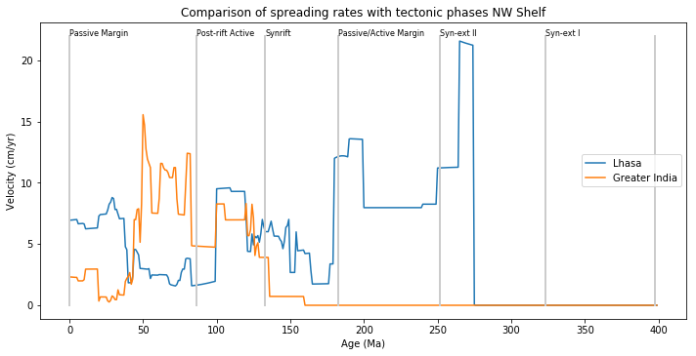

Meeting with Sabin about caveats of pyGplates and Gplates

gmlz= ziped

gml= not zipped

It loads everyone into memory

In gplates = keeps the rotation files as separate layers

Sanity check in gplates first

Pygplates no-deformation

Recommend:

Adding all the rotation files or at least the global ones, which are split between 0-250Ma and 250-400Ma. Ben said to combined them in a list in PyGplates

And in Gplates you have to load both files and connect them

Merge reconstruction tree layers, ok

Global rotation file = pygplates

Global file capture the rifting

Drop a point

Unitises open kinematic points use focused feature

Then export the file with the spreading rates as a csv [See notes from Gplates workshop]

Argoland =

668= Sulawesi

308=

Then send this to Chris Elders. The interesting issue is that in Syn-extII the spreading rates of Lhasa only increase right at the end of the rifting episode. And then in the Synrift- Jurassic the spreading rates are slower than in the Triassic cooling phase although the trend is increasing as supposed to constant (“concept of aceleration”). Then in the post-rift active phase the rates are high again! What the plot illustrates clearly is that for the upper K Greater India does all the rifting work. It would be interesting to plot the tectonic phases for the Perth Basin. Also add the age limits for time periods

# 06/03/2019

I ran the following in the command line

docker pull brmather/pygplates-course

docker run --name pygplates -p 8888:8888 brmather/pygplates-course

docker start pygplates

docker stop pygplates

and then I typed <http://localhost:8888> on the browser

Then uploaded the notebooks that Ben sent

Thanks Ben, this is really cool!

However, I got the error at the bottom of the email. I tried to fix it by checking the function in velocities_by_plate_id.py but I couldn’t figure out what’s the problem.

I was wondering if you could clarify why all of the coordinates in *points_downunder*are in Australia and none are located in Antarctica, how does the code “know” that the spreading rates are with Antarctica?

Also forgot to ask why is reconstruction_time = 30 # Ma But the velocity plot goes from 0 to 100Ma?

Last but now least, how do you check the plateID? I remember you mentioned that in the course but I forgot.

NameErrorTraceback (most recent call last)

<ipython-input-5-74c5d14a88dc> in <module>()

     21

     22 for t, reconstruction_time in enumerate(reconstruction_times):

---> 23     out_data = calculate_velocities(rotation_filename, point_features, radians, reconstruction_time)

     24     tlon, tlat, vel, ovel, arc, oarc, plateID = np.array(out_data).T

     25

NameError: name 'radians' is not defined

Thanks!

Sara

+Is this the best reconstruction to use? Or should I user other model=ask Sabin

802 Antarctic Peninsula

802 East Antarctica

801 Australia

Hi Matt,

As promised here is the notebook with the spreading rates through time for the rifting of Australia and Antarctica. Ben Mather kindly provided the original notebook which I’ve modified.

As Ben suggested in points_downunder (in Australia-Antarctica spreading rates_060319_SM.ipynb) you can provide any array, for example a bunch of points along the SE coast of Australia in for the Otway case.

I’ve overlayed the tectonic phases of the Otway Basin (ages eye bulled) and what is interesting is that in the first phase of extension the spreading rates are close to 0.

Sabin: Ben said that it might be related to the rotation pole, can you comment as to why the rates might be close to 0?

Kevin: I think you mentioned  that there was controversy about the spreading rates in the Otway? If yes can you please remind me in which age range?

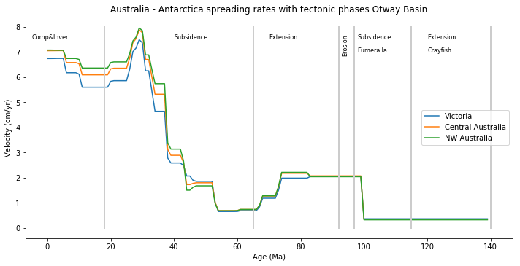

Hi Sara,

The early phase of extension is slow because likely the 100 Ma pole partitions the total deformation in time. The timing is probably poorly constrained, but I could be wrong.

The relevant paper is Williams et al., 2011, and I would contact Simon Williams [simon.williams@sydney.edu.au](mailto:simon.williams@sydney.edu.au) for further clarification, as he built that model for Aus-Ant rifting.

Cheers,

Sabin

To do:

-Upload Sabin’s 2019 model

-Do the same for NWS Argo vs Greater india rifting

# 05/03/2019

Hi Sara,  
  
Here is a useful notebook. You need the supplementary python file in the same working directory and possibly my docker image... I think brmather/pygplates-course on docker hub should do the trick. That's the one we used for the BGH workshop.

I've plotted two things: 1) a map of the continental areas reconstructed at 30 Ma, and 2) a plot of velocities for 3 arbitrary points on the present-day Australian continent. You might want to add some more points or use the calculate_velocities_along_reconstructed_geometry function in the supplementary python file and feed it the coastline.  
  
Let me know how you get on!  
  
Cheers,  
Ben

# 13/02/2019

Hi all,

Here are some resources for the pyGPlates part of the workshop:

Slides - [https://slides.com/brmather/deck-2](https://protect-au.mimecast.com/s/Cz0iCnxyvXcNGBp3I9f2Nf?domain=slides.com)

Binder - [https://mybinder.org/v2/gh/EarthByte/pygplates-course-solutions/master?filepath=0-StartHere.ipynb](https://protect-au.mimecast.com/s/lV2BCoVzwKh3XWpPizJGkZ?domain=mybinder.org)

Github - <https://github.com/EarthByte/pygplates-course-solutions>

Docker - [https://cloud.docker.com/u/brmather/repository/docker/brmather/pygplates-course](https://protect-au.mimecast.com/s/7Jp8Cp8AxKs3z6EOiYc07g?domain=cloud.docker.com)

The tutorials are available in the cloud with binder. We will run through the first 3 examples, but there are many more examples to go through at you leisure. Please be back from lunch by 2pm.

Cheers,

Ben

###Notes from Gplates workshop

Everything relates to Africa because of it was in the middle of Gondwana

Need to create synthetic plates when they have been destroyed

The assumption is that the sea-floor spreading is symmetric

Project files save time but be aware of how they work!

Work space as self contained as possible [just like in ArcGis]

Completely missed the crustal thickness utility

You first create the topology and then go features> crustal thickness points

Then it can be exported as a feature

Looked

seafloor spreading

Dynamic topography

And slices of mantle [the data to be loaded is 6_3D_Volume_Tomography as a scalar ]

##############

First level