JOLTS_laborblog
##
## The 'cran_repo' argument in shelf() was not set, so it will use
## cran_repo = 'https://cran.r-project.org' by default.
##
## To avoid this message, set the 'cran_repo' argument to a CRAN
## mirror URL (see https://cran.r-project.org/mirrors.html) or set
## 'quiet = TRUE'.
#setwd("C:/Users/sestep/Documents/jolts/")
plot_08
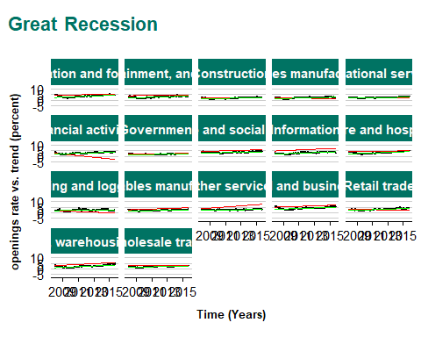
plot_20
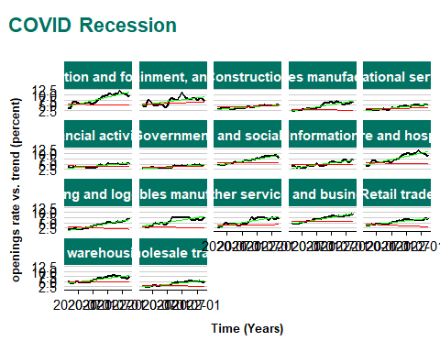
plot.RAINBOW
