CDI COLLEGE
ASSIGNMENT 2
Technical Analysis Using R
Preliminary Stage
Student Name | Sara Mohamed Mohamed Flefla
Course | BDA400 – Data Science Tools and Techniques
Assignment | CA_BDA400_A02
Portfolio Symbols | AMZN, GOOGL, TSLA
Submission Date | November 12, 2026
GitHub Repository
Sara’s exact repository URL must be added after confirmation.

1. Introduction and Objectives
This report documents the preliminary stage of a technical-analysis project using R. The work covers the R/RStudio environment, required packages, portfolio configuration, stock-data importing, basic statistics, data display, and closing-price visualizations.
- Create a GitHub repository named TechnicalAnalysis and organize the assignment files.
- Install and configure R and RStudio.
- Install quantmod, TTR, xts, and ggplot2.
- Create portfolio.txt with one stock symbol per line.
- Import stock data and calculate moving average, mean, mode, median, and standard deviation.
- Display imported data, statistics, and stock-price charts.

2. GitHub Account and Repository
The assignment requires a GitHub repository named TechnicalAnalysis, an Assignment2 subfolder, and a repository link in the report. The RStudio working folder used for Sara’s project is Flefla_Sara_CA_BDA400_A02_package. Sara’s exact GitHub URL has not been confirmed, so it is intentionally not guessed. Before submission, insert genuine screenshots of Sara’s GitHub account, repository, and Assignment2 folder, then add the exact URL to the cover page.

3. Installing and Configuring R and RStudio
RStudio was opened successfully on Windows. The Console displayed R version 4.6.2. The working directory was set to:
C:/Users/ADMIN/Downloads/Flefla_Sara_CA_BDA400_A02_package
The available evidence confirms an active RStudio session, but does not show the original R download wizard or every installation step. Add genuine installation screenshots if the instructor requires them.

4. Installing Required R Packages
The project uses quantmod for market-data retrieval, TTR for technical-analysis calculations, xts for time-indexed data, and ggplot2 for charts. The script checks for and loads these packages. Keep a genuine Console screenshot showing successful package installation/loading.

5. Project Configuration and Portfolio
The portfolio.txt file contains one ticker symbol per line:
AMZN
GOOGL
TSLA
The script reads these symbols and stores the successfully imported time-series objects in portfolio_data.

6. Function to Import Stock Data
The load_stock_data() function reads portfolio.txt, removes blank entries, and retrieves data through quantmod. Each imported stock object is stored separately in portfolio_data. The Console confirmed that names(portfolio_data) returned AMZN, GOOGL, and TSLA.

7. Function to Compute Basic Statistics
The analysis calculates the latest 20-day simple moving average, mean, mode, median, and standard deviation using each stock’s closing prices. The following values were visible in the RStudio summary output:
Symbol | 20-day MA | Mean | Mode | Median | Std. Dev.
AMZN | 255.8675 | 241.9198 | 222.69 | 244.85 | 19.90911
GOOGL | 308.1835 | 333.8298 | 318.58 | 336.02 | 28.88584
TSLA | 381.8350 | 395.0312 | 372.11 | 395.23 | 38.02328
These values reproduce the recorded run and may change when the script is executed again because market prices and available data can change.

8. Displaying Data and Visualizations
The script generates closing-price line charts for all three portfolio symbols and saves them in Stock_Charts. The screenshot below confirms that the folder contains AMZN.png, GOOGL.png, and TSLA.png, and displays the TSLA Closing Price chart.
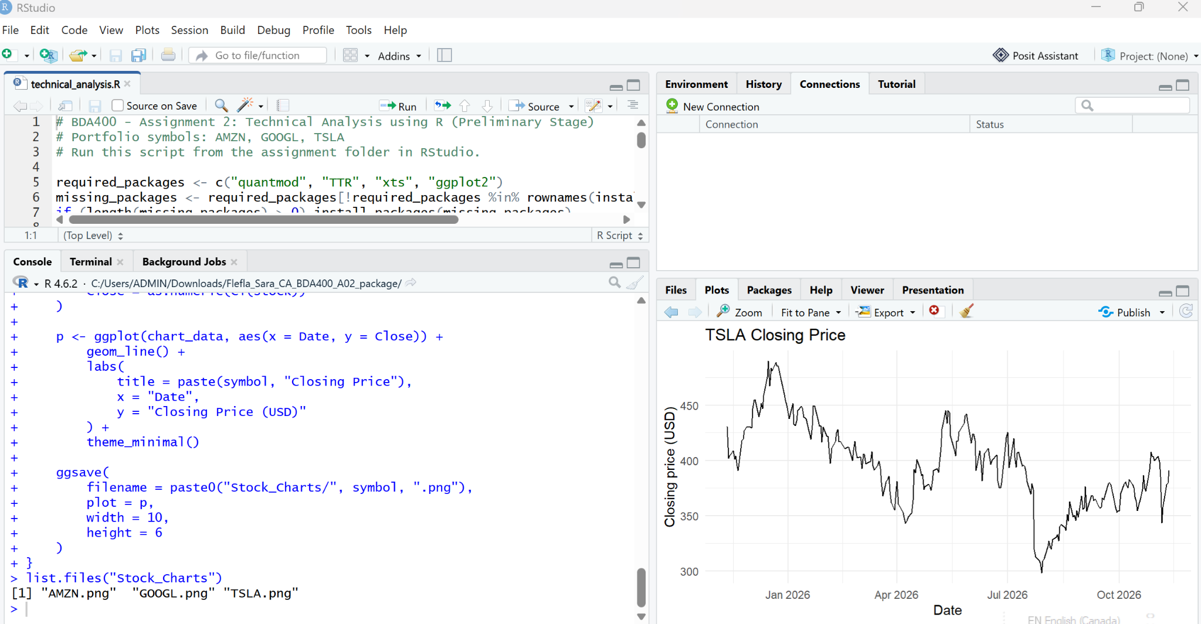
Figure 1. RStudio confirms the three saved chart files; the Plots pane displays the TSLA closing-price chart.
The script also exports the combined summary statistics to stock_statistics.csv. Confirm that this CSV file is present in the project folder and upload it to GitHub.

9. How to Run the Project
- Open the Flefla_Sara_CA_BDA400_A02_package folder in RStudio.
- Confirm that portfolio.txt and technical_analysis.R are in the working directory.
- Open technical_analysis.R and run the script from top to bottom using Source.
- Allow the script to install any missing required packages.
- Review the Console for imported data and calculated statistics.
- Confirm that Stock_Charts contains AMZN.png, GOOGL.png, and TSLA.png.
- Confirm that stock_statistics.csv has been created.
- Upload all deliverables to Sara’s TechnicalAnalysis/Assignment2 GitHub folder.

10. Project Deliverables
- portfolio.txt – AMZN, GOOGL, and TSLA, one symbol per line.
- technical_analysis.R – package setup, data import, statistics, display, and chart-generation code.
- stock_statistics.csv – combined summary statistics.
- Stock_Charts/AMZN.png, Stock_Charts/GOOGL.png, and Stock_Charts/TSLA.png – generated charts.
- README.txt / README.md – project notes and run instructions.
- Flefla_Sara_CA_BDA400_A02.docx and Flefla_Sara_CA_BDA400_A02.pdf – report formats.

11. Conclusion
The R workflow for Sara’s portfolio has been executed: AMZN, GOOGL, and TSLA were loaded into portfolio_data, summary statistics were calculated, and three closing-price chart files were generated. The GitHub repository URL and remaining setup screenshots must be added before final submission.

12. Final Submission Checklist
Requirement | Evidence / Status
TechnicalAnalysis GitHub repository and exact URL | Needs confirmation / screenshot
Assignment2 folder uploaded to GitHub | Still needs GitHub screenshot; local project folder is confirmed.
R and RStudio installed and running | RStudio running; installation-step evidence still needed
quantmod, TTR, xts, ggplot2 | Script uses/checks packages; add package Console evidence
portfolio.txt with AMZN, GOOGL, TSLA | Confirmed in project workflow
technical_analysis.R | Confirmed visible in the project folder screenshot.
stock_statistics.csv | Confirmed visible in the project folder screenshot.
Three chart images | Stock_Charts folder visible; individual chart files confirmed in prior RStudio screenshot.
Report in MS Word with screenshots | Report prepared; add remaining genuine evidence
Repository URL: add Sara’s confirmed TechnicalAnalysis repository link here.

13. Additional Evidence – Project Folder and Saved Output
The screenshot below shows the local project folder Flefla_Sara_CA_BDA400_A02_package. It confirms that the folder contains stock_statistics.csv, the assignment PDF report, portfolio text file, README, technical_analysis R script, and Stock_Charts folder.
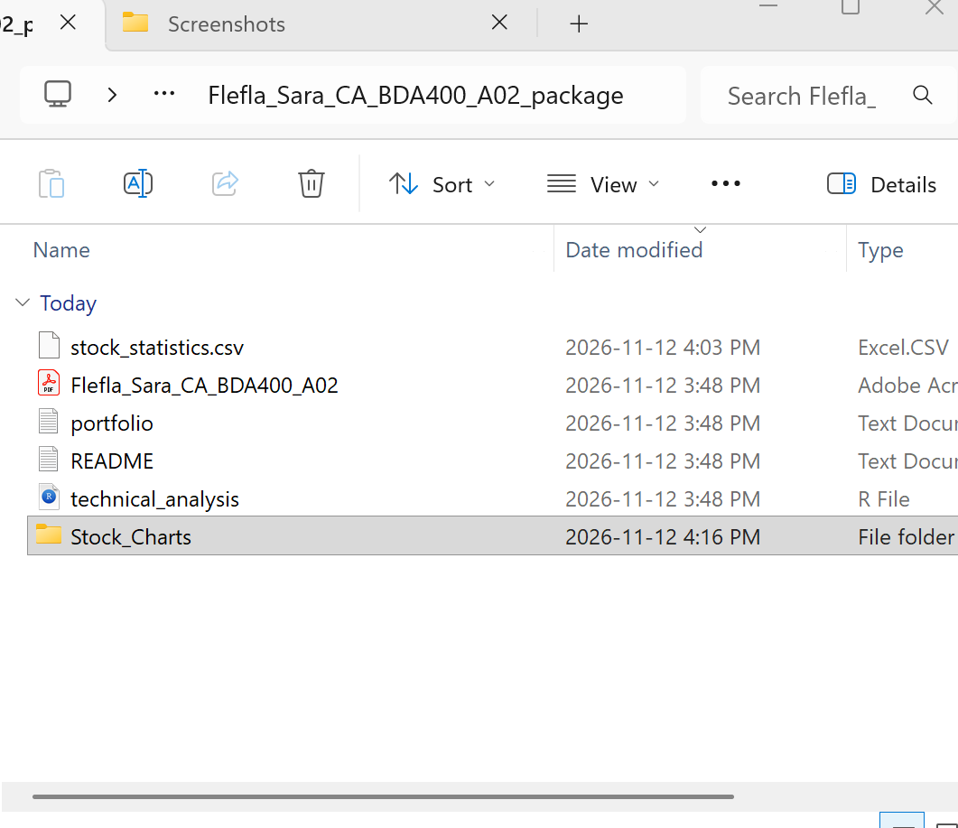
Figure 2. Local Assignment 2 project folder showing stock_statistics.csv and the project files.
Evidence update: stock_statistics.csv is confirmed as present in the local project folder. This screenshot does not show that the files have been uploaded to GitHub, so the repository upload and exact repository URL still need to be verified separately.

14. RStudio Installation Evidence
The following screenshots document the RStudio installation process on the computer used for this assignment. They show the setup welcome screen, the selected installation folder, the installation in progress, and the successful completion message.
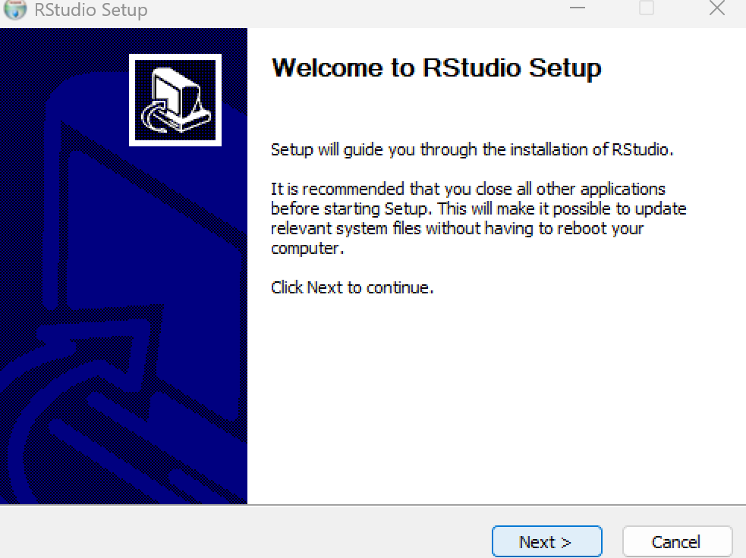
Figure 3. RStudio Setup welcome screen.
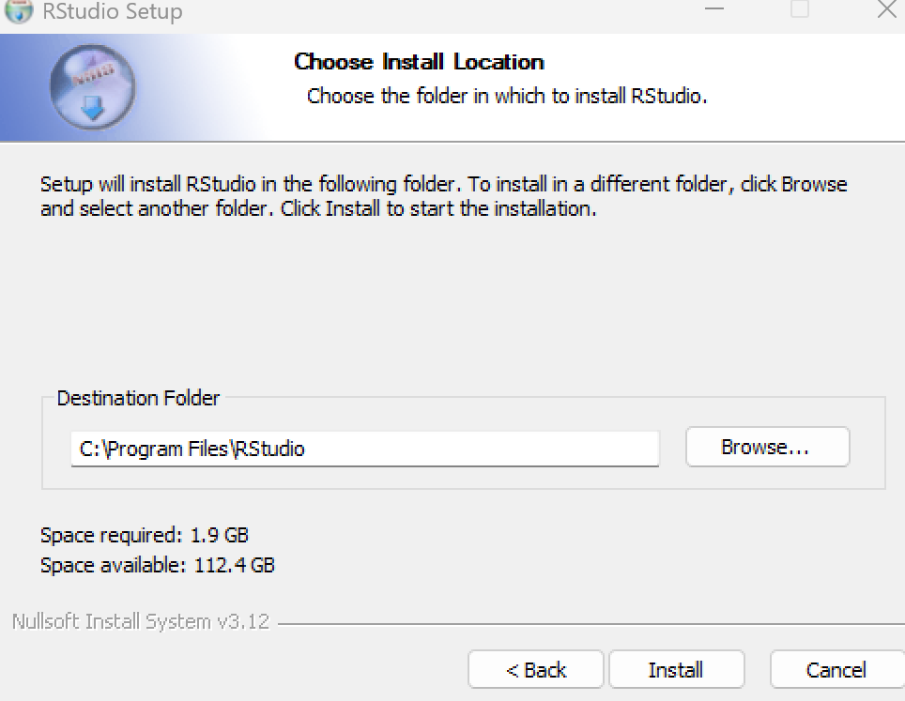
Figure 4. RStudio installation location selected.
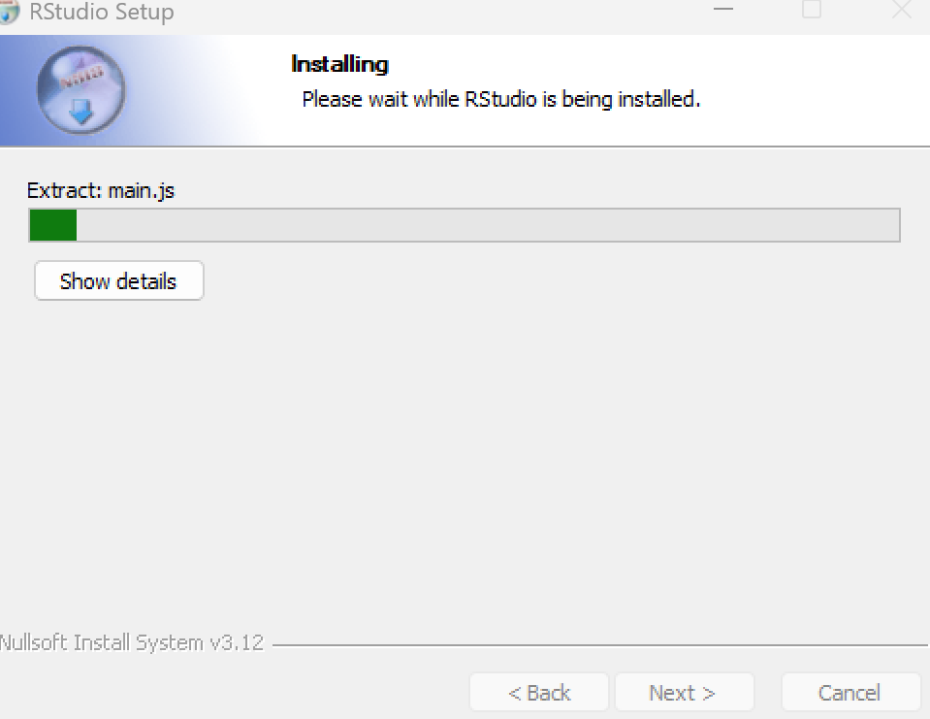
Figure 5. RStudio installation in progress.
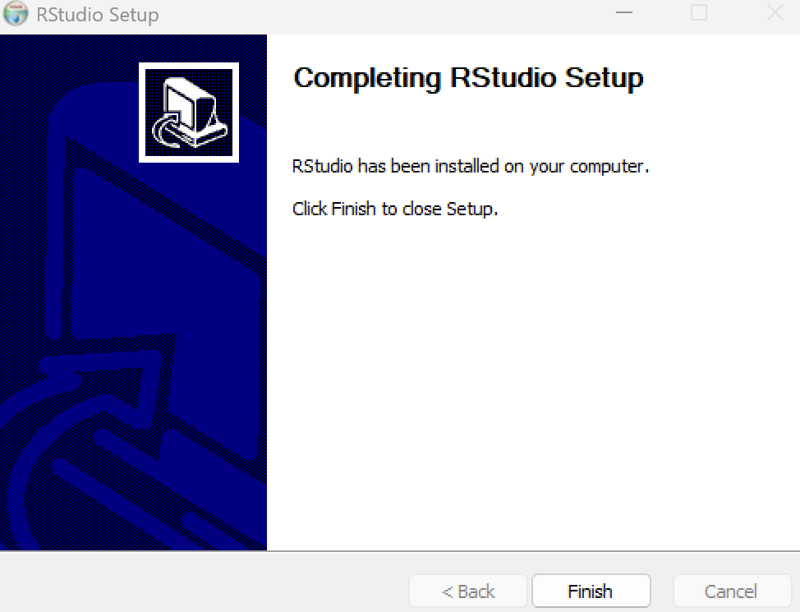
Figure 6. RStudio installation completed successfully.
These screenshots confirm that RStudio was installed successfully. They are installation evidence only; the analysis results and project files are documented in the earlier sections.

