AWS VPC Creation
Project Overview
This document provides a comprehensive step-by-step guide for setting up an AWS VPC (Virtual Private Cloud) as part of a Hybrid Cloud Infrastructure. The architecture connects an on-premises data center to AWS using a Site-to-Site VPN, enabling secure and seamless communication between the two environments.

Objective
• Establish a fully isolated AWS VPC with public and private subnet tiers
• Enable internet access for public resources via Internet Gateway
• Allow private subnets outbound internet access via NAT Gateway
• Apply security controls using Security Groups and Network ACLs
• Set up a Bastion Host to securely access instances in the private subnet
• Create an Auto Scaling Group to automatically scale EC2 instances within the subnets

Architecture Design.
The diagram below illustrates the high-level network topology of the hybrid infrastructure:
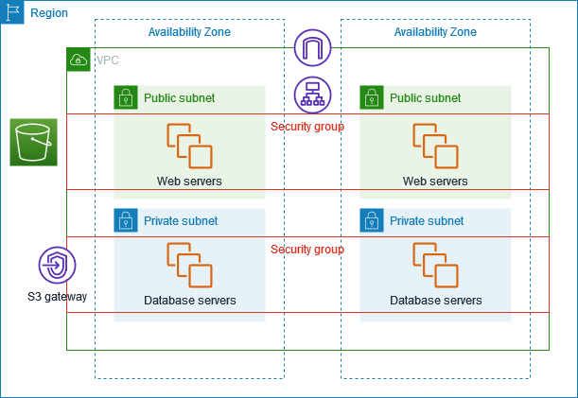

What is AWS?
Amazon Web Services (AWS) is a comprehensive cloud computing platform by Amazon that provides on-demand access to physical and virtual infrastructure, including servers, storage, networking, and databases hosted across Amazon's globally distributed data centres, delivered over the internet on a pay-as-you-go model.

Prerequisites to setup VPC
Before beginning the VPC setup, ensure the following are in place:
- Active AWS Account with appropriate IAM permissions (Administrator-Access or custom VPC policy)
- Decide your VPC CIDR block (e.g., 10.0.0.0/16)
- Plan subnet CIDRs for public and private tiers across at least 2 Availability Zones
- Decide the number of EC2 instances and their instance types for the Auto Scaling Group
- A terminal (Linux/macOS) or WSL2 on Windows
- An SSH key pair created — either via AWS Console (EC2 > Key Pairs) or locally using
- AWS Console access (or Terraform installed for IaC approach)

Network Design
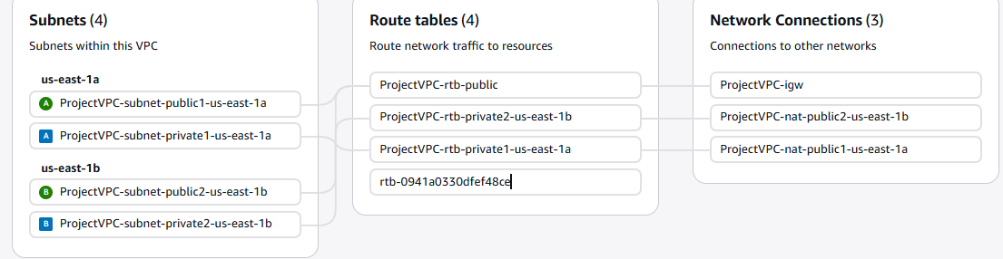

What Things we Setup:
1. Setting Up VPC..
A VPC is a virtual network that you create in the cloud. It allows you to have your own private section of the internet, just like having your own network within a larger network. Within this VPC, you can create and manage various resources, such as servers, databases, and storage.

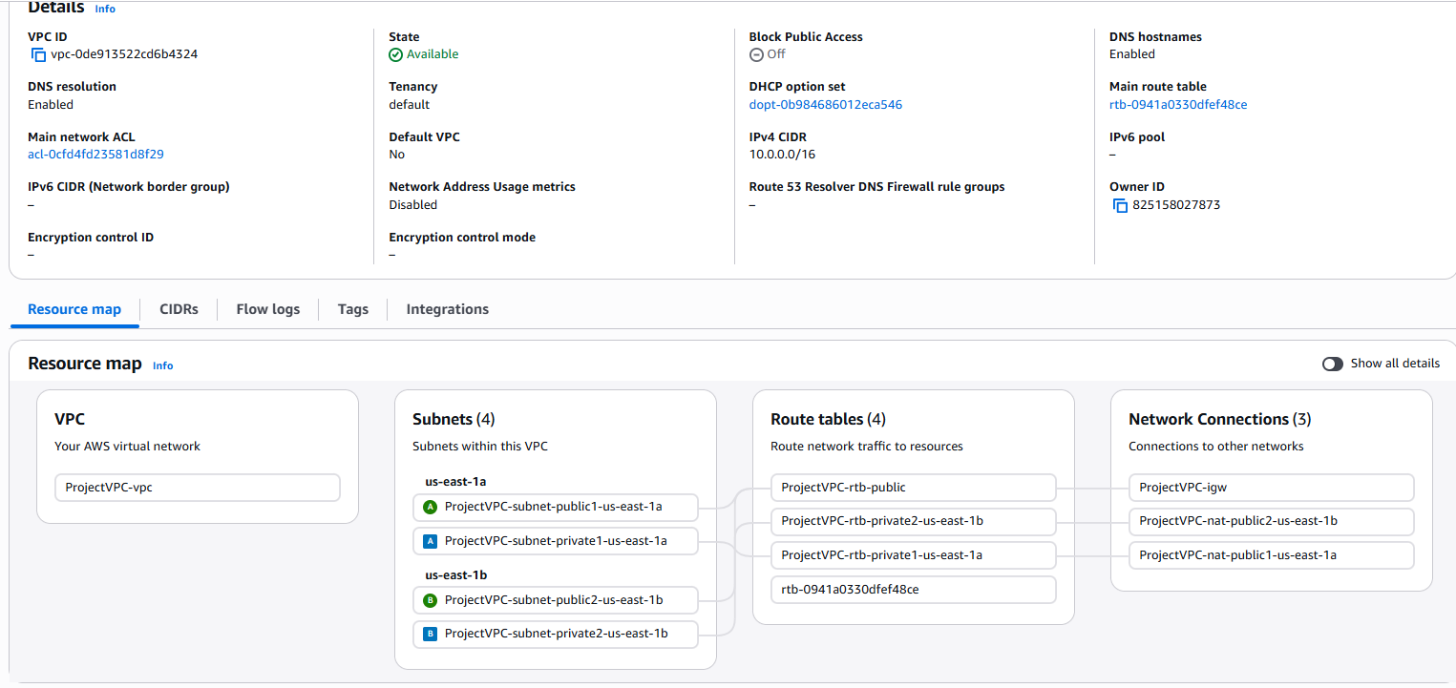
2. Created a Auto scaling Group
Auto Scaling dynamically provisions and terminates instances within a VPC to maintain application performance and availability.
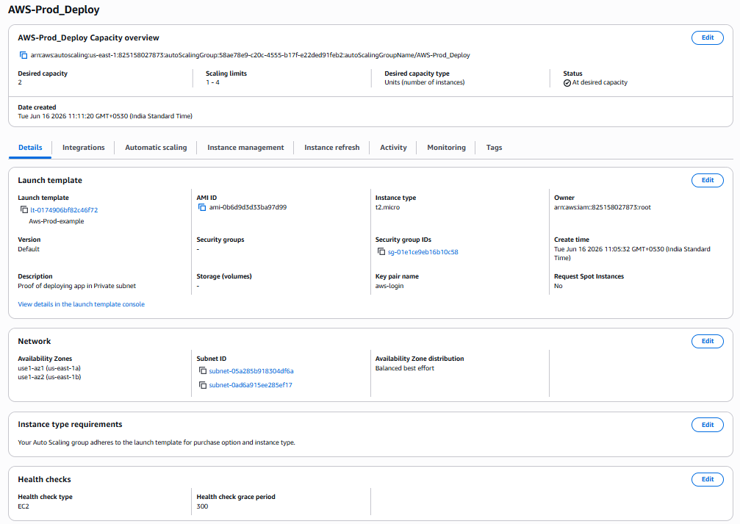

3. EC2 Instance Creation through Auto Scaling Group
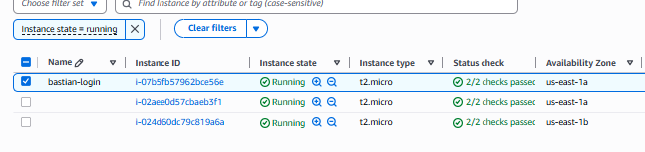
It shows the 3 Instances Created :
- 2 of the Instances are created by Auto Scaling group
- And the 1 named Bastian-login created individually inside public subnet to communicate with private subnet instances.

The Private Subnet Instance Config:
