DC Workshop Session 1 Instructions:
- Start with the MATLAB Online workshop: https://www.mathworks.com/licensecenter/classroom/5592100/
Click ‘Access MATLAB Online’. You may need to log in to your MATLAB account.
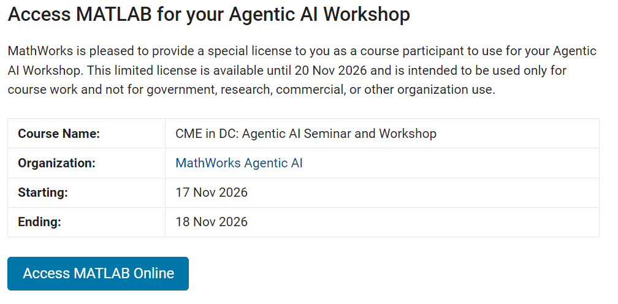
- Type ‘terminal’ in the Command Window and press Enter.
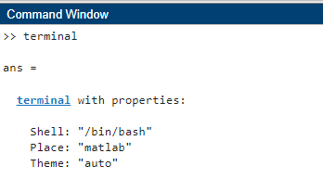
- In the terminal, type codex to open the OpenAI Codex terminal in MATLAB Online.
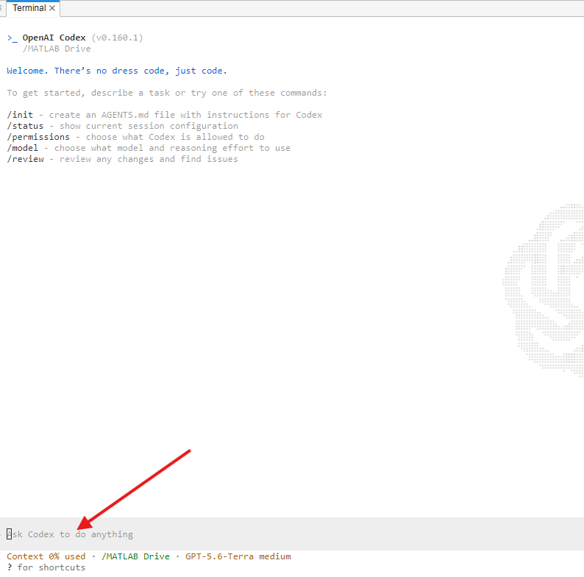
- Allow the MCP server to run tool "evaluate_matlab_code" for the duration of the session
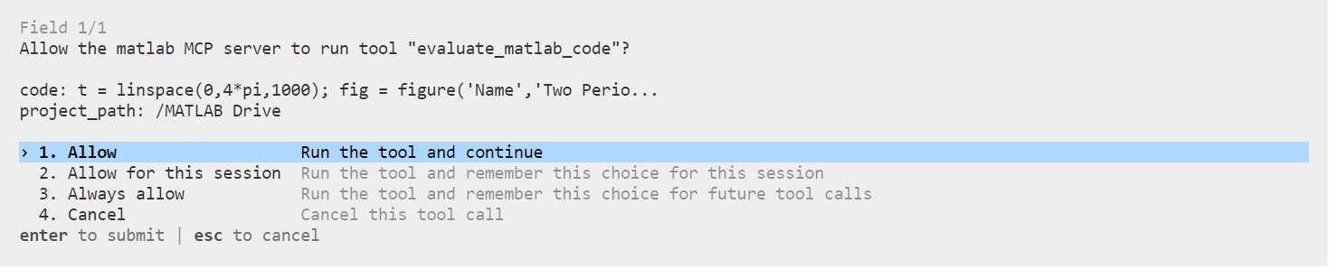
- Locate the ‘tsReg.m’ function file.
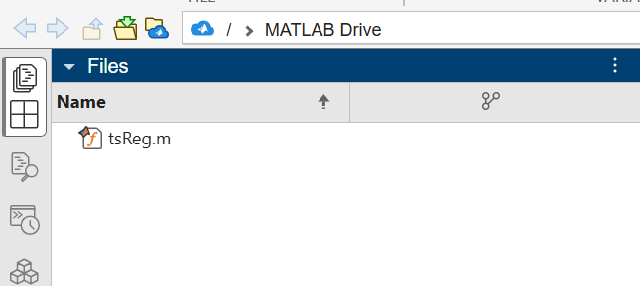
- Prompt 1: Run the tsReg function for five different confidence level values.
Several Figure windows will pop up with regression plots for five different confidence level values.
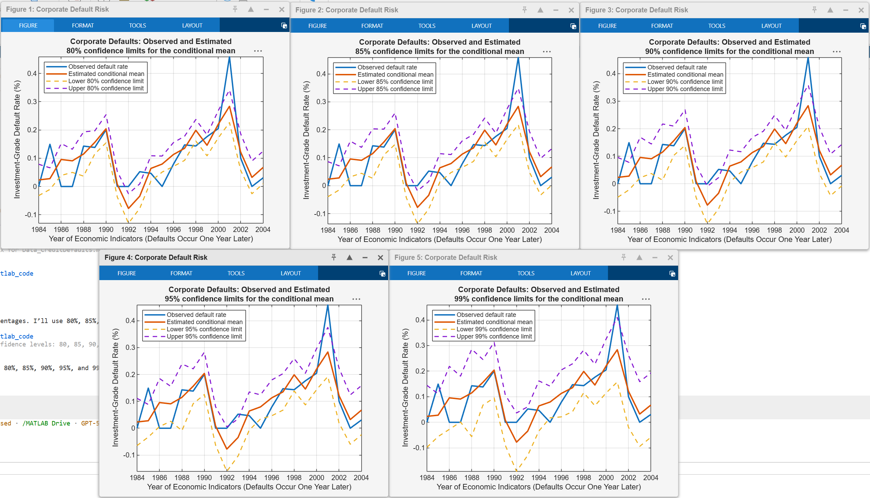
- Prompt 2: Refactor ‘tsReg.m’ as ‘tsReg2.m’ to plot the figure on a user specified year range.
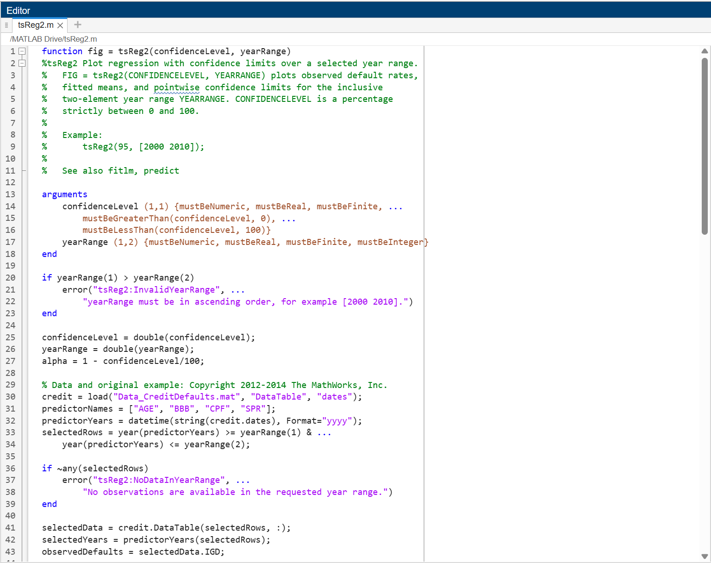
- Prompt 3: Use ‘tsReg2.m’ to plot the linear regression between 1990 and 2000 with a 95% confidence limit.
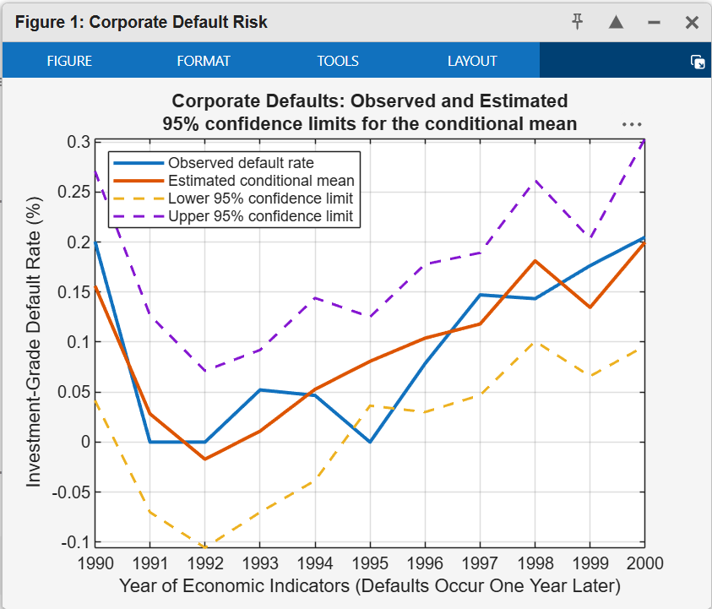
- Prompt 4: /plan
Enter Codex’s plan mode
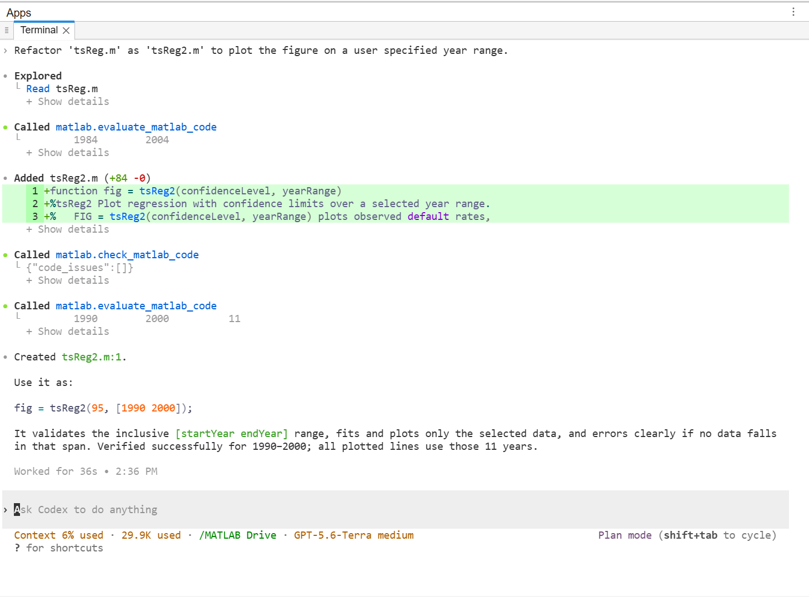
- Prompt 5: Write a plan to create a MATLAB app as a .m file on top of tsReg2 that displays the regression and allows you to change the time range and confidence level each with a slider.
Evaluate the plan written in the terminal and determine if you’d like to implement it or make modifications.
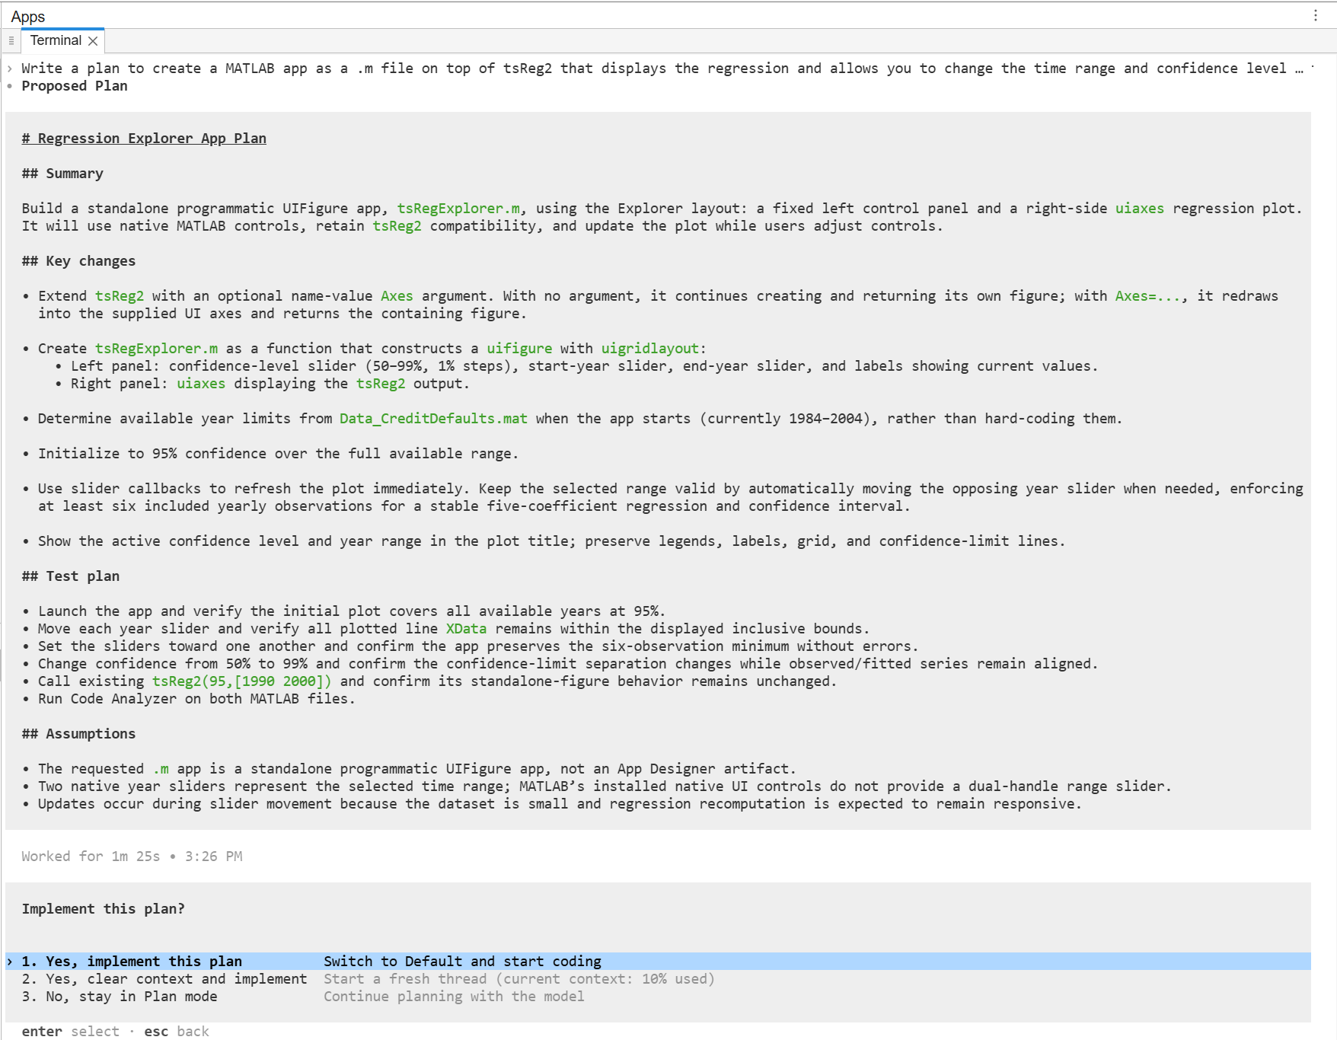
- Allow the agent to implement the plan

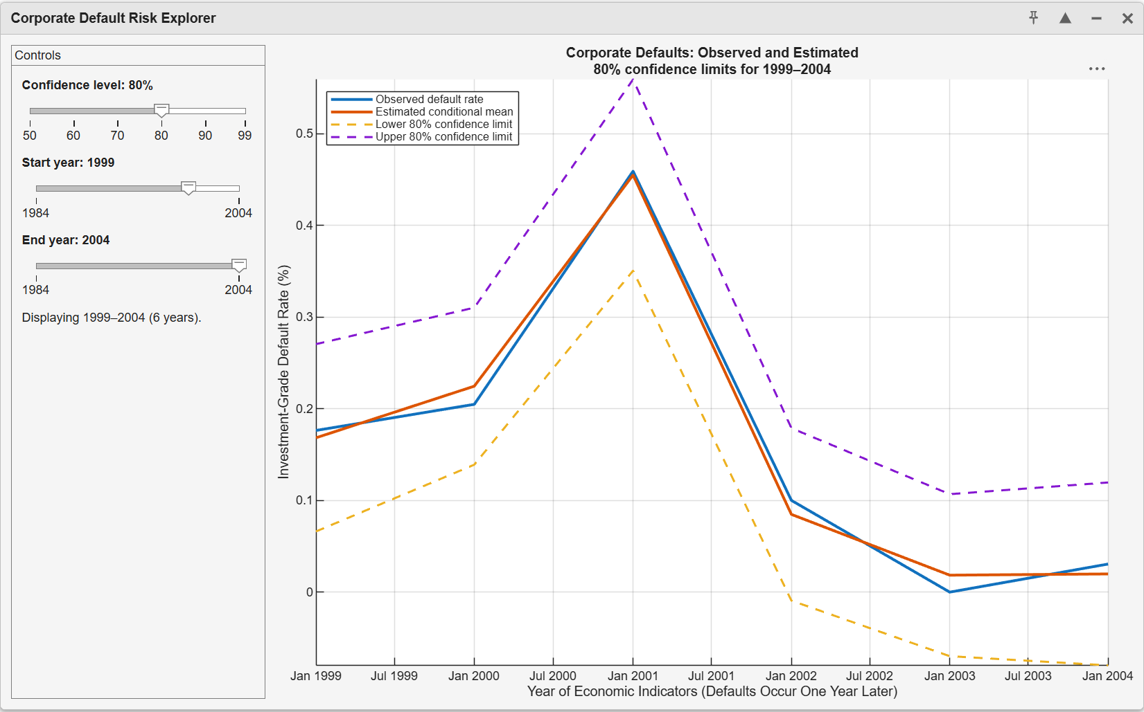
- Explore MATLAB Apps on your own with Codex!
Sample prompts:
- Add a dropdown box to the tsReg2App to select the regression types available in that function, with a default to linear.
- Add a switch to the app to add robust regression via bisquare weighting.
- Change the app to add checkboxes for which available indicators you want to be in the regression.
- Add a reset button to the bottom to change all of the parameters back to their defaults.
- I’m not crazy about the colors you picked for the lines on the plot. Pick tropical themed colors.

- Prompt 6: Save this app into an executable called ‘tsRegApp’ and save that executable to the current operating directory.


