Name: Sara gamal taha
Group:SE3

Lab 1: Exploring Cloud Virtualization and Data Center Architecture
- Screenshot comparisons of VM vs container resource usage
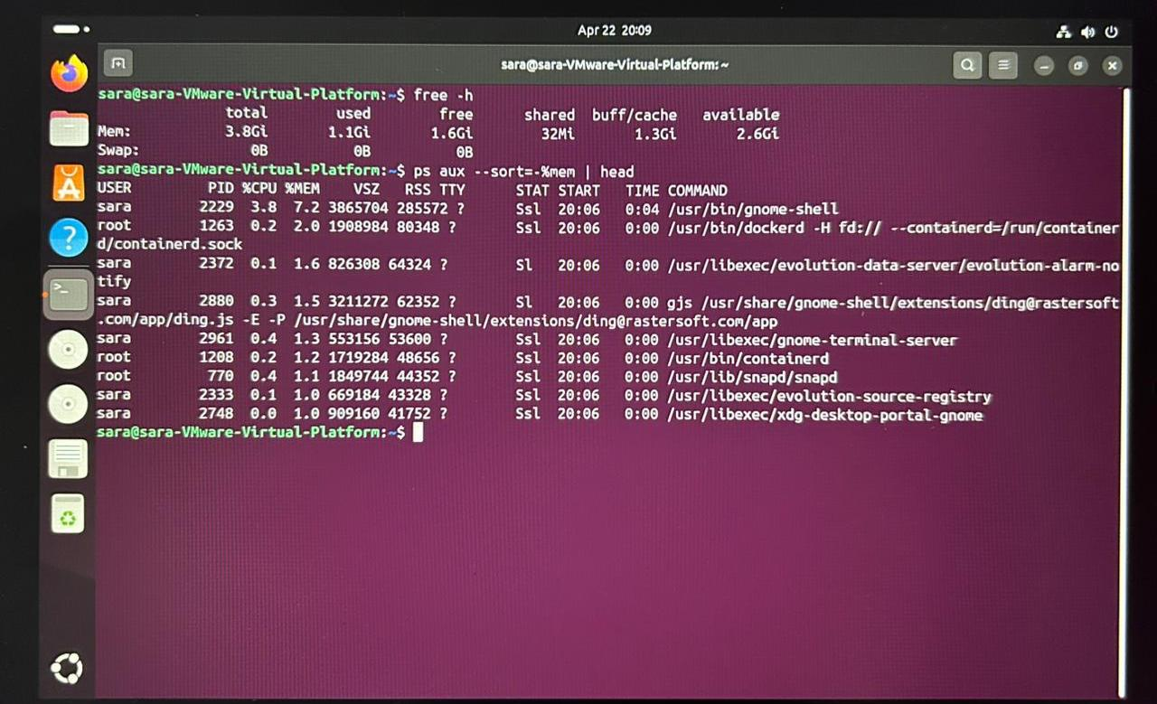
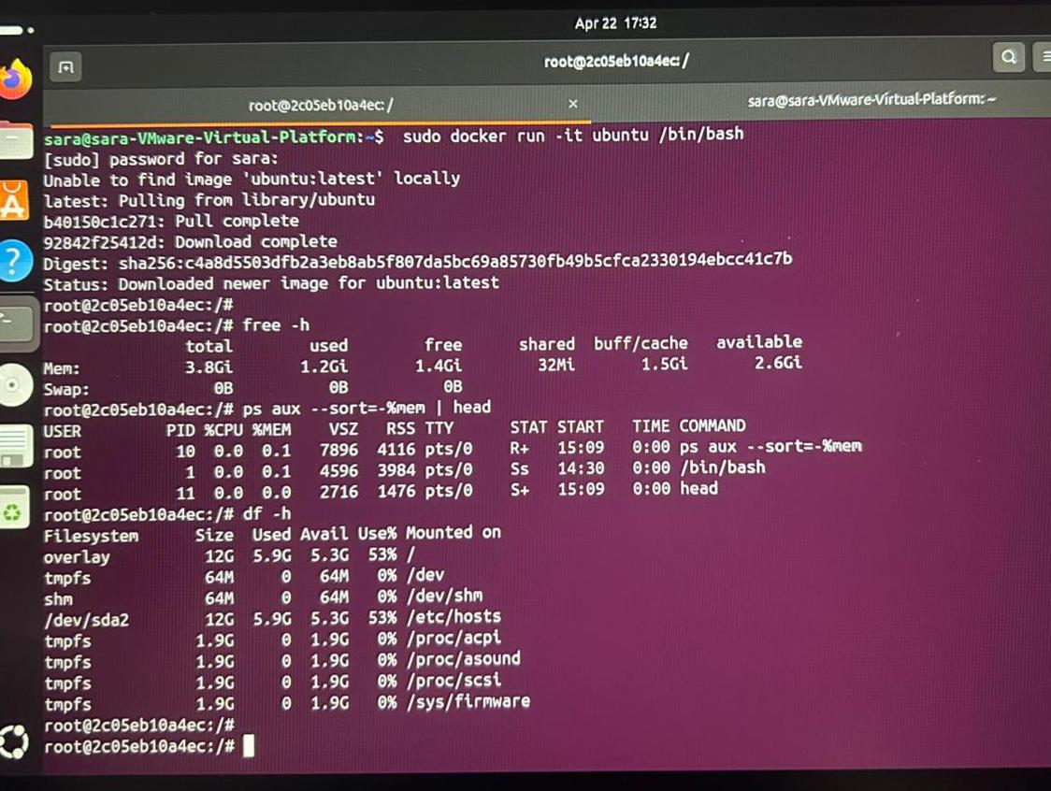

Containers use less memory and start faster than VMs because they share the host OS, while VMs run a full operating system.
- Latency histogram of web service.
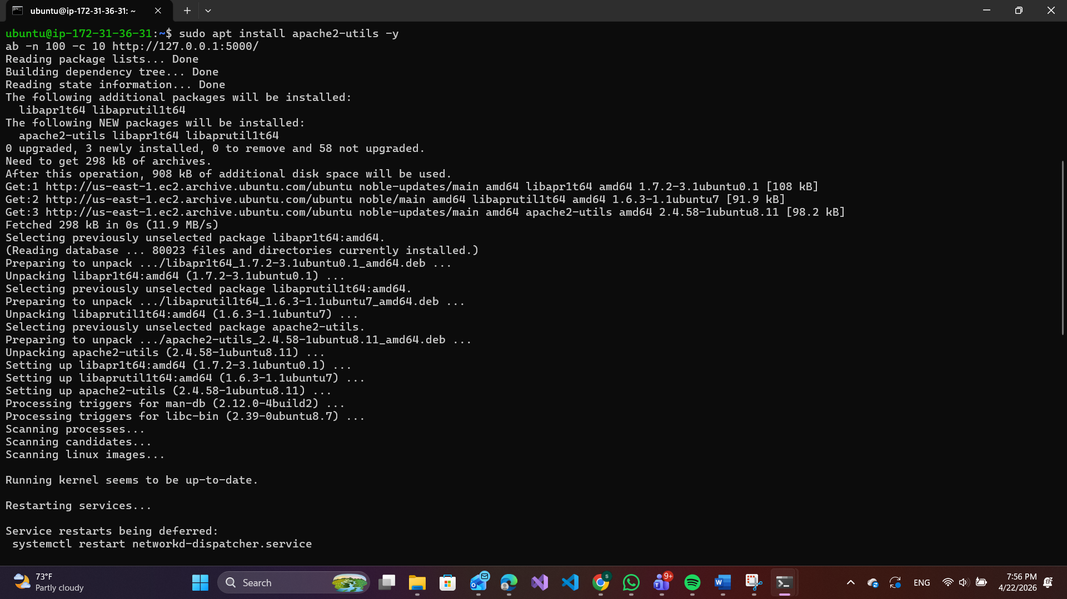
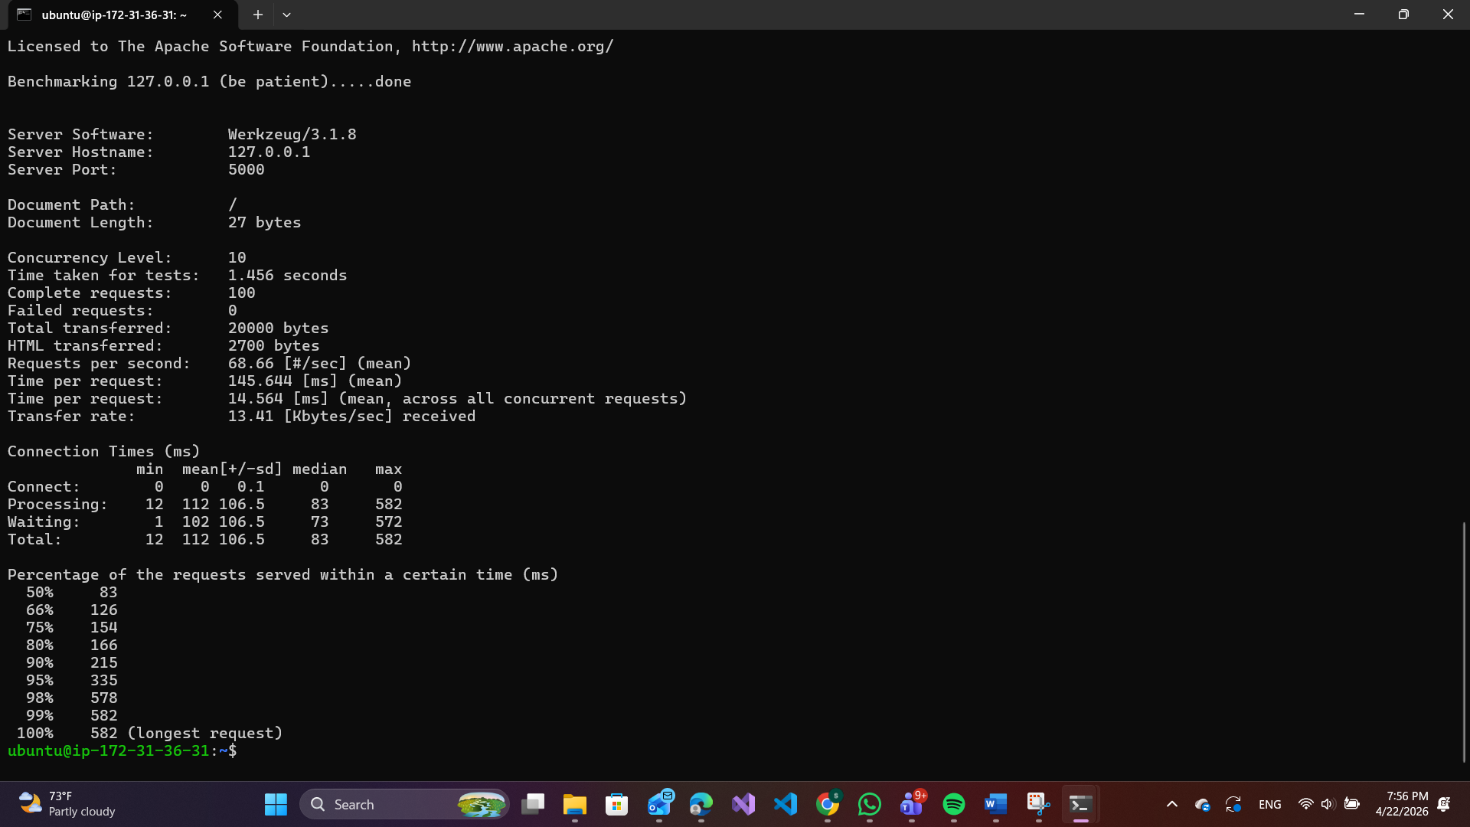
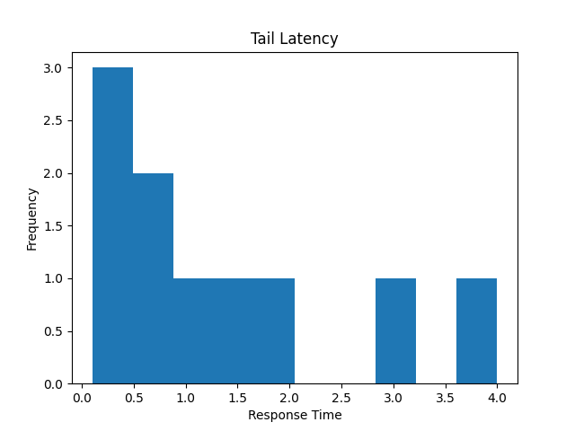
Tail latency becomes more significant as concurrency increases, which can impact overall system performance in distributed systems.

- Short writeup: Which architecture (VM or container) is better for microservices? Why?
Containers are generally better for microservices because they are lightweight, start quickly, and use fewer resources compared to virtual machines. Containers share the host operating system, making them more efficient and scalable for deploying many small services.
However, virtual machines provide stronger isolation and are useful in cases where full OS separation or enhanced security is required.

