Generic System Requirements

general configuration
configuration:
Location:
->Toolchain ->C library
then choose (x) glibc

set root password
configuration:
Location: │
│ -> System configuration -> Enable root login with password → Root password
write your password between () brakets

to change prompt message go to etc/profile
change the highlighted lines with the name you want

if [ "$PS1" ]; then
if [ "`id -u`" -eq 0 ]; then
export PS1='Hamada_Mayada_shell>' #change prompt name
else
export PS1='Hamada_Mayada_rootShell>' #change prompt name in root user
fi
fi

Add the overlay path in configuration:
Location:
->System configuration ->(your overlay folder path)Root filesystem overlay directories

Feature-Specific System Requirements

"Auto detection of mass-storage devices that can be connected via USB (e.g. Flash,
Memory Card)." continuously check for new inserted mass storage devices.
The MP3 Player will keep track of all .MP3 files available on any storage media.
When removing the storage device that contain the running song the MP3 Player will update the playlist with the remaining songs. Also speak out (Text-to-Speech) notification when a storage device is added or removed.

Create a daemon service script in etc/init.d/S01-automount-daemon-service, it must start with the naming convention,
it trigers another script in myApplications/automount-deamon

"Manual Control of Music Player (Play/Pause, Next, Previous, Shuffle), either via Push Buttons and Keyboard Commands."

The MP3 Player shall control playing the .MP3 files by pressing the "Play/Pause" push
button, jump to the next song when pressing the "Next" push button, restart the current song on pressing the "Previous" push button once, also play the previous song when pressing the "Previous" push button two successive times within 1 Second, And jump to a random song when pressing the "Shuffle" push button.

Configurations for playing audio files:
-> Target packages -> Libraries -> Audio/Sound -> portaudio

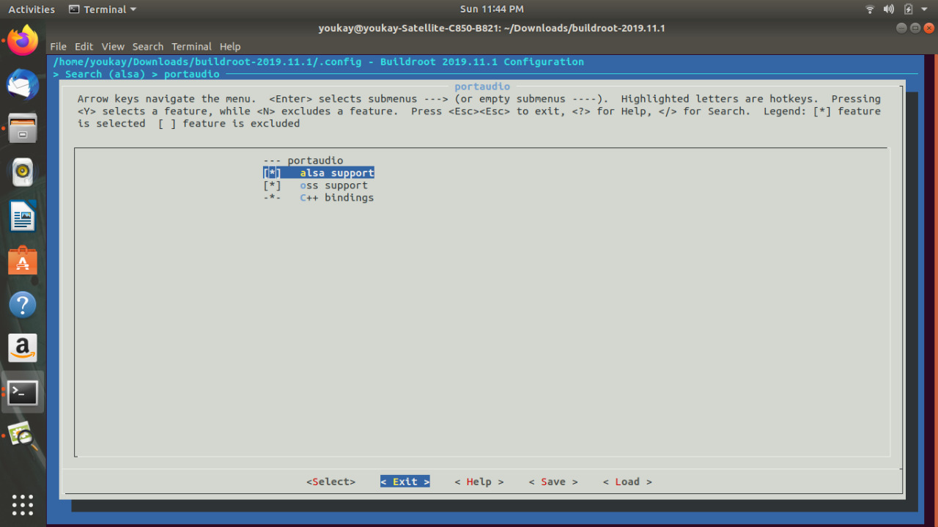

-> Target packages -> Audio and video applications -> alsa-utils
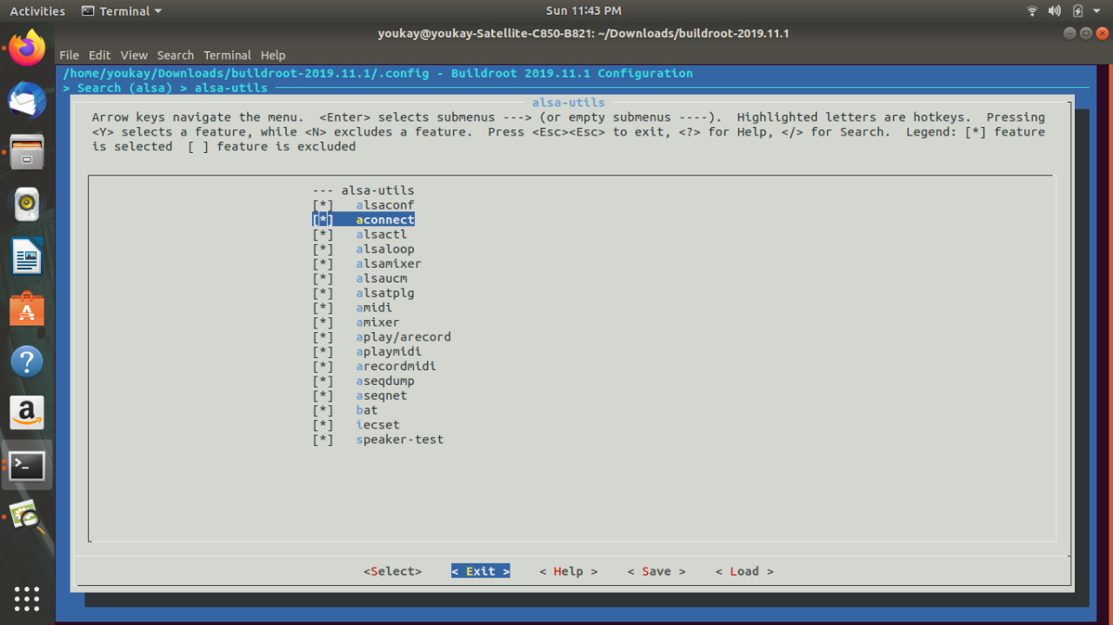

make sure to add also (atest, aumix, jack2, madplay) configuration from
-> Target packages -> Audio and video applications ->

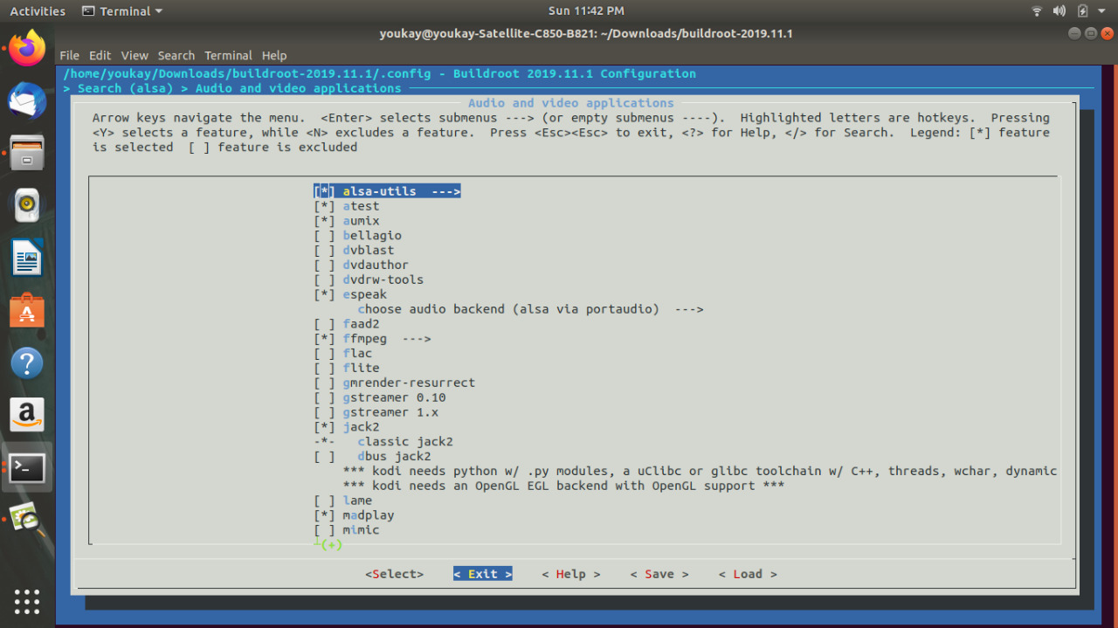

Target packages -> Libraries -> Audio/Sound -> alsa-lib --->

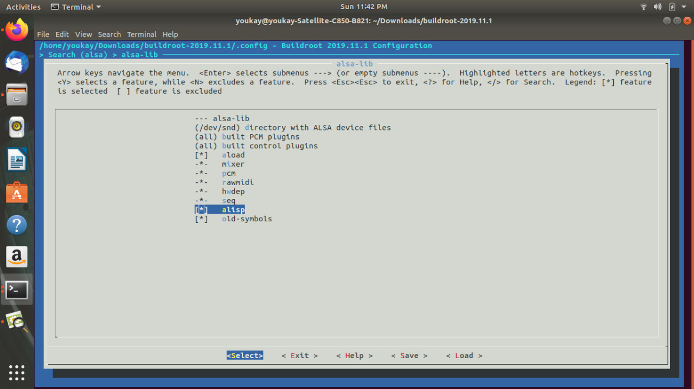

Target packages -> Libraries -> Audio/Sound

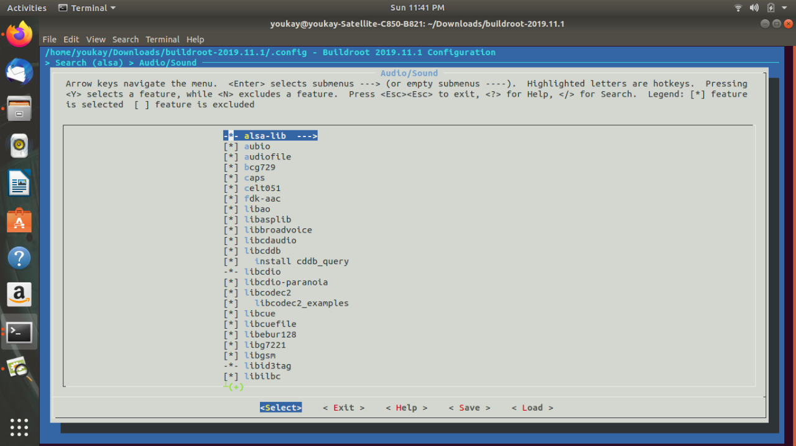

Control the MP3 from push buttons:
Create 2 daemon services scripts in /etc/init.d/S03-music-deamon-service and etc/init.d/S02-switch-deamon-service it must start with the naming convention,
both trigers another scripts in /myApplications/music-deamon and /myApplications/switch-deamon

the switch-deamon script configure the GPIO pins as input and continuously monitor the inputs from buttons and send signals to the process playing the song also write in folders that acts like global flags and files containing info about the current playing song

the music-deamon script reads the flag files and the current song info and acts upon in playing a specific song or pause song

Control the MP3 from terminal keyboard commands:
The MP3 Player shall start playing the .MP3 files when entering "play" , pause the played .MP3 file when entering "pause", skip to the next song when entering "next", play the previous song when entering "previous", jump to a random song when entering "shuffle" on the commandline.

Create scrpits with the same name of the commands you want in /bin/ exp: /bin/play
and simulate in each script the same behavior of push buttons

ssh terminal

open ssh terminal through Ethernet :

The Output Image have static network IP "192.168.1.6" and netmask "255.255.255.0". The ssh enabled on startup and accessible via "root" user. also Greet the user with this greeting text "Welcome to hamada and mayada MP3 Player" once.

Configuration:
Location:
-> Target packages -> Networking applications -> openssh

go to /etc/network/interfaces

and add the flowing lines to set static IP and net mask

auto eth0
#iface eth0 inet dhcp
iface eth0 inet static
pre-up /etc/network/nfs_check
wait-delay 15
hostname $(hostname)
address 192.168.2.6
netmask 255.255.255.0

after that go to /etc/ssh/.sshd_config.swp
and change the corresponding lines with the highlighted text

PermitRootLogin yes

PubkeyAuthentication yes

AuthorizedKeysFile .ssh/authorized_keys

PasswordAuthentication yes

Terminal messages for user

The MP3 Player shall output on the serial/ssh terminal
"MP3 Playing > [File_Name.mp3] Via [audio device name]" when starting playing
.MP3 file, "MP3 Paused > [File_Name.mp3]" when pausing the .MP3 file, And "No .MP3 files found" when it can't find any .mp3 file on the system.
The messages is refreshed on the serial/ssh terminal every 1 second.

Create ‘terminalmsgs’ script that continuously reads pauseFile flag and echo the messages to the terminal

the scripts runs when a terminal opens as a background process by adding the command ./terminalmsgs & in /etc/profile file

Audio notification
The MP3 Player speaks out (Text-to-Speech) a notification when an when a storage device is added or removed.

configuration:
Location:
->Target Packages -> Audio and Video applications -> espeak
then choose (x)alsa via portaudio (as a backend)

-> Target packages -> Audio and video applications -> -*- pulseaudio
and mark on [*] start as a system daemon

add the commands in automount-deamon script
exp: espeak "fe flasha etshalet" --stdout|aplay

