Project 2 – Sources
DATABASES
- Dutch data resources
https://www.government.nl/topics/climate-change/role-of-knowledge-and-data-institutes
- Greenhouse Gas Emissions from the Netherlands
http://www.emissieregistratie.nl/erpubliek/erpub/international/broeikasgassen.en.aspx
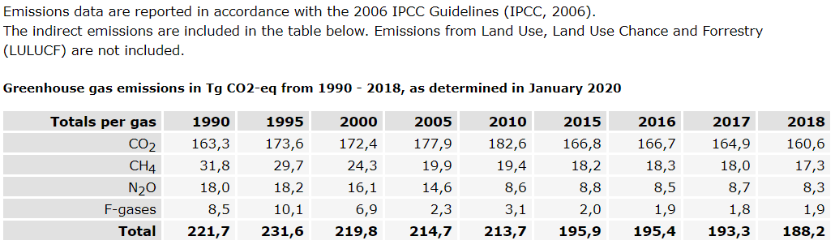
- Climate Monitor
Huge Database where you can have access to many records and sort them by town, province, area … and select the years.
https://klimaatmonitor.databank.nl/
- BP Statistical Review of World Energy
https://www.bp.com/en/global/corporate/energy-economics/statistical-review-of-world-energy/downloads.html

RESOURCES
- Paris Climate Agreement 2015
https://www.apc-paris.com/cop-21
- Regional Energy Strategy North-Holland South (Contains Amsterdam)
https://energieregionhz.nl/over-res
- 2020 European Goals
https://ec.europa.eu/clima/policies/strategies/2020_en
- Dutch goals within the agreement
https://www.government.nl/topics/climate-change/eu-policy
https://www.government.nl/topics/climate-change/news/2015/12/14/the-netherlands-commits-to-historic-climate-change-agreement
- Energy efficiency
https://www.iea.org/topics/energy-efficiency
https://www.iea.org/data-and-statistics?country=NETHLAND&fuel=CO2%20emissions&indicator=CO2%20emissions%20by%20energy%20source
https://www.iea.org/data-and-statistics/data-tables/?country=NETHLAND&energy=Renewables%20%26%20waste&year=1990 !!!!

