Request for Proposal (RFP)

Project Proposal: Fitness App
Group Member: Sarah Fayyaz (048) Javeria Shabbir (021)
1. Project Overview
This document outlines a proposal for the development of a personalized nutrition and recipe application. The application will empower users to achieve their health goals by providing tailored diet plans and easy access to a vast database of recipes.

2. Problem Statement
In an age of abundant information, many individuals struggle to find a diet plan that is both effective and suited to their personal needs. Generic diet advice often fails to account for individual factors like age, weight, and specific health goals. This leads to frustration, ineffective results, and a lack of motivation.

3. Business Objectives and Preliminary Requirements

3.1 Business Objectives
The system aims to:
- Provide a personalized diet planning application to help users achieve their health goals.
- Offer a user-friendly platform that simplifies healthy eating through personalized plans and a comprehensive recipe database.
- Increase user engagement by providing a tool that supports and tracks progress toward health goals.

3.2 Preliminary Requirements
Functional Requirements:
- The system must collect user data (age, weight, height, gender, health goal) to generate a personalized diet plan.
- The system must have a searchable database of recipes.
- Each recipe must include ingredients, preparation steps, and calorie counts.
- The generated diet plan must include food recommendations, recipes, ingredients, and calorie counts.
- The diet plan must specify the frequency of consumption for meals.
- The daily calorie intake must be distributed across four meals: Breakfast (25%), Lunch (35%), Dinner (30%), and Snacks (10%).
Non-Functional Requirements:
- The application's user interface must be clean and intuitive.
- The app's layout must have the name/logo on the left and a search bar, login button, and "Diet Suggestion" button on the right.
- The system should be reliable and available with minimal downtime.
- The application should be responsive and have a fast loading time.
- The system must protect user data and ensure privacy and security.
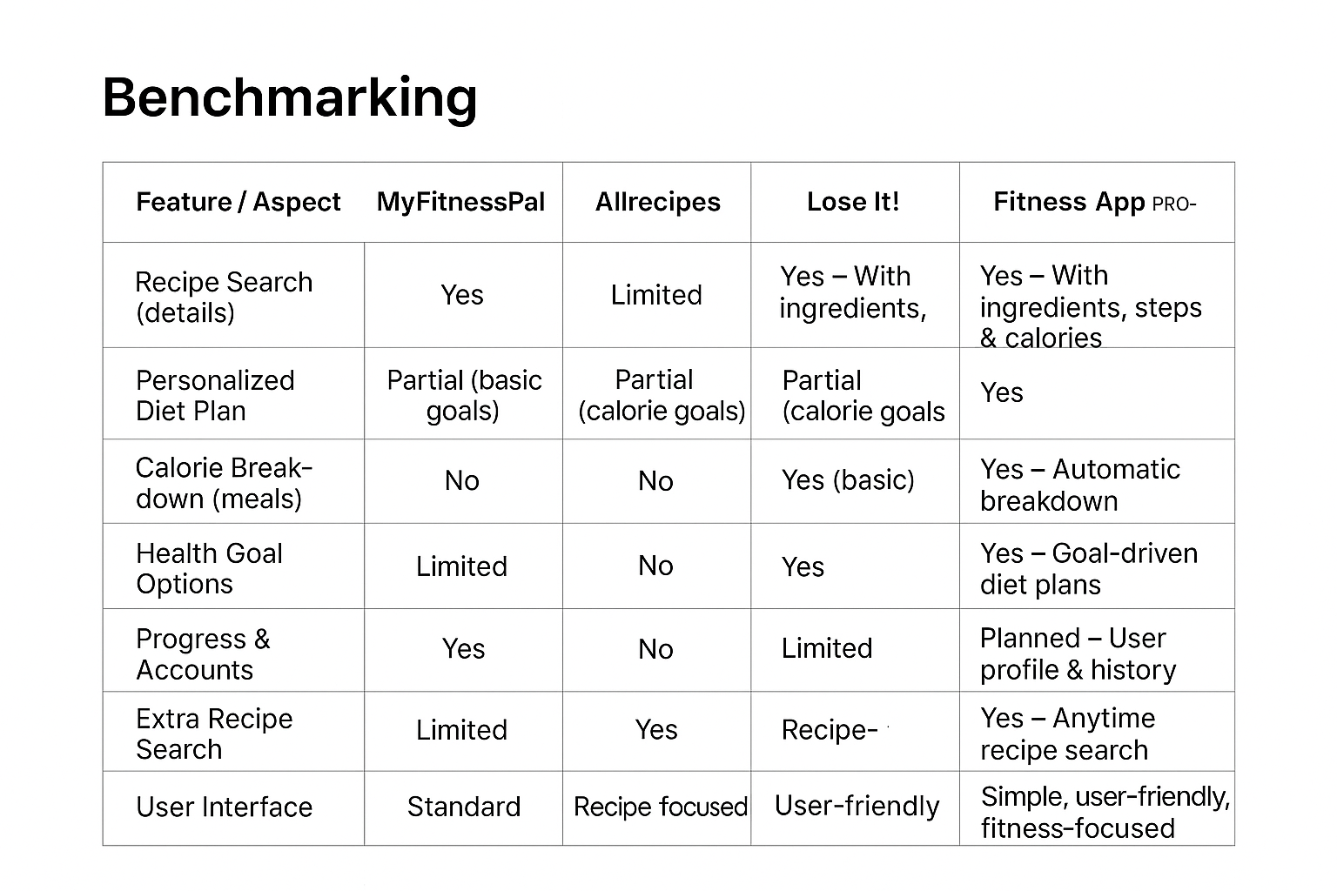
4. Current Situation and Opportunity Statement
The current market offers various fitness and recipe apps, but few seamlessly integrate personalized diet planning with a searchable recipe database. This project represents a significant opportunity to fill this market gap by providing a holistic solution that is both highly personalized and convenient.

5. Options and Recommendations
We recommend a phased approach to development. The initial phase will focus on building the core features: the user interface, the diet suggestion form, the diet plan generation algorithm, and the recipe search functionality. Subsequent phases can include features like user accounts to save favorite recipes and track progress, and a social sharing feature.

6. Potential Risks and Mitigation Plan
Risk: Inaccurate diet plan calculations.

Mitigation: The development team will work with a certified nutritionist to validate the diet plan algorithms to ensure accuracy and safety.

Risk: Insufficient recipe data.

Mitigation: The project will begin with a foundational database of popular recipes, with a plan to continuously add more content and potentially allow user-submitted recipes in future updates.

7. Schedule Estimate (3 Months)
The project will be developed in three phases, focusing first on core functionality (profile, goals, diet suggestion, and recipe search), then expanding into personalized meal planning and calorie distribution, and finally refining with progress tracking, testing, and final delivery.
Month | Tasks | Features Delivered
Month 1 – Core Setup | • Requirement analysis and UI/UX design  • Implement user profile (age, weight, height, gender)  • Add login/signup system  • Develop recipe search functionality (ingredients, steps, calories)  • Basic interface for profile and search | User accounts  Profile setup  Recipe search module  Initial UI
Month 2 – Diet & Goals | • Implement health goal customization (Lose, Gain, Maintain, Diabetes-Friendly)  • Build personalized diet plan generation  • Add calorie distribution across meals (Breakfast 25%, Lunch 35%, Dinner 30%, Snacks 10%)  • Enhance interface for diet plan display | Personalized diet plans  Calorie breakdown  Goal-based recommendations  Improved UI
Month 3 – Tracking & Finalization | • Implement progress tracking (planned for accounts)  • Allow extra recipe recommendations beyond diet plan  • Conduct testing and debugging  • Gather user feedback and refine features  • Prepare final documentation and demo | Progress tracking (basic)  Extra recipe search  System testing  Final refinements  Project delivery

