**1)**

I assume, for the following problems, that when we draw a hand of 5 cards from a deck of 52, we are drawing without replacement.

(a). Below, I calculate the probability of getting a blush by counting the number of ways one could draw a hand of 5 cards from 26. I then divide this number by the total number of ways to draw a hand of 5 cards from a deck of 52.

$$Probability \left(blush\right)=\left(\begin{matrix}26 \\ 5\end{matrix}\right) ÷ \left(\begin{matrix}52 \\ 5\end{matrix}\right)$$

$$=65,780 ÷2,598,960$$

$$=0.02531 ≈2.53\%$$

(b). I calculate the probability of getting a flash by first looking at the number of ways I could choose the suit which will appear twice in the hand (4 ways). I then multiply this by the number of ways I could choose those two cards from the same suit and by the number of ways I could choose one card from each of the remaining suits. Lastly, I divide the product of the number of ways these decisions could occur by the total number of ways to choose 5 cards from a deck of 52.

$$Probability \left(flash\right)=\left( \left(\begin{matrix}4 \\ 1\end{matrix}\right) \left(\begin{matrix}13 \\ 2\end{matrix}\right) \left(\begin{matrix}13 \\ 1\end{matrix}\right) \left(\begin{matrix}13 \\ 1\end{matrix}\right) \left(\begin{matrix}13 \\ 1\end{matrix}\right) \right) ÷ \left(\begin{matrix}52 \\ 5\end{matrix}\right)$$

$$=\left(\left(4\right)\left(78\right)(2,197)\right)÷2,598,960$$

$$=0.263745 ≈26.37\%$$

(c). To calculate the probability of getting a royal scandal, I first multiply the number of ways to choose two Kings from four suits by the number of ways to choose two Queens from four suits by the number of ways to choose the Jack from four suits. I then take this product and divide it by the total number of ways one could choose a hand of 5 cards from a deck of 52.

$$Probability \left(royal scandal\right)=\left( \left(\begin{matrix}4 \\ 2\end{matrix}\right) \left(\begin{matrix}4 \\ 2\end{matrix}\right) \left(\begin{matrix}4 \\ 1\end{matrix}\right) \right) ÷ \left(\begin{matrix}52 \\ 5\end{matrix}\right)$$

$$=\left(6\right)\left(6\right)\left(4\right)÷2,598,960$$

$$=0.000055 ≈0.0055\%$$

**2)**

Below, I simulate the election problem in the same way as I would simulate 100 tosses of a biased coin with the bias such that the probability of landing on heads (voting in favor of candidate A) is equal to 0.55.

$$Probability \left( A<50 \right)= \sum_{k=0}^{49}{\left(\begin{matrix}100 \\ k\end{matrix}\right){0.55}^{k}*{0.45}^{100-k}}$$

$$=0.134576 ≈13.46\%$$

**3)**

(3.1).

$Probability \left(someone^{'}s birthday today\right)=1-Probability\left( no one^{'}s birthday today\right)$

In general, for the number of students k, we have…

$$=1-{\left(\frac{364}{365}\right)}^{k}$$

So when the number of students, k = 30 we get…

$$=1-{\left(\frac{364}{365}\right)}^{30}$$

$$=0.079009 ≈7.90\%$$

Now we find k such that the probability that someone’s birthday is today is $\frac{1}{2}$.

$$1-{\left(\frac{364}{365}\right)}^{x}= \frac{1}{2}$$

$${\left(\frac{364}{365}\right)}^{x}= \frac{1}{2}$$

$$\log_{\left(\frac{364}{365}\right)}{\frac{1}{2}=x}$$

$$x=252.652 ≈253 people$$

(3.2).

$$Prob\left(sharing birth/death date\right)=1-Prob (not sharing birth/death date)$$

$$=1-\left(\left(1-\frac{1}{{\left(365\right)}^{2}}\right)\left(1-\frac{2}{{\left(365\right)}^{2}}\right)…\left(1-\frac{k-1}{({365)}^{2}}\right)\right)$$

When using the birthday problem approximation, we have…

$$Prob \left(not sharing birth/death date\right)≈1+\left(1- \frac{1}{{\left(365\right)}^{2}}\right)\left(1-\frac{2}{{\left(365\right)}^{2}}\right)…\left(1-\frac{k-1}{{\left(365\right)}^{2}}\right)$$

$$≈e^{-\left(1+2+ … + \frac{\left(k-1\right)}{{\left(365\right)}^{2}}\right)}$$

$$≈ e^{\left(\frac{-k\left(k-1\right)}{2*{(365)}^{2}}\right)}$$

$$≈ e^{\left(\frac{-{\left(k-1\right)}^{2}}{2*{\left(365\right)}^{2}}\right)}$$

With k = 1,000 people, calculate…

$$Prob (not sharing birth/death date) ≈ e^{\left(\frac{-{\left(1000-1\right)}^{2}}{2*{\left(365\right)}^{2}}\right)} =0.023623$$

$$1-Prob (not sharing birth/death date) =1-0.023623$$

$$Prob (sharing birth/death date) =0.976377 ≈97.64\% chance$$

(3.3).

*(a).*

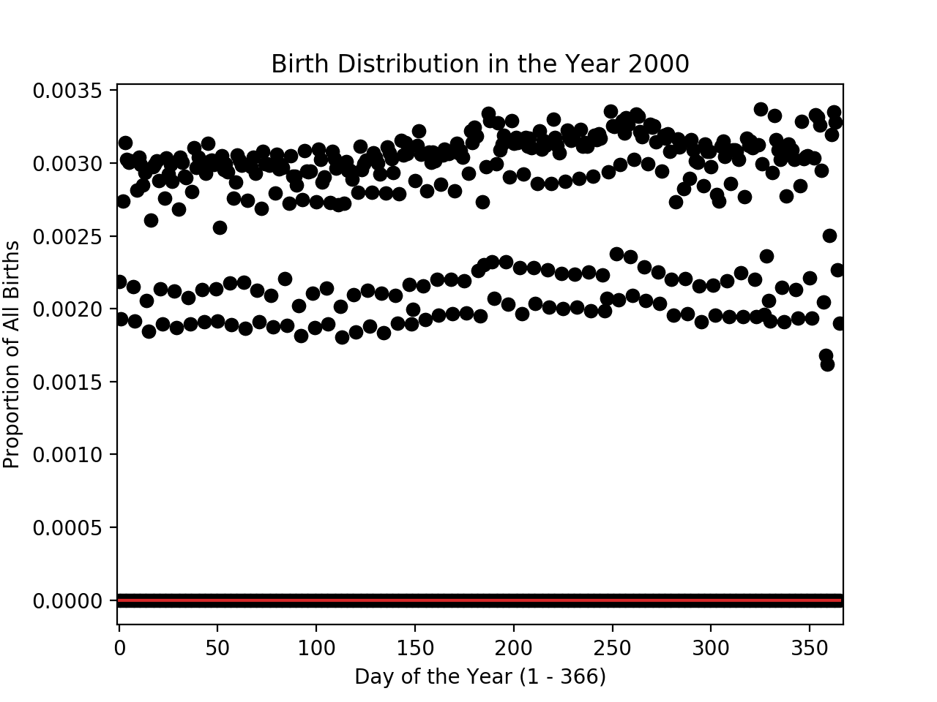

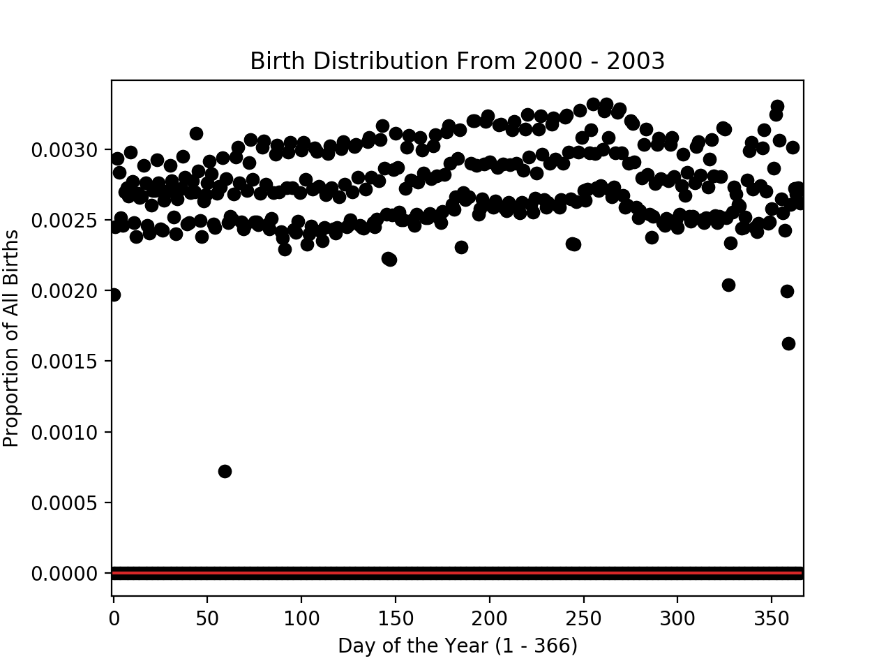

*(b).*

Because my computer had trouble processing my code when I tried to use a large trial number (1,000 times for each k value), the graph I include here below was generated using a much smaller trial number. (I suspect this is an issue with my computer, though, so please see the “prob_coincidence()” and “birthday()” functions in the attached code.) As a result, I expect that this attached graph shows even more variation between the real birthday distribution in orange and the theoretical one in blue than I would have seen if the graph had used a higher trial number. With that said, it seems that the real distribution in orange largely follows the same trend as our theoretical blue trend line—only with more natural fluctuations. The uniform probability distribution therefore seems to model the real-life version of our problem quite well, if perhaps a bit too neatly.

