Sarah Ford

Assignment 4

**Part I.**

1) $X \left(\left\{and, but, them, for, what, to, he, she\right\}\right)=2$

2) $P\left(X=3\right)=\frac{\left(\begin{matrix}15 \\ 3\end{matrix}\right)*\left(\begin{matrix}85 \\ 7-3\end{matrix}\right)}{\left(\begin{matrix}100 \\ 7\end{matrix}\right)}=\frac{455*2,024,785}{16,007,560,800}=0.057553$

$P\left(X=0\right)=\frac{\left(\begin{matrix}15 \\ 0\end{matrix}\right)*\left(\begin{matrix}85 \\ 7-0\end{matrix}\right)}{\left(\begin{matrix}100 \\ 7\end{matrix}\right)}=\frac{1*4,935,847,320}{16,007,560,800}=0.308345$

3) $P\left(X=k\right)=\frac{\left(\begin{matrix}K \\ k\end{matrix}\right)\left(\begin{matrix}N-K \\ n-k\end{matrix}\right)}{\left(\begin{matrix}N \\ n\end{matrix}\right)}=\frac{\left(\begin{matrix}15 \\ k\end{matrix}\right)\left(\begin{matrix}85 \\ 7-k\end{matrix}\right)}{\left(\begin{matrix}100 \\ 7\end{matrix}\right)}$

*K = # of total words beginning with the letter t*

*k = # of observed words beginning with the letter t*

*N = # of words*

*n = # of draws*

4)

5) See attached code, function “PMF_stem_X()”.

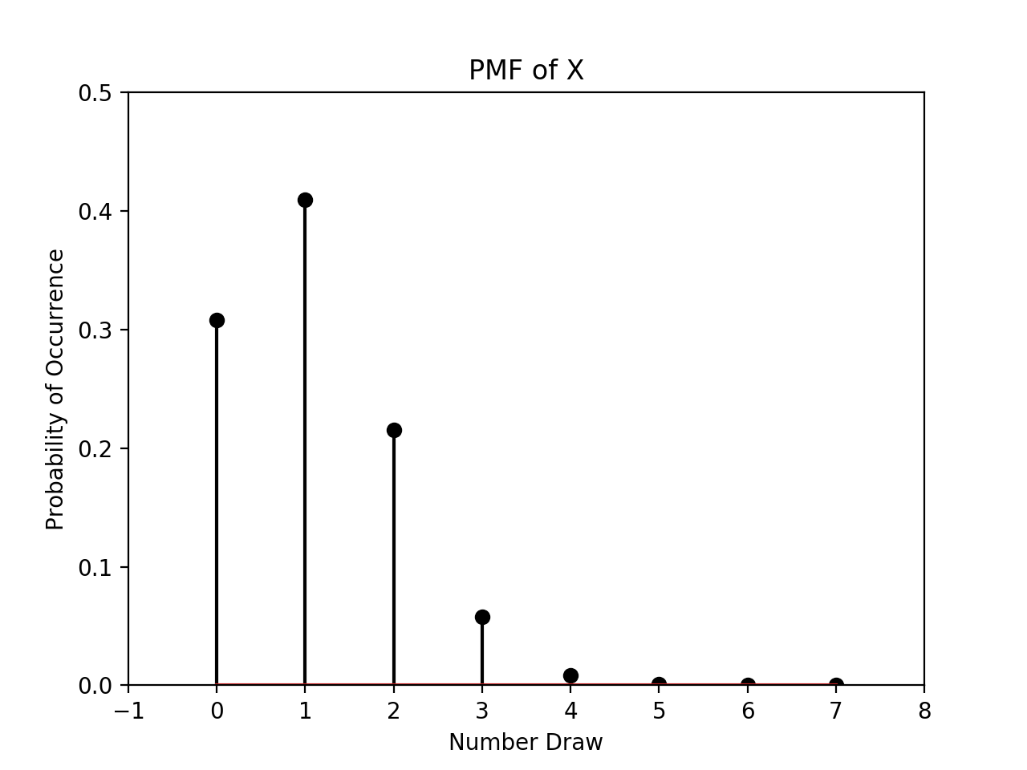

6)

7) See attached code, function “distribution_X()”.

8) See attached code, function “ave_min_expected()”.

**Part II.**

1) $P\left(Y=k\right)=\left(\begin{matrix}1000 \\ k\end{matrix}\right)({0.0027)}^{k}({0.9973)}^{1000-k}$

2) $P\left(Y=k\right)=\left(\frac{{2.7}^{k}}{k!}\right)({e)}^{-2.7}$

3)

Exactly: $P\left(Y=0\right)=\left(\begin{matrix}1000 \\ 0\end{matrix}\right)({0.0027)}^{0}({0.9973)}^{1000}=0.066961$

Approximation: $P\left(Y=0\right)=\left(\frac{{2.7}^{0}}{0!}\right)({e)}^{-2.7}=0.067206$

Exactly: $P\left(Y=1\right)=\left(\begin{matrix}1000 \\ 1\end{matrix}\right)({0.0027)}^{1}({0.9973)}^{1000-1}=0.181283$

Approximation:

4) See attached code, function “Part2_Y()”

5) See attached code, function “PMF_stem_Y()”

