Sarah Ford

**2)** ** In the figures below, shaded areas indicate the probabilities **

**a.**

P(value on at least one of the spinners is less than ½) = ¾ = 75%

(0,1) (1,1)

(0,0)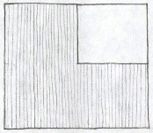(1,0)

**b.**

P(values on two spinners are within ½ of each other) = ¾ = 75%

(0,1) (1,1)

(0,0) 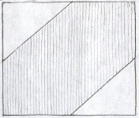(1,0)

**c.**

P(values on two spinners are equal) = 0%

(0,1) (1,1)

(0,0) 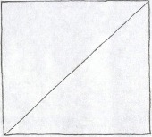 (1,0)

**d.**

P(at least one value is less than ½ and both are within ½ of each other) = ½ = 50%

(0,1) (1,1)

(0,0) 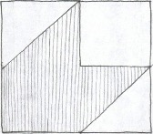 (1,0)

**e.**

P(able to make a triangle) = ¼ = 25%

(0,1) (1,1)

(0,0) 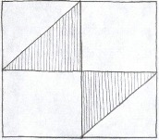 (1,0)

**3)**

**a.**

The value at x = 0 is 2 because the area underneath the graph must be 1. Therefore, we solve the equation $\frac{y × 1}{2}=1$, where y is the height of the graph, and we find y = 2 at x = 0.

**b.**

The slope of the PDF line is -2x + 2, so we solve

$$\int_{0}^{1/{12}}{-2x+2}$$

and find that the probability that a dart lands within 1 inch (1/12 of a foot) is equal to 15.97%

**c.**

Given the slope of the dartboard PDF line is -2x+2, we solve

$$\left(-2x+2\right)x+\frac{(2-\left(-2x+2\right))x}{2}=0.5$$

and find that the distance x within which approximately half the darts fall is about 0.29 feet.

**d.**

The formula for the CDF is:

$\left\{\begin{aligned}0 , x<0 \\ 2x-x^{2} , 0≤x≤1 \\ 1 , x>1\end{aligned}\right.$

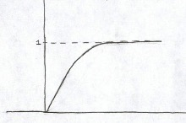

**e.**

$$E\left(X\right)= \int_{0}^{1}{\left(-2x+2\right)x=\frac{1}{3}}$$

**Extra Credit 4.1**

$Length 1=x$, $Length 2=\left(1-x\right)×y$, $Length 3=(1-x)×(1-y)$

All three lengths must be less than ½ in order to form a triangle, yielding:

$(1-x)×y≤\frac{1}{2}$ and $(1-x)×\left(1-y\right)≤\frac{1}{2}$

In order to find the area bound by these inequalities within our 1x1 box, we take:

$$\int_{0}^{0.5}{\left(\frac{-1}{2\left(x-1\right)}-\left(\frac{1}{2\left(x-1\right)}+1\right)\right)dx ×2}$$

$$=0.193147×2$$

$$=0.386294≈38.63\%$$