1)

$$Given μ=1,000×0.48=480, and σ= \sqrt{1,000×0.48×(1-0.48)}=15.799$$

$$P\left(X ≥500\right)=1-Φ(500)$$

$$=1-Φ\left(\frac{500-480}{15.799}\right)$$

$$≈0.10277≈10.28\%$$

2)

a.

$P\left(1\right)= \frac{1}{6}$ $P\left(2\right)= \frac{1}{3}$ $P\left(4\right)= \frac{1}{6}$ $P\left(5\right)=\frac{1}{6}$ $P\left(6\right)= \frac{1}{6}$

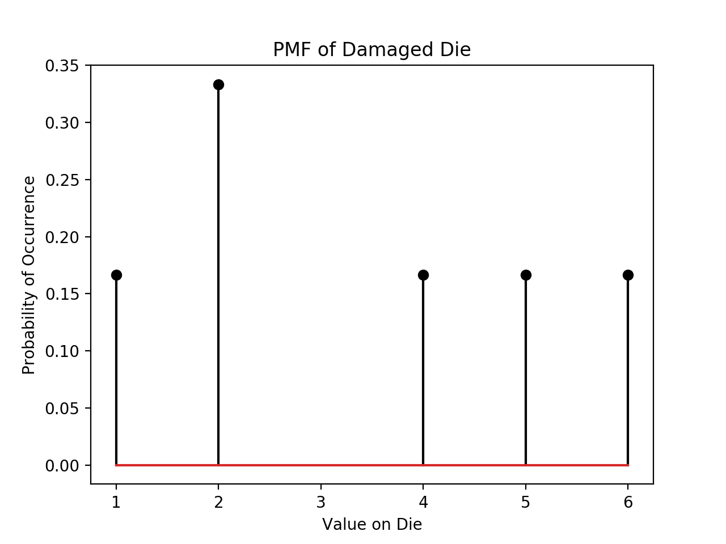

b.

$$E\left(X\right)= \frac{1}{6}×\left(1+4+5+6\right)+\frac{1}{3}×(2)$$

$$= \frac{10}{3}$$

c.

$$Var\left(X\right)=E\left(X^{2}\right)-E{(X)}^{2}$$

$$E\left(X^{2}\right)= \frac{1}{6}×\left(1^{2}+4^{2}+5^{2}+6^{2}\right)+ \frac{1}{3}×\left(2^{2}\right)=\frac{43}{3}$$

$$E{(X)}^{2}={\left(\frac{10}{3}\right)}^{2}=\frac{100}{9}$$

$$E\left(X^{2}\right)-E{\left(X\right)}^{2}=\frac{43}{3}-\frac{100}{9}$$

$$Var(X)=\frac{29}{9}$$

$$σ\left(X\right)= \sqrt{\frac{29}{9}}$$

d.

$$P\left[3 ≤X≤4\right]=P\left(\left|X-\frac{3+4}{2}\right|<\frac{4-3}{2}\right)≥1-\frac{\frac{29}{9}+{\left(\frac{10}{3}-\frac{3+4}{2}\right)}^{2}}{{\left(\frac{1}{2}\right)}^{2}}$$

$$P\left[3≤X≤4\right]≥1-13$$

$$P\left[3≤x≤4\right]≥-12$$

e.

$E\left(S_{n}\right)=\left(\frac{10}{3}\right)×n$ $Var\left(S_{n}\right)=\left(\frac{29}{9}\right)×n$ $σ\left(S_{n}\right)= \sqrt{\frac{29}{9}×n}$

$$P\left[3n ≤X≤4n\right]≥1-\frac{\frac{29}{9}n+\left(\frac{10}{3}n-\frac{7}{2}n\right)}{{\left(\frac{n}{2}\right)}^{2}}$$

$$≥1-\frac{172}{3n}$$

f.

$$P\left[150≤S_{50}≤200\right]$$

$$≈P\left[\frac{149-\frac{50×100}{3}}{\sqrt{\frac{29}{9}×50}}≤\frac{S_{50}-\frac{50×100}{3}}{\sqrt{\frac{29}{9}×50}}≤\frac{201-\frac{50×100}{3}}{\sqrt{\frac{29}{9}×50}}\right]$$

$$= Φ\left(\frac{201-\frac{500}{3}}{\sqrt{\frac{29}{9}×50}}\right)-Φ\left(\frac{149-\frac{500}{3}}{\sqrt{\frac{29}{9}×50}}\right)$$

$$≈0.99747-0.07458$$

$$≈0.9229$$

g.

See Code, function S_50()

h. ** NOTE ** COULD NOT SUPERIMPOSE STANDARD NORMAL DENSITY W/OUT SCIPY

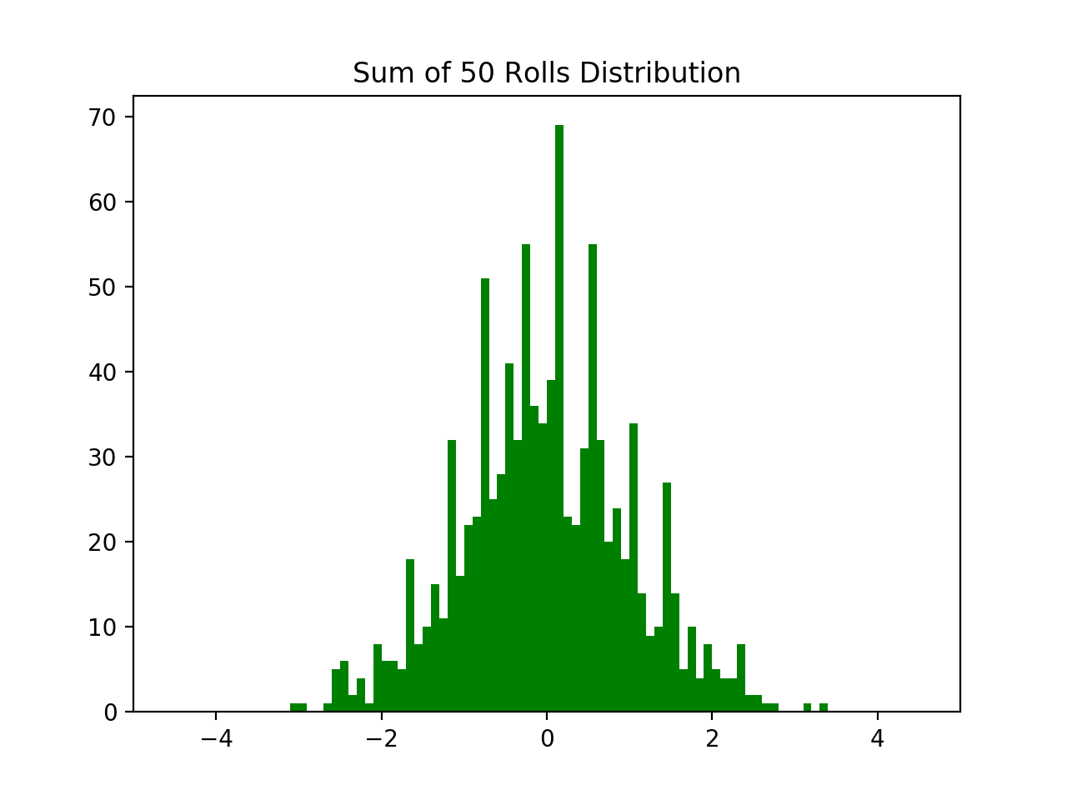

i. ** NOTE ** COULD NOT COMPLETE THIS PART W/OUT SCIPY

(3)

a.

$$\lim_{n→∞}{P\left(A_{n}=0.8\right)=1}$$

As *n* grows increasingly large, the average deviates less and less from the true mean of 0.8.

b.

$$\lim_{n→∞}{P(0.7n<S_{n}<}0.8n)=P(\frac{0.7n-0.8n}{\sqrt{0.16n}}≤\frac{S_{n}-0.8n}{\sqrt{0.16n}}≤\frac{0.8n-0.8n}{\sqrt{0.16n}}$$

$$=Φ\left(0\right)-Φ\left(\frac{-0.01n}{\sqrt{0.16n}}\right)$$

$$=\frac{1}{2}$$

c.

$$\lim_{n→∞}{P\left(S_{n}<0.8n+\sqrt{n}\right)=P(}\frac{S_{n}-0.8n}{\sqrt{0.16n}}<\frac{\sqrt{n}}{\sqrt{0.16n}}$$

$$=Φ\left(\frac{\sqrt{n}}{\sqrt{0.16n}}\right)≈0.9938$$

d.

$σ(A_{n})\sqrt{\frac{0.16}{n}}$ $μ=\frac{1}{n}\left(0.8n\right)=0.8$

$$P\left(0.79≤A_{n}≤0.81\right)=P\left(\frac{0.79-0.8}{\sqrt{\frac{0.16}{n}}}≤\frac{A_{n}-0.8}{\sqrt{\frac{0.16}{n}}}≤\frac{0.81-0.8}{\sqrt{\frac{0.16}{n}}}\right)$$

$$=P\left(\frac{-0.01}{\sqrt{\frac{0.16}{n}}}≤\frac{A_{n}-0.8}{\sqrt{\frac{0.16}{n}}}≤\frac{0.01}{\sqrt{\frac{0.16}{n}}}\right)$$

$$=Φ\left(\frac{0.01}{\sqrt{\frac{0.16}{n}}}\right)-Φ\left(\frac{-0.01}{\sqrt{\frac{0.16}{n}}}\right)$$

$$=1$$

e.

$$\lim_{n→∞}{P\left(0.79<A_{n}<0.8+\frac{1}{\sqrt{n}}\right)=P\left(\frac{-0.01}{\sqrt{\frac{0.16}{n}}}≤\frac{A_{n}-0.8}{\sqrt{\frac{0.16}{n}}}≤\frac{0.01+\frac{1}{\sqrt{n}}}{\sqrt{\frac{0.16}{n}}}\right)}$$

$$=Φ\left(\frac{0.01+\frac{1}{\sqrt{n}}}{\sqrt{\frac{0.16}{n}}}\right)-Φ\left(\frac{-0.01}{\sqrt{\frac{0.16}{n}}}\right)$$

$$=1$$