Calibration Gailtal

Number of Runs: 2.3 Mio, Euclidean Distance best 100: 0.165-0.171
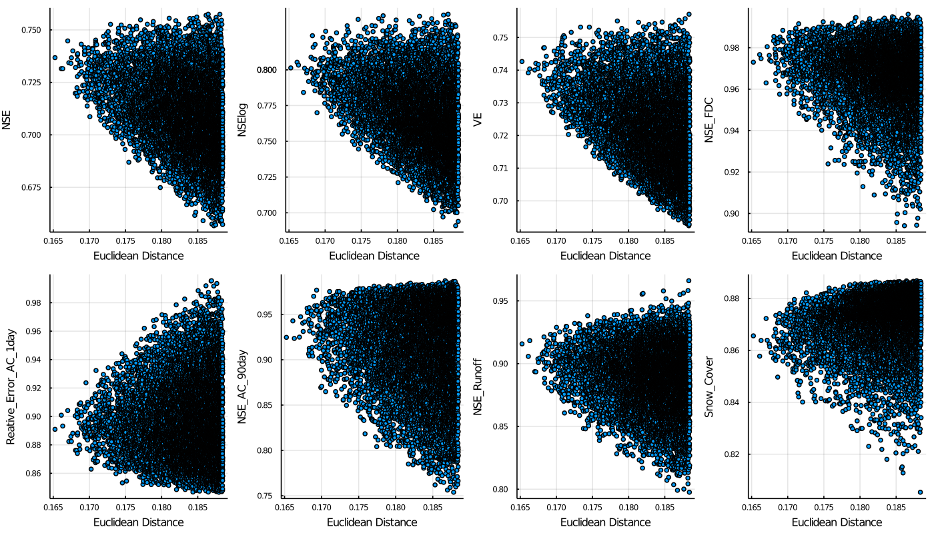

The figure shows the best 10000 fit based on the Euclidean Distance. It shows how the fits perform based on the individual objective functions that contribute to the overall fit. It can be seen that the flow duration curve, the autocorrelation curve and the representation between the division in runoff and evaporation are very well represented. Also, the snow cover is well represented. The log NSE also performs well, whereas the NSE and the VE perform okay.
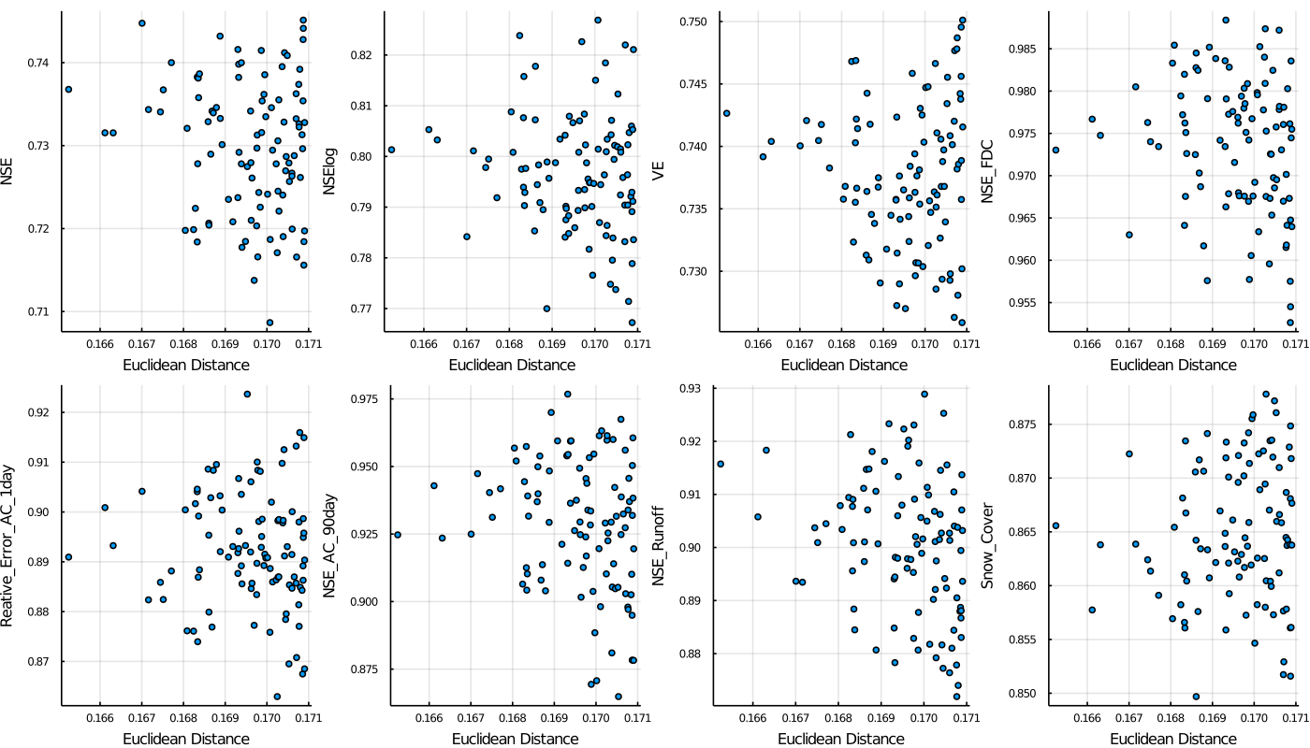
Looking at the 100 best parameter fits it can be seen that the NSE and log NSE are also above 0.7. The fit therefore seems good.
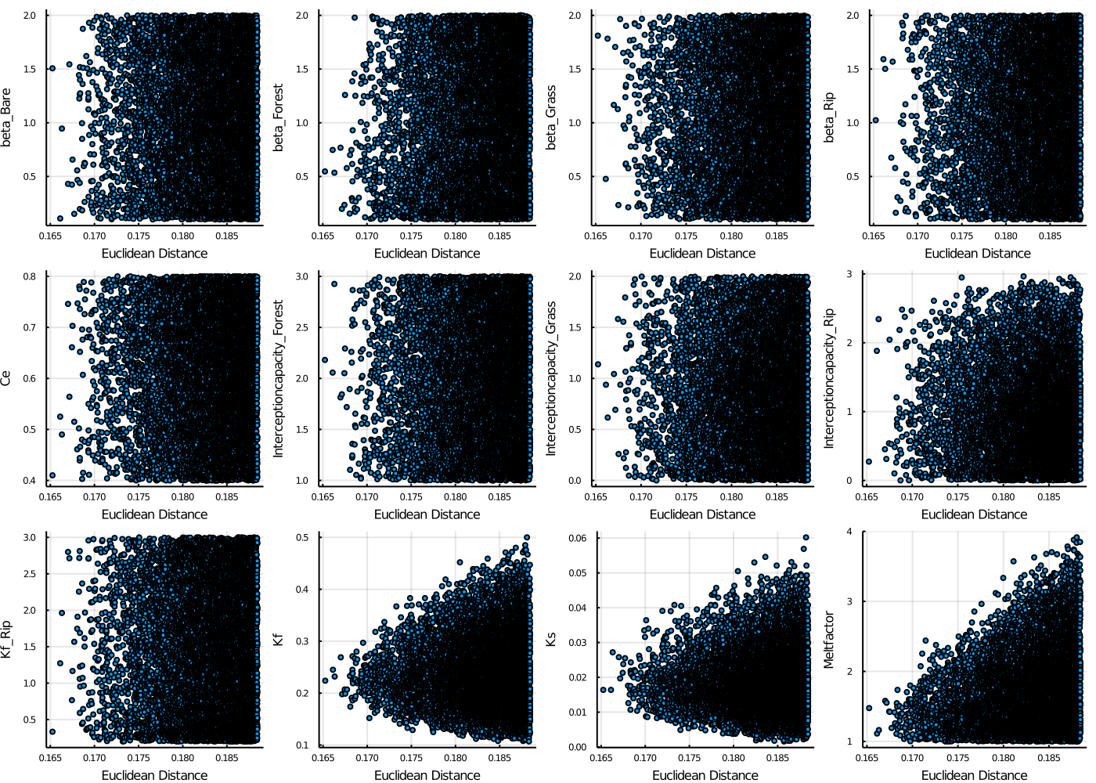
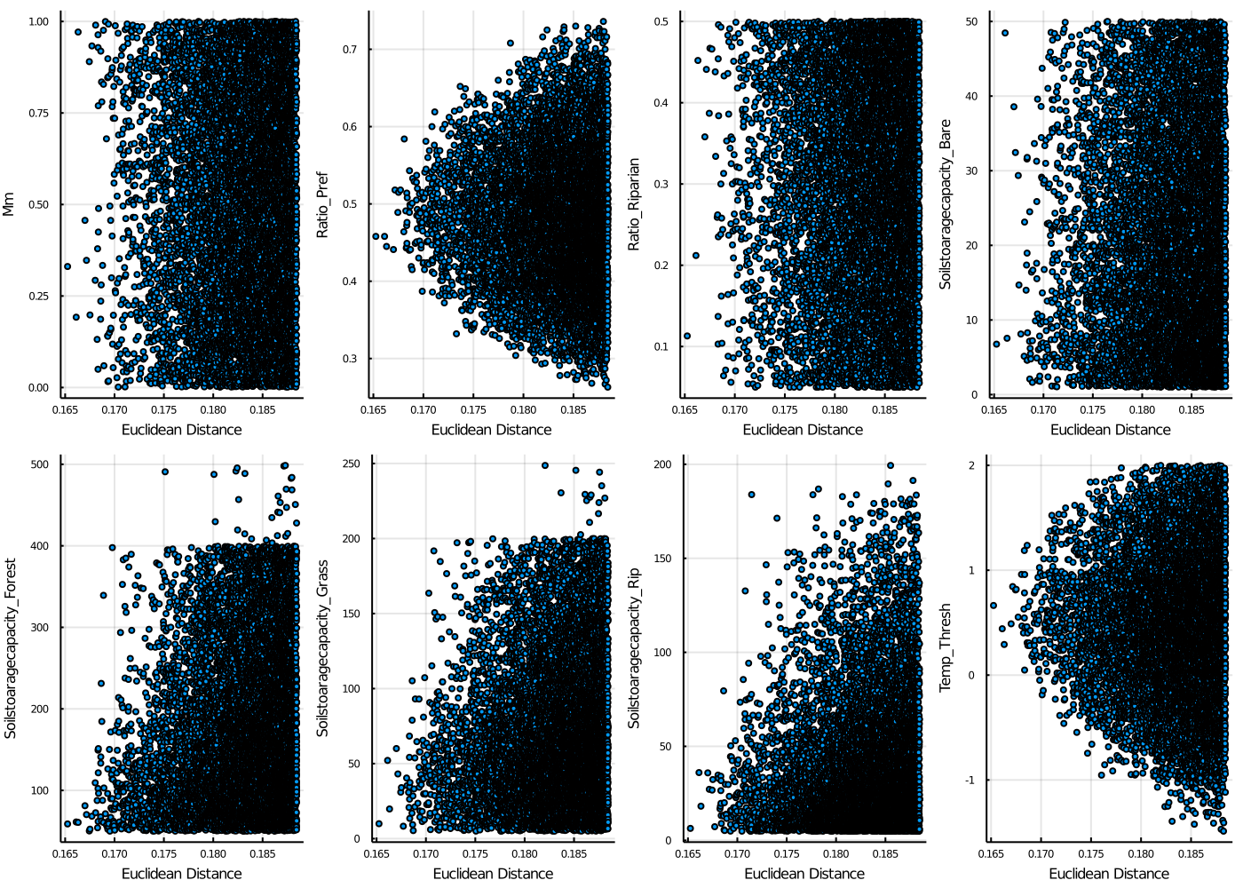
Looking at the parameter fits of the 10000 best fits it can be distinguished that:
- beta values cover the whole range of possible values
- Interceptioncapacities as well, although the riparian interceptioncapacity does not reach upper limit
- Ce and Kf_Rip are also distributed over the whole range
- for Kf and Ks a trend towards 0.2 and 0.002 can be distinguished
- the meltfactor decreases with better fits, being in the lower range of 1-2
- Mm and Ratio Riparian are distirbuted over the whole range
- Ratio of Preferential Flow converges towards 0.5
- the Soilstoragecapacities seem to converge towards lower values
- the threshold temperature lies between 0 and 1

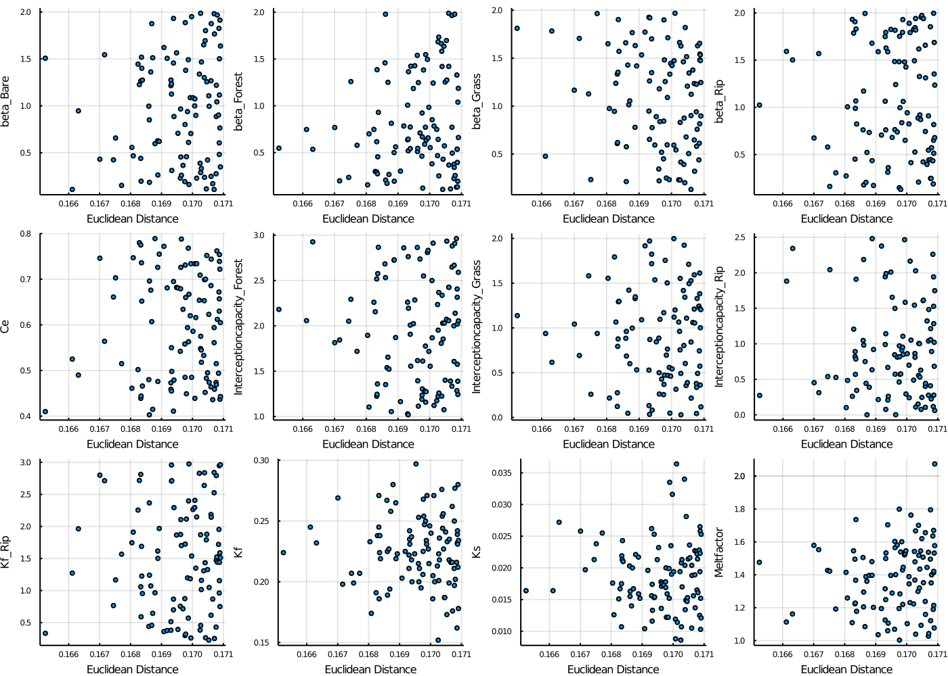
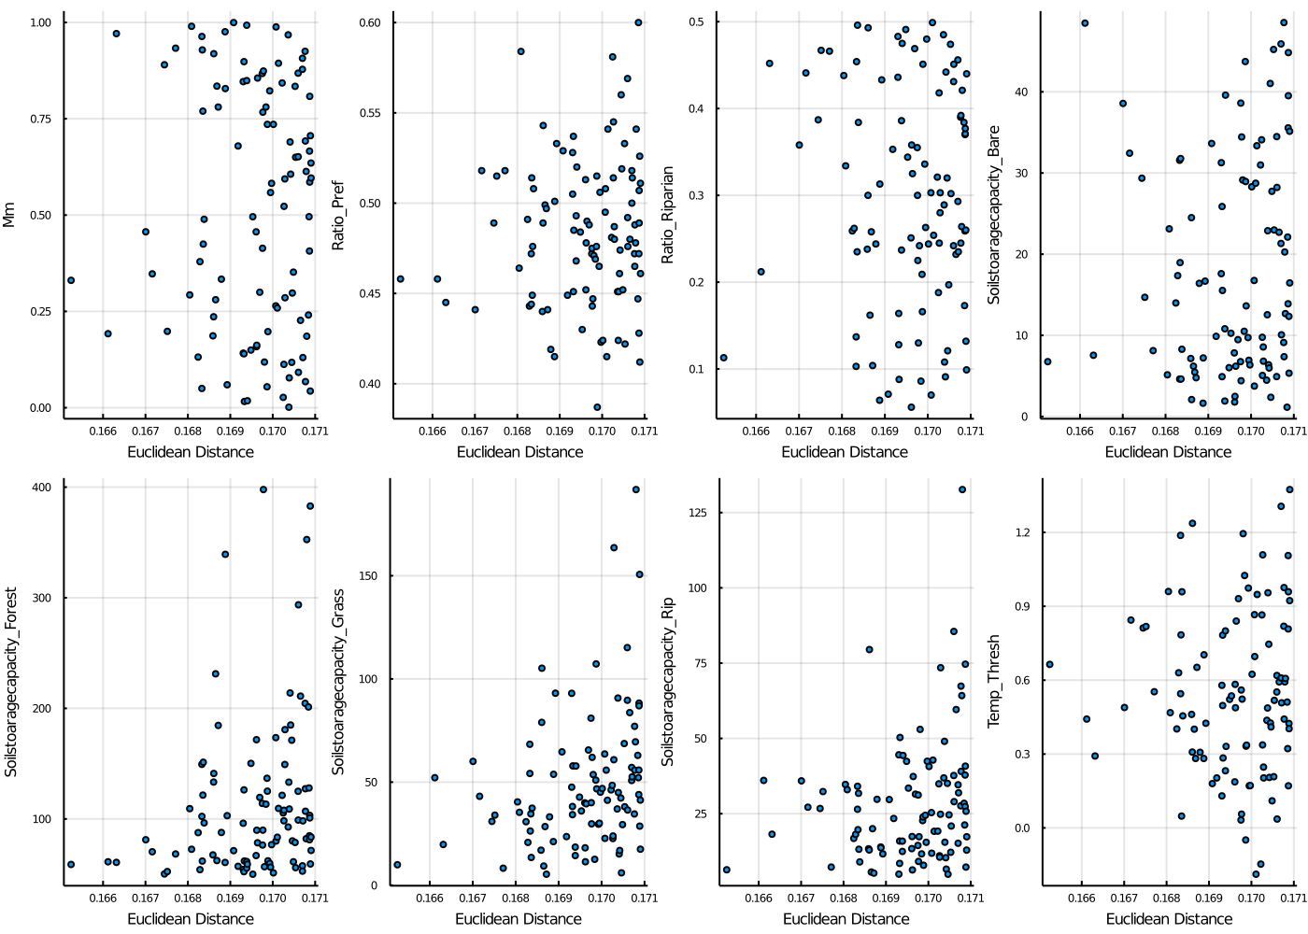

- the soilstoragecapacity of the riparian HRU is below 125

Comments:
- Meltfactor seems quite low, maybe because of a lot of forest within the catchment (57%), I only took one meltfactor… If the forest coverage would change in future my model would probably not run well…
- taking 1 or 2 Mio Runs does not make a real difference (0.167 – 0.1725)

Validation
- Validation of 5 years: Eculidean Distance increases by up to 0.05
- the overall Euclidean Distance is 0.17-0.22
- AC, FDC, snow cover and Runoff are still very good in validation:
- NSE, VE and NSElog decrease more severly

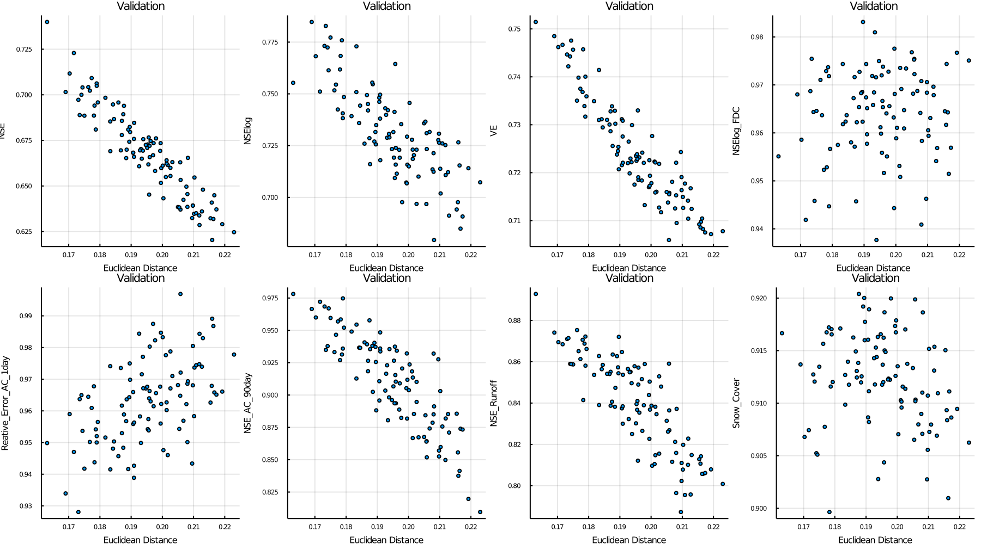
Looking at the relative change of objective functions between the calibration and validation it can be seen, that the performance of the model of NSE, NSElog, VE and runoff decreases, whereas it increases for AC and snow cover

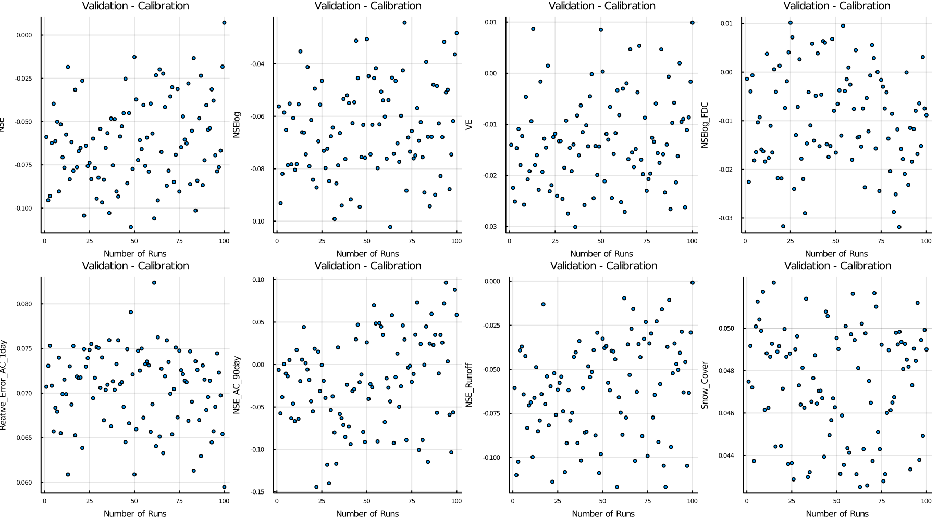

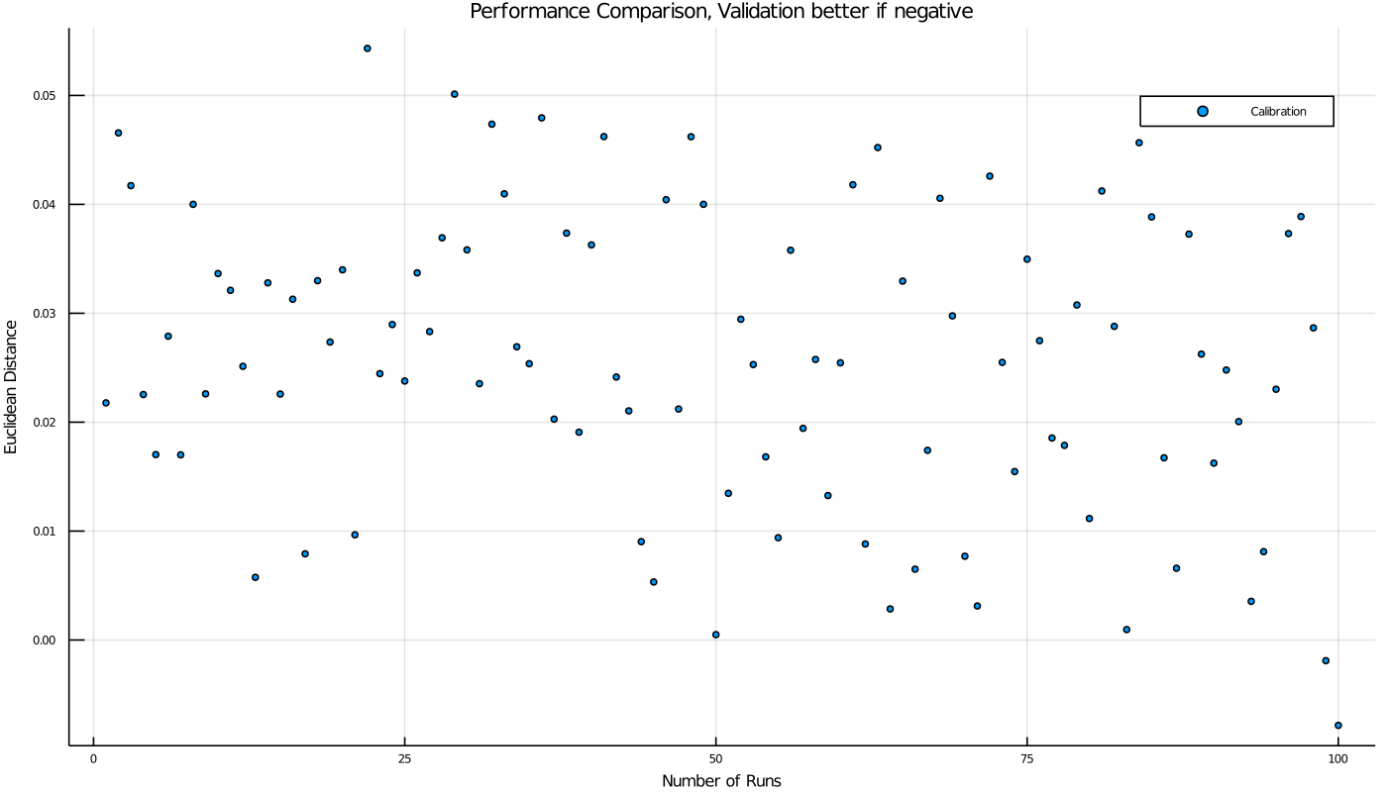

Ideas:
- heigher weight for NSE and logNSE?

