Hw 5

Sarah Hassan

3/5/2021

library(tidyverse)

## ── Attaching packages ─────────────────────────────────────── tidyverse 1.3.0 ──

## ✓ ggplot2 3.3.2 ✓ purrr 0.3.4  
## ✓ tibble 3.0.4 ✓ dplyr 1.0.2  
## ✓ tidyr 1.1.2 ✓ stringr 1.4.0  
## ✓ readr 1.3.1 ✓ forcats 0.5.0

## ── Conflicts ────────────────────────────────────────── tidyverse_conflicts() ──  
## x dplyr::filter() masks stats::filter()  
## x dplyr::lag() masks stats::lag()

library(Sleuth3)  
library(broom)  
  
Stockreturns <- c(-8.36, 1.63, -2.27, -2.93, -2.70,   
 -2.93, -9.14, -2.64, 6.82, -2.35,   
 -3.58, 6.13, 7.00, -15.25, -8.66,  
 -1.03, -9.16, -1.25, -1.22, -10.27,  
 -5.11, -0.80, -1.44, 1.28, -0.65,  
 4.34, 12.22, -7.21, -0.09, 7.34,   
 5.04, -7.24, -2.14, -1.01, -1.41,   
 12.03, -2.53, 4.33, 1.35)  
Stockreturns

## [1] -8.36 1.63 -2.27 -2.93 -2.70 -2.93 -9.14 -2.64 6.82 -2.35  
## [11] -3.58 6.13 7.00 -15.25 -8.66 -1.03 -9.16 -1.25 -1.22 -10.27  
## [21] -5.11 -0.80 -1.44 1.28 -0.65 4.34 12.22 -7.21 -0.09 7.34  
## [31] 5.04 -7.24 -2.14 -1.01 -1.41 12.03 -2.53 4.33 1.35

#1  
mean(Stockreturns)

## [1] -1.124615

#2  
sd(Stockreturns)

## [1] 5.977673

#3  
pnorm(q = -1.5, mean = -1.124615, sd = 5.977673)

## [1] 0.4749637

#4  
qnorm(p = 0.3,mean = -1.124615, sd = 5.977673)

## [1] -4.25931

#5  
summary(Stockreturns)

## Min. 1st Qu. Median Mean 3rd Qu. Max.   
## -15.250 -3.255 -1.410 -1.125 1.490 12.220

#Q1 = -3.255  
  
#6  
boxplot(Stockreturns)

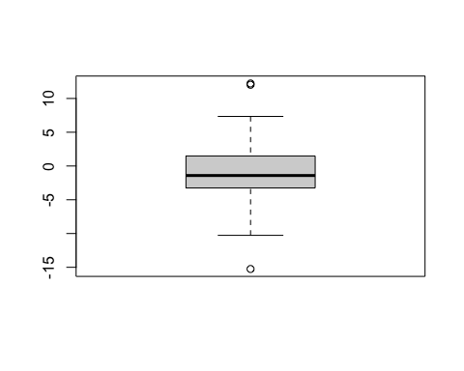

qqnorm(Stockreturns)  
qqline(Stockreturns)

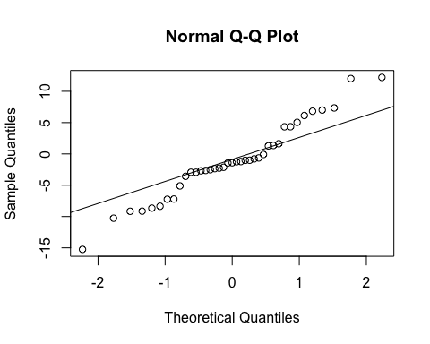

#7  
# H0: Return rate mean <= -1.125   
# HA: Return rate mean > -1.125  
  
#8  
t.test(Stockreturns,mu=-1.125, alternative = "greater", conf.level = .95)

##   
## One Sample t-test  
##   
## data: Stockreturns  
## t = 0.00040182, df = 38, p-value = 0.4998  
## alternative hypothesis: true mean is greater than -1.125  
## 95 percent confidence interval:  
## -2.738401 Inf  
## sample estimates:  
## mean of x   
## -1.124615

#Since our p value = 0.4998 which is > than .05, we can reject the null hypothesis  
  
#9  
#Since we rejected the null hypthesis, which stated that the return rate mean was less than or equal to the average of -1.125, we can conclude with 95% confidence that the broker did not perform worse than average.