CS 255 System Design Document

UML Diagrams

UML Use Case Diagram
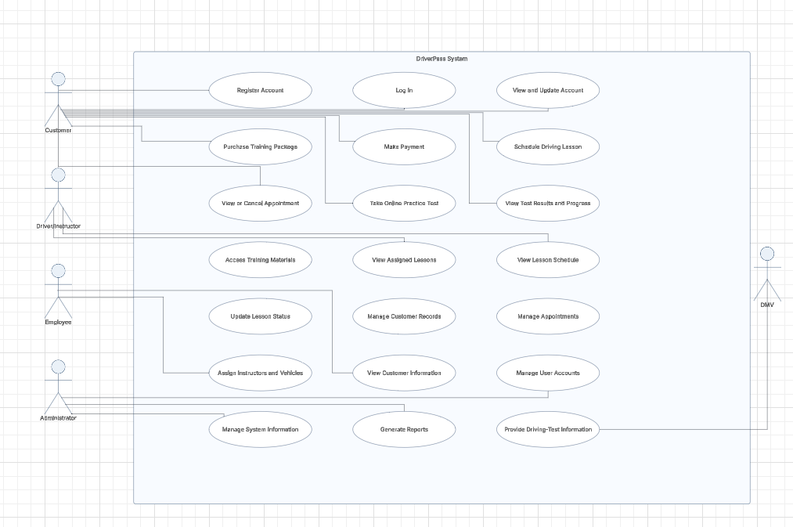

UML Activity Diagrams
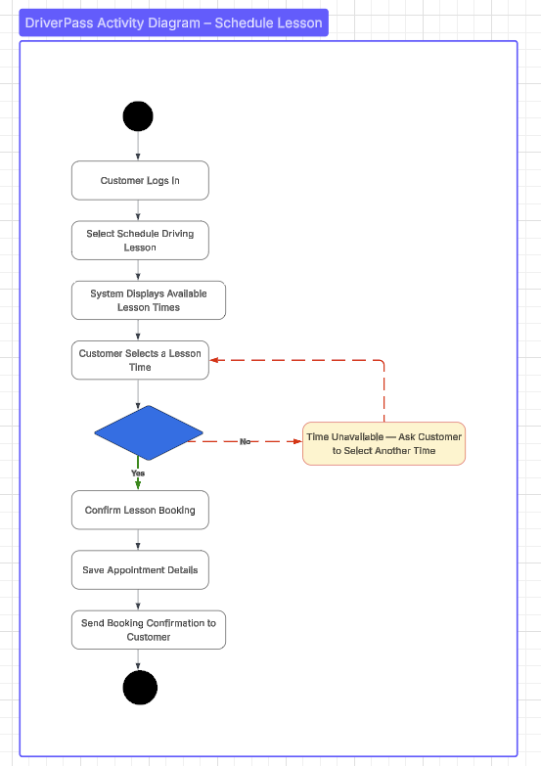

UML Sequence Diagram
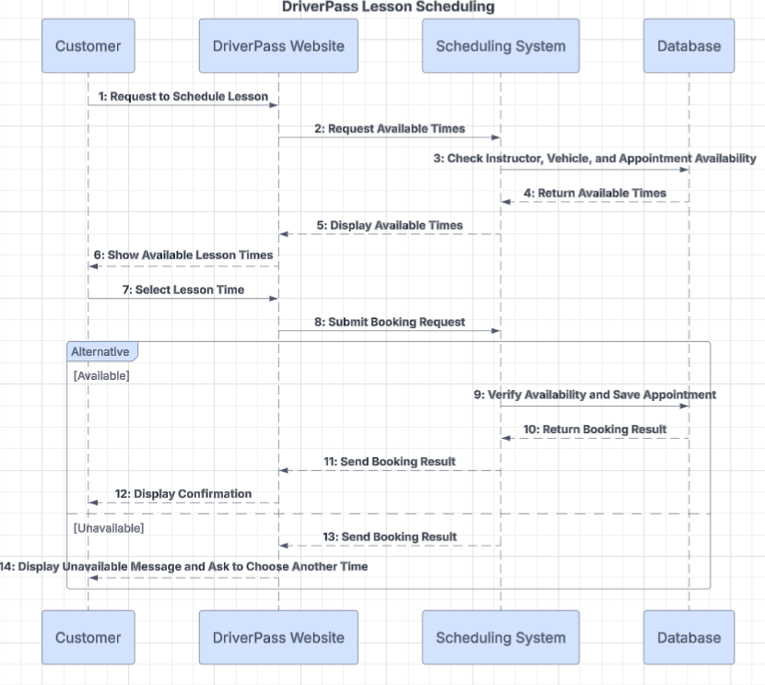

UML Class Diagram
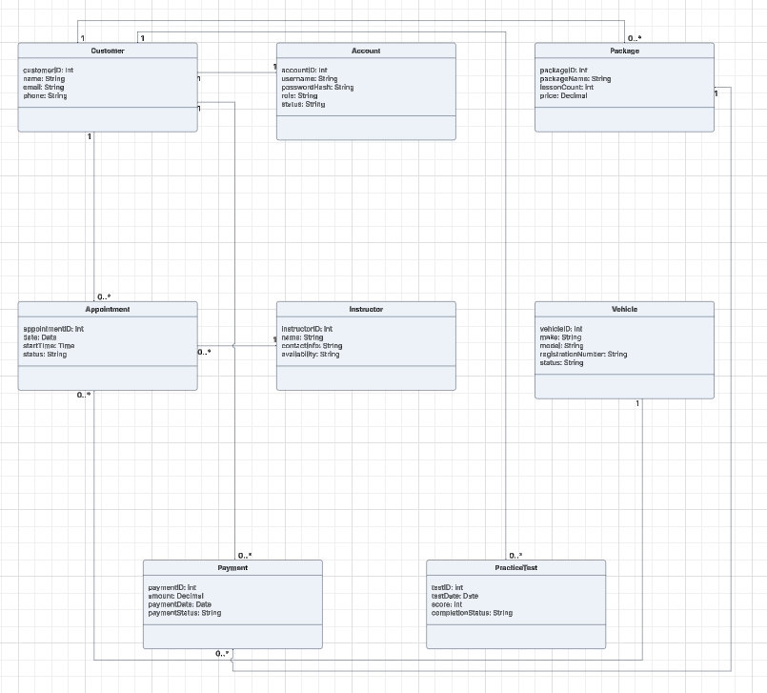

Technical Requirements

Hardware Requirements

DriverPass will need reliable hosting equipment or a cloud-based server to store customer information, lesson schedules, payment records, and practice test results. Customers should be able to access the system using a computer, tablet, or smartphone with an internet connection. Employees and driving instructors will also need internet-connected devices to manage appointments and review customer information.

Software Requirements

DriverPass should be a web-based application that works with common internet browsers. Customers should be able to create accounts, log in, purchase training packages, make payments, schedule driving lessons, take online practice tests, and view their progress. Employees should be able to manage customer records, appointments, instructors, and vehicles. Administrators should be able to manage user accounts and review system information. The system will also need database software to store and organize information.

Development Tools

Lucidchart will be used to create the UML diagrams for the system design. Developers will need programming tools, database management tools, and software testing tools to build and maintain the application. Testing should confirm that account registration, lesson scheduling, payment processing, and practice tests work correctly. The diagrams created for this project will help developers understand how the system should operate before they begin implementation.

Infrastructure Requirements

DriverPass will need secure hosting, reliable internet connectivity, and a database that can support multiple users at the same time. The system should include regular data backups and a recovery plan in case of technical problems. It should also support secure connections to external payment services. DMV information should be updated through an authorized source or by authorized staff when direct integration is not available. The system should be designed so it can be maintained and updated as DriverPass's needs change.

Security Requirements

The system should require users to log in before accessing private information. Customers should only be able to view their own accounts, appointments, payments, and practice test results. Instructors, employees, and administrators should have different access permissions based on their responsibilities. Passwords must be stored securely, and sensitive information should be protected when it is transmitted or stored. Payments should be processed through a secure payment provider. Regular backups and security updates will also help protect the system and its information.

Performance and Reliability Requirements

DriverPass should respond to customer requests within a reasonable amount of time and remain available during normal business operations. Before confirming a driving lesson, the system should check that the instructor, vehicle, and requested time are available. This will help prevent scheduling conflicts. If a payment service or another external service becomes unavailable, the system should notify the user rather than incorrectly confirming an incomplete transaction. These requirements will help DriverPass provide a reliable service to customers and employees.

