**5E Lesson Plan**

**Authors:** Aly Troy and Sarah Huerta (black text for both)

**Title of Lesson:** Don’t be MAD about Mean Absolute Deviation...

**Length of Lesson**: 55 Minutes

**Name/Level of Course**: 7th Grade Mathematics

**Why Is This Lesson Appropriate for Middle School Students? (paragraph form)**

During this lesson, students will work in their Keegan groups to analyze data from the materials given. This activity will allow students to work together and see other ways of logic and reasoning when working through the problem set rather than just working on their own. After the group work, we will lead a class discussion to see the students finding. This is will allow the students to interact with not only their group, but with a class as a whole and allow for positive social interactions between the students.

**Technology Lesson?** Yes or *No*

**Source of the Lesson:** http://www.cpalms.org/Public/PreviewResourceStudentTutorial/Preview/165097

**Concept Paragraph:**

Mean Absolute Deviation is the average distance of each data point from the mean. It is used to determine the variance of the data points with in the set of data. Applications of the Mean Absolute Deviation is used by scientist in data analysis and also by mathematicians for statistical analysis. Though the Mean Absolute Deviation can seem simplistic at first, a common misconception that students may have is when taking the absolute value of the differences, students may believe that the need to take the “opposite” of the negative numbers instead of the absolute value. This will lead to students turning positive difference negative and vice versa.

**Learning Objectives:**

SWBAT formulate generalizations about data sets

SWBAT analyze different sample sets’ Mean Absolute Deviation and their distributions

**State Standards:**

Standard #: MAFS.7.SP.2.3

Informally assess the degree of visual overlap of two numerical data distributions with similar variabilities, measuring the difference between the centers by expressing it as a multiple of a measure of variability

**A brief explanation of the Formative Assessment used and how it will inform your lesson:**

Commit and toss is an anonymous elicitation technique used to make students’ thinking visible to the class. It provides a safe, fun, and engaging way for all students to make their ideas known without individual students being identified by their answers. Students are given an assessment probe. After completing the probe, students crumble their papers into balls, and toss them into a bin upon a signal from the teacher. Then the teacher reads aloud the papers from the bin without ridiculing or acknowledging the answers.

**Safety:**

N/A

**Materials List and Advanced Preparations:**

Students are already grouped in the classroom by tables and shoulder partners, in this activity, they will be working with their shoulder partners (table of three will group as three or be paired with other three groups)

Lionfish video for engagement-

<https://www.cnbc.com/2016/08/02/the-seemingly-unstoppable-fish-flooding-floridas-coast-and-supermarkets.html>

Elaboration Video-

<https://www.youtube.com/watch?v=8YiWzYsBf4g>

Powerpoint of lesson

Data Deviation_1 per student_22 students

Don’t be MAD about Mean Absolute Deviation_1 per student_ 22 Students

Data bags_ 1 per group_14 groups

|  |  |  |
| --- | --- | --- |
| ENGAGEMENT Time: 5 Minutes | | |
| What the Teacher Will Do | Probing/Eliciting Questions | Desired Response  [Commonly Held Misconception] |
| Conducting Formative Assessment  Commit and Toss-  *EXPLANATION UNDER FORMATIVE ASSESSMENT ABOVE*    Say: Don’t worry about what your neighbors think, just take you best guess.      After collected, pick out 5-10 answers to write on the board.    KEEP THESE NUMBERS ON THE BOARD THROUGHOUT THE LESSON BECAUSE THESE NUMBERS ARE USED IN THE EXPLANATION | How many trees do you think there are on your campus?      What are some things you guys see about the data?    Looking at these numbers how do you think someone got them? | mean/ median/ mode/ outliers/ range    Guessed, didn’t really know |
| Show video introducing lionfish  <https://www.cnbc.com/2016/08/02/the-seemingly-unstoppable-fish-flooding-floridas-coast-and-supermarkets.html> | Does anyone know what lionfish are?      How do you think biologists try to solve problems like the lionfish? | cool fish/ eat them/ they are bad (invasive)      Statistics/ experiments |
| Transition Statement:  We are now going to use our science brains to analyze sets of Lionfish |  |  |

|  |  |  |
| --- | --- | --- |
| EXPLORATION Time: 15-20 Minutes | | |
| What the Teacher Will Do | Probing/Eliciting Questions | Desired Response  [Commonly Held Misconception] |
| Pass out data bags, which contain fish data ages that the students will use in the exploration to calculate the mean absolute deviation and worksheet Data Deviations” to each group.  While one partner is passing out bags, other will say” Shelby Moneysmith, a biologist at Biscayne National Park here in florida works to examine the ages and population sizes of these fish.”  Today we are going to be mathematicians and do some statistical analysis for Shelby.”  Say “As a group, you will work together to find out some information about the different reefs in order to help her find the variance in ages of the lionfish.  Ask a student to read the directions aloud to the class. Remind the students that they need a teacher initials in order to move on to the next part.  While teachers circulate, pick up data bags as they move on to the questions of the worksheet.  Teachers need to remind students to work as a group to discuss question on the worksheet.  Give students a 10/5 minute warning. | What is Mean Absolute Deviation?  Based on each of the three words, (Mean,Absolute, Deviation) what do you think we will be trying to find out about our data?  Why do you think we have to take the absolute value of our differences?  What do you notice about the fish ages?  is there a variety of ages in the population groups?  What effect do you think the variety of ages have on the population. | [students may use context clues to determine that Mean Absolute Deviation is the absolute mean of the deviations] MAD describes the variability in the data.  We we find the absolute deviation of the mean.  We can’t have negative distances from the mean.  There are a lot of different ones, they are all close together.  if you have younger and older fish, when the old ones die, the young once can still keep the population alive. |
| Transition Statement:  Say “Since we’ve all finished finding our Mean Absolute Deviation values, let’s take a closer look as to what these values mean…” |  |  |

|  |  |  |
| --- | --- | --- |
| EXPLANATION Time:15 Minutes | | |
| What the Teacher Will Do | Probing/Eliciting Questions | Desired Response  [Commonly Held Misconception] |
| Say: Now let’s share some of our findings!  The teacher will select groups to share their answers with the class and write them on the board. The teacher will not have time to call on all of the groups so the choices need to be strategic for who will be called on to share. If several groups have the same “findings” then only have one group share out. If there is a group with a particularly interesting idea then be sure to include them. The teacher will need to include any misconceptions here as well.  Teacher will ask “Can anyone tell me their steps on how they found their numbers?”  Let’s go over how we got them.  Change powerpoint slide to steps to find MAD.  *call on student, student response”  “Very Good! the first step was to find the mean of our data set.  Teacher will calculate the mean of the data on the board from engagement. After, we found the difference between each data point and took the mean and took the absolute value of each value. teacher will then calculate the differences. ”  *Call on student*  “Correct! We take the average of all those values.” Teacher will lastly calculate the average of the  differences.  Teacher’s will say” Let’s look at the last question on our worksheet? Can we can someone to share what they discussed about what would make your MAD different? What are some of the factors in the lionfish environment that can affect them?” | What have we found out about MAD?  What can change our numbers?  What can we predict about the meaning of the numbers we got for our MAD values?.  “So can anyone tell me what the first step on the worksheet?”  What are the steps to finding the Mean Absolute Deviation?  “And can anyone tell me what the last step on our worksheet was?”  What would make your MAD different? In the case of Lionfish, what factors would change it? | the larger the numbers, the more variance there is in the data and smaller numbers mean less variance.  students may have a misconception about larger/smaller MAd values and what they mean.  find the mean, take the absolute value of the differences, find the average of the differences. |
| “Mean Absolute Deviation describes the variability in the data. Specifically, it is the average distance from each data value to the mean.” This can let scientist know how varied their data is. For example, if a scientist’s mean shows that that all the ages around around 6 years old, but they have a mean absolute deviation of about 1, they know that there data is clustered together, rather than more spread out.  It lets us, biologist, researchers, statisticians, figure out how much the data varises from the mean and is used in data analysis:  *call on some students* | “Does anyone have any questions about how to find Mean Absolute Deviation?”  “So why do we need to know how to find these?”  Can anyone think of a real world situation that this could be used?  What does it tell you when comparing more than one set of data?  Why do we need data analysis?  How can real world people use MAD? | It can help biologist, researchers, statisticians, figure out how much the data varises from the mean and is used in data analysis.  the data is different between the different groups? |
| Transition Statement:  “Here is a real world example for you guys to think about…” |  |  |

|  |  |  |
| --- | --- | --- |
| ELABORATION Time: 5 Minutes | | |
| What the Teacher Will Do | Probing/Eliciting Questions | Desired Response  [Commonly Held Misconception] |
| In the real world, Mean absolute deviation not only gets used by biologist, engineers use it to safety regulations for roller coasters like the ones you ride at amusement parks.  INSERT VIDEO LINK:  <https://www.youtube.com/watch?v=8YiWzYsBf4g>  *Start video at 1:30*    After the students view the video, ask them about what math the engineers had to use: | Can anyone tell me how the engineers could use MAD to determine how the variability in acceleration affects the safety? |  |
| Let’s look back at the activity we completed.        Initiate discussion on using stats to solve the lionfish dilemma: | Why do we need statistics?  How do we use statistics?        Looking at the numbers we’ve computed, how can we use this to solve our lionfish problems? | solve problems/ show relationships |
| Transition Statement:  Now that we have a clear understanding of statistics and how we use it, let’s individually test our knowledge! |  |  |

|  |  |  |
| --- | --- | --- |
| EVALUATION Time: 10 Minutes | | |
| What the Teacher Will Do | Probing/Eliciting Questions | Student Responses and Misconceptions |
| We will pass out quizzes to the students as we pick up the iPads from the activity.  “Remember we are doing this quiz by ourselves.”  We will walk around to ensure independent work while gathering a sense if they have understood the lesson | How will we be taking this test? | Independently |
| Say: Five minutes left. |  |  |
| Transition Statement: Once you are finished with the quiz please place your papers here. |  |  |

|  |
| --- |
| HANDOUTS AND ASSESSMENT WITH RUBRIC OR ANSWER KEY |
| ATTACHED  Worksheet (Data Deviation/Interactive Notes)  Powerpoint  Evaluation |

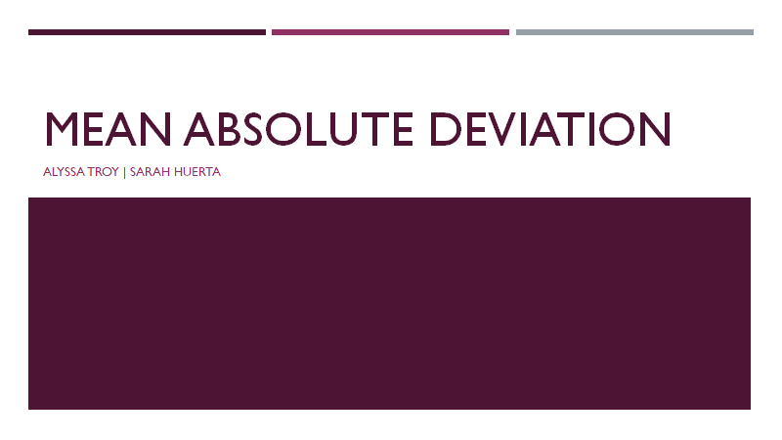

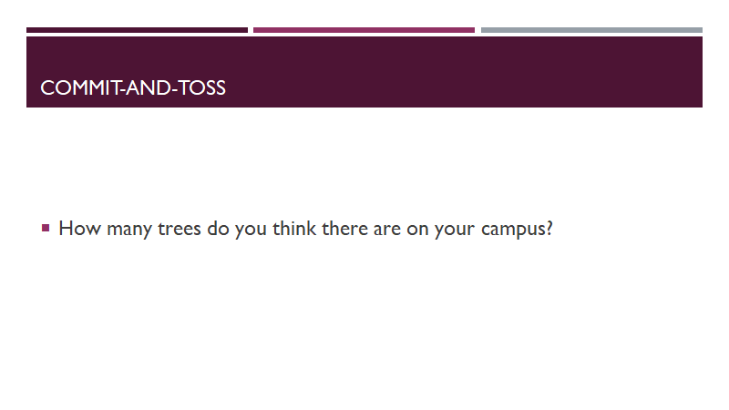

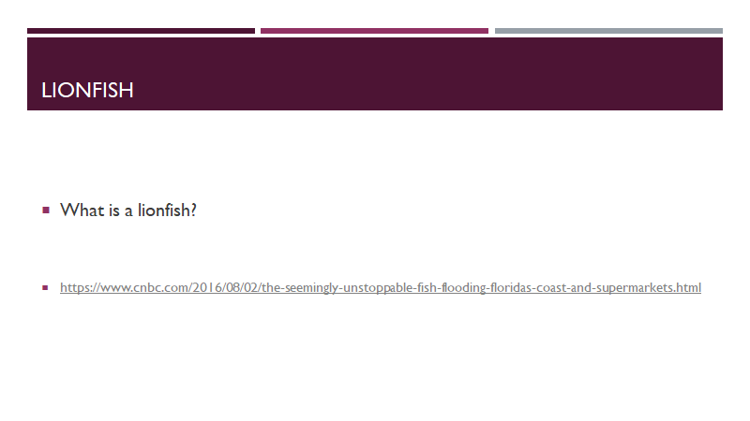

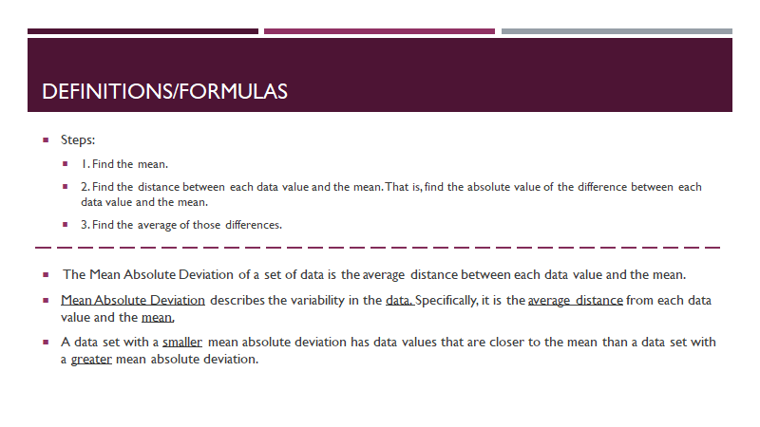

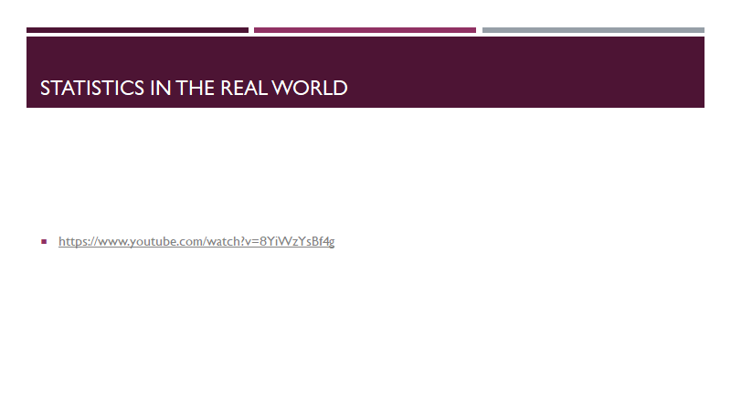

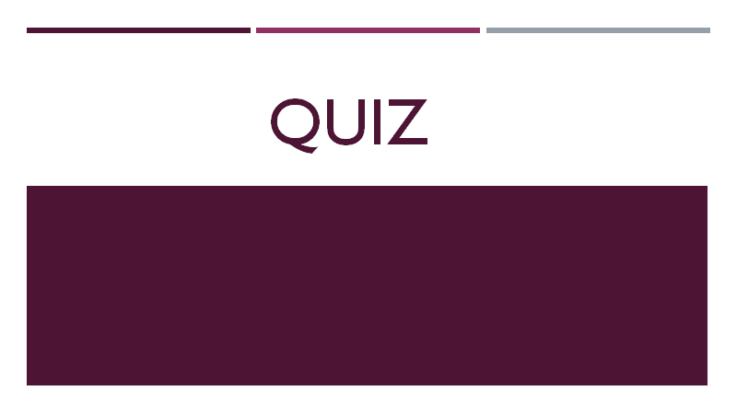

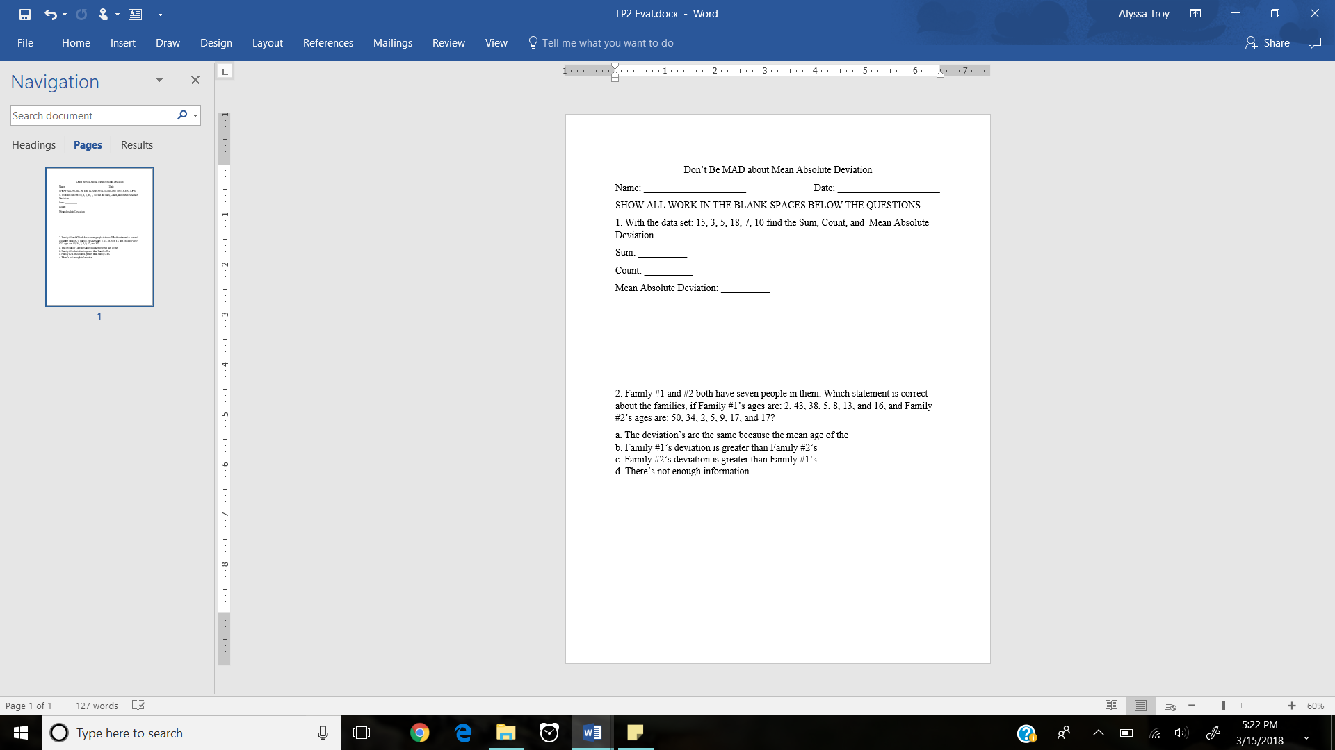

QUIZ ANSWERS:

1. Sum: 58 Count: 6 MAD: 9.67 2. C

