Katherine Allen

Gavin Mayes

Tristan Cravello

Sarah Huerta

Red Group Topical Outline

Topic: Industrial Revolution

**Day One: Introduction to the Industrial Revolution: What it was and what led up to it (Sarah)**

SS.912.A.3: Analyze the transformation of the American economy and the changing social and political conditions in response to the Industrial Revolution.

Phonological awareness: LAFS.1112.L.3.4 Standard: Determine or clarify the meaning of unknown and multiple-meaning words and phrases based on *grades 11–12 reading and content*, choosing flexibly from a range of strategies. Use context (e.g., the overall meaning of a sentence, paragraph, or text; a word’s position or function in a sentence) as a clue to the meaning of a word or phrase.

For this lesson, students will work in 6 small groups to read introductory primary sources about the beginning of the Industrial Revolution and the social, economical and political changes that occurred right before. There will be 3 different articles. Two groups will read the same article. The primary sources the students read will have underlined vocabulary words that may be new to the readers and the students will first work together to predict what the words could mean based on the roots, prefixes, or suffixes of the word. After the group comes to a consensus on what they think the words mean, The groups will trade articles with a different set of students who had the same article. The students of the other group will then try to determine which created definitions go to which vocabulary words. After the groups finish matching the words, we will come back together as a class to clarify and correct any misunderstandings that the students might have.

**Day Two: Changing Social Climate (Gavin)**

SS.912.A.3: Analyze the transformation of the American economy and the changing social and political conditions in response to the Industrial Revolution.

Fluency: LAFS.1112.RI.1.2: Determine two or more central ideas of a text and analyze their development over the course of the text, including how they interact and build on one another to provide a complex analysis; provide an objective summary of the text.

I will distribute an excerpt from a primary source to my students; we will then do a popcorn reading session where a student reads a few sentences aloud, and then another student is chosen to read. Other students are expected to be reading along. After this, students will be provided with a few more sources and will be asked to read and analyze how the social climate changed during the Industrial Revolution in the primary source read aloud and at least one other of their choosing. Students will then write a short response about their texts, specifically about the social climate during this period, citing specific evidence from the sources. After writing this response, students will be put into groups to discuss what sources they read and what they discovered about the Industrial Revolution's societal changes. After this, the teacher will lead a class-wide discussion on the changes found in these sources, first letting students speak about what they discovered in their reading, and then hitting any other points that students might have looked past. Allowing students to read over the primary source that was read aloud multiple times is an effective strategy to help students with fluency. Also, the popcorn reading is a model of fluent reading, which helps struggling readers with reading fluently.

**Day Three: Changing Political and Economic Climate (Katie)**

SS.912.A.3: Analyze the transformation of the American economy and the changing social and political conditions in response to the Industrial Revolution.

Vocabulary: LAFS.1112.L.3.6 Standard: Acquire and use accurately general academic and domain-specific words and phrases, sufficient for reading, writing, speaking, and listening at the college and career readiness level; demonstrate independence in gathering vocabulary knowledge when considering a word or phrase important to comprehension or expression.

For this lesson, students will learn about the major political and economic changes during the Industrial Revolution. This lesson will be focused heavily on vocabulary terms such as capitalism, monopoly, and specialization. First, the students will take notes during a brief lecture on the economic and political changes during the late 19th century. The class will then be split into pre-assigned groups, where they will make a flowchart or timeline using a list of vocabulary terms to demonstrate the economic and political changes that they have just learned about. For ELL students and students with exceptionalities, they will be placed into groups where they are allowed to choose from a number of the vocabulary words instead of using the whole list. For example, if there are 20 words on the list that must be used on the chart, the group of ELLs and students with exceptionalities only has to use 15. This allows them to learn the same material at a lesser pace and to deal with the words that they are most comfortable with.

**Day Four: Workers’ Response (Katie)**

SS.912.A.3: Analyze the transformation of the American economy and the changing social and political conditions in response to the Industrial Revolution.

Oral Language: LAFS.1112.L.2.3 Standard: Apply knowledge of language to understand how language functions in different contexts, to make effective choices for meaning or style, and to comprehend more fully when reading or listening.

a. Vary syntax for effect, consulting references (e.g., Tufte’s Artful Sentences) for guidance as needed; apply an understanding of syntax to the study of complex texts when reading.

The goal of this lesson is for students to understand the responses by workers to the poor working conditions of the Industrial Revolution and to be able to develop an argument for labor laws based on document analysis. The students will work in groups to analyze documents about workplace accidents and conditions. Each student will be assigned a different document and will have to share the information from their document with their group members. For ELLs and students with exceptionalities reading on a lower proficiency level than their peers, they will be given documents that are on a lower reading level with keywords highlighted and with pictures to help them better comprehend the material. After analyzing the documents, the students will work together to prepare a brief (approx. four minute) speech that will be presented by all members about why labor laws need to be established. Each student should spend around the same amount of time speaking. In this case, ELLs and students with exceptionalities will be scored on a rubric that focuses more on the material than on grammar or speech errors.

**Day Five: Implications of the Industrial Revolution (Tristan)**

SS.912.A.3: Analyze the transformation of the American economy and the changing social and political conditions in response to the Industrial Revolution.

Comprehension: Standard LAFS.1112.RH.1.2: Determine the central ideas or information of a primary or secondary source; provide an accurate summary that makes clear the relationships among the key details and ideas.

From this lesson, students will learn the implications of the Industrial Revolution, particularly how the Industrial Revolution impacted the state of Florida. The students will work in groups of 5 to analyze a primary source document regarding Cigarmakers’ Union Dispute in Tampa from 1938-39. The goal of this lesson is to determine the main idea of the selected text and provide a summary of what they read with at least five supporting details in a short essay. Depending on their abilities, ELL students may receive the text translated into their first language. Students with exceptionalities will be able to write in bullet points instead of paragraphs. They can use technology to express their thoughts if needed.

**Oral Language Lesson Plan**

|  |  |  |  |
| --- | --- | --- | --- |
| **Date:** | **Teacher:** | **Grade Level:** | |
| **September 23rd, 2020** | **Ms. Allen** | **11th** | |
| **Florida Standard** | **Objective** | **Assessment of Objective/Progress Monitoring** | |
| SS.912.A.3: Analyze the transformation of the American economy and the changing social and political conditions in response to the Industrial Revolution | The student will be able to (TSWBAT) understand the responses by workers to the working conditions of the Industrial Revolution. | Text evidence notes (Informal Assessment) | |
| LAFS.1112.L.2.3: Apply knowledge of language to understand how language functions in different contexts, to make effective choices for meaning or style, and to comprehend more fully when reading or listening.    a. Vary syntax for effect, consulting reference (e.g., Tufte’s Artful Sentences) for guidance as needed; apply an understanding of syntax to the study of complex texts when reading. | TSWBAT develop an argument for labor laws based on document analysis. | Oral Language Formative Assessment: Four minute speech (Informal Assessment) | |
| **English Language Proficiency Objective** | **Language Domain: Circle all that apply** | **Level of ELL: Circle all that apply** | |
| The ELL student will be able to tell why labor laws needed to be established during the Industrial Revolution. | **Listening Reading**      **Speaking Writing** | **Level 1: Entering Level 4: Expanding**  **Level 2: Emerging Level 5: Bridging**  **Level 3: Developing Level 6: Reaching** | |
| **Target Vocabulary** | **Required Resources/Materials:** | **References/Attachments** | |
| - Strike  - Union  - Reform  - Child labor  - Mass production  - Assembly line  - The Jungle  - Upton Sinclair  - Triangle Shirtwaist Factory Fire | - Excerpt from *The Jungle* by Upton Sinclaire  - Reading about Triangle Shirtwaist Factory Fire  - Industrial Revolution: Working Conditions reading (for ELLs and students with exceptionalities)  - Labor Movement reading (for most advanced proficiency students)  - Primary sources | 9-12th Grade Social Studies Common Core Florida Standards. Cpalms.org. Florida Department of Education. Retrieved September 23, 2020 from <https://www.cpalms.org/Public/PreviewIdea/Preview/837>  11th Grade English Language Arts Common Core Florida Standards. Cpalms.org. Florida Department of Education. Retrieved September 23, 2020 from <https://www.cpalms.org/Public/PreviewStandard/Preview/6146>  Ducksters. (2020). *Industrial Revolution: Working Conditions for Kids*. Ducksters Education Site. <https://www.ducksters.com/history/us_1800s/working_conditions_industrial_revolution.php>  History.com Editors. (2020). *Labor Movement.* HISTORY. <https://www.history.com/topics/19th-century/labor>  Kubic, M. (2016). *CommonLit / The Triangle Shirtwaist Factory Fire.* CommonLit. <https://www.commonlit.org/en/texts/the-triangle-shirtwaist-factory-fire>  Primary Sources. (n.d.). *Industrial Revolution*. Retrieved September 23, 2020, from <https://industrialrevolution9thomas.weebly.com/primary-sources.html>  Sinclair, U. (1906). *The Jungle.* <https://www.commonlit.org/texts/excerpt-from-the-jungle> | |
| **Activating Strategy** | | **Accommodations:** | |
| -The teacher will (TTW) hand each student documents to read for document analysis in groups as well as a handout for the assignment. In each group, the students will have different documents. They will have to work together to share the information from their readings in order to do the following steps.  -TTW explain that the students will have four minutes to prepare a brief speech that will be presented by all group members about why labor laws needed to be established.  -After four minutes, TTW allow students to spend approximately four minutes speaking. | | **ELLs** | -The ELL student will receive documents with keywords highlighted and with pictures. |
| **Students with Exceptionalities** | -For students below grade level, s/he will receive documents with keywords highlighted and with pictures. |
| **Teacher Modeling (I do):** | | | |
| TTW briefly show students how to extract the main points from a paragraph and formulate an argumentative sentence from the main points.This will be done by the teacher writing a list of the main points on a separate sheet of paper and then composing the sentence from the points. | | **ELLs** | TTW highlight/underline the main points in the reading so that the ELLs can see the points in the paragraph as well as written down. She will also read the main points out as she writes them so that they can see and hear them. |
| **Students with Exceptionalities** | TTW highlight/underline the main points in the reading so that the students with exceptionalities can see the points in the paragraph as well as written down. She will also read the main points out as she writes them so that they can see and hear them. |
| **Guided Practice (We do)** | | | |
| TTW work with the students as a class to examine a document that all of the students can use points from.  TTW ask the class to help her extract the main points from the document.  TTW work with the class to formulate a very brief example of a speech that can be made from the main points. | | **ELLs** | TTW have the students read the main points as a class and will have a volunteer read the speech so that the students can see, hear, and speak to fully understand the goal of the activity. |
| **Students with Exceptionalities** | TTW have the students read the main points as a class and will have a volunteer read the speech so that the students can see, hear, and speak to fully understand the goal of the activity. |
| **Independent Practice (You do)** | | | |
| In groups, the students will read their assigned documents and formulate a speech supporting labor laws while specifically citing reasons from the text.  TTW ask students to turn in their Workers’ Rights Assignment handout at the end of class. | | **ELLs** | **-** ELLs will be given easier to read documents and will not be expected to speak for as long as their more proficient peers. A rubric will be used for them that focuses more heavily on the content of their argument than the grammar and confidence of their argument. |
| **Students with Exceptionalities** | **-** Students with exceptionalities will be given easier to read documents and will not be expected to speak for as long as their more proficient peers. A rubric will be used for them that focuses more heavily on the content of their argument than the grammar and confidence of their argument. |
| **Closure (Includes a summary of the learning and an exit activity)** | | | |
| Throughout this lesson, the students learned about the poor working conditions of the Industrial Revolution, the responses to these working conditions, how to extract main points from a document, how to work with groups to formulate an argumentative speech, and how to present a speech.  The exit activity will be a self-reflection activity. The students will follow a 3-2-1 exit ticket model. They will take a few minutes to think about 3 things they learned, 2 things they still have questions about and 1 thing they thought was interesting. This activity is good for students of all proficiency levels. The students will write their exit activity in journals that all exit activities go in during the school year. This will help the teacher keep track of how the students’ reflections and proficiency progress over the course of the semester or school year. | | **ELLs** | -The ELL student may receive sentence starters to help him/her reflect what they learned. |
| **Students with Exceptionalities** | **-**Students with Exceptionalities may receive sentence starters to help him/her reflect what they learned. |

**Oral Language Lesson Plan**

**Speech Assignment Handout**

(for non-ELLs and students without exceptionalities)

**Workers’ Rights Assignment**

Name:_______________________________________________ Date:___________ Period:___

**Directions:** For this assignment, read your handout, write down at least five main points and then formulate a few sentences (5-7) based on your points that you will use in your part of the speech.

|  |
| --- |
| **Main Points:**  **1.**  **2.**  **3.**  **4.**  **5.** |
| **Your Portion of the Speech:** This does not have to be word-for-word what you present, but these should be complete sentences and you should include this information in your speech. |

**Speech Assignment Handout**

(for ELLs and students with exceptionalities)

**Workers’ Rights Assignment**

Name:_______________________________________________ Date:___________ Period:___

**Directions:** For this assignment, read your handout, write down at least three main points and then formulate a few sentences (2-4) based on your points that you will use in your part of the speech.

|  |
| --- |
| **Main Points:**  **1.**  **2.**  **3.** |
| **Your Portion of the Speech:** This does not have to be word-for-word what you present, but these should be complete sentences and you should include this information in your speech. |

**Speech Rubric**

(for non-ELLs and students without exceptionalities)

|  |  |  |
| --- | --- | --- |
| Concerns  *Areas that need work* | Criteria  *Standards for performance* | Advanced  *Evidence of Exceeding Standards* |
|  | Criteria #1  Student wrote down at least five main points. |  |
|  | Criteria #2  Student wrote down at least five sentences. |  |
|  | Criteria #3  Student’s speech reflected the information on their worksheet. |  |
|  | Criteria #4  Student spoke clearly and confidently. |  |
|  | Criteria #5  Student’s speech contained factual information. |  |

**Speech Rubric**

(for ELLs and students with exceptionalities)

|  |  |  |
| --- | --- | --- |
| Concerns  *Areas that need work* | Criteria  *Standards for performance* | Advanced  *Evidence of Exceeding Standards* |
|  | Criteria #1  Student wrote down at least three main points. |  |
|  | Criteria #2  Student wrote down at least two sentences. |  |
|  | Criteria #3  Student’s speech reflected the information on their worksheet. |  |
|  | Criteria #4  Student’s speech contained factual information. |  |
|  | Criteria #5  Student made an effort to speak. |  |

**3-2-1 Activity Prompt**

(for non-ELLs and students without exceptionalities)

For this reflection, you will complete a 3-2-1 activity. **You will write three things that you learned, two things you found interesting, and one question that you still have about the lesson.** You may use words and pictures to express what you are trying to say.

**3-2-1 Activity Prompt**

(for ELLs and students with exceptionalities)

For this reflection, you will complete a 3-2-1 activity. You will write:

**3** things that you learned

**2** things that you found interesting

**1** question that you have about the lesson

You may use words and pictures to express what you are trying to say.

**Sentence Starters:**

“Today I learned _______”

“I learned about _______”

“One thing that I found interesting was ________”

“I thought it was interesting that ________”

“One question that I still have is ________”

“I am still curious about ________”

“I am still unsure about ________”

**3-2-1 Activity Rubric**

(for all students)

|  |  |  |
| --- | --- | --- |
| Concerns  *Areas that need work* | Criteria  *Standards for performance* | Advanced  *Evidence of Exceeding Standards* |
|  | Criteria #1  Student demonstrated evidence of knowledge gained from lesson. |  |
|  | Criteria #2  Student used words or pictures to show their understanding. |  |
|  | Criteria #3  Student followed directions based on the instructions given. |  |

**Phonological Awareness Lesson Plan**

|  |  |  |  |
| --- | --- | --- | --- |
| **Date:** | **Teacher:** | **Grade Level:** | |
| **October 7th, 2020** | **Ms. Huerta** | **11th** | |
| **Florida Standard** | **Objective** | **Assessment of Objective/Progress Monitoring** | |
| SS.912.A.3: Analyze the transformation of the American economy and the changing social and political conditions in response to the Industrial Revolution. | The student will be able to (TSWBAT) understand the origins of the Industrial Revolution. | Written summary about climate of US prior to Industrial Revolution (informal assessment) | |
| LAFS.1112.L.3.4 Standard: Determine or clarify the meaning of unknown and multiple-meaning words and phrases based on *grades 11–12 reading and content*, choosing flexibly from a range of strategies. Use context (e.g., the overall meaning of a sentence, paragraph, or text; a word’s position or function in a sentence) as a clue to the meaning of a word or phrase. | TSWBAT come up with possible definitions of new vocabulary words based on their roots, prefixes, and suffixes as well as the syllables in which they are used in a word. | Written definitions sheet from activity (informal assessment) | |
| **English Language Proficiency Objective** | **Language Domain: Circle all that apply** | **Level of ELL: Circle all that apply** | |
| The ELL will be able to determine at least one social, economic, and political aspect of the US prior to the Industrial Revolution. | **Listening Reading**    **Speaking Writing** | **Level 1: Entering Level 4: Expanding**  **Level 2: Emerging Level 5: Bridging**  **Level 3: Developing Level 6: Reaching** | |
| **Target Vocabulary** | **Required Resources/Materials:** | **References/Attachments** | |
| -Industrialization  -Economic Expansion  -Unions  -Work Shifts  -Factories and textiles  -Capitalism  -Mass production  -Societal Class | -Eli Whitney’s Patent for the Cotton Gin  -Samuel Slater quotations about his industrial mill  -Factory Rules from the Handbooks to Lovell  -Given a piece of paper to write their definitions of words on, and a piece of paper to match definitions to specific words. | 9-12th Grade Social Studies Common Core Florida Standards. Cpalms.org. Florida Department of Education. Retrieved October 7, 2020 from <https://www.cpalms.org/Public/PreviewIdea/Preview/837>  11th Grade English Language Arts Common Core Florida Standards. Cpalms.org. Florida Department of Education. Retrieved October 7, 2020 from <https://www.cpalms.org/Public/PreviewStandard/Preview/6147>  National Geographic Learning. Teaching the Fundamentals: Phonemic Awareness, Phonics, Decoding, and Spelling. Retrieved October 7, 2020 from <https://ngl.cengage.com/assets/downloads/ave_pro0000000320/am_tinajero_teach_fund_seb21_0413a.pdf>  Schur, J. (2016). Eli Whitney’s Patent for the Cotton Gin. Retrieved October 7, 2020 from <https://www.archives.gov/education/lessons/cotton-gin-patent>  UMBC Center for History Education. Life at Lowell Mills. Retrieved October 7, 2020 from <https://www.umbc.edu/che/tahlessons/pdf/Methods_of_Reform_The_Lowell_Mill_Girls_RS_3.pdf>  Weinberg, R. (2018). Slate Mill Quotations. Retrieved October 7, 2020 from <https://nature.berkeley.edu/departments/espm/env-hist/espm160/assignments/slater/slater_qts.htm> | |
| **Activating Strategy** | | **Accommodations:** | |
| -The teacher will (TTW) begin class by having a discussion with the students about what they know about using context clues and prefixes, suffixes, and roots to determine potential definitions of words. This will prepare the students for the group activity. TTW also ask them what they know about the Industrial Revolution and what vocabulary words come to mind when they hear ‘Industrial Revolution.’ TTW write these words on a poster along with their meaning. This is especially beneficial for ELLs and students with exceptionalities because it gives them some background knowledge about the subject before delving into the activity. | | **ELLs** | - ELLs will receive a document that has the definitions of functional vocabulary for the lesson. This includes words like context and define. |
| **Students with Exceptionalities** | -For students below grade level, s/he will receive a document that has the definitions of functional vocabulary for the lesson. This includes words like context and define. |
| **Teacher Modeling (I do):** | | | |
| TTWread an excerpt from one of the documents to the class. The excerpt will contain a new vocabulary word. TTW then model the target sound of the word, say how many syllables in a word, spell the word, and say the word again. | | **ELLs** | TTW provide the ELLs a copy of the excerpt that s/he is using for the modeling so that the student can follow along. |
| **Students with Exceptionalities** | TTW provide students with exceptionalities a copy of the excerpt that s/he is using for the modeling so that the student can follow along. |
| **Guided Practice (We do)** | | | |
| TTW have a volunteer read another excerpt from the same reading and ask another volunteer how many syllables are in a keyword. The teacher will say the word from the reading. Although s/he already knows the meaning of the word, TTW explain to the class that they will not know what the word is until they have read the definitions when working in groups. | | **ELLs** | ELLs are given another example of modeling, this time from their peers. This will give them confidence because when they see their peers successfully doing the task, their own self-efficacy raises too. |
| **Students with Exceptionalities** | Students with exceptionalities are in a similar boat as the ELLs, as they get another effective example of modeling. This activity also lets students think of themselves as competent actors who will be able to help each of their classmates. |
| **Independent Practice (You do)** | | | |
| First, in groups, the students will read an article independently. Then, a student reads with a partner. Lastly, the whole group reads together. After reading three times, the students try to decode the underlined vocabulary as well as other high-frequency words within the article. They will then write the syllables down before determining the definitions. Then, they will swap their definitions with those that another group who read the same article wrote down. The students will then try to match the new definitions to the vocabulary word in their articles.  TTW collect the definition sheets when the task is done. | | **ELLs** | **-** ELLs will be given documents that use the same vocabulary words but have pictures and graphics to help their understanding. |
| **Students with Exceptionalities** | **-** Students with exceptionalities will be given documents that use the same vocabulary words but have pictures and graphics to help their understanding. |
| **Closure (Includes a summary of the learning and an exit activity)** | | | |
| Throughout this lesson, the students learned about the social, economic, and political climate of the US leading up to the Industrial Revolution. They also learned to look at the roots, prefixes, and suffixes of words paired with context to determine potential definitions. There will be a class discussion about which words were the easiest and most difficult to decode. The class will work together with the teacher to come up with a shared definition for each new vocabulary word that they worked with in the lesson. The exit activity will be a 1-2 paragraph summary of the social, political, and economic state of the US prior to the Industrial Revolution that uses at least five new vocabulary words. Students may also choose to draw their summary instead of writing it, so long as they write the vocabulary words. | | **ELLs** | -The ELL will be expected to use at least three new vocabulary words. |
| **Students with Exceptionalities** | **-**Students with Exceptionalities will be expected to use at least three new vocabulary words. |

Article Links

<https://institute.global/policy/industrial-revolution-politics-and-public-policy>

<https://www.loc.gov/collections/national-child-labor-committee/about-this-collection/>

<https://www.ushistory.org/us/22a.asp>

**Fluency Lesson Plan**

|  |  |  |  |
| --- | --- | --- | --- |
| **Date:** | **Teacher:** | **Grade Level:** | |
| **October 14th, 2020** | **Mr. Mayes** | **11th** | |
| **Florida Standard** | **Objective** | **Assessment of Objective/Progress Monitoring** | |
| SS.912.A.3: Analyze the transformation of the American economy and the changing social and political conditions in response to the Industrial Revolution | The student will be able to (TSWBAT) to analyze how the social climate changed during the Industrial Revolution. | Text evidence notes (Informal Assessment) | |
| LAFS.1112.RI.1.2: Determine two or more central ideas of a text and analyze their development over the course of the text, including how they interact and build on one another to provide a complex analysis; provide an objective summary of the text. | TSWBAT demonstrate fluency (reading accurately at 95% or higher) by reading primary sources in a leveled text. | Fluency Observation Tool: Guided Reading Formative Assessment Sheet (Informal Assessment) | |
| **English Language Proficiency Objective** | **Language Domain: Circle all that apply** | **Level of ELL: Circle all that apply** | |
| The ELL will be able to discover major societal changes that occurred during the Industrial Revolution. | **Listening Reading**      **Speaking Writing** | **Level 1: Entering Level 4: Expanding**  **Level 2: Emerging Level 5: Bridging**  **Level 3: Developing Level 6: Reaching** | |
| **Target Vocabulary** | **Required Resources/Materials:** | **References/Attachments** | |
| - Immigration  - Social classes  - Upper class  - Lower Class  - Urbanization  - Working class  - Emigration  - Suffrage  - Labor unions  - Reform  - Strikes | US Census information from before, during, and after Industrial Revolution  “Immigrants: America's Industrial Growth Depended on Them” reading  “Social Changes During Industrial Revolution” reading  “Something new starts every day” reading  “Social Effects of the Industrial Revolution” reading | 9-12th Grade Social Studies Common Core Florida Standards. Cpalms.org. Florida Department of Education. Retrieved October 13, 2020 from <https://www.cpalms.org/Public/PreviewIdea/Preview/837>  11th Grade English Language Arts Common Core Florida Standards. Cpalms.org. Florida Department of Education. Retrieved October 13, 2020 from <https://www.cpalms.org/Public/PreviewStandard/Preview/6030>  *Immigrants: America’s industrial growth depended on them*. (n.d.). Retrieved from <https://www.manythings.org/voa/history/135.html>  *Social changes during industrial revolution*. (n.d.). Retrieved from <https://schoolworkhelper.net/social-changes-during-industrial-revolution/>  *Social effects of the industrial revolution (1800-1920)*. (n.d.). Retrieved from <https://www.lcps.org/cms/lib4/VA01000195/Centricity/Domain/10599/Social%20Effects%20of%20the%20Industrial%20Revolution.pdf>  *Something new starts every day. Sold wholesale and retail, by Leonard Deming ... No. 61 Hanover Street, Boston. Monographic.* Retrieved from the Library of Congress, <https://www.loc.gov/item/amss.as112730/>.  United States Census Office. 11Th Census, 1. & Gannett, H. (1898) Statistical atlas of the United States, based upon the results of the eleventh census. Washington, Govt. print. off. [Map] Retrieved from the Library of Congress, <https://www.loc.gov/item/07019233/>. | |
| **Activating Strategy** | | **Accommodations:** | |
| -The teacher will (TTW) distribute one primary source to students that discusses an outline of how the Industrial Revolution changed the social landscape of the United States. After distributing this, there will be a popcorn reading activity where all students in class will read aloud; if a student is not reading aloud they are reading along silently. | | **ELLs** | The ELL student gets an example of modelling from the teacher and their peers, they will also get a chance to practice their fluency during this exercise and will have the direct help of the teacher if they are struggling. |
| **Students with Exceptionalities** | These students also get an example of modelling and are able to practice their fluency by reading aloud to their peers. |
| **Teacher Modeling (I do):** | | | |
| -TTW be the first to read during the popcorn activity, and will be listening intently when other students read aloud. The teacher will be there to help students who are struggling.  -TTW observe and listen to the class during the groupwork activity to make sure students are staying focused and on task as well as be there to help them if needed. | | **ELLs** | ELLs get an example of reading fluently through teacher modelling at the beginning of class, this will help them understand the first few sentences fluently because they are reading and hearing the words pronounced correctly. |
| **Students with Exceptionalities** | Students with exceptionalities also get an example of modelling. |
| **Guided Practice (We do)** | | | |
| -TTW lead the popcorn reading activity with the class, making every student read aloud the first source.  -TTW hand out more sources and split students into groups of four. In these groups, students will silently read and write down notes about their source. After everyone has finished reading in their group, they will read aloud their notes that explain the main idea of their source. They will also have to directly quote one line of their passage that is directly related to the main idea in an effort to practice their reading fluency. During this groupwork, the teacher is observing and intervening only whenever necessary, so the “we do” part refers more to the students working together and not independently. | | **ELLs** | -TTW provide ELL students with additional vocabulary resources for words they may have difficulty understanding. TTW also create a safe and productive atmosphere for students to feel comfortable speaking in.  -TT may want to have ELL read aloud from a source on his/her reading level to compare progress across the two levels of text. |
| **Students with Exceptionalities** | -TTW provide students with exceptionalities similar resources as the ELLs and the teacher will have peers or themselve guide the student through their portion of the reading.  -TT may want to also have a student with exceptionalities read aloud from a source at his/her reading level to compare progress across the two levels of text. |
| **Independent Practice (You do)** | | | |
| -After working in groups, students will answer questions about what changes they found in the social sphere of the United States after the Industrial Revolution. They will write these answers down independently, then they will quickly share their answers aloud to the class. | | **ELLs** | ELLs will be given a chance to practice their fluency with their peers again whenever they share their answers with the class. |
| **Students with Exceptionalities** | Students with exceptionalities are given multiple avenues to learn the content, they will be listening to their peers speak, they will be writing their answers about the changes the Industrial Revolution brought about, and will be able to discuss with their peers about these changes. |
| **Closure (Includes a summary of the learning and an exit activity)** | | | |
| -In this lesson, the students discussed the changes in the social sphere of the United States post Industrial Revolution. The exit activity is a group discussion about these changes; the teacher will ask students what they thought was the most surprising change and why. The teacher will then ask students what was one quote that stood out from their article, and ask them the significance of this quote. | | **ELLs** | The ELL student will be given another opportunity to practice their fluency, and they will be given multiple examples of fluency through modelling during the discussion. |
| **Students with Exceptionalities** | Students with exceptionalities are once again able to learn through multiple avenues, but they will also be able to use sources directly to support their answers which will help with their reading and fluency. |

|  |  |  |  |  |
| --- | --- | --- | --- | --- |
| **RUBRIC for Class Activities** | | | | |
|  | **Students are active in the groupwork activity, they directly quote one line in the passage that related to the main idea, and students turn in their questions from the exit activity: 5 points** | **Students do two of the three listed criteria in the full credit box: 4 points** | **Students do one of the three listed criteria in the full credit box: 2 points** | **Students are not active in the groupwork, do not list a quote from the passage that relates to the main idea, and they do not turn in any questions from the exit activity: 0 points** |
| Student Name: |  |  |  |  |
|  |  |  |  |  |
|  |  |  |  |  |
|  |  |  |  |  |
|  |  |  |  |  |
|  |  |  |  |  |

**Vocabulary Lesson Plan**

|  |  |  |  |
| --- | --- | --- | --- |
| **Date:** | **Teacher:** | **Grade Level:** | |
| **October 28th, 2020** | **Ms. Allen** | **11th** | |
| **Florida Standard** | **Objective** | **Assessment of Objective/Progress Monitoring** | |
| SS.912.A.3: Analyze the transformation of the American economy and the changing social and political conditions in response to the Industrial Revolution | The student will be able to (TSWBAT) analyze the major political and economic changes during the Industrial Revolution. | Timeline graphic organizer using a list of vocabulary terms to demonstrate the political and economic changes (informal assessment) | |
| LAFS.1112.L.3.6: Acquire and use accurately general academic and domain-specific words and phrases, sufficient for reading, writing, speaking, and listening at the college and career readiness level; demonstrate independence in gathering vocabulary knowledge when considering a word or phrase important to comprehension and expression. | TSWBAT conceptualize key terms in a flowchart or timeline to demonstrate the economic and political changes of the Industrial Revolution. | Activating word sorting activity (informal assessment) | |
| **English Language Proficiency Objective** | **Language Domain: Circle all that apply** | **Level of ELL: Circle all that apply** | |
| The ELL will be able to define the terms: *capitalism, monopoly, specialization, and suffrage* orally and in writing. | **Listening Reading**      **Speaking Writing** | **Level 1: Entering Level 4: Expanding**  **Level 2: Emerging Level 5: Bridging**  **Level 3: Developing Level 6: Reaching** | |
| **Target Vocabulary** | **Required Resources/Materials:** | **References/Attachments** | |
| -Industrialization  -Capitalism  -Monopoly  -Corporation  -Specialization  -Suffrage  -Socialism  -Communism | -PPT lecture  -Timeline outline  -Activating strategy worksheet (vocabulary list)  -Guided note worksheet | |  | | --- | | 9-12th Grade Social Studies Common Core Florida Standards. Cpalms.org. Florida Department of Education. Retrieved October 28, 2020 from<https://www.cpalms.org/Public/PreviewIdea/Preview/837>    11th Grade English Language Arts Common Core Florida Standards. Cpalms.org. Florida Department of Education. Retrieved October 28, 2020 from<https://www.cpalms.org/Public/PreviewIdea/Preview/6149>  Finley, T. (2015). *22 powerful closure activities*. Retrieved from <https://www.edutopia.org/blog/22-powerful-closure-activities-todd-finley>  Module 15: Industrialization. Yourchartlotteschools.net. Charlotte County Schools. Retrieved October 28, 2020 from <https://www.yourcharlotteschools.net/site/handlers/filedownload.ashx?moduleinstanceid=30762&dataid=33633&FileName=Module%2015.pdf> | | |
| **Activating Strategy** | | **Accommodations:** | |
| -The teacher will (TTW) ask the students to do a brainstorming activity. For this activity, the students will be provided with a list of words that relate to the topic of economic and political changes during the second Industrial Revolution. The students will indicate if they have seen the word before and if they can define it. If the students can define the word, they should do so either using words or pictures.  -After this activity, TTW present a brief lecture about the economic and political changes that occured in the US during the second Industrial Revolution. During this lecture, the students will have to take notes on the lecture. | | **ELLs** | This activity is suitable for ELLs because they are allowed to draw what they know instead of writing.  Regarding notes, ELLs will be provided with a guided note sheet that has partial definitions for certain words so that during the powerpoint they can follow along and complete the definitions as the teacher shares them. |
| **Students with Exceptionalities** | This activity is suitable for students with exceptionalities because they are allowed to draw what they know instead of writing.  Regarding notes, students with exceptionalities will be provided with a guided note sheet that has partial definitions for certain words so that during the powerpoint they can follow along and complete the definitions as the teacher shares them. |
| **Teacher Modeling (I do):** | | | |
| -TTW introduce the activity for the students. For this activity, the students will be working in groups to create a timeline of the economic and political changes that occurred during the second Industrial Revolution based on the notes that they took during the lecture.  -TTW choose a vocabulary word from the list given during the activating activity and will use it in a short phrase and place it on a timeline. | | **ELLs** | ELLs will be able to use multiple modes to transmit their content knowledge onto the timeline, meaning they will be able to read their notes to their peers, speak to their peers about what their notes mean and how the timeline should be organized, and listen to their peers’ input about how to construct the timeline, also giving them the ability to practice English both socially and academically. They also get an example of modeling as the teacher is showing them how timelines are constructed. |
| **Students with Exceptionalities** | These students also are able to use multiple ways to demonstrate their content knowledge, and have the ability to help their peers directly with the groupwork activity. |
| **Guided Practice (We do)** | | | |
| -TTW ask a volunteer to choose another word from the list.  -TTW ask another volunteer to place this word on the timeline. | | **ELLs** | ELLs get another example of modeling, and can participate in this example which gives them an opportunity to show their content knowledge. |
| **Students with Exceptionalities** | These students get another example of modeling, and also get a chance to show their content knowledge. |
| **Independent Practice (You do)** | | | |
| TTW put students into groups of four. Within these groups, the students will work together to use twelve vocabulary words from the list in combination with their notes in order to make a timeline with fifteen events. | | **ELLs** | ELLs and students with exceptionalities will be put in groups together and will only be expected to use six vocabulary words and have eight events. |
| **Students with Exceptionalities** | Students with exceptionalities and ELLs will be put in groups together and will only be expected to use six vocabulary words and have eight events. |
| **Closure (Includes a summary of the learning and an exit activity)** | | | |
| Throughout this lesson, the students learned about the economic and political changes that occurred in the US during the second wave of the Industrial Revolution.  The exit activity will be a snowstorm. Each student will write down what they thought was the most interesting part of the lesson or one thing that they learned. The students will then, at the same time, toss their paper in the air. They will pick up the nearest paper to them, and each student will read aloud what is written on the paper. | | **ELLs** | The ELL students will get a chance to once again share their content knowledge in multiple ways, they can also practice their writing, reading, speaking, and listening skills. They will also be reading a statement from one of their peers, so it will be in language they more easily understand. |
| **Students with Exceptionalities** | Students with exceptionalities are once again given the opportunity to share their content knowledge in multiple ways, they also get the chance to make the content personal by writing down their favorite part of the lesson. |

**Vocabulary Lesson Plan**

**Activating Strategy Worksheet**

(for all students)

**Directions:** For this exercise, put a check (√) in the box that best illustrates, or shows, how familiar you are with each word.

**Example:**

|  |  |  |  |
| --- | --- | --- | --- |
|  | **I have never heard this word before.** | **I have heard this word, but I cannot define it.** | **I can define this word.** |
| **Classroom** |  |  | **√** |

|  |  |  |  |
| --- | --- | --- | --- |
|  | **I have never heard this word before.** | **I have heard this word, but I cannot define it.** | **I can define this word.** |
| **Industrialization** |  |  |  |
| **Capitalism** |  |  |  |
| **Monopoly** |  |  |  |
| **Cooperation** |  |  |  |
| **Specialization** |  |  |  |
| **Suffrage** |  |  |  |
| **Socialism** |  |  |  |
| **Communism** |  |  |  |

**Guided Notes**

(for ELLs and students with exceptionalities)

* The **Second Industrial Revolution** began in the year _______.
* With the rise of **industrialization**, which is the _______________________________________________________________, people began to move to bigger cities in the search for jobs.
* **Capitalism**, which is an economic system in which ___________________

_______________________________, began to emerge during this time.

* Counter to **capitalism**, _______________ also rose in this time, which is when all of the means of production are controlled by one entity.
* **Socialism** is similar to _______________.
* **Monopolies** are a common occurrence in the economic system of _________________.

**Timeline Activity**

(for non-ELLs and students without exceptionalities)

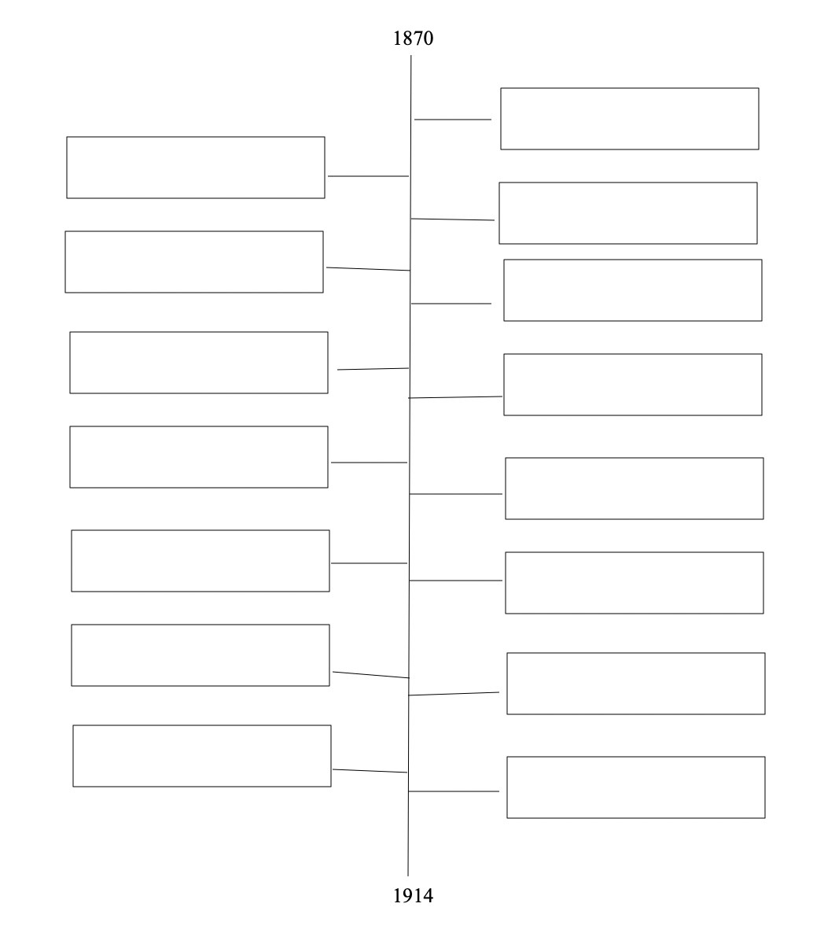

**Timeline Activity**

(for ELLs and students with exceptionalities)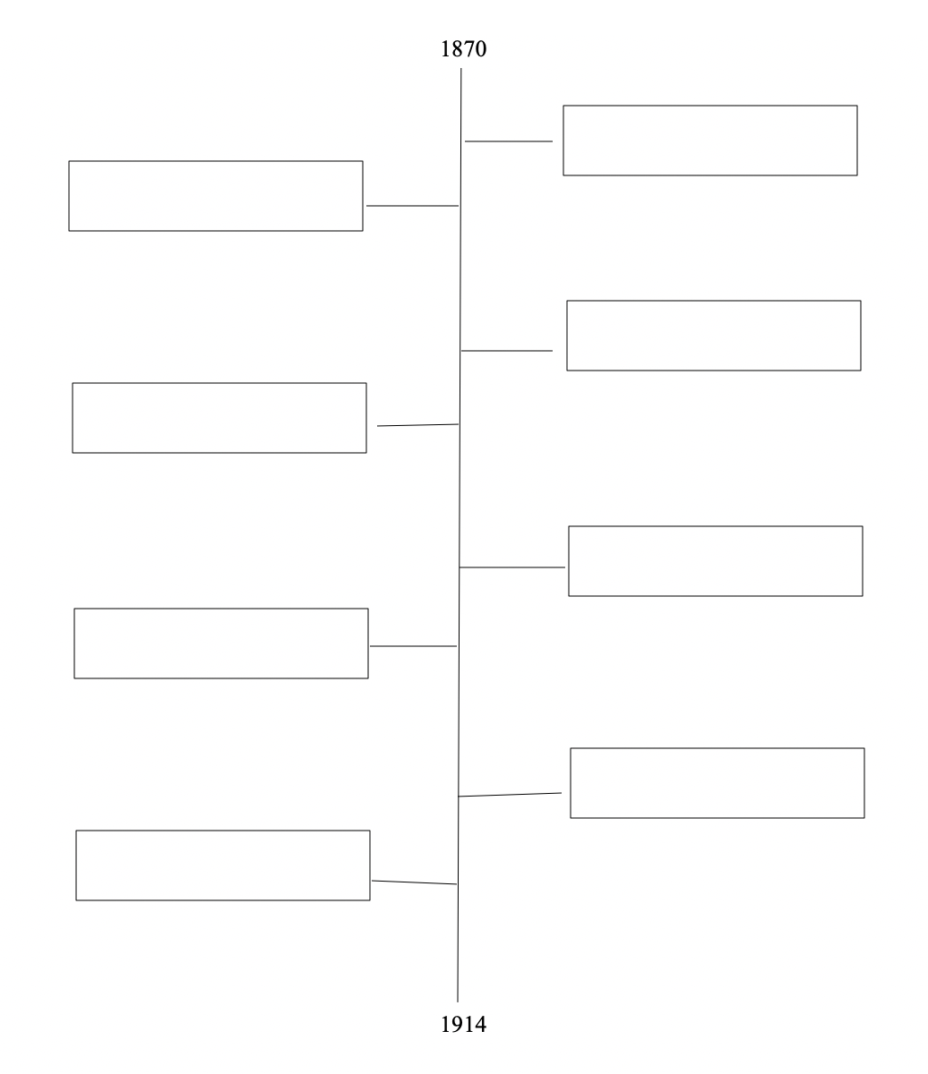

**Timeline Activity Rubric**

(for non-ELLs and students without exceptionalities)

|  |  |  |
| --- | --- | --- |
| Concerns  *Areas that need work* | Criteria  *Standards for performance* | Advanced  *Evidence of Exceeding Standards* |
|  | Criteria #1  Timeline included fifteen events. |  |
|  | Criteria #2  Timeline included eight vocabulary words from the lesson. |  |
|  | Criteria #3  Timeline is historically accurate. |  |
|  | Criteria #4  Student shows evidence of understanding of material. |  |

**Timeline Activity Rubric**

(for ELLs and students with exceptionalities)

|  |  |  |
| --- | --- | --- |
| Concerns  *Areas that need work* | Criteria  *Standards for performance* | Advanced  *Evidence of Exceeding Standards* |
|  | Criteria #1  Timeline included eight events. |  |
|  | Criteria #2  Timeline included six vocabulary words from the lesson. |  |
|  | Criteria #3  Timeline is historically accurate. |  |
|  | Criteria #4  Student shows evidence of understanding of material. |  |

**Comprehension Lesson Plan**

|  |  |  |  |
| --- | --- | --- | --- |
| **Date:** | **Teacher:** | **Grade Level:** | |
| **November 15th, 2020** | **Mr. Cravello** | **11th** | |
| **Florida Standard** | **Objective** | **Assessment of Objective/Progress Monitoring** | |
| SS.912.A.3: Analyze the transformation of the American economy and the changing social and political conditions in response to the Industrial Revolution | The student will be able to (TSWBAT) evaluate the implications of the Industrial Revolution, particularly how the Industrial Revolution impacted the state of Florida. | Exit Ticket: Students will write a short paragraph that explains the main idea and details of the events they read. They should include elements of how the Industrial Revolution impacted Florida. (Formal Assessment) | |
| LAFS.1112.RH.1.2: Determine the central ideas or information of a primary or secondary source; provide an accurate summary that makes clear the relationships among the key details and ideas | TSWBAT identify the main idea of a selected text and provide a summary of what they have read with supporting details embedded in the summary. | Document Analysis worksheet (Informal Assessment) | |
| **English Language Proficiency Objective** | **Language Domain: Circle all that apply** | **Level of ELL: Circle all that apply** | |
| The ELL will be able to recount the events that occurred in Tampa, Florida after the Industrial Revolution. | **Listening Reading**      **Speaking Writing** | **Level 1: Entering Level 4: Expanding**  **Level 2: Emerging Level 5: Bridging**  **Level 3: Developing Level 6: Reaching** | |
| **Target Vocabulary** | **Required Resources/Materials:** | **References/Attachments** | |
| -Industrialization  -Cigar industry  -Mass production  -Strike  -Union  -Reform | -Cigarmakers’ Union Dispute in Tampa primary source  -Document Analysis Worksheet  -Document Analysis Worksheet (simplified version for ELLs) | |  | | --- | | 9-12th Grade Social Studies Common Core Florida Standards. Cpalms.org. Florida Department of Education. Retrieved November 15, 2020 from<https://www.cpalms.org/Public/PreviewIdea/Preview/837>    11th Grade English Language Arts Common Core Florida Standards. Cpalms.org. Florida Department of Education. Retrieved November 15, 2020 from<https://www.cpalms.org/Public/PreviewStandard/Preview/6183>  Cigarmaker’s Union Dispute. Floridamemory.com. Florida Memory. Retrieved November 15, 2020 from <https://www.floridamemory.com/learn/classroom/learning-units/cigar-industry/documents/labor/>  Document Analysis Worksheets. Archives.gov. U.S. National Archives and Records Administration. Retrieved November 15, 2020 from <https://www.archives.gov/education/lessons/worksheets>  <https://www.archives.gov/files/education/lessons/worksheets/written_document_analysis_worksheet_novice.pdf>  <https://www.archives.gov/files/education/lessons/worksheets/written_document_analysis_worksheet.pdf> | | |
| **Activating Strategy** | | **Accommodations:** | |
| -The teacher will (TTW) hand the reading and Document Analysis worksheet.  -TTW ask students to write what they know about labor movements in Florida at the time of the Industrial Revolution and the early 20th century.  -TTW also ask students to write what they know about the relationship between cigar industry and labor movement.  -The written responses will be shared in a brief discussion. | | **ELLs** | The ELL student will receive sentence starters for answering the prior knowledge questions. |
| **Students with Exceptionalities** | For students below grade level, s/he will receive sentence starters for answering the prior knowledge questions. |
| **Teacher Modeling (I do):** | | | |
| -TTW explain that students will use the document analysis worksheet to connect background knowledge to text context. They can use that knowledge to predict possible context by looking at themes from past lessons.  -TTW model how to fill out/write the statements of the Document Analysis before reading the primary source.  -TTW then model and explain how to use text evidence as support.  -TTW split students into groups of 5. | | **ELLs** | The ELL students can receive a modified version of the document analysis worksheet with statements written in simple phrases or short sentences. S/he may receive picture cards for any vocabulary found within the statements. |
| **Students with Exceptionalities** | Students with exceptionalities will be given the document analysis worksheet while the teacher is modeling so that they can follow along or will receive similar accommodations to ELLs. |
| **Guided Practice (We do)** | | | |
| -TTW work with the students to answer the first two questions of the document analysis and discuss the responses with their group.  -TTW ask students to explain where their evidence is coming from in the text. | | **ELLs** | The ELL students can receive a modified version of the document analysis worksheet with statements written in simple phrases or short sentences. S/he may receive picture cards for any vocabulary found within the statements. |
| **Students with Exceptionalities** | Students with exceptionalities will be able to write in bullet points format instead of paragraphs. |
| **Independent Practice (You do)** | | | |
| -After the guided practice, the students will complete the rest of the document analysis on their own. They will read and research the primary source independently.  -Students will highlight/underline phrases from the text to show their textual evidence. | | **ELLs** | The ELL students can receive a modified version of the document analysis worksheet with statements written in simple phrases or short sentences. S/he may receive picture cards for any vocabulary found within the statements. |
| **Students with Exceptionalities** | Students with exceptionalities will be able to write in bullet points format instead of paragraphs. |
| **Closure (Includes a summary of the learning and an exit activity)** | | | |
| -After the students read the primary source and complete the document analysis, TTW ask each group to discuss their findings to the class. TTW ask what does the document tell us about the role of the cigar industry in the labor movement.  -After the groups complete their discussions, students will return to their seats. The students will then complete an independent exit ticket, where they will write a short paragraph that explains the main idea and details of the events they read. | | **ELLs** | The ELL student may receive sentence starters to help him/her summarize the main ideas of reading. |
| **Students with Exceptionalities** | Students with exceptionalities may write in bullet points rather than paragraphs. |

**Document Analysis Worksheet Rubric**

|  |  |  |  |  |
| --- | --- | --- | --- | --- |
|  | Exemplary | Adequate | Minimal | Attempted |
| Analysis of document | Offers in-depth analysis and interpretation of document; distinguishes between fact and opinion; explores reliability of author; compares and contrasts author’s point-of-view with views of others. | Offers accurate analysis of the document. | Demonstrates only a minimal understanding of the document. | Reiterates one or two facts from the document but does not offer any analysis or interpretation of the document. |
| Knowledge of historical context | Shows evidence of thorough knowledge of period in which sources were written; relates primary sources to specific historical context in which it was written. | Uses previous general historical knowledge to examine issues included in the document. | Limited use of previous historical knowledge without complete accuracy. | Barely indicates any previous historical knowledge. |
| Identification of key issues or main ideas | Identifies the key issues and main points included in the primary source; shows understanding of author’s goal(s). | Identifies most but not all of the key issues and main points in the primary source. | Describes in general one issue or concept included in the primary source. | Deals with only briefly and vaguely with the key issues and main points in the document. |
| Resources | Uses several resources in addition to primary source. | Use 1-2 outside resources in addition to primary source. | Relies heavily on the material/information provided. | Relies exclusively on the material/information provided; no evidence of outside resources. |
| Identification of Literacy Devices | Analyzes author’s use of literacy devices such as irony, analogy, sarcasm, etc. | Mention’s author’s use of literacy devices but does not develop fully. | Does not discuss author’s use of literacy devices. | Does not discuss author’s use of literacy devices. |
| Understanding of Audience | Shows strong understanding of author’s audience. | Shows some understanding of author’s audience. | Shows little understanding of author’s audience. | Shows no understanding of author’s audience. |

**Exit Ticket Rubric**

|  |  |  |
| --- | --- | --- |
| **3**  **Comprehensive and Thorough** | **2**  **Partial and Limited** | **1**  **Weak and Incomplete** |
| Exit ticket is organized and easy to understand. | Exit ticket is difficult to read or understand. | Exit ticket is blank or impossible to understand. |
| All parts of the question are answered. Student made a serious attempt to answer the prompt. | Some parts of the question may not be answered. Student made limited attempt to answer the prompt. | Student makes no effort to answer the prompt. May simply write “I don’t know” or leave it blank. |
| Student’s response shows a complete attention and engagement to learning task. | Student’s response shows some attention and engagement to learning task. | Student’s response does not reflect attention to learning task. |