Stata Assignment 4
Sarah Pickersgill
We wish to evaluate the association between being 30+ years old (exposure) and risk for macrosomia (birth weight of baby greater than or equal to 4500 grams). In this assignment, you will create a number of new variables, determine a crude estimate between increased maternal age and macrosomia, generate risk estimates stratified by other factors, generate adjusted risk estimates, and finally jointly stratify by two factors. When you create new variables, remember to label the new variables and values and add the coding to your do file. Please turn in your updated do file (pasted into your word document), as well as answers or output corresponding to those items that are bolded below:

- Create new variables for increased maternal age ≥30, macrosomia (birthweight ≥4500 grams), having less than a high school education (Grade<12 years), having multiple sex partners in the last year, and ever smoking in either the first or second trimester (combined variable, ever vs never smoked) of the pregnancy. What is the prevalence of each of these five new variables?
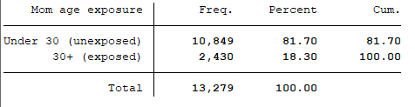 18.3 % mothers are 30+ years old
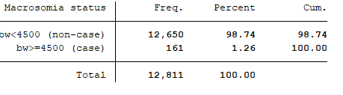1.26 % macrosomia prev.
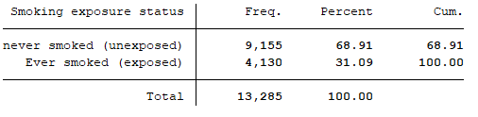31.09 % have smoked
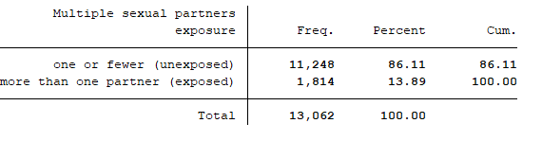 13.89% w/ 2+ sexual partners
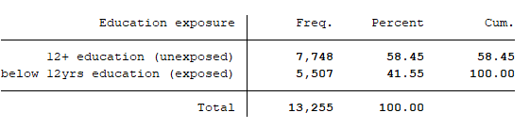 41.55% below 12 yrs education

- Produce an appropriate 2x2 table and determine the crude relative risk and 95% CI for the association between being an older Mom and macrosomia.
The crude relative risk is 1.77 [1.26 , 2.49]. Meaning that macrosomia is 1.77 times more likely for mothers aged of 30 and over than for younger mothers (under 30 years old). The p-value for the risk ratio is 0.0008.

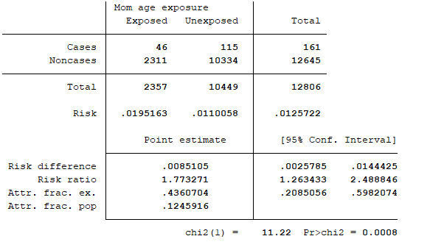

- Now we will assess two factors as potential effect modifiers in the relationship of interest. a) What are the relative risks and 95% CIs for the relationship between being an older Mom and macrosomia in women who ever did or did not smoke? Do you think smoking is an effect modifier?
The relative risk for the relationship between being an older mom and macrosomia in women who have ever smoked is 1.93 [0.911 , 4.11]
The relative risk for the relationship between being an older mom and macrosomia in women who have never smoked is 1.68 [1.15 , 2.45]
Is smoking an effect modifier? I would say it is yes. The relative risks are more than 10% different. Additionally, smoking is known to be associated with low birth weight, so it has biologic plausibility for being an effect modified. The only thing that gives me pause is that the confidence interval for the ever-smoked group is large and completely overlaps the confidence interval for the never-smoked group.

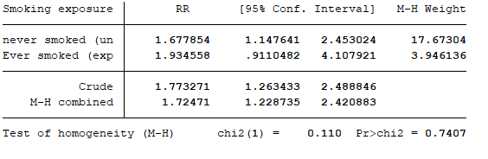
b) What are the relative risks and 95% CIs for the relationship between being an older Mom and macrosomia in women with and without multiple sex partners? Do you think having multiple sex partners is an effect modifier?
The relative risk for the relationship between being an older mom and macrosomia in women with multiple sexual partners is 3.08 [1.00 ,9.44]
The relative risk for the relationship between being an older mom and macrosomia in women without multiple sexual partners is 1.57 [1.09 , 2.27]
Is # of sex partners an effect modifier? I would say no here. Although the relative risk is significantly higher for the multiple sex partners group (almost double that of the other stratum) I don’t think there is any plausible biologic mechanism for this effect modification. Furthermore, the confidence interval is also very wide for the multiple partners’ stratum and so I would be hesitant to definitely call this an effect modifier anyway.

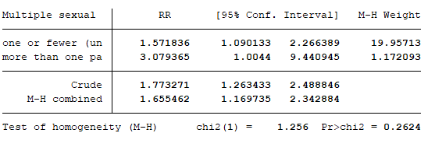

- Now we will assess two factors as potential confounders in the relationship of interest.
a) What is the relative risk and 95% CI for the relationship between being an older Mom and macrosomia adjusted for race/ethnicity group? Do you think race/ethnicity is a confounder?
Concluding that smoking status is an effect modifier means that going forward, we have to stratify our analysis (although it looks like that is questions #5 so I guess I’ll do that analysis there and just do the simple confounding assessment here..)
In this analysis, the relative risk for the relationship between being an older mom and macrosomia adjusted for race/ethnicity is 1.81 [1.29 , 2.55]. This is not significantly different than the crude risk ration of 1.77 so I would say that there is no strong evidence of confounding.
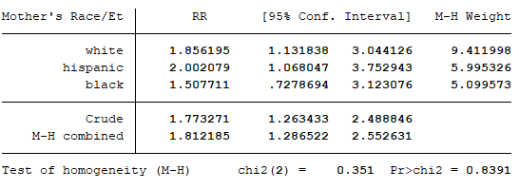
b) What is the relative risk and 95% CI for the relationship between being an older Mom and macrosomia adjusted for lack of a high school education? Do you think education is a confounder?
The relative risk for the relationship between being an older mom and macrosomia adjusted for lack of a high school education is 1.72 [1.22 , 2.42] which is very close to the crude risk ratio of 1.77 so I would again conclude that there is not sufficient evidence to support the claim that education status is a confounder.
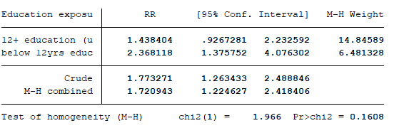
- Let’s suppose we have decided that smoking was an effect modifier and race/ethnicity group was a confounder. What are the relative risks and 95% CIs for the relationship between being an older Mom and macrosomia, stratified by smoking status (ever/never) and adjusted for race/ethnicity group?
Never smoked crude RR = 1.69
The relative risk for the relatinship between being an older mom nad macrosomia for non-smokers, adjusted for race/ethnicity is 1.61 [1.10 , 2.37]. This is similar to that of the crude RR for never smokers – meaning the that there isn’t strong evidence of confounding by race/ethnicity.
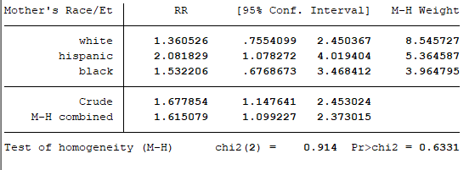
Ever smoked crude RR = 1.93
The relative risk for the relatinship between being an older mom and macrosomia for ever-smokers, adjusted for race/ethnicity is 2.16 [1.02 , 4.56]. This is 12% higher than the crude RR of 1.93. So you could say that there is some (relatively weak) evidence of confounding by race ethnicty among smokers in the relationship between mom age and macrosomia.
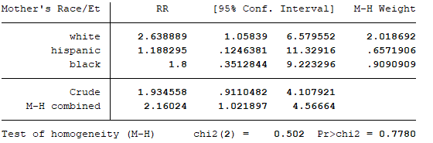

- Let’s suppose we have decided that both smoking and having multiple partners were both effect modifiers. What are the relative risks and 95% CIs for the relationship between being an older Mom and macrosomia, stratified by both smoking status (ever/never) and having multiple partners?
We would then have to stratify for both features. Seeing as we already did this in question 3 I assume you want us to also adjust for race/ethnicity?
Strata | RR (adjusted for race/ethnicity)
Never smoke | 1.61 [1.10 , 2.37]
Ever smoke | 2.16 [1.02 , 4.56]
Single sexual partner | 1.59 [1.10 , 2.31]
Multiple sexual partners | 3.80 [1.25 , 11.53]

In this analysis we can see that the most significant different between crude and adjusted RR is in the multiple sexual partners’ strata (when adjusting for race/ethnicity). The adjusted RR ~23% higher, indicating that race/ethnicity is a confounder in the multiple sexual partners strata.

For single sexual partner:
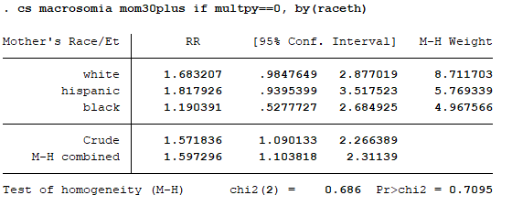
For multiple sexual partners:
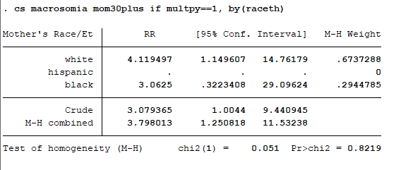

APPENDIX:
version 15

cd "C:\Users\Sarah\Epi510\Stata"
use vicpls2

/////Labeling some variables from last HW /////
label variable deldate "Delivery date (ddmonyyyy)"
label variable enrdate "Enrollment date (ddmonyyy)"
label variable daysbetween "days between enrollment & delivery"

////Creating categorical variable for momage & bw //////
gen mom30plus = .
replace mom30plus=0 if momage<30
replace mom30plus=1 if momage>=30 & momage~=.
gen macrosomia = .
replace macrosomia=1 if bw >=4500 & bw~=.
replace macrosomia=0 if bw<4500
gen belowhseduc = .
replace belowhseduc=1 if grade<12
replace belowhseduc=0 if grade>=12 & grade~=.
gen multpy = .
replace multpy=1 if partyr>=2 & partyr ~=.
replace multpy=0 if partyr<=1
gen eversmoke = .
replace eversmoke=1 if cigs1>0 | cigs2>0 & cigs1~=. & cigs2~=.
replace eversmoke=0 if cigs1==0 & cigs2==0

//adding label definitions and labels //
label variable mom30plus "Mom age exposure"
la define l_mom30plus 1 "30+ (exposed)" 0 "Under 30 (unexposed)"
label values mom30plus l_mom30plus
label variable macrosomia "Macrosomia status"
label define l_macrosomia 1 "bw>=4500 (case)" 0 "bw<4500 (non-case)"
label values macrosomia l_macrosomia
label variable belowhseduc "Education exposure"
label define l_belowhseduc 1 "below 12yrs education (exposed)" 0 "12+ education (unexposed)"
label values belowhseduc l_belowhseduc
label variable multpy "Multiple sexual partners exposure"
label define l_multpy 1 "more than one partner (exposed)" 0 "one or fewer (unexposed)"
label values multpy l_multpy
label variable eversmoke "Smoking exposure status"
label define l_eversmoke 1 "Ever smoked (exposed)" 0 "never smoked (unexposed)"
label values eversmoke l_eversmoke

//Determine prevalences //
ta mom30plus
ta macrosomia
ta belowhseduc
ta multpy
ta eversmoke

// 2x2 table for association between being an older Mom and macrosomia //
cs macrosomia mom30plus

//analysis of effect modification //
cs macrosomia mom30plus, by(eversmoke)
cs macrosomia mom30plus, by(multpy)
cs macrosomia mom30plus, by(raceth)
cs macrosomia mom30plus, by(belowhseduc)

//stratify by smoking status for confouding analysis //
cs macrosomia mom30plus if eversmoke==0, by(raceth)
cs macrosomia mom30plus if eversmoke==1, by(raceth)

//stratify by sex partners for confouding analysis //
cs macrosomia mom30plus if multpy==0, by(raceth)
cs macrosomia mom30plus if multpy==1, by(raceth)

