#BAN502 - Module 4 - Assignment 2

##Schaeffer, Sarah

###Classification Trees

Load Libraries

Loading and Cleaning the Data

drug = read_csv("drug_data.csv")

##   
## -- Column specification --------------------------------------------------------  
## cols(  
## .default = col_character(),  
## Column1 = col_double(),  
## Column2 = col_double(),  
## Column3 = col_double(),  
## Column4 = col_double(),  
## Column5 = col_double(),  
## Column6 = col_double(),  
## Column7 = col_double(),  
## Column8 = col_double(),  
## Column9 = col_double(),  
## Column10 = col_double(),  
## Column11 = col_double(),  
## Column12 = col_double(),  
## Column13 = col_double()  
## )  
## i Use `spec()` for the full column specifications.

names(drug) = c("ID", "Age", "Gender", "Education", "Country", "Ethnicity",  
"Nscore", "Escore", "Oscore", "Ascore", "Cscore", "Impulsive",  
"SS", "Alcohol", "Amphet", "Amyl", "Benzos", "Caff", "Cannabis",  
"Choc", "Coke", "Crack", "Ecstasy", "Heroin", "Ketamine", "Legalh",  
"LSD", "Meth", "Mushrooms", "Nicotine", "Semer", "VSA")  
  
  
#str(drug)

drug[drug == "CL0"] = "No"   
drug[drug == "CL1"] = "No"   
drug[drug == "CL2"] = "Yes"   
drug[drug == "CL3"] = "Yes"   
drug[drug == "CL4"] = "Yes"   
drug[drug == "CL5"] = "Yes"   
drug[drug == "CL6"] = "Yes"

drug_clean = drug %>% mutate_at(vars(Age:Ethnicity), funs(as_factor)) %>%   
 mutate(Age = factor(Age, labels = c("18_24", "25_34", "35_44","45_54", "55_64", "65_"))) %>%  
 mutate(Gender = factor(Gender, labels = c("Male", "Female"))) %>%   
 mutate(Education = factor(Education, labels = c("Under16", "At16", "At17", "At18", "SomeCollege", "ProfessionalCert", "Bachelors", "Masters", "Doctorate"))) %>%  
 mutate(Country = factor(Country, labels = c("USA", "NewZealand", "Other", "Australia", "Ireland","Canada","UK"))) %>%  
 mutate(Ethnicity = factor(Ethnicity, labels = c("Black", "Asian", "White", "White/Black", "Other", "White/Asian", "Black/Asian"))) %>%  
 mutate_at(vars(Alcohol:VSA), funs(as_factor)) %>% select(-ID)

## Warning: `funs()` is deprecated as of dplyr 0.8.0.  
## Please use a list of either functions or lambdas:   
##   
## # Simple named list:   
## list(mean = mean, median = median)  
##   
## # Auto named with `tibble::lst()`:   
## tibble::lst(mean, median)  
##   
## # Using lambdas  
## list(~ mean(., trim = .2), ~ median(., na.rm = TRUE))  
## This warning is displayed once every 8 hours.  
## Call `lifecycle::last_warnings()` to see where this warning was generated.

#str(drug_clean)

drug_clean = drug_clean %>%  
 select(!Alcohol:Mushrooms) %>%  
 select(!Semer:VSA)   
names(drug_clean)

## [1] "Age" "Gender" "Education" "Country" "Ethnicity" "Nscore"   
## [7] "Escore" "Oscore" "Ascore" "Cscore" "Impulsive" "SS"   
## [13] "Nicotine"

###Task1

#summary(drug_clean)  
  
skim(drug_clean)

Data summary

|  |  |
| --- | --- |
| Name | drug_clean |
| Number of rows | 1885 |
| Number of columns | 13 |
| _______________________ |  |
| Column type frequency: |  |
| factor | 6 |
| numeric | 7 |
| ________________________ |  |
| Group variables | None |

**Variable type: factor**

|  |  |  |  |  |  |
| --- | --- | --- | --- | --- | --- |
| skim_variable | n_missing | complete_rate | ordered | n_unique | top_counts |
| Age | 0 | 1 | FALSE | 6 | 18_: 643, 25_: 481, 35_: 356, 45_: 294 |
| Gender | 0 | 1 | FALSE | 2 | Mal: 943, Fem: 942 |
| Education | 0 | 1 | FALSE | 9 | Som: 506, Bac: 480, Mas: 283, Pro: 270 |
| Country | 0 | 1 | FALSE | 7 | UK: 1044, USA: 557, Oth: 118, Can: 87 |
| Ethnicity | 0 | 1 | FALSE | 7 | Whi: 1720, Oth: 63, Bla: 33, Asi: 26 |
| Nicotine | 0 | 1 | FALSE | 2 | Yes: 1264, No: 621 |

**Variable type: numeric**

|  |  |  |  |  |  |  |  |  |  |  |
| --- | --- | --- | --- | --- | --- | --- | --- | --- | --- | --- |
| skim_variable | n_missing | complete_rate | mean | sd | p0 | p25 | p50 | p75 | p100 | hist |
| Nscore | 0 | 1 | 0.00 | 1.00 | -3.46 | -0.68 | 0.04 | 0.63 | 3.27 | ▁▃▇▅▁ |
| Escore | 0 | 1 | 0.00 | 1.00 | -3.27 | -0.70 | 0.00 | 0.64 | 3.27 | ▁▃▇▃▁ |
| Oscore | 0 | 1 | 0.00 | 1.00 | -3.27 | -0.72 | -0.02 | 0.72 | 2.90 | ▁▃▇▆▁ |
| Ascore | 0 | 1 | 0.00 | 1.00 | -3.46 | -0.61 | -0.02 | 0.76 | 3.46 | ▁▃▇▃▁ |
| Cscore | 0 | 1 | 0.00 | 1.00 | -3.46 | -0.65 | -0.01 | 0.58 | 3.46 | ▁▃▇▃▁ |
| Impulsive | 0 | 1 | 0.01 | 0.95 | -2.56 | -0.71 | -0.22 | 0.53 | 2.90 | ▁▆▇▃▁ |
| SS | 0 | 1 | 0.00 | 0.96 | -2.08 | -0.53 | 0.08 | 0.77 | 1.92 | ▂▇▇▇▅ |

Based on the summary of the drug_clean dataset, there does not appear to be any missing data.

###Task2

set.seed(1234)   
drug_clean_split = initial_split(drug_clean, prop = 0.7, strata = Nicotine)   
train = training(drug_clean_split)  
test = testing(drug_clean_split)

###Task3

Visualizations

p1 = ggplot(train, aes(x = Age, fill = Nicotine)) + theme(axis.text.x = element_text(angle = 90, vjust = 0.5, hjust=1)) + geom_bar(position = "fill")  
p2 = ggplot(train, aes(x = Gender, fill = Nicotine)) + geom_bar(position = "fill")  
p3 = ggplot(train, aes(x = Education, fill = Nicotine)) + theme(axis.text.x = element_text(angle = 90, vjust = 0.25, hjust=0.25)) + geom_bar(position = "fill")  
p4 = ggplot(train, aes(x = Country, fill = Nicotine)) + theme(axis.text.x = element_text(angle = 90, vjust = 0.5, hjust=1)) + geom_bar(position = "fill")  
p5 = ggplot(train, aes(x = Ethnicity, fill = Nicotine)) + theme(axis.text.x = element_text(angle = 90, vjust = 0.5, hjust=1)) + geom_bar(position = "fill")  
grid.arrange(p1,p2,p3,p4,p5)

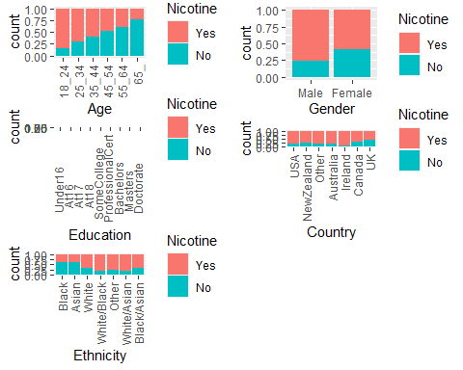

*Age: as age increases nicotine consumption decreases* *Gender: more females consume nicotine than males* *Education: those with a professional certification or higher level of education are less likely to consume nicotine* *Country: those from the UK or Canada are less likely to consume nicotine. Those from Ireland are most likely to consume nicotine* *Ethnicity: those of Black and Asian ethnicity are less likely to consume nicotine.*

p1 = ggplot(train, aes(x = Nicotine, y = Nscore)) + geom_boxplot()  
p2 = ggplot(train, aes(x = Nicotine, y = Escore)) + geom_boxplot()  
p3 = ggplot(train, aes(x = Nicotine, y = Oscore)) + geom_boxplot()  
p4 = ggplot(train, aes(x = Nicotine, y = Ascore)) + geom_boxplot()  
grid.arrange(p1,p2,p3,p4, ncol = 2)

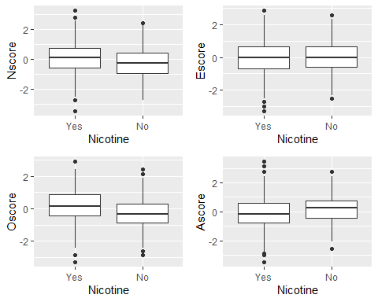

*Nscore: Those who consume nicotine are likely to have a slightly higher Nscore* *Escore: nicotine consumption likely does not affect Escore* *Oscore: Those who consume nicotine are likely to have a higher Oscore* *Ascore: Those who do not consume are likely to have a slightly higher Ascore*

p1 = ggplot(train, aes(x = Nicotine, y = Cscore)) + geom_boxplot()  
p2 = ggplot(train, aes(x = Nicotine, y = Impulsive)) + geom_boxplot()  
p3 = ggplot(train, aes(x = Nicotine, y = SS)) + geom_boxplot()  
grid.arrange(p1,p2,p3, ncol = 2)

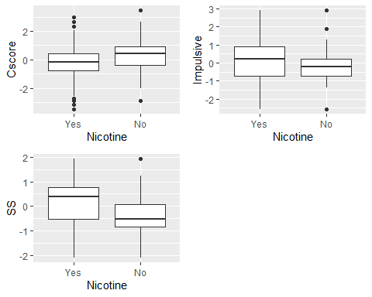

*Cscore: Those who do not consume nicotine are likely to have a higher Cscore* *Impulsive: The range of impulsive is greater for those who consume nicotine versus those who do not consume nicotine* *SS: Those who consume nicotine are likely to have a higher SS value*

###Task4

Set Folds

set.seed(123)  
drug_clean_rf_folds = vfold_cv(train, v = 5)

drug_clean_recipe = recipe(Nicotine ~., train) %>%  
 step_dummy(all_nominal(), -all_outcomes())  
  
drug_clean_rf_model = rand_forest(mtry = tune(), min_n = tune(), trees = 100) %>%   
 set_engine("ranger", importance = "permutation") %>%   
 set_mode("classification")  
  
drug_clean_wflow =   
 workflow() %>%   
 add_model(drug_clean_rf_model) %>%   
 add_recipe(drug_clean_recipe)  
  
drug_clean_rf_grid = grid_regular(  
 mtry(range = c(2, 8)),   
 min_n(range = c(5, 20)),   
 levels = 10  
)  
  
set.seed(123)  
drug_clean_rf_res_tuned = tune_grid(  
 drug_clean_wflow,  
 resamples = drug_clean_rf_folds,  
 grid = drug_clean_rf_grid   
)

##   
## Attaching package: 'rlang'

## The following objects are masked from 'package:purrr':  
##   
## %@%, as_function, flatten, flatten_chr, flatten_dbl, flatten_int,  
## flatten_lgl, flatten_raw, invoke, list_along, modify, prepend,  
## splice

##   
## Attaching package: 'vctrs'

## The following object is masked from 'package:dplyr':  
##   
## data_frame

## The following object is masked from 'package:tibble':  
##   
## data_frame

Visualize

drug_clean_rf_res_tuned %>%  
 collect_metrics() %>%  
 filter(.metric == "accuracy") %>%  
 mutate(min_n = factor(min_n)) %>%  
 ggplot(aes(mtry, mean, color = min_n)) +  
 geom_line(alpha = 0.5, size = 1.5) +  
 geom_point() +  
 labs(y = "Accuracy")

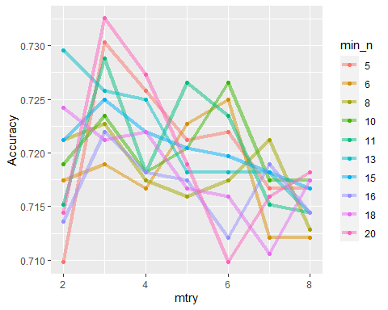

###Task5

Based on the visualization from Task 4, I have determined the best mtry value to be 3 and the best min_n value to be 20. Nw let’s run the code and see if htis matches.

drug_clean_best_rf = select_best(drug_clean_rf_res_tuned, "accuracy")  
  
drug_clean_final_rf = finalize_workflow(  
 drug_clean_wflow,  
 drug_clean_best_rf  
)  
  
drug_clean_final_rf

## == Workflow ====================================================================  
## Preprocessor: Recipe  
## Model: rand_forest()  
##   
## -- Preprocessor ----------------------------------------------------------------  
## 1 Recipe Step  
##   
## * step_dummy()  
##   
## -- Model -----------------------------------------------------------------------  
## Random Forest Model Specification (classification)  
##   
## Main Arguments:  
## mtry = 3  
## trees = 100  
## min_n = 20  
##   
## Engine-Specific Arguments:  
## importance = permutation  
##   
## Computational engine: ranger

drug_clean_final_rf_fit = fit(drug_clean_final_rf, train)

Variable Importance

drug_clean_final_rf_fit %>% pull_workflow_fit() %>% vip(geom = "point")

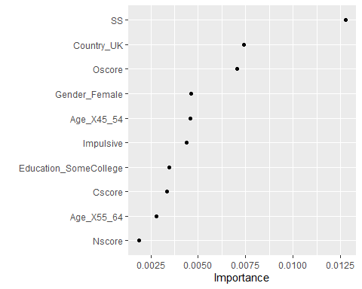

The most important variables are:

SS is the most important variable which is sensation seeing

Country is also an important variable, which UK within that subset being the most important.

Oscore is the third most important variable which is openness to experience.

After these 3 variables, the remaining variables seem to tail off in turns off importance.

###Task6

trainpredrf = predict(drug_clean_final_rf_fit, train)  
head(trainpredrf)

## # A tibble: 6 x 1  
## .pred_class  
## <fct>   
## 1 Yes   
## 2 Yes   
## 3 Yes   
## 4 No   
## 5 Yes   
## 6 Yes

Training Set Predictions

confusionMatrix(trainpredrf$.pred_class, train$Nicotine,   
 positive = "Yes")

## Confusion Matrix and Statistics  
##   
## Reference  
## Prediction Yes No  
## Yes 850 171  
## No 35 264  
##   
## Accuracy : 0.8439   
## 95% CI : (0.8232, 0.8631)  
## No Information Rate : 0.6705   
## P-Value [Acc > NIR] : < 2.2e-16   
##   
## Kappa : 0.6163   
##   
## Mcnemar's Test P-Value : < 2.2e-16   
##   
## Sensitivity : 0.9605   
## Specificity : 0.6069   
## Pos Pred Value : 0.8325   
## Neg Pred Value : 0.8829   
## Prevalence : 0.6705   
## Detection Rate : 0.6439   
## Detection Prevalence : 0.7735   
## Balanced Accuracy : 0.7837   
##   
## 'Positive' Class : Yes   
##

Test Set Predictions

testpredrf = predict(drug_clean_final_rf_fit, test)  
head(testpredrf)

## # A tibble: 6 x 1  
## .pred_class  
## <fct>   
## 1 Yes   
## 2 No   
## 3 No   
## 4 Yes   
## 5 No   
## 6 Yes

confusionMatrix(testpredrf$.pred_class, test$Nicotine,   
 positive = "Yes")

## Confusion Matrix and Statistics  
##   
## Reference  
## Prediction Yes No  
## Yes 337 121  
## No 42 65  
##   
## Accuracy : 0.7115   
## 95% CI : (0.6722, 0.7486)  
## No Information Rate : 0.6708   
## P-Value [Acc > NIR] : 0.02111   
##   
## Kappa : 0.2676   
##   
## Mcnemar's Test P-Value : 9.999e-10   
##   
## Sensitivity : 0.8892   
## Specificity : 0.3495   
## Pos Pred Value : 0.7358   
## Neg Pred Value : 0.6075   
## Prevalence : 0.6708   
## Detection Rate : 0.5965   
## Detection Prevalence : 0.8106   
## Balanced Accuracy : 0.6193   
##   
## 'Positive' Class : Yes   
##

The model on the training set is 85.08% accurate and only 70.09% accurate on the test set. In my opinion, this a relatively low accuracy rate. Additionally, there is quite a large discrepancy between the training and the set set predictions accuracy rate which makes this model less than ideal.

###Task7

This model could be used in the “real-world” to help health insurance companies an appropriate premium rate to charge someone. The use of nicotine is known to potentially cause numerous health problems and an insurance company as a result would want to charge a higher premium to those who consume nicotine. Knowing the likelihood that someone would consume or has consumed nicotine would be helpful when determining someone’s heath insurance premium. This data set contains personality measurements that can be used to make this determination. As long as the model is overstating the number of people that may use nicotine than I would recommend “real-world” use. If it understating the number of people that may use nicotine than this could potentially cost an insurance company a lot of money and I would shy away from using this model. Additionally, I have concerns about the low accuracy of this model. I would have potentially liked to add additional factors during the data collection that would possibly have a more intuitive influence over nicotine useage (such as does anyone in your household consume nicotine).