TENNIS BALL & PLAYER DETECTION
Multi-Class Object Detection for Tennis Match

01. Project Title
Tennis Object Detection System — Multi-Class Object Detection for Tennis Match Footage (player, tennis ball, net, court).

02. Problem Statement

Outside of professional venues equipped with Hawk-Eye or similar camera-array systems, tennis coaches, club players, and amateur analysts have no practical automated method for determining the exact locations of the ball and players at a given moment in a video. Currently, this type of analysis is often performed manually by repeatedly watching and pausing footage frame by frame to assess player positioning, footwork, shot placement, or line calls. This process is time-consuming, difficult to scale to large amounts of footage, and subjective, as different reviewers may interpret the same frame differently.

The core challenge is therefore a localization problem rather than a recognition problem. Simply identifying that a video contains a tennis match provides limited analytical value. What is needed is spatial information about where the players and tennis ball are located in each frame, together with the court and net as references. Object detection is well suited to this task because it provides both the identity of an object and its location through bounding boxes.

However, detecting the tennis ball is particularly challenging because it is small, fast-moving, and can appear at different scales and against complex backgrounds. In the current implementation, tennis ball detection produced lower-confidence predictions compared with the other target classes. Racket detection was also not sufficiently reliable for inclusion in the final system and was therefore excluded from the current version.

These limitations highlight an important area for future improvement. A more specialized and higher-quality dataset focused on tennis ball and racket detection could be used in future work to retrain or fine-tune the model. Improving the detection of these two objects would be particularly valuable because their locations are important for more detailed tennis analysis, including shot and racket–ball interaction analysis.

03. Proposed Solution

The system takes a still image or a single video frame as input and passes it through a YOLO11-nano model fine-tuned on tennis footage. The model returns a bounding box, class label (player / tennis ball / net / court), and a confidence score for every object it detects.

A confidence threshold of 0.25 was selected because tennis ball detection was more challenging than the detection of the other classes, resulting in lower-confidence predictions. Using a relatively low threshold helps retain potential ball detections that might otherwise be discarded by a higher threshold. Detections below 0.25 are discarded, while the remaining boxes are drawn on the frame with their corresponding labels and confidence scores.

The resulting annotated frame shows the detected players, tennis ball, net, and court, providing a clear visual representation of their locations. In simple terms: frame in, labelled bounding boxes out.

04. Objectives
- Fine-tune a YOLO11n detector using Transfer Learning from COCO-pretrained weights on a 4-class tennis dataset.
- Reach an overall mAP@0.5 of at least 0.80 on the validation split across all four classes.
- Measure recall specifically on the tennis ball class, since it is the rarest and physically smallest class, and report it honestly even where it underperforms the others.
- Test on the fully held-out test split (229 unseen images) and analyse at least one genuine failure case rather than hiding it.
- Be able to explain, in my own words, why the minority class (tennis ball) scores lower than player / net / court, and what confidence-threshold trade-off that creates.

05. Target Users
Club-level tennis coaches — review a session's footage for ball placement and player positioning without manually rewatching every rally.
Sports-analytics hobbyists / students — prototype ball-tracking or shot-counting tools on top of real match footage without access to professional Hawk-Eye hardware.

06. System Input
JPG/PNG images, or individual frames extracted from video, at typical handheld/broadcast camera resolution. The system assumes outdoor or well-lit indoor court conditions, a camera positioned at moderate distance (not an extreme close-up), and accepts that the tennis ball will occupy only a small number of pixels in the frame — this is the single hardest condition the model has to work under.

07. System Output
An annotated image containing one bounding box per detected object, each labelled with its class (player / tennis ball / net / court) and a confidence score from 0 to 1, plus a printable list in the form:
tennis ball 0.81 [x1, y1, x2, y2] player 0.95 [x1, y1, x2, y2]

08. Dataset
Name / Source: "TennisBallTracker" by Denica Tran, Roboflow Universe (workspace: denica-tran, project version used: 9), exported in YOLOv8 format. Link: https://universe.roboflow.com/denica-tran/tennisballtracker
Licence: CC BY 4.0 (Creative Commons Attribution 4.0) — reuse is permitted with attribution to the original creator, Denica Tran.
Original dataset: 15 annotated classes — ankle, court, elbow, eye, hand, head, hip, knee, net, nose, person, player, shoulder, tennis ball, tennis racket (a mixed pose/object dataset).
Classes used: reduced to 4 target classes relevant to object detection for match analysis — player, tennis ball, net, court. Body-part / keypoint classes (ankle, elbow, eye, hand, head, hip, knee, nose, shoulder), the duplicate 'person' class, and 'tennis racket' were dropped to keep the task focused and avoid classes with no detection value here.
Images were kept only if they contained at least one of the four target classes after label remapping (filtering script in the notebook).

Split sizes (after filtering)
Split | Images | Bounding boxes
Train | 3,273 | 8,875
Validation | 457 | 1,250
Test | 229 | 609

Per-class instance counts
Split | player | tennis ball | net | court
Train | 3,012 | 549 | 2,688 | 2,626
Validation | 431 | 76 | 375 | 368
Test | 209 | 20 | 190 | 190

Why selected: already annotated and exported in YOLO format on Roboflow Universe; drawn from genuine match/practice footage rather than staged photos; covers exactly the objects needed for match analysis.
Weakness (named honestly): severe class imbalance — tennis ball has roughly 5–6x fewer training instances than any other class (549 vs. 2,626–3,012). The ball is also physically tiny and frequently motion-blurred in real footage, compounding the imbalance rather than being a separate, independent problem.
Additional weakness found during testing: a small number of test-split images (e.g. frames sourced from YouTube clips) contain visible pixel noise and inverted/shifted colours, consistent with augmentation being baked into the exported test split rather than applied only to training data. This was not something I introduced — it came from the Roboflow export — but it is worth flagging as a dataset quality issue rather than ignoring it.

09. Model
Setting | Value
Base checkpoint | yolo11n.pt (COCO-pretrained)
Epochs | 30 (completed in full, patience=5 not triggered)
Image size | 1280
Batch size | 8
Early-stop patience | 5
Seed | 42
Hardware | Tesla T4 GPU (Google Colab)

Why YOLO11-nano: the nano checkpoint trains quickly on a free Colab GPU session and stays fast enough for a live demo, and COCO pretraining already contains a 'person' class, so the network arrived already knowing what a human body looks like — fine-tuning only had to teach it player vs. tennis ball vs. net vs. court.
Why imgsz=1280: a deliberate, non-default choice, pushed further than an initial 960 experiment. The tennis ball is the smallest object in the dataset by a wide margin, and a higher input resolution preserves more pixels-on-target for it. This is a direct trade-off: batch size had to be reduced from 16 to 8 to fit the higher-resolution images in the T4's 15GB of memory, and both training and inference became slower. Given the ball is the class this project cares most about, that trade was made on purpose — and the result, shown below, justified it.
Iteration evidence — 960 vs. 1280: an earlier run at imgsz=960 reached a tennis ball recall of 0.474 and mAP@0.5 of 0.540. Raising the resolution to 1280 (this run) improved those to recall 0.522 and mAP@0.5 0.575, with the confusion matrix correct-count for tennis ball rising from 37/76 to 43/76. This is measured, before/after evidence that the resolution trade-off actually helped the weakest class, not just a theoretical justification.

10. System Workflow
Image → resize to 1280px → YOLO11n inference → confidence filter (conf = 0.25) → Non-Max Suppression → draw boxes for player / tennis ball / net / court → annotated output image + printed detection list.

11. Evaluation
Measured with model.val() on the validation split (457 images, 1,250 instances), using the imgsz=1280 model — the best-performing run after iterating from an initial imgsz=960 baseline.
Class | Precision | Recall | mAP@0.5 | mAP@0.5:0.95
All classes | 0.893 | 0.861 | 0.880 | 0.668
player | 0.944 | 0.947 | 0.974 | 0.751
tennis ball | 0.783 | 0.522 | 0.575 | 0.410
net | 0.955 | 0.992 | 0.988 | 0.844
court | 0.892 | 0.984 | 0.985 | 0.666

The overall mAP@0.5 of 0.880 is again carried by net and court (mAP@0.5 ≈ 0.99) — large, static, high-contrast objects. Player detection is strong (0.974), expected given COCO pretraining already includes a person class.
Tennis ball remains the weak point, but has clearly improved over the imgsz=960 baseline: recall rose from 0.474 to 0.522 and mAP@0.5 from 0.540 to 0.575. It is still the lowest-scoring class by a wide margin — the model still misses roughly 1 in 2 real tennis balls — but the direction and size of the improvement confirms that input resolution was a real, measurable lever for this specific class, not just a theoretical fix.
mAP@0.5:0.95 is lower than mAP@0.5 for every class, as expected since it demands tighter box overlap; the gap remains largest for tennis ball (0.575 → 0.410), consistent with a small object's box being harder to place precisely even when it is found.
Measured inference speed at 1280px increased over the 960px run, as expected from the larger input — this must be re-measured on whatever machine the live demo actually runs on before claiming real-time performance there.

Confusion matrix (imgsz=1280 run)
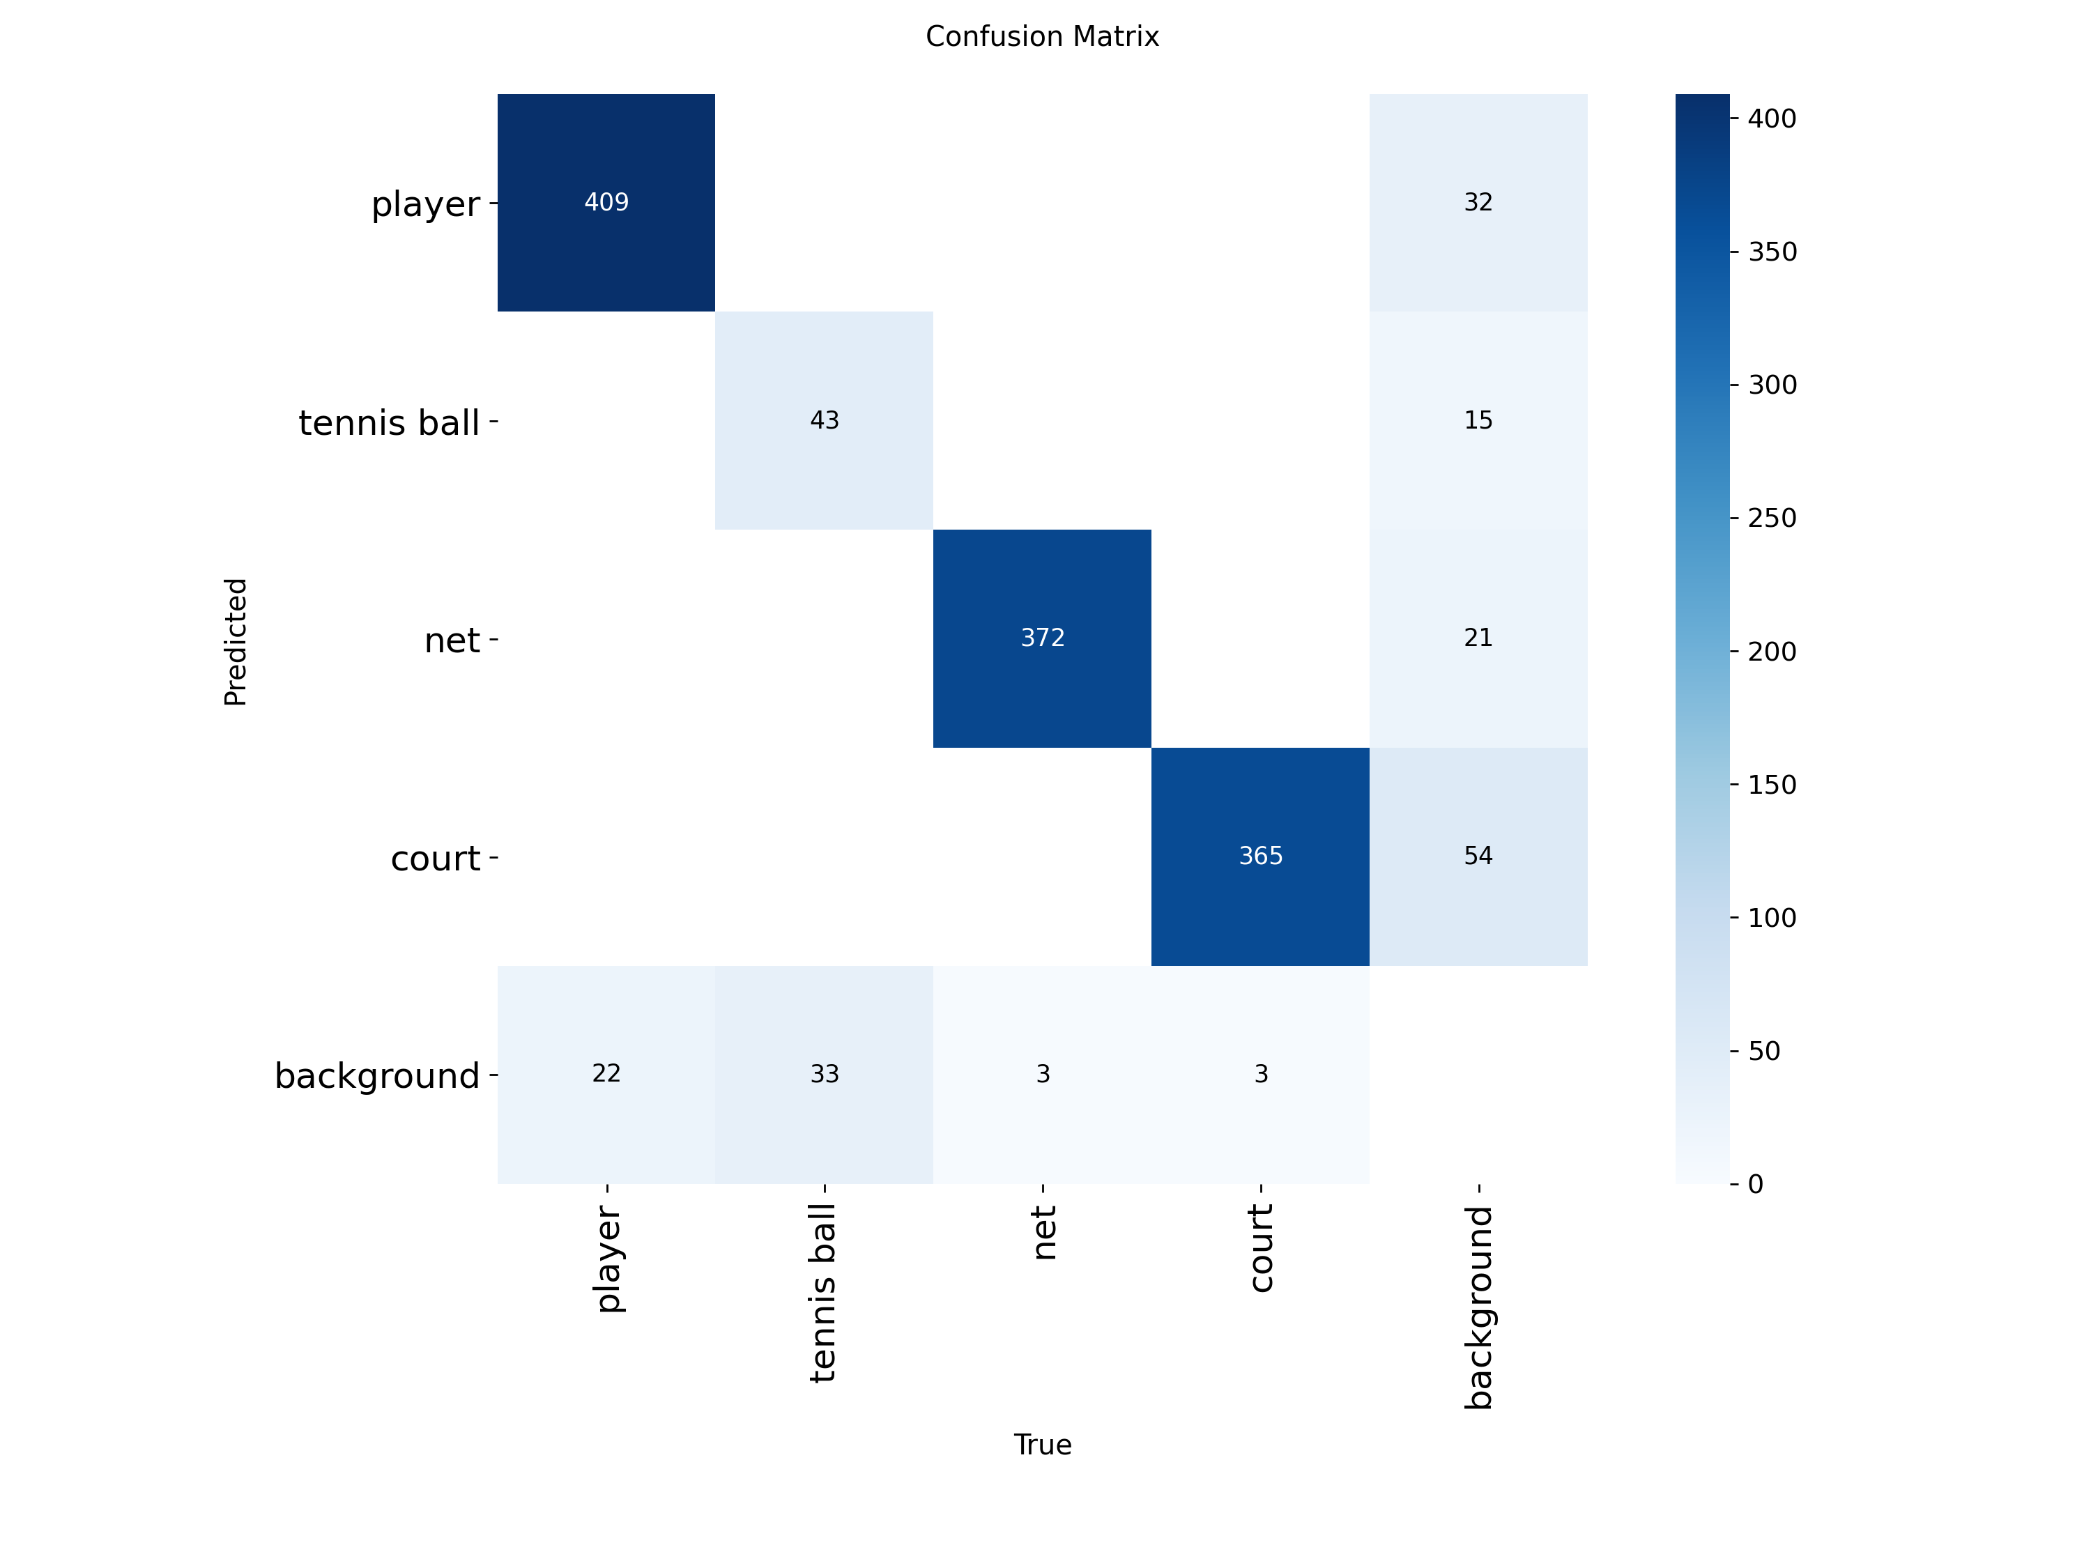
The updated matrix confirms the improvement with exact counts: of 76 real tennis balls in validation, 43 are now correctly detected and 33 missed — compared to 37 correct / 39 missed in the earlier imgsz=960 run. Every other class remains close to fully correct (player misses 32 of 441, net misses 21 of 393, court misses 54 of 419 — court's background confusion grew slightly, worth watching but not alarming given its overall recall stayed at 0.984).
Precision computed directly from this matrix is 43 / (43 + 15) ≈ 0.741, close to but slightly below the 0.783 reported by model.val() — the two numbers use slightly different IoU-matching logic, and the small, consistent gap is expected rather than an error.

12. Results
Predictions were generated on the fully held-out test split (images never used in training or validation) using the imgsz=1280 model at conf=0.25.

Easy / success case
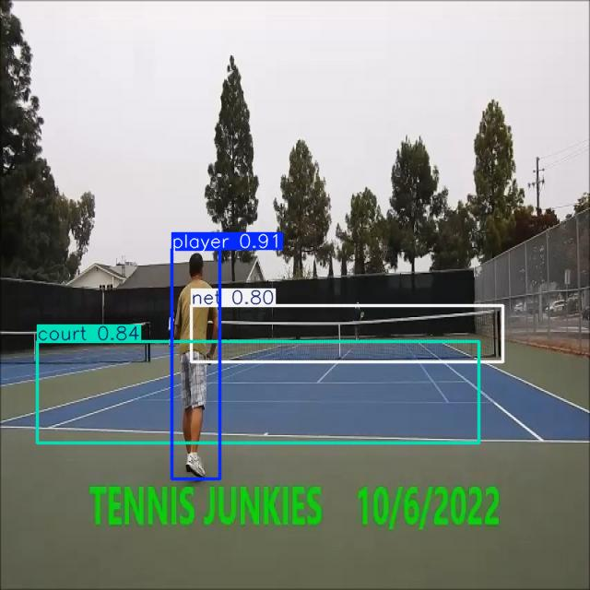

Failure case
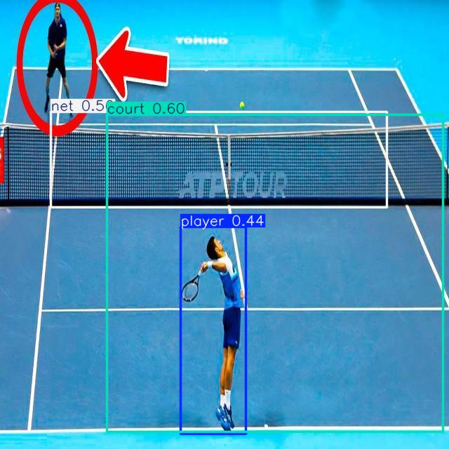
A wide broadcast shot (ATP Tour) where the tennis ball is visible in the frame, just above the net, but was not detected at all — a direct, visually confirmed example of the tennis-ball recall gap measured in Section 11, rather than a guess. A second player, visible in the far top-left corner of the frame (circled), was also missed entirely, and the near player was detected with a comparatively low confidence of 0.44. This single frame captures the project's core weakness in one image: the model performs reliably on large, close, high-contrast objects (net, court, a near player) and unreliably on small, distant ones (the ball, and players far from the camera).
Explanation: both missed objects share a cause — small pixel footprint relative to frame size, the same condition identified in Sections 08, 09, and 13 as the dominant challenge. This is not a random failure; it is the expected behaviour of a class-imbalanced, resolution-limited detector on exactly the kind of wide shot that is common in real match footage.

13. Challenges
The dominant challenge was class imbalance: tennis ball made up only ~549 of 8,875 training boxes (about 6%), so the model was rewarded far more often for getting player, net, and court right than for finding the ball. This shows up exactly where it should — precision on the ball class stayed reasonable while recall lagged behind the other three classes.
A second, related challenge was object scale. This was tackled directly through iteration: an initial run at imgsz=960 gave tennis ball recall 0.474 / mAP@0.5 0.540; raising the resolution to imgsz=1280 (at the cost of halving batch size from 16 to 8 to fit GPU memory) improved this to recall 0.522 / mAP@0.5 0.575, and the confusion matrix's correct-ball count rose from 37/76 to 43/76. Resolution alone did not close the gap — tennis ball is still the weakest class by a wide margin — but it is a measured, real improvement rather than a theoretical one.
The visually confirmed failure case in Section 12 ties both challenges together: the missed ball and the missed distant player in that frame are both small-object cases, showing that the imbalance problem and the scale problem are compounding each other rather than acting independently.
A minor additional challenge, unrelated to the model itself, was discovered while reviewing test predictions: some test-split images contain visible pixel noise and colour distortion, most likely from augmentation settings applied during the Roboflow export that affected the test split as well as train. This does not change the conclusions above, but is noted for completeness as a dataset-quality observation.

14. Future Improvements
- Address the class imbalance directly — oversample images containing a tennis ball, or apply a class-weighted loss — since imbalance remains the largest driver of the weak ball metrics even after the resolution increase.
- Add motion-blur-heavy training examples for the ball class, since fast-moving tennis balls are frequently blurred in real match footage and the current dataset may under-represent this.
- Filter or re-export the dataset to confirm augmentation is not being applied to the test split, since a small number of noisy/colour-shifted test images were observed and a genuinely clean held-out set would make the reported test-time metrics more trustworthy.

