Tennis Player Action Classification
Image Classification using a CNN Built From Scratch
Project Report

Student Name | Sarah Tawfiq
Module | Image Processing & Convolutional Neural Networks
Instructor | Mohamed Waleed

Table of Contents
Table of Contents 2
1. Introduction 3
2. Problem Statement 3
3. Objectives 3
4. Dataset Description 3
5. Data Preprocessing 4
6. CNN Architecture 4
7. Training Process 5
8. Evaluation & Results 6
9. Prediction on New Images 7
10. Challenges Faced 8
11. Future Improvements 8
• Collect a larger and more diverse dataset containing multiple players, camera angles, backgrounds, and lighting conditions to improve generalization. 8
• Experiment with Batch Normalization and different CNN architectures to investigate whether the model's performance can be improved. 8
• Tune the model's hyperparameters, such as learning rate, batch size, number of filters, and dropout rate. 8
• Increase the variety of data augmentation techniques to make the model more robust to variations in real-world images. 8
• Explore video-based approaches in future work to capture the full motion of a tennis stroke rather than classifying a single image frame. 8
12. Conclusion 9
This project successfully developed an end-to-end four-class tennis action image classification system using a Convolutional Neural Network built and trained entirely from scratch. 9
The model was trained to classify tennis player actions into Backhand, Forehand, Ready Position, and Serve. The best model achieved a validation accuracy of 87.00% with a validation loss of 0.4258. 9
The model performance was evaluated using accuracy and loss curves, a confusion matrix, and a classification report. Early Stopping was also used to prevent overfitting and restore the best-performing model weights. 9
The project objectives were successfully achieved. The model's validation accuracy was significantly higher than the 25% random-guessing baseline for a four-class classification problem, demonstrating that the CNN successfully learned meaningful visual patterns from the training images. 9
13. References 9

1. Introduction
This report documents the design, implementation, and evaluation of a Convolutional Neural Network (CNN) built entirely from scratch to classify images of tennis players into one of four action categories: backhand, forehand, serve, and ready position. No pre-trained models or transfer learning were used; every layer of the network was designed and trained from the ground up, in line with the project's requirement to demonstrate core CNN fundamentals.

2. Problem Statement
Manually reviewing hours of training or match footage to identify and count specific tennis strokes is slow and error-prone. This project frames stroke identification as an image classification problem: given a single still image of a player, automatically predict which of four actions is being performed.

3. Objectives
- Build and train a CNN from scratch (no pre-trained weights) for 4-class image classification.
- Achieve a validation accuracy that clearly outperforms random guessing (25% baseline for 4 classes).
- Analyze model performance using accuracy/loss curves and a confusion matrix.
- Demonstrate the trained model on unseen images.

4. Dataset Description
Dataset: Tennis Player Actions Dataset (Kaggle / Mendeley Data).
- 4 classes: backhand, forehand, serve, ready_position.
- 500 images per class — 2,000 images total.
- Images are self-recorded RGB frames of a single player performing each action.
Note: the original dataset also provides COCO-format pose keypoint annotations. These were intentionally excluded, as pose estimation falls outside the scope of this image classification project — only the labeled images were used.
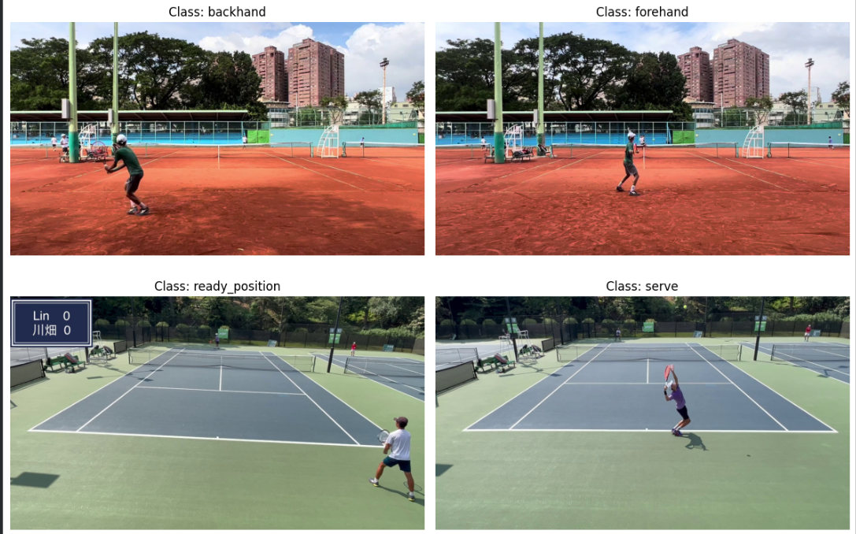

5. Data Preprocessing
- Images resized to 150x150 pixels.
- Pixel values normalized from [0, 255] to [0, 1].
- Dataset split: 80% training / 20% validation.
- Data augmentation was applied to the training set using horizontal flipping, random rotation (up to ±10% of a full rotation range), and random zoom (up to 10%) to improve generalization and reduce overfitting.

6. CNN Architecture
The network follows a standard progressive feature-extraction design:
- Conv2D(32, 3x3) → ReLU → MaxPooling2D
- Conv2D(64, 3x3) → ReLU
- Conv2D(128, 3x3) → ReLU → MaxPooling2D
- Flatten → Dropout(0.5)
- Dense(128) → ReLU
- Dense(4) → Softmax
Filter depth doubles at each block (32 → 64 → 128) to let the network learn increasingly abstract features (from edges to limb/pose configurations) while pooling progressively reduces spatial dimensions. Dropout before the dense head mitigates overfitting on the relatively small dataset.
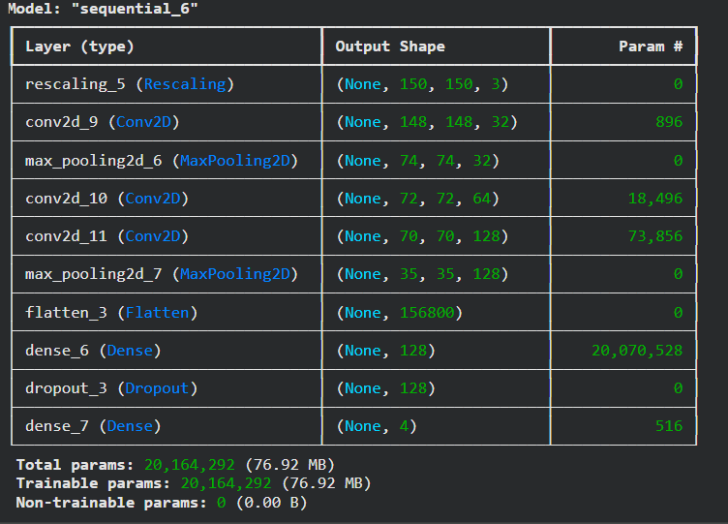

7. Training Process
- Optimizer: Adam
- Loss function: Categorical Crossentropy
- Batch size: 32
- Epochs: 50, with EarlyStopping (patience = 3)
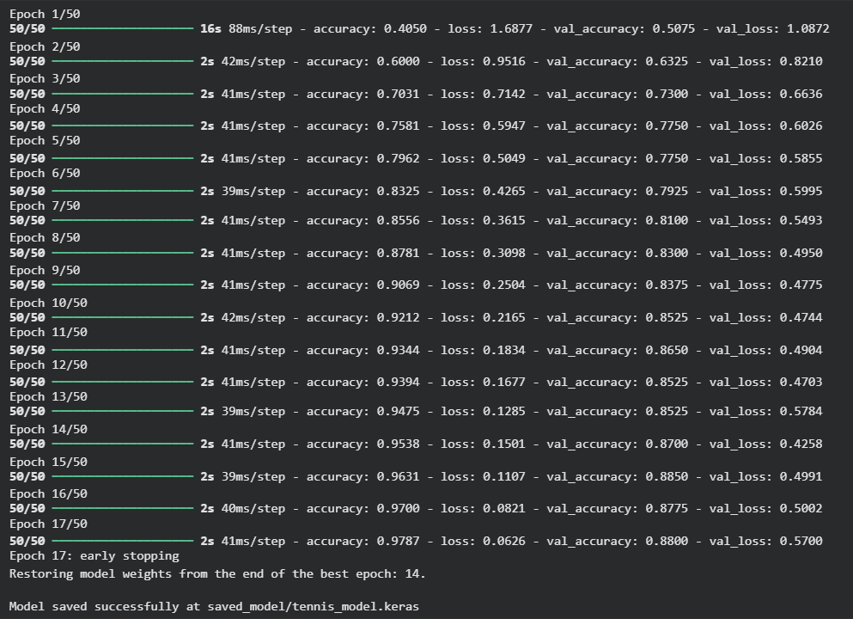

8. Evaluation & Results
Final performance on the held-out validation set:
Validation Accuracy | 87.00%
Validation Loss | 0.4258
Best epoch | 14

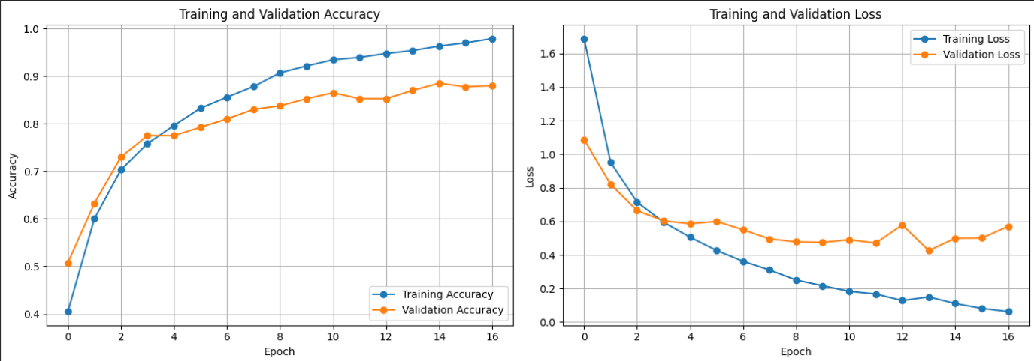
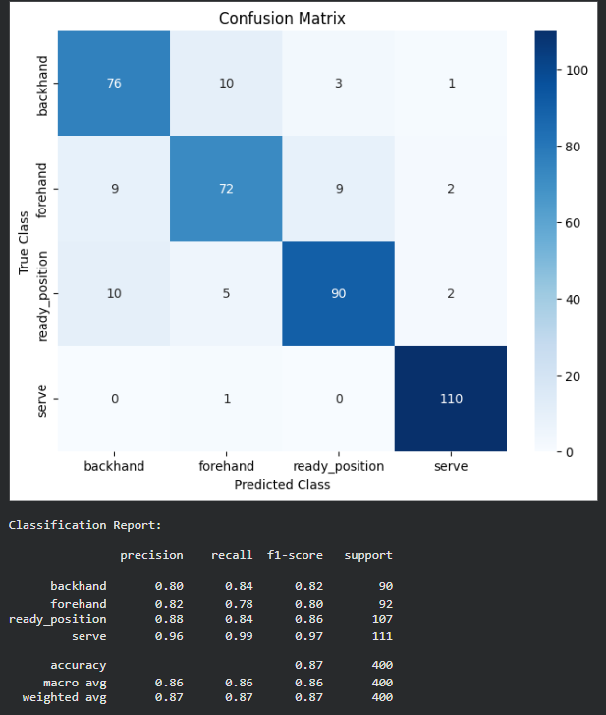

9. Prediction on New Images
The trained model was tested on unseen images placed outside the training/validation split to verify it generalizes:
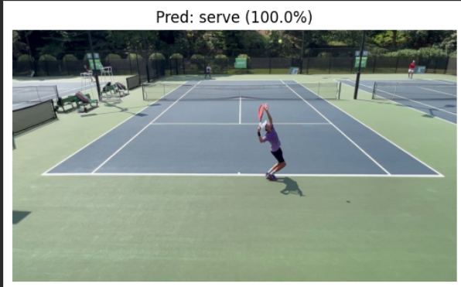

10. Challenges Faced
- Limited dataset size: The dataset contains 2,000 images, which can make it challenging for the CNN to generalize well to different images.
- Visual similarity between some classes: Some tennis actions, especially Forehand and Ready Position, can have similar body postures, making them more difficult to distinguish.
- Overfitting: The model showed a difference between training and validation performance during training. To address this, Dropout, Data Augmentation, and Early Stopping were used to improve generalization.
- Model reproducibility: Training a neural network can produce slightly different results due to randomness. Random seeds were set to make the training process more reproducible.

11. Future Improvements

Collect a larger and more diverse dataset containing multiple players, camera angles, backgrounds, and lighting conditions to improve generalization.

Experiment with Batch Normalization and different CNN architectures to investigate whether the model's performance can be improved.

Tune the model's hyperparameters, such as learning rate, batch size, number of filters, and dropout rate.

Increase the variety of data augmentation techniques to make the model more robust to variations in real-world images.

Explore video-based approaches in future work to capture the full motion of a tennis stroke rather than classifying a single image frame.

12. Conclusion

This project successfully developed an end-to-end four-class tennis action image classification system using a Convolutional Neural Network built and trained entirely from scratch.

The model was trained to classify tennis player actions into Backhand, Forehand, Ready Position, and Serve. The best model achieved a validation accuracy of 87.00% with a validation loss of 0.4258.

The model performance was evaluated using accuracy and loss curves, a confusion matrix, and a classification report. Early Stopping was also used to prevent overfitting and restore the best-performing model weights.

The project objectives were successfully achieved. The model's validation accuracy was significantly higher than the 25% random-guessing baseline for a four-class classification problem, demonstrating that the CNN successfully learned meaningful visual patterns from the training images.

13. References
1. Tennis Player Actions Dataset — Kaggle / Mendeley Data:
https://www.kaggle.com/datasets/orvile/tennis-player-actions-dataset

2. TensorFlow Documentation:
https://www.tensorflow.org/api_docs

