**Electrolysis of solutions**

*If the electrolyte is a compound in solution, then to work out the products at the electrodes, you have to remember a number of rules*

**Products at the cathode**

The product at the **cathode** depends upon the position of the metal in comparison to the position of hydrogen in the reactivity series:

* If the metal is above hydrogen in the reactivity series, then hydrogen ions (H+) are attracted to the cathode, where each one gains an electron and forms hydrogen gas (H2). For example, during the electrolysis of sodium chloride solution, hydrogen gas is formed at the cathode
* If the metal is below hydrogen in the reactivity series, then the metal ions are attracted to the cathode, they gain electrons and form the metal. For example, during the electrolysis of copper sulphate solution, copper is formed at the cathode

**Products at the anode**

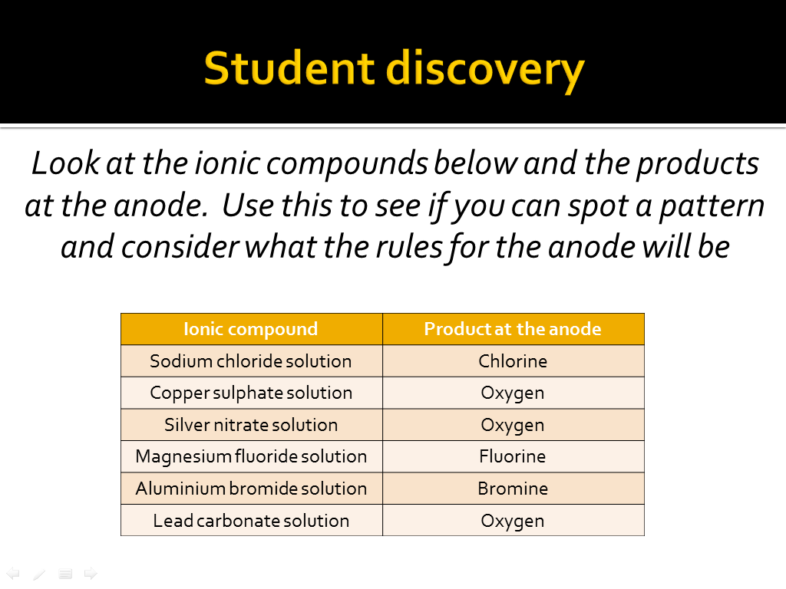

The product at the **anode** depends upon the specific negative ion that is in the solution

* If the negative ions are halide ions, then the halide ions are attracted to the anode, where they each ______ 1 electron and the ____________ will be produced at the anode. For example, during the electrolysis of sodium chloride solution, the ___________ ions are attracted to the anode and chlorine gas is formed.
* If the negative ions are sulfate, carbonate or nitrate, then ________ ions are attracted to the anode, where they each lose ___ electrons and oxygen gas is produced at the anode

**Predicting products**

|  |  |  |
| --- | --- | --- |
| Electrolyte | Product at the cathode | Product at the anode |
| Potassium fluoride solution |  |  |
| Silver sulphate solution |  |  |
| Magnesium bromide solution |  |  |