**Design Document**

1. **Introduction**

This project is part of our third-year module Professional Practice in IT. We are third year Software Development students. Our task is to create an application that a user would find helpful and use often. For our application we have decided to make a farm application. The app is for people with farms or for people that have large groups of animals or herds, who, by using our application can easily keep track of their animal’s information.

The user will hopefully be able to log in to get their personal information. We will be using the animal number to control the information the farmer will receive. It also allows the farmer to complete different interactions with the app and their animals. Our application will be called Farm Hand. Farming Software is starting to become more popular in recent years, so we have decided to make this application as it would be helpful in tracking large herds for farmers instead of having all the information on paper.

1. **Purpose**

This design document is to instruct people on the overall idea of our application. It contains information on how the app works and the different features it offers to the users. The technology that we used is also listed below and why we used it. It tells you our idea with further development of the application and what we believe would be good in order for our application to be successful and helpful for those it is directed at.

1. **System Requirements**

Our finished product will be a Farm Hand application. It will contain the user’s information about their animals and they will be able to do different things within the application.

It is a single user app. The user will log on and there will be only one user at a time using the app. Different users will be able to log on from their phones to see their applications. The log in is for the user to be able to access just their own information and have their animals private and available to just them.

What will the app features do and what amount of data entry screens do we have?

Our app will first present you with a log in screen. You will have to provide your name, password and herd number. When you are logged in you are then brought to the main functions of our app. All the functions will be in different tabs.

Our first tab will present you with a home page. The home page will display the information about the user’s animals and the different details that they have given about their animal.

The second tab will be an add page. User’s will be able to add their animal information to the database and will be asked to enter an animal number, date of birth for that animal, gender and breed. All this information will be added and saved. It will then appear on the individuals home page if they navigate back.

The update tab will allow you to change the information about an animal that has already been registered. You will not be able to update the information about an animal that is not in the system. You can update all the information except for the animal number.

The last tab will be an option for you to delete your animal altogether. You will be presented with all the animals in your system and will be able to choose whichever one you would like to delete. We have decided this would be useful if the animal has been sold or if something has happened to it.

The application will output the information that the user has in the database. We plan to have the information outputted to the home page to view all the details and also to the delete page where you can see all the animals and chose which ones to delete.

We believe these functions are the most important for our app and for the user in order to get the application running correctly for someone with a farm or a large group of animals. Our user interaction will be simple for all to use and work with and easy for them to make the changes they wish.

1. **Technical Aspect**

We will use a 3-tier architecture. We will be using PHP and MYSQL on our virtual machine so the database will be accessible at all times. The front-end will be done using Ionic. This will control the look of the project and the user implementation. The Ionic will have a post request to the PHP using the IP address we have used for the server.

The purpose of the database will be to keep the user’s information secure and available always. Our database is going to be kept on the google platform virtual machine, this allows us to use an external IP address that is connected to our application using our Ionic code. This allows us to get the information from our database to our application using MYSQL functions in our PHP.

The database will store the user’s login information so that only users that are recognised can log in. The database will store the users name and encrypted password with hex code. It also will store the herd number the farmer uses for all its animals to be stored under.

Then under the herd number the database will have two tables. One table will be user and will store the information about the user logging in.

The second table will be herd number, and this will contain all the information about the different animals including their number, gender, breed and D.O.B.

The Ionic is being used for designing the user implementation of the application. It also contains the code that will be used to connect the Ionic to the PHP. We are using a post request to get and send the information to our database. This will then allow us to print the information in our app for the user to access and will allow us to make changes to the database from our app using the IP address and we can access functions that we have in our PHP. The MYSQL statements to add, update and delete, and the queries to show what is in the database will be done in the functions in the PHP. This will then be sent to the ionic completing the user’s requests.

1. **Design Methodology**

We investigated which types of API’s we could use that would work well with Ionic. We have a good understanding of MYSQL so decided to use that to hold our database. We have in the past used Ionic to make applications as part of our course. We believed we had a good understanding of setting up an Ionic application and understood how the code works.

We investigated using MYSQL with ionic and PHP. After much research we decided to use PHP. This made it easier for us to research as MYSQL and Ionic are not new to us, so we were able to understand a lot of online information about how well they work together.

We spoke to different people in our course, watched online videos and blogs. We had no previous knowledge of PHP. We are serving our PHP and MySQL on a remote machine served by google platform.

1. **Features of the PHP and our database**

We will be using 3 PHP files to help run our database. The Index, Functions and Registers. Ionic connects with the Index file. Then the index inputs the functions and function registrations. The function names we will be passing as parameters are found here.

1. **Bugs in our Project**

Our login for the application is not being verified by the database. This then means that the user is accessing all the information in the database and not just their own animal information.

The information is still being passed to the tabs page.

1. **Future Development of the application**

We have many ideas for future development of this application. One of our ideas would be that the farmer would be able to update their herd to say which animals have been bought or sold and when. Then they would be able to say if certain animals died and the date.

The part we found the toughest during the development was connecting the database with the ionic and getting all the PHP functions working. Seeing that we have achieved this we will be able to concentrate more on the new features.

A main function we would like to develop for our app would be to use the information on the animals’ ear tag and the herd card that farmers are already using. We would be able to scan the barcode on the herd card and this would display all the information about the herd or animal.

**Conclusion**

As this project was group work we learned a lot for GitHub and how to branch and merge our commits. It also helped with working together as a team with people. We were both able to split the work evenly and help each other when we needed to.

As we had never done any previous PHP we learned a lot using that. This was one of our first projects with connecting a secure database to store the information in our application. We were able to get the connection between both working fully, while we did have most of our trouble here with the PHP and Ionic. To get the IP address to have a remote connection we had to change the ports on the virtual machine.

Overall, we were happy with the idea of our app and believe with further development it would be very useful to people. The project was long and contained a lot of research for both of us.

**Implementation**

1. **Code**

We First emailed our Supervisor on 25/01/18. We met martin this evening and he gave us a brief outline as to what our project would be. A 3-tier architecture application using ionic.

We went away and investigated what type of application we would make and the type of technologies we would use. We decided to create an application for farmers to keep track of what animals they have. We are using ionic, PHP and MySQL. Week 05/02/18.

We Created the Database on the Google Cloud and connected it to a PHP file. We could view the database using localhost alone. Week 12/02/18.

We started to design our front end. We created a basic tabs ionic template and changed the layout and tabs names. We created 4 tabs. The home, add, delete and update. Week 26/02/18.

We Opened the port 8080 and 3306 inward and outward on the virtual machine. We then attempted to connect the ionic with the PHP using http post requests. We came into problems here and had to change the PHP files. Week 05/03/18.

We Created a folder called API within the wamp64/www. It contains 3 main PHP files. Index.php, function.php and register.php. Each of these files are linked to one another. We call :

this.http.post('http://104.199.57.94/api/', add).subscribe((data) => {

This connects with the IP address and passes the parameter add, which directly forwards the user to a given function. Week 19/03/18.

We Created the PHP functions for delete, update and add. Created pop up alerts for when an animal is added, updated or deleted. It clears the form also. Week 26/03/18.

We got advised by out supervisor to create a login page and pass the herd number when adding, updating and deleting from the database. We had trouble connecting this page to the virtual machine. Week 16/04/18.

When the user logs in the information is being passed to the tabs page. However it Is not validating the user in the database (Allowing all users) access to the database. Week 23/04/18.

1. **Installation & Configuration Guide**

* In order to use Ionic on a windows device, you must have node.js installed. Use the following link and download node.js.

<https://nodejs.org/en/>

* Install Cordova onto your local machine

npm install -g cordova

* In order to download ionic, go to the command prompt and downloads both cardova and ionic .

npm install -g cordova ionic

* If you already have cordova and ionic installed, you may need to update it.

npm update -g cordova ionic

* Download git onto your computer.

<https://git-scm.com/downloads>

* Clone this repository onto your local computer. Navigate into a folder you want the project to be in.

Git clone <https://github.com/sarahCarroll/Group3rdYearProject.git>

* Go to Group3rdYearProject folder.

Cd Group3rdYearProject

* Use the command “ionic serve” and follow any further prompts to import/update files.
* Open a browser and go to localhost:8100 and you will be prompted to login.

1. **User Guide**

* Follow the installation guide to be sure that all the appropriate technologies are installed.
* In order to run the application, go to the appropriate location in your file directory using the command prompt and run the command “ionic serve”

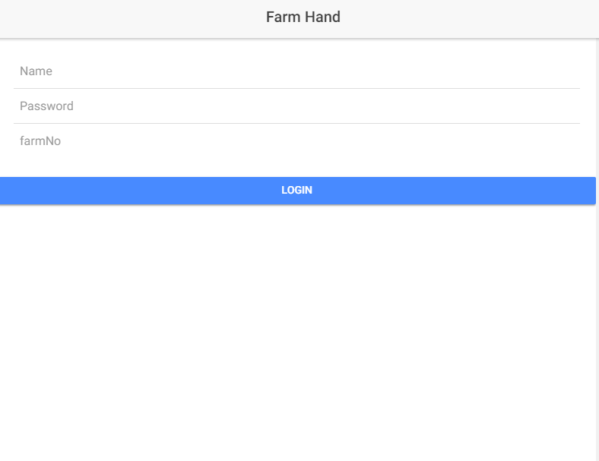

* When you launch the program, you will be greeted with a login page. The user must use a valid username, password and herd number. Use login name Sarah, password sarah and farm number 123.

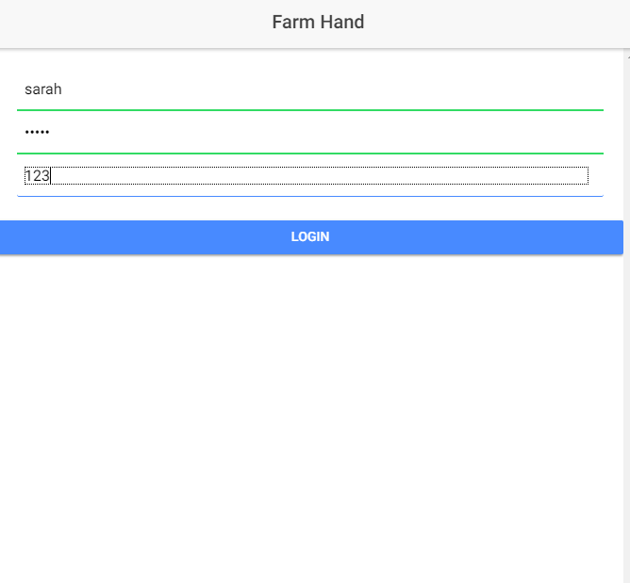

* If the login information is correct you will be brought to the tabs page and see your animals.

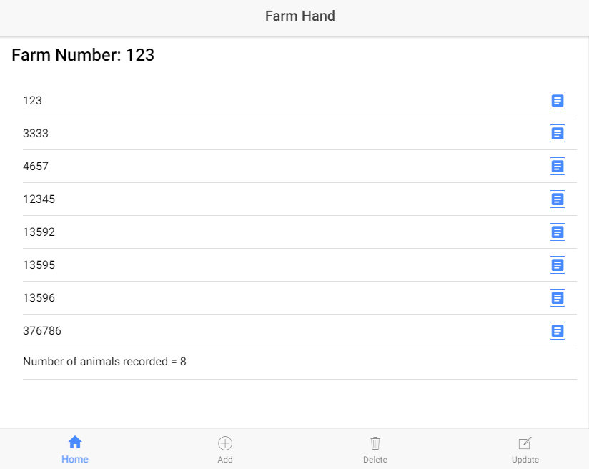

* The user will be able to add, update delete from them database of animals using the appropriate tabs to navigate between the pages.

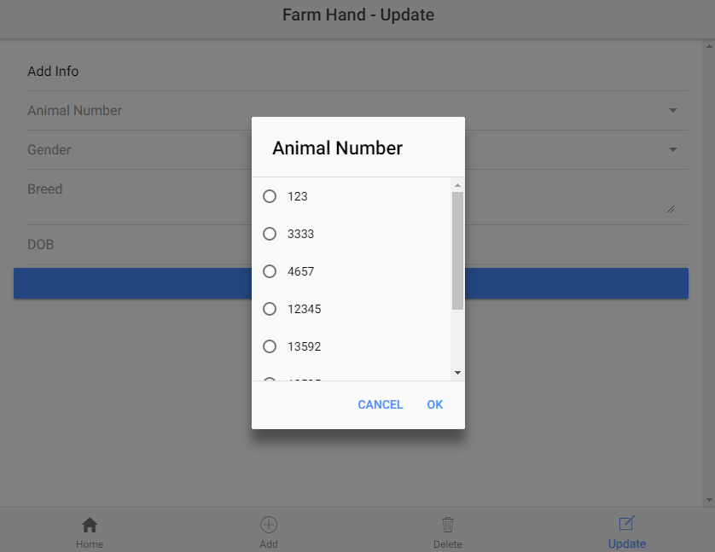

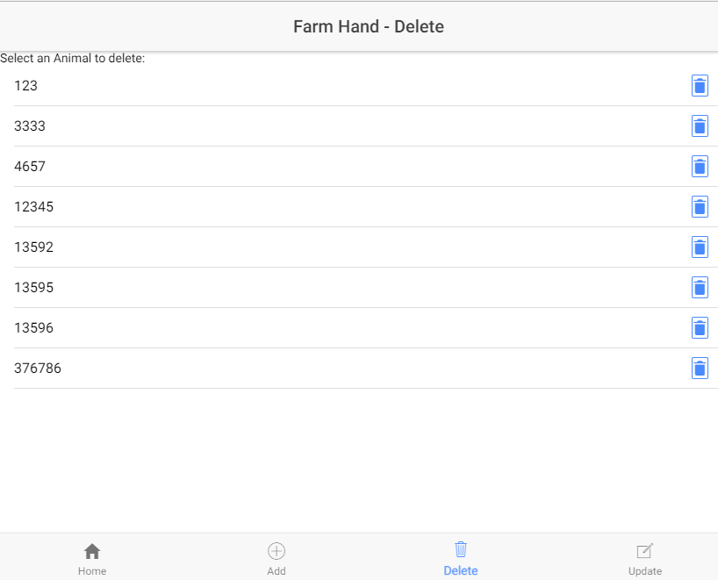

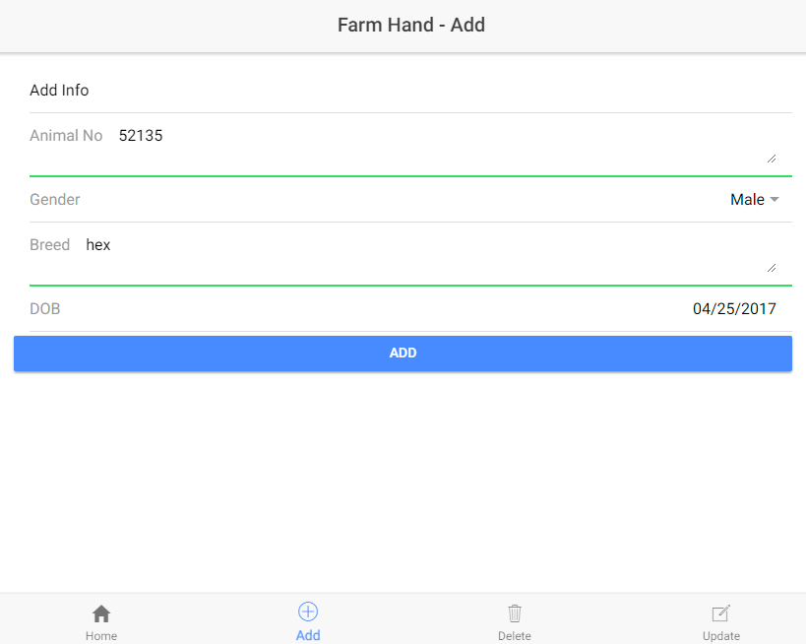

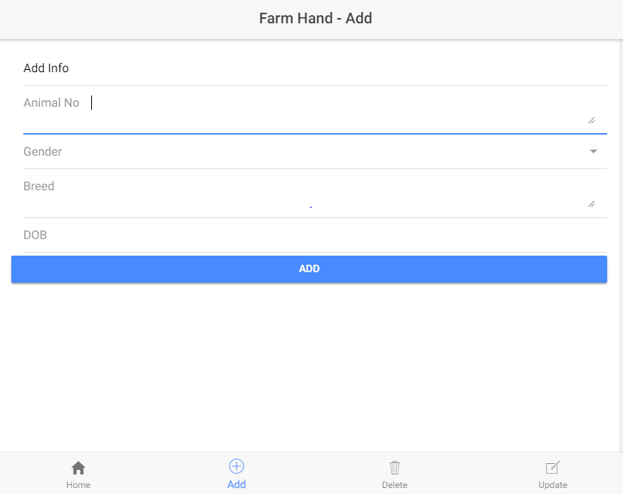

**References**

<http://masteringionic.com/blog/2016-12-15-using-php-and-mysql-with-ionic/>

<https://forum.ionicframework.com/t/ionic-3-empty-list-with-ngfor-and-pipe-present-data-from-object-solved/111706>

<https://robferguson.org/blog/2017/11/19/ionic-3-and-forms/>

<https://blog.angular-university.io/angular-2-ngfor/>

<https://forum.ionicframework.com/t/2-way-data-binding-to-an-array-element-in-an-ngfor-ionic-2-rc1/67977>

<https://www.9lessons.info/2017/06/ionic-angular-php-login-restful-api.html>

<https://www.codeproject.com/articles/1005150/posting-data-from-ionic-app-to-php-server>

<http://adodb.org/dokuwiki/doku.php>

<http://php.net/manual/en/pdo.query.php>

<https://phpdelusions.net/pdo#dsn>

<https://forum.ionicframework.com/t/problems-inserting-data-to-mysql-new-to-ionic/36679>

<https://stackoverflow.com/questions/44174821/how-to-insert-data-in-mysql-database-using-ionic-2-i-have-tried-many-solutions>

<https://stackoverflow.com/questions/38365761/angular2-use-ngmodel-with-ngmodeloptions-standalone-true-to-link-to-a>

<https://forum.ionicframework.com/t/get-selected-value-from-a-select/20241/3>

<https://www.joshmorony.com/adding-background-geolocation-to-an-ionic-2-application/>

<https://ionicframework.com/docs/api/components/select/Select/>

<https://stackoverflow.com/questions/35660306/angular-cannot-find-a-differ-supporting-object-object-object>

<http://masteringionic.com/blog/2016-12-15-using-php-and-mysql-with-ionic/>

<https://stackoverflow.com/questions/28592400/fatal-error-call-to-a-member-function-prepare-on-null/28593099>

<https://stackoverflow.com/questions/35888531/angular2-how-to-subscribe-to-http-post-observable-inside-a-service-and-a-compon>

<https://www.w3schools.com/php/php_forms.asp>

<http://php.net/manual/en/function.file-get-contents.php>

<https://stackoverflow.com/questions/2471605/php-warning-undefined-property-stdclass-fix>

<https://www.concretepage.com/angular-2/angular-2-http-post-example>