First Knit

sarah daniels

Aug 19, 2019

Table of Contents

2019-08-19 2

A Little Survey 2

Where are you now? 2

my answer 2

Others and You? 3

my answer 3

Aspirations? 3

my answer 3

Past adventures? 3

my answer 3

Why are you taking Math 115? 3

my answer 3

Homework Help and Getting around? 3

my answer 4

### 2019-08-19

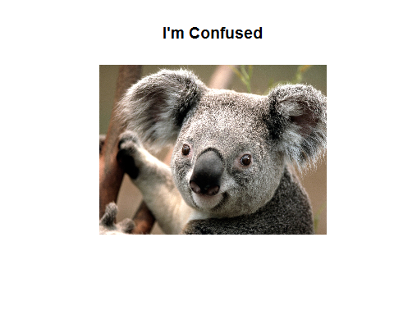

# A Little Survey

Here are just a few questions so I can get to know you and so you can get practice submitting an assignment in Canvas. For each question, insert your answer underneath. Make sure each answer is at the minimum a complete sentence with correctly spelled words and correct puncuation. Half the points in this assignment depend on your picture and name being correct!! Be sure to put your photo in the AAA_Owner_Info folder and call it My_photo.jpg after first renaming the current one to Koala.jpg .

## Where are you now?

What row are you in, front,middle or back? Do you usually choose a similiar row in other classes? What is the computer number where you are sitting? How on a scale of 1 to 10 (1=low, 10=high) How you feel about periodic seat re-assignment, say how and why. Teams, have you ever worked on one in a class setting?

### my answer

Iam in the 5th row, in the center towards the aisle. Yes, I usually choose a seat in the center somwhere. My computer number is 71827. I don’t usually like periodic seat-reassignment, if I enjoy the people I’m sitting next to. I rate it a 5. yes I’ve worked in various group projects.

## Others and You?

What name do you prefer to be called by your classmates and instructor, if your buddys call you something but you want me to call you something else - what would that be?

### my answer

I don’t have any nicknames that i prefer to be called in the classroom. Sarah is fine.

## Aspirations?

What do you want to achieve in life? What college subject do you think would be of the greatest interest to you? What degree or certificate are you trying to achieve?

### my answer

I want to be able to start my own buisness from the ground up, somethung that will have a big impact in the community. I was going for a nursing degree but Just recently decided that’s not what I want. i“m still in the process of figuring it out.

## Past adventures?

Have you ever gone to foreign countries, if so which ones, if not Where might you go in the future? Have you ever been in the military, if so which branch, if not which branch would you choose if you got drafted, and why?

### my answer

I have not been to a foreign country but I want to try Bali, or figi, maybe even colombia.

## Why are you taking Math 115?

What grade do you need to attain in stats to not upset your future plans, What is your plan?

### my answer

I would love to get an A. If I was to get a B I would be fine with that too, If that was the best I coud do.

## Homework Help and Getting around?

On a scale of 1 to 10, where 1 is a total dummy (doesn’t know a mouse from a keyboard) and 10 is a complete geek (knows computer stuff in and out) How do you rate yourself? Do you have a computer you can use at home? If so, what kind is it (windows, Apple, Linux)? Do you have internet access at home?  
How do you get to class? Are there issues that limit when you can be at the college?Where and when did you attend high school? Do you currently have a job?

### my answer

I would be about a 4 on my computer skills. I have an apole computer at home that I have access to. i get to class by using my car. I attended highschool at Quartz Hill Highschool. I currently work as a bank teller at Logix.