Phase III: System Modeling and Prototype

Prepared by Elementary Engineers:

Olga Sheehan, Sara Hakkoum,

Eric Holm, Ethan Fiero

Instructor: Dr. Jung

Framingham State University

Spring 2016

## Abstract

The “Fraction Worksheet Creator” (FWC) is an off-line worksheet generation tool designed by Elementary Engineers to help elementary school teachers to create a lot of exercises for students to study and practice fractions. The fractions worksheets are randomly created and never repeated so the teachers have an endless supply of quality fractions worksheets to use in the classroom or at home.

The purpose of this document is to explain the designed system model using class diagram for the “Fraction Worksheet Creator” (FWC) software for the user. It will illustrate the partial prototype version and demonstrate the features of the software.

This document is primarily intended to be proposed to a customer and the board of directors for their approval and a reference for developing the first version of the system for the development team.

Table of Contents

Abstract 1

Overview 3

Teacher registration 5

Teacher – Forced password reset 5

Teacher Home 6

Teacher – Worksheet History 6

Teacher – Classes 7

Teacher – Adding a New Class 7

Teacher – Edit Class 8

Graphical Mockup 8

## Overview

Basics

**Teacher/User Login Profile**

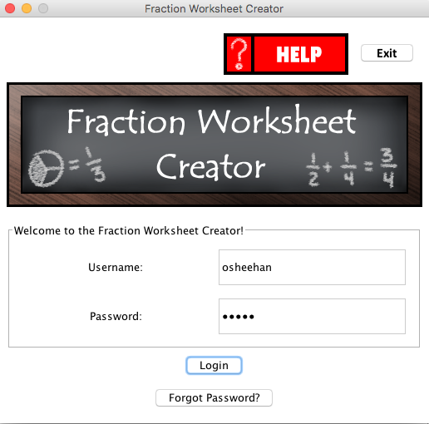

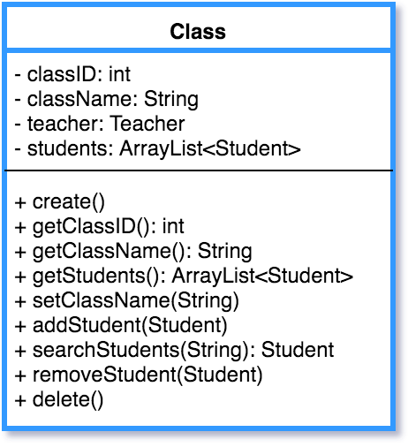

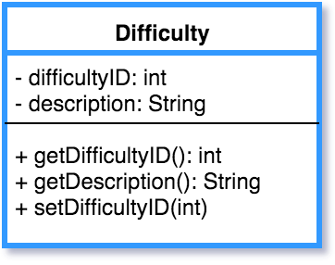

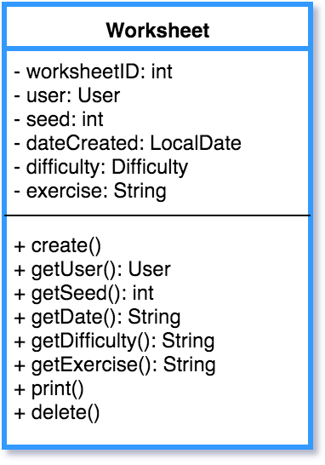

The **.random** package of the Fraction Worksheet Creator is heart of programs primary function of creating worksheets. There are multiple classes that build off one another to accomplish the task of generating the PDF files for the worksheets and answer sheets.

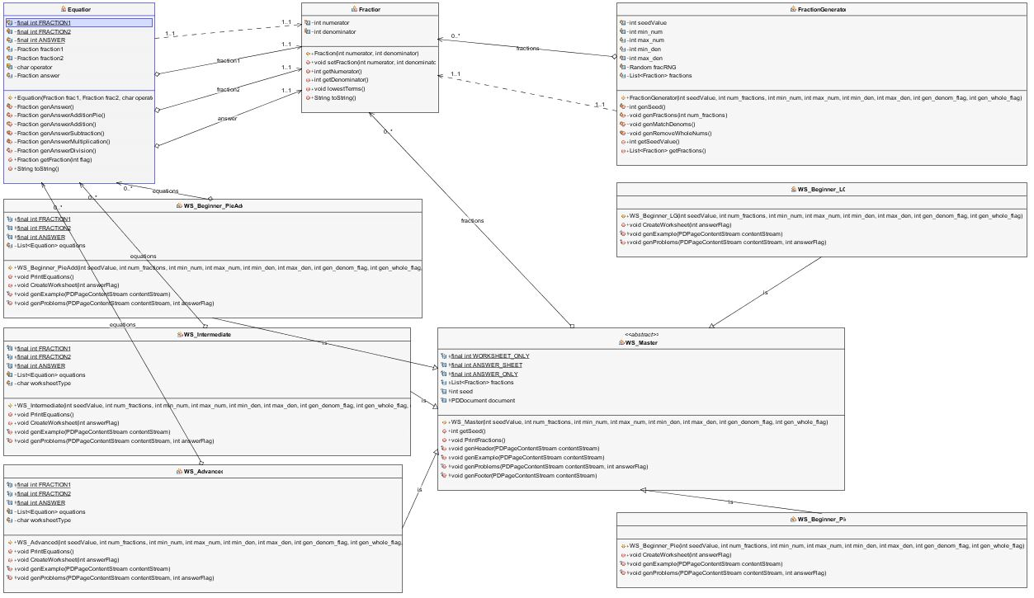

**FractionGenerator (FNG)**

Generates a random set of fractions based on the parameters provided. This includes limits on the numerator, denominator, if whole numbers can be generated, and if matching denominators are required. Passes the fractions to calling classes as a List.

Equation

Forms equations based on the fractions generated by the FNG. Then based on the operator for this equation it calculates the answer, which is stored in an additional Fraction class object.

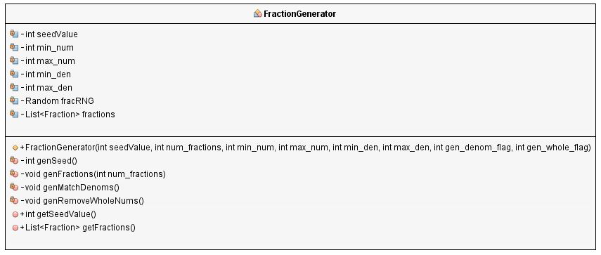

**Equation**

Forms equations based on the fractions generated by the FNG. Then based on the operator for this equation it calculates the answer which is stored in an additional Fraction class object.

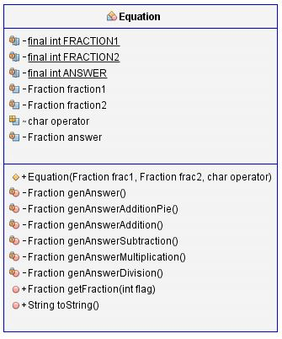

**Fraction**

The base class for describing a fraction. Includes the numerator and denominator and provides the ability to reduce fractions to their lowest terms.

## 

The following subclasses use **WS_Master**

**WS_Beginner_LG** – Beginner Least to Greatest problems

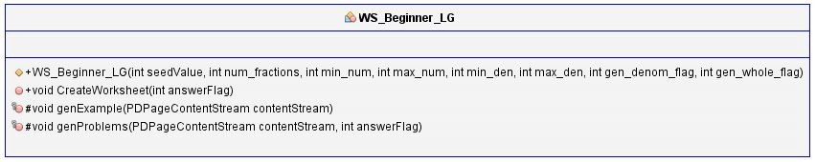

**WS_Beginner_Pie** – Beginner pie diagram to fraction problems

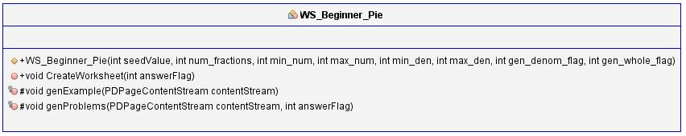

**WS_Beginner_PieAdd** – Beginner pie diagram addition problems

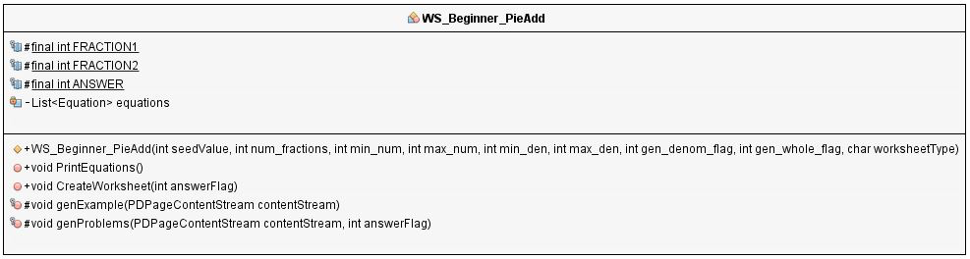

Beginner worksheets require separate subclasses since there is little commonality between the different worksheets at this level.

**WS_Intermediate** – All three intermediate worksheets (Addition, Subtraction, Multiplication/Division) use this one subclass since the only differentiator is the operator. The equation class handles the answers being different based on the operator used for the sheet.

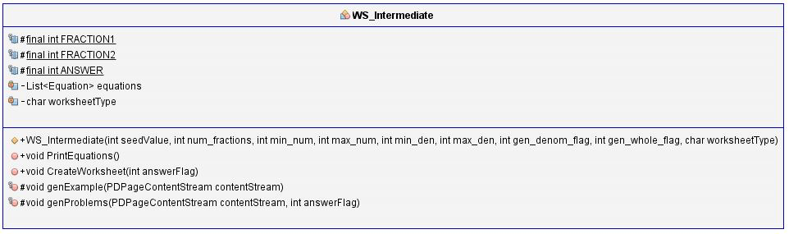

**WS_Advanced** – All three advanced worksheets (Addition, Subtraction, Multiplication/Division) use this one subclass since the only differentiator is the operator. The equation class handles the answers being different based on the operator used for the sheet.

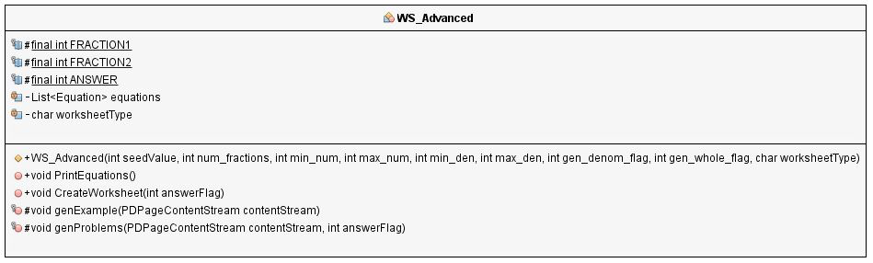

**WS_Master**

An abstract class used to store common data for all worksheets. This includes the list of fractions generated by the FNG, the seed value used to create the fractions and the base worksheet document. This includes common header and footer methods for all worksheets. Example and Problem methods must be implemented by all subclasses.

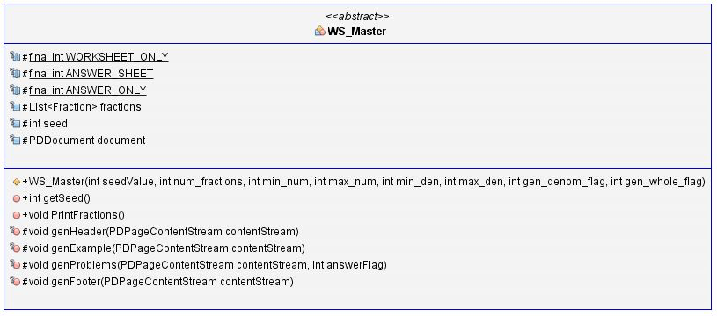

## Teacher Home

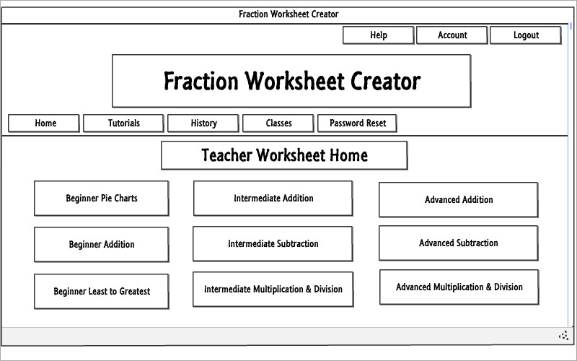

The teacher homepage is where the teacher can generate random fractions worksheets of different difficulties and exercise types.

## Graphical Mockup

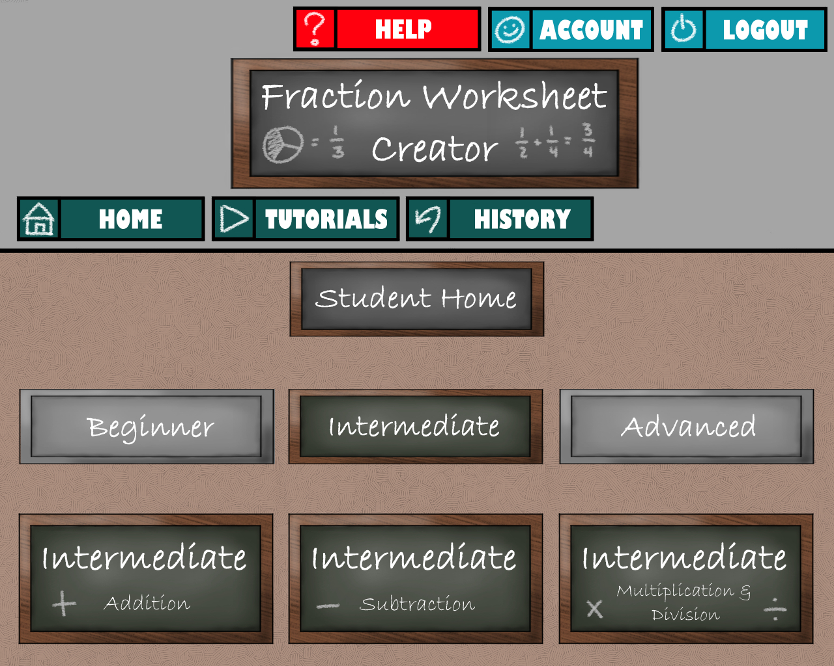

This is a sample of what the finished user interface may look like after including

graphical components.