-Report about section8

A simple application that allows users to interact by randomly changing images when clicking on the buttons associated with them

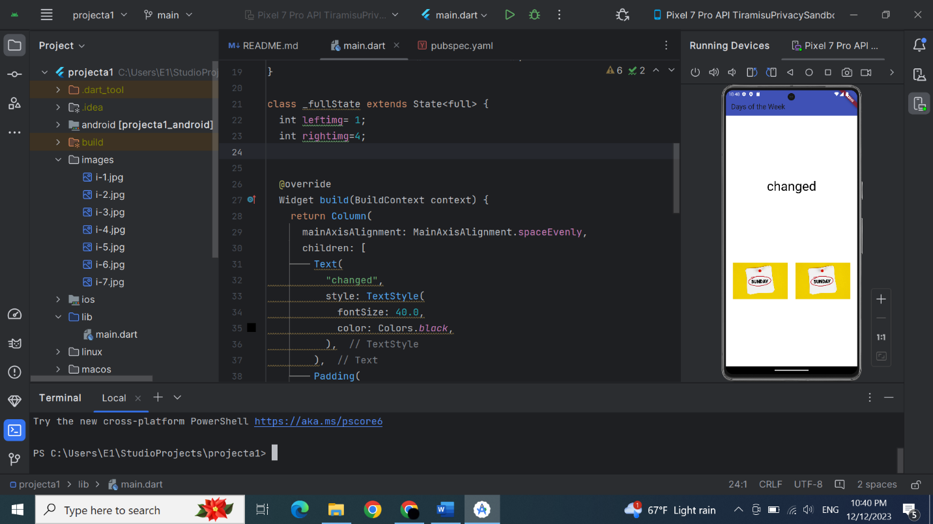

*-StatefulWidget*

*is used to build Flutter applications that require interaction and changes in the user interface in response to events and state changes*

*-StatelessWidget*

*is used to create a static and unchanging part of the user interface that does not require rebuilding or updating based on changes in the state.*

# *-Row& Column*

*In Flutter, Row and Column are layout widgets that help organize and arrange child widgets horizontally (Row) or vertically (Column).*

*Using row and Column in Flutter, you can add a variety of elements and widgets to create flexible layouts*

Text

Image

Lists(list view)

Text field

ets

## *-Expanded*

*Expanded is a Flutter widget used to expand the flex space allocated to a widget within a Flex. It is typically used in a Row or Column to distribute space among its children.*

# *-Buttons & onPressed*

*The FlatButton, RaisedButton and OutlineButton widgets have been replaced by TextButton, ElevatedButton, and OutlinedButton respectively*

*onPressed is a property in Flutter used to specify the function to be executed when a specific element is clicked or pressed. It is often used with interactive elements such as buttons.*