Secure University Network with Mini SOC Lab
Security Testing Report
Cisco Packet Tracer Portfolio Project

1. Executive Summary
This report documents the design, configuration, and testing of a secure university network lab. The network was built in Cisco Packet Tracer using VLAN segmentation, trunking, router-on-a-stick inter-VLAN routing, and extended ACLs. The security goal was to isolate sensitive internal networks while allowing controlled access to the university server.
Final Result: Successfully completed. The Students and Guest networks were restricted from accessing internal networks, while access to the University Server was allowed as required.

2. Project Objectives
- Design a segmented university network using VLANs.
- Configure trunking between the switch and router.
- Implement inter-VLAN routing using router-on-a-stick.
- Create ACL-based security rules for Students and Guest networks.
- Verify allowed and blocked traffic using CLI testing results.
- Document the project for GitHub, CV, and interview discussion.

3. Network Topology

Figure 1: Network Topology
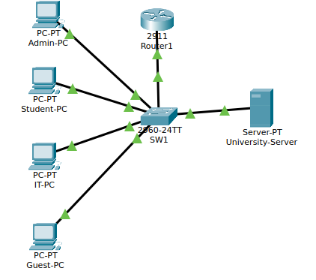
Figure 1: Network Topology
Device | Role
Router1 / R1 | Inter-VLAN routing and ACL enforcement
SW1 | Layer 2 switch and VLAN segmentation
Admin-PC | Administration department endpoint
Student-PC | Student network endpoint
IT-PC | IT department endpoint
Guest-PC | Guest network endpoint
University-Server | Shared university server

4. VLAN and IP Addressing Plan
VLAN | Name | Subnet | Gateway | Switch Port
10 | Admin | 192.168.10.0/24 | 192.168.10.1 | Fa0/1
20 | Students | 192.168.20.0/24 | 192.168.20.1 | Fa0/2
30 | IT | 192.168.30.0/24 | 192.168.30.1 | Fa0/3
40 | Guest | 192.168.40.0/24 | 192.168.40.1 | Fa0/4
50 | Servers | 192.168.50.0/24 | 192.168.50.1 | Fa0/5

5. Security Policy
The ACLs were designed to enforce the following access-control policy:
Source Network | Allowed Access | Blocked Access
Admin | Full internal access | None in this lab
IT | Full internal access | None in this lab
Students | University Server only | Admin, IT, and Guest networks
Guest | University Server only | Admin, Students, IT, and other server-network hosts

6. Configuration Verification Evidence

Figure 2: VLAN Configuration Verification
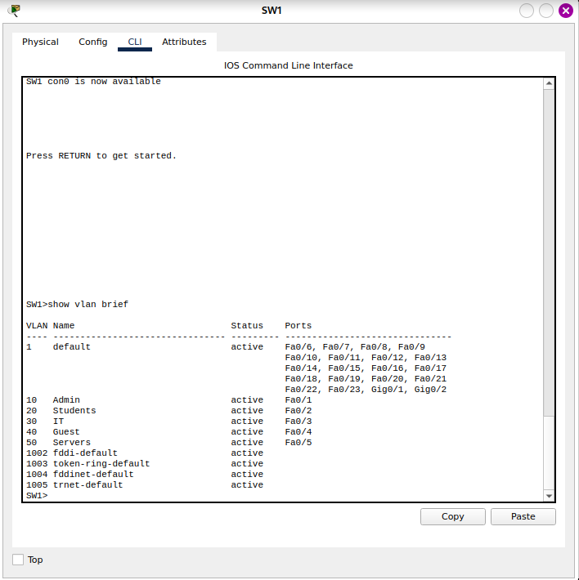
Figure 2: VLAN Configuration Verification

Figure 3: Trunk Verification
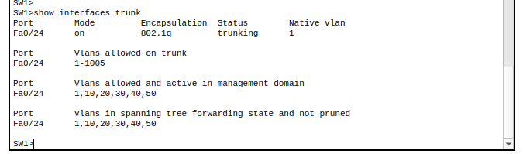
Figure 3: Trunk Verification

Figure 4: Router Sub-Interfaces Verification
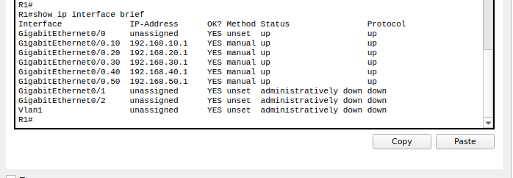
Figure 4: Router Sub-Interfaces Verification

Figure 5: ACL Rules and Match Counters
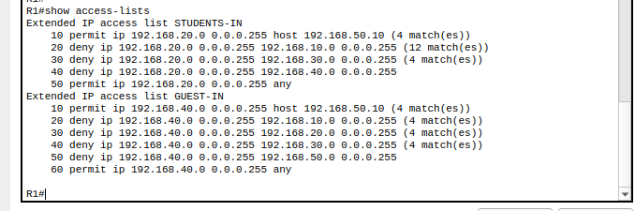
Figure 5: ACL Rules and Match Counters

Figure 6: Students ACL Applied Inbound
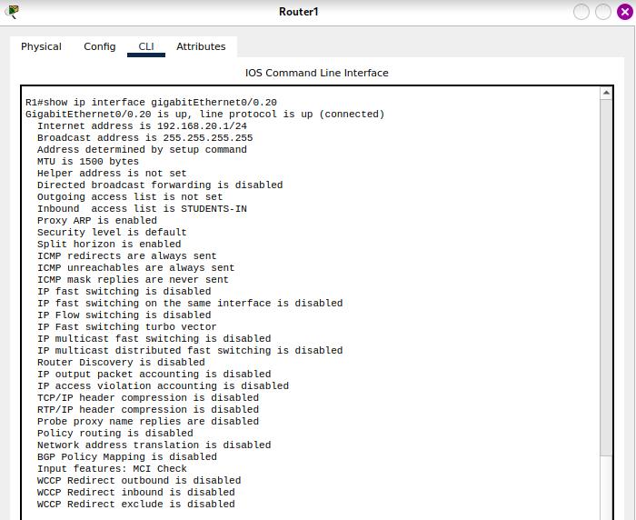
Figure 6: Students ACL Applied Inbound

Figure 7: Guest ACL Applied Inbound
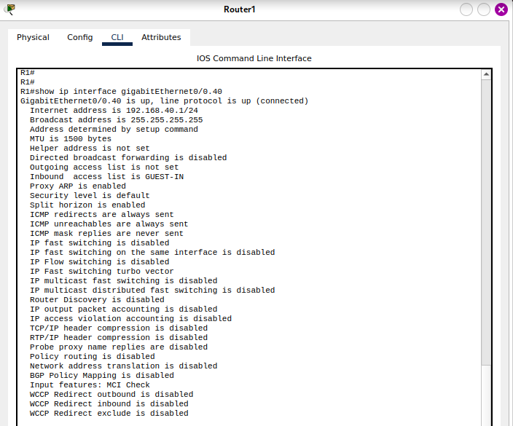
Figure 7: Guest ACL Applied Inbound

7. Security Testing Results
Test Case | Expected Result | Actual Result | Status
Student to University Server | Allowed | Successful ping replies from 192.168.50.10 | Passed
Student to Admin-PC | Blocked | Destination host unreachable from 192.168.20.1 | Passed
Student to IT-PC | Blocked | Destination host unreachable from 192.168.20.1 | Passed
Guest to University Server | Allowed | Successful ping replies from 192.168.50.10 | Passed
Guest to Admin-PC | Blocked | Destination host unreachable from 192.168.40.1 | Passed
Guest to Student-PC | Blocked | Destination host unreachable from 192.168.40.1 | Passed
Guest to IT-PC | Blocked | Destination host unreachable from 192.168.40.1 | Passed

Interpretation: Successful replies confirm allowed traffic. Destination host unreachable confirms that ACLs blocked unauthorized access attempts at the router gateway.

Figure 8: Student Network Access Test
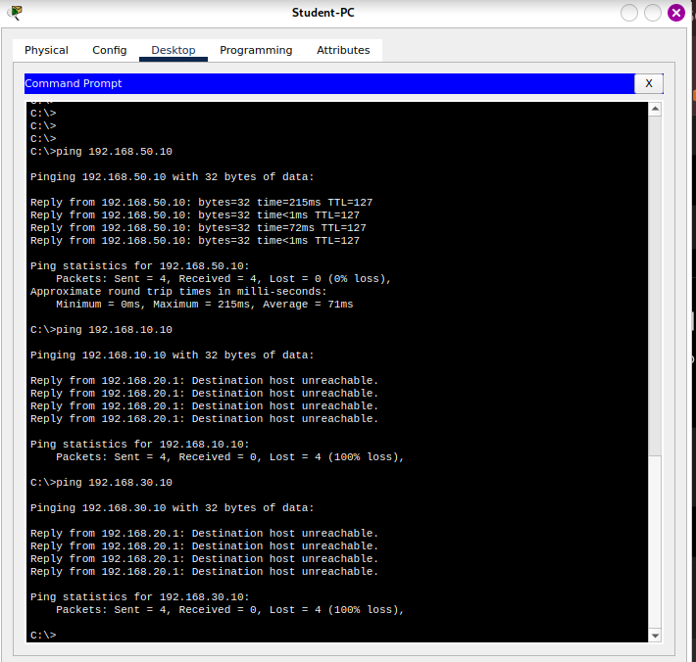
Figure 8: Student Network Access Test

Figure 9: Guest Network Access Test
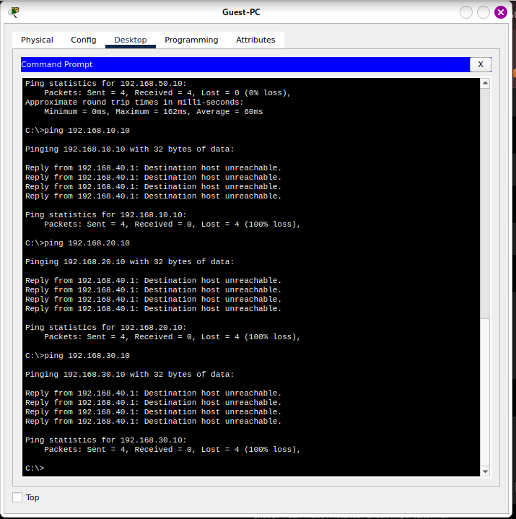
Figure 9: Guest Network Access Test

8. Conclusion
The secure university network lab was successfully configured and verified. VLAN segmentation separated university departments, router-on-a-stick enabled inter-VLAN routing, and extended ACLs enforced network access restrictions. Testing confirmed that Students and Guest users could access the University Server but were blocked from sensitive internal networks.

9. CV / LinkedIn Project Entry
Secure University Network with Mini SOC Lab — Cisco Packet Tracer
- Designed a segmented university network using VLANs, trunking, router-on-a-stick inter-VLAN routing, and ACL-based access control.
- Implemented security rules to isolate Students and Guest networks from sensitive internal networks while allowing controlled access to the university server.
- Verified the configuration through Cisco IOS CLI commands and documented allowed/blocked traffic using testing evidence.

10. Recommended GitHub Repository Structure
- README.md
- screenshots/01-topology.png through 09-guest-access-test.png
- reports/Security_Testing_Report.docx
- Optional: secure-university-network.pkt Packet Tracer file

