Sarah MacAdam

sam8bz

1. P(B) = 0.5

P(!D|C) = 0.8

P(A, !B, C, !D) = 0.03

P(A| !B, C, !D) = 0.10638

1. The formula represents the probability that on time step j-1 we had already learned, given that we got O correct on time step j.
2. V0 = [0.25, 0.25, 0.25, 0.25, 0]

p = [[0, .6, 0, .4, 0],

[0, 0, .6, 0, .4],

[.4, 0, 0, .6, 0],

[.4, 0, 0, 0, .6],

[0, 0, 0, 0, 1]]

where p[i][j] represents the probability of transitioning from position i to j

1. V1 = [0.2, 0.15, 0.15, 0.25, 0.25]
2. V10 = [0.0111, 0.0093, 0.0077, 0.0125, 0.9595]

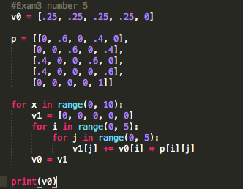

6.

Die1: 0.25

Die2: 0.5

Die2:

0.5

Die1: 0.25

Silver

Gold

Die2: 0.5

Die1: 0.75

Die2: 0.5

Die1: 0.75

7.

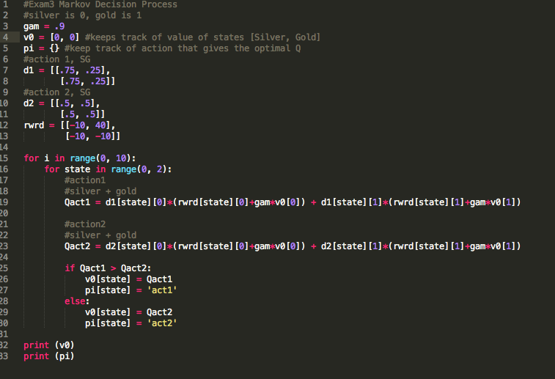

Value of silver = 47.203700334965944

Value of gold = 27.741017174977106]

Policy **Silver**: roll die 2 **Gold**: roll die 1