Ames Housing Price Prediction
Regression Analysis Project Report

1. Project Overview
This project builds a regression model to predict residential house sale prices using the Ames Housing dataset. The workflow covers exploratory data analysis (EDA), missing-value handling, feature engineering, preprocessing, and training/evaluating Linear and Ridge Regression models, with model selection via cross-validation.

2. Dataset Information
The dataset is the Ames Housing dataset, obtained through Kaggle's “House Prices: Advanced Regression Techniques” competition. The training file contains 1,460 rows and 81 columns (79 explanatory variables plus Id and the target SalePrice). The Id column was dropped, and an 80/20 train-test split (random_state = 42) was created from this data for evaluation; Kaggle's separate test.csv was not used since the assignment required evaluation on a held-out test set. After feature engineering, the modeling dataset had 83 predictor features prior to one-hot encoding.

3. Brief EDA Findings
SalePrice is right-skewed, with most homes priced between $100,000 and $250,000 and a long tail of higher-value properties. Overall Quality (OverallQual) showed the strongest positive relationship with SalePrice, followed by above-ground living area (GrLivArea) — both trends are visualized below.
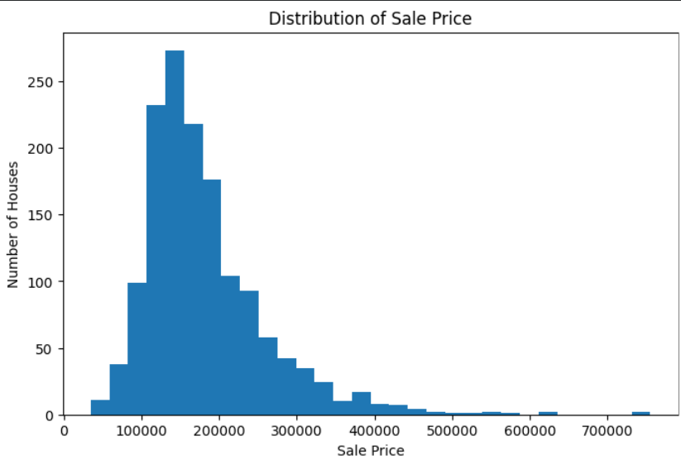
Figure 1: Distribution of Sale Price
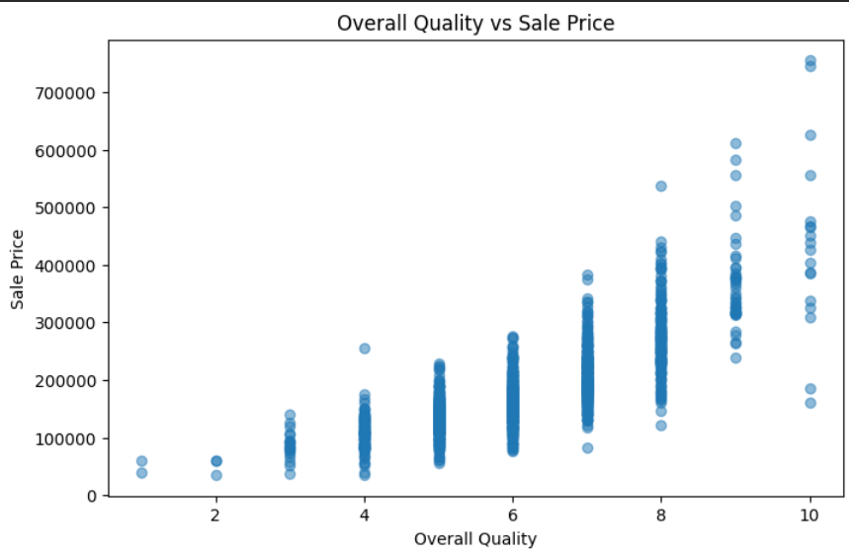
Figure 2: Overall Quality vs Sale Price

4. Living Area vs Sale Price
Above-ground living area (GrLivArea) shows a clear positive, roughly linear relationship with SalePrice, with a small number of large-area outliers that sold below the general trend.
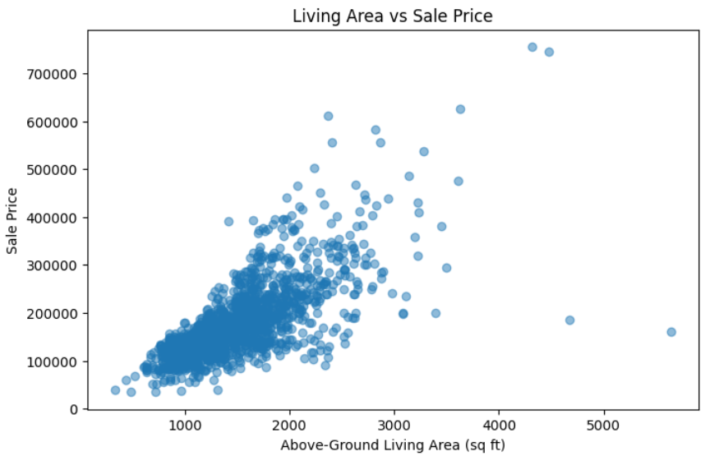
Figure 3: Above-Ground Living Area vs Sale Price

5. Correlation Findings
The table below lists the top 10 numerical features by correlation with SalePrice. OverallQual had the strongest positive correlation, followed by GrLivArea. The remaining strong relationships were mainly related to garage capacity/area, basement and floor area, bathrooms, room count, and house age/year variables.
Feature | Correlation with SalePrice
OverallQual | 0.790982
GrLivArea | 0.708624
GarageCars | 0.640409
GarageArea | 0.623431
TotalBsmtSF | 0.613581
1stFlrSF | 0.605852
FullBath | 0.560664
TotRmsAbvGrd | 0.533723
YearBuilt | 0.522897
YearRemodAdd | 0.507101

6. Missing-Value Handling
- Categorical features where a missing value means absence of that feature (e.g., PoolQC, Alley, Fence, FireplaceQu, and garage/basement categorical fields) were filled with “None”.
- LotFrontage → filled with the median.
- GarageYrBlt and MasVnrArea → filled with 0.
- Electrical → filled with the most frequent value (SBrkr).
- A final check confirmed 0 remaining missing values.

7. Feature Engineering
Four new features were engineered: TotalSF = TotalBsmtSF + 1stFlrSF + 2ndFlrSF; TotalBathrooms = FullBath + 0.5×HalfBath + BsmtFullBath + 0.5×BsmtHalfBath; HouseAge = YrSold − YearBuilt; and RemodAge = YrSold − YearRemodAdd. One RemodAge value was negative (a house had a remodel year recorded after its sale year) and was corrected to 0 rather than left as an invalid negative age.

8. Preprocessing
- The Id column was removed.
- An 80/20 train-test split was created (random_state = 42).
- Numerical features were scaled with StandardScaler.
- Categorical features were encoded with OneHotEncoder(handle_unknown="ignore").
- A ColumnTransformer and Pipeline were used to keep preprocessing integrated with the models.

9. Linear Regression Baseline
A Linear Regression model was trained as a baseline on the preprocessed features. While simple and interpretable, it proved highly sensitive to outliers and multicollinearity among the engineered/categorical features, resulting in poor generalization on the held-out test set (see Model Comparison below).

10. Ridge Regression & Cross-Validation
To address the baseline's instability, Ridge Regression (L2-regularized linear regression) was used. Six alpha values (0.01, 0.1, 1, 10, 100, 1000) were evaluated using 5-fold cross-validation with negative RMSE as the scoring metric. The best-performing value was alpha = 10, with a best mean CV RMSE of 32,634.56.

11. Model Comparison
The table below reports performance on the held-out 20% test set (not training performance):
Model | RMSE | MAE | R²
Linear Regression | 95,748.93 | 23,356.50 | -0.1952
Ridge Regression | 30,535.73 | 19,175.49 | 0.8784

Ridge Regression substantially outperformed the Linear Regression baseline on every metric, confirming that regularization was necessary to control the instability introduced by collinear and high-leverage features.
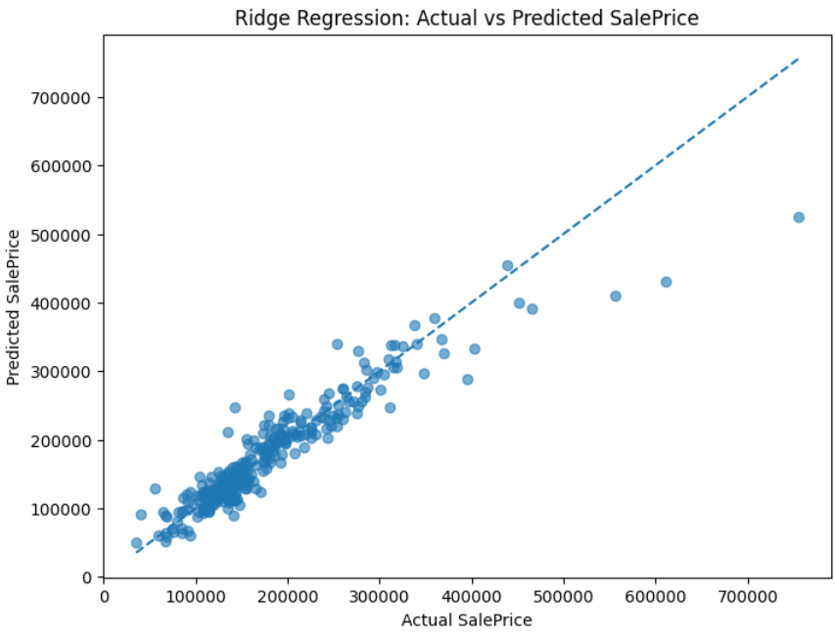
Figure 4: Ridge Regression — Actual vs Predicted SalePrice

12. Residual Analysis
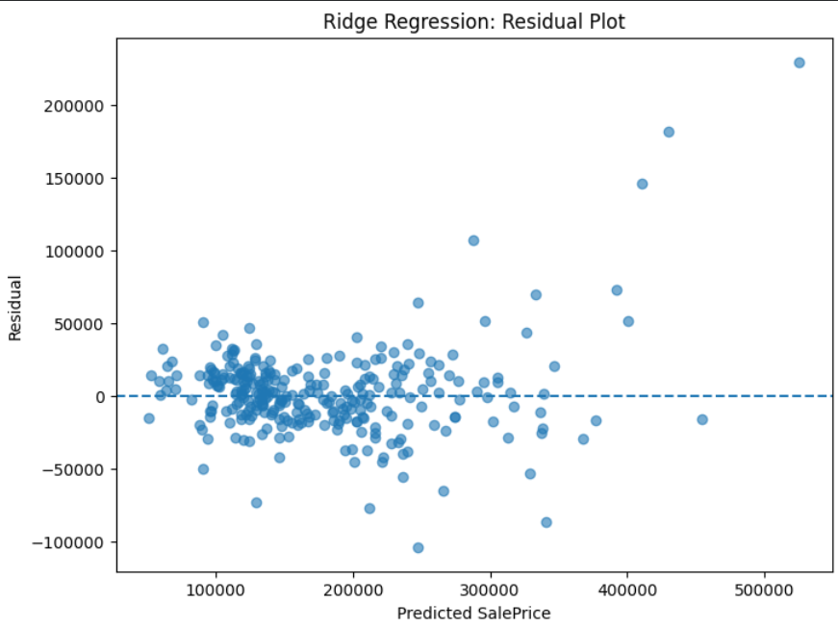
Figure 5: Ridge Regression — Residual Plot
Residuals are centered around zero and fairly evenly scattered for lower and mid-range predicted prices, indicating the model captures the main pricing trend well in that range. Variance increases at higher predicted prices, with a few larger positive residuals, meaning the model tends to underpredict some of the most expensive homes. This is consistent with having fewer high-price training examples for the model to learn from.

13. Challenges Faced
The baseline Linear Regression produced an extreme negative prediction for one valid test-set house (actual price $171,000, predicted approximately −$1.39 million). Rather than deleting the observation, it was investigated directly; the record was not corrupted, though it had an unusually large PoolArea of 576 sq ft. Ridge regularization was then applied to improve model stability and prevent individual high-leverage features from dominating the predictions.

14. Conclusion
Overall Quality and above-ground living area were the strongest predictors of sale price in this dataset. A plain Linear Regression baseline was unstable and generalized poorly (negative test R²), while Ridge Regression with alpha = 10, selected via 5-fold cross-validation, produced a much more reliable model with an R² of 0.8784 and substantially lower RMSE and MAE on the held-out test set. This confirms that regularization was an effective and necessary step for this dataset.

15. Technologies Used
Python, pandas, NumPy, scikit-learn (Pipeline, ColumnTransformer, StandardScaler, OneHotEncoder, LinearRegression, Ridge, cross-validation), Matplotlib, and Jupyter Notebook.

16. GitHub Repository
Ames House Price Regression

