Descriptive Statistics

## Loading required package: zoo
##
## Attaching package: 'zoo'
##
## The following objects are masked from 'package:base':
##
## as.Date, as.Date.numeric
##
## Loading required package: xts
##
## Attaching package: 'PerformanceAnalytics'
##
## The following object is masked from 'package:graphics':
##
## legend
##
## Loading required package: timeDate
##
## Attaching package: 'timeDate'
##
## The following objects are masked from 'package:PerformanceAnalytics':
##
## kurtosis, skewness
##
##
## Attaching package: 'timeSeries'
##
## The following object is masked from 'package:zoo':
##
## time<-

Calculating Compound Return
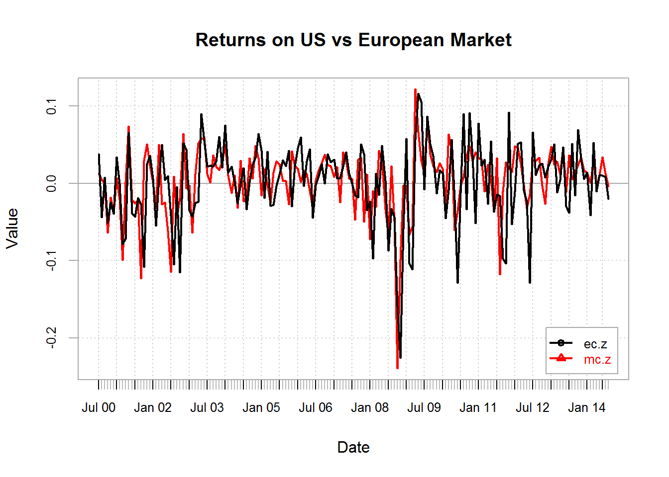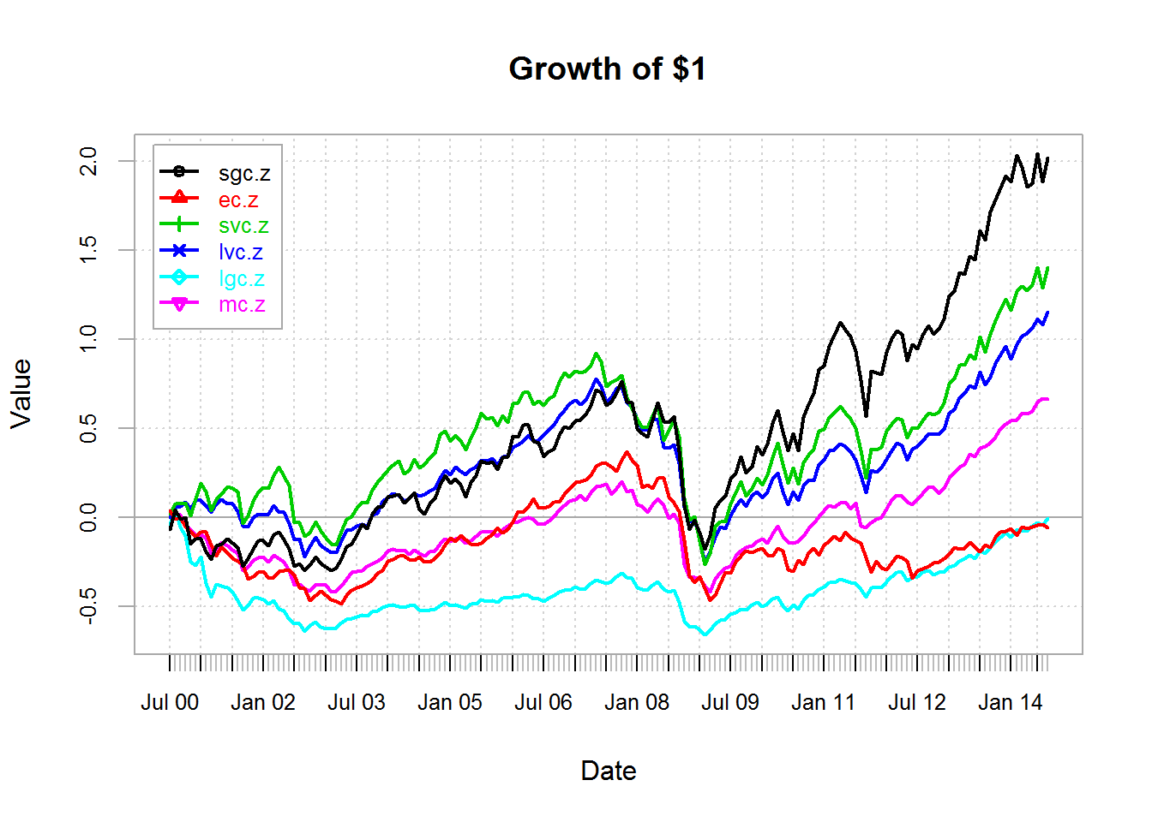

Examining the Frequency Distribution
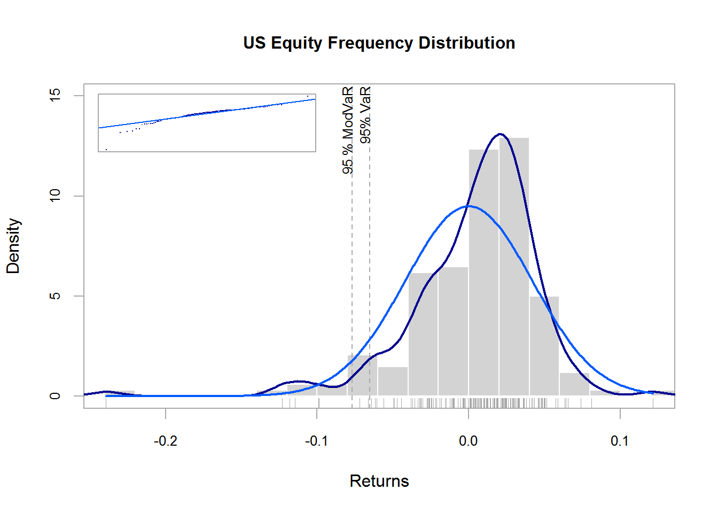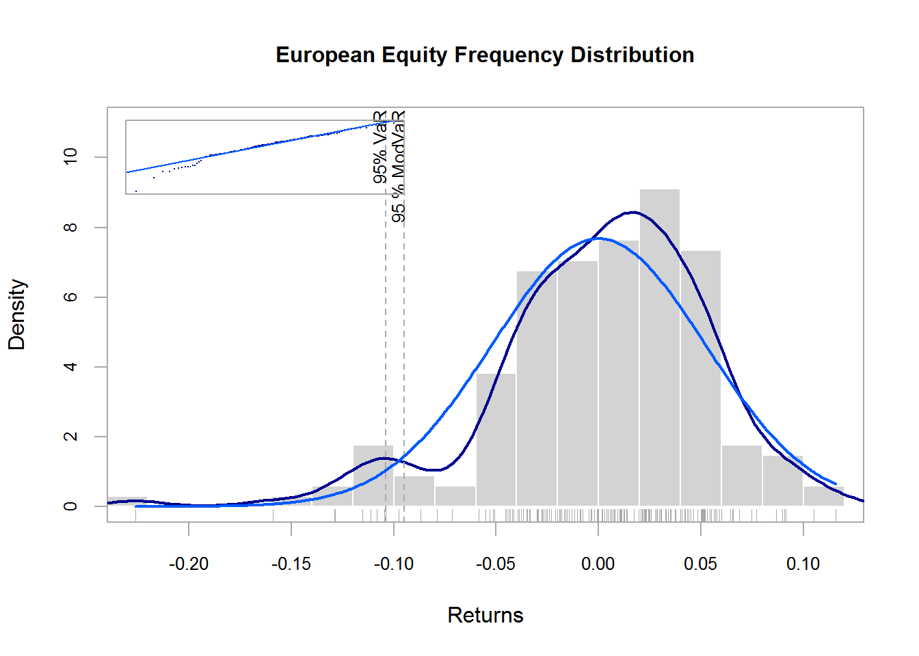

Charting Asset Classes with same Histogram Breaks to Facilitate Comparison
## [1] "histogram"
## [1] "breaks" "counts" "density" "mids" "xname" "equidist"
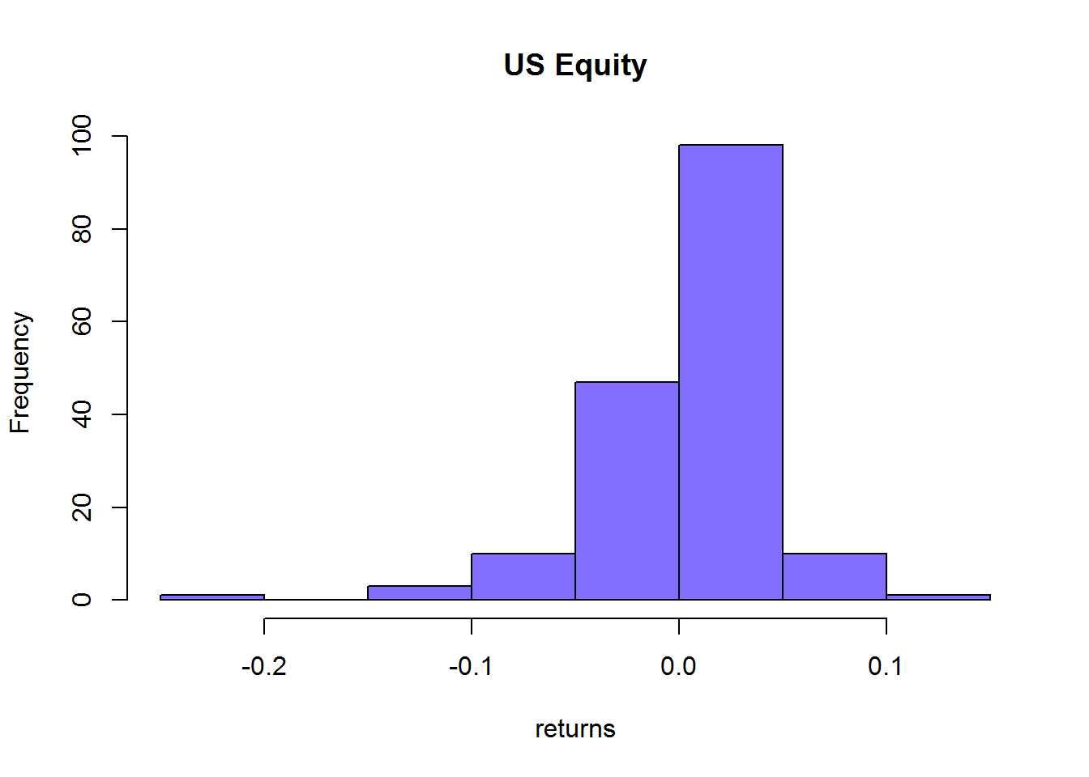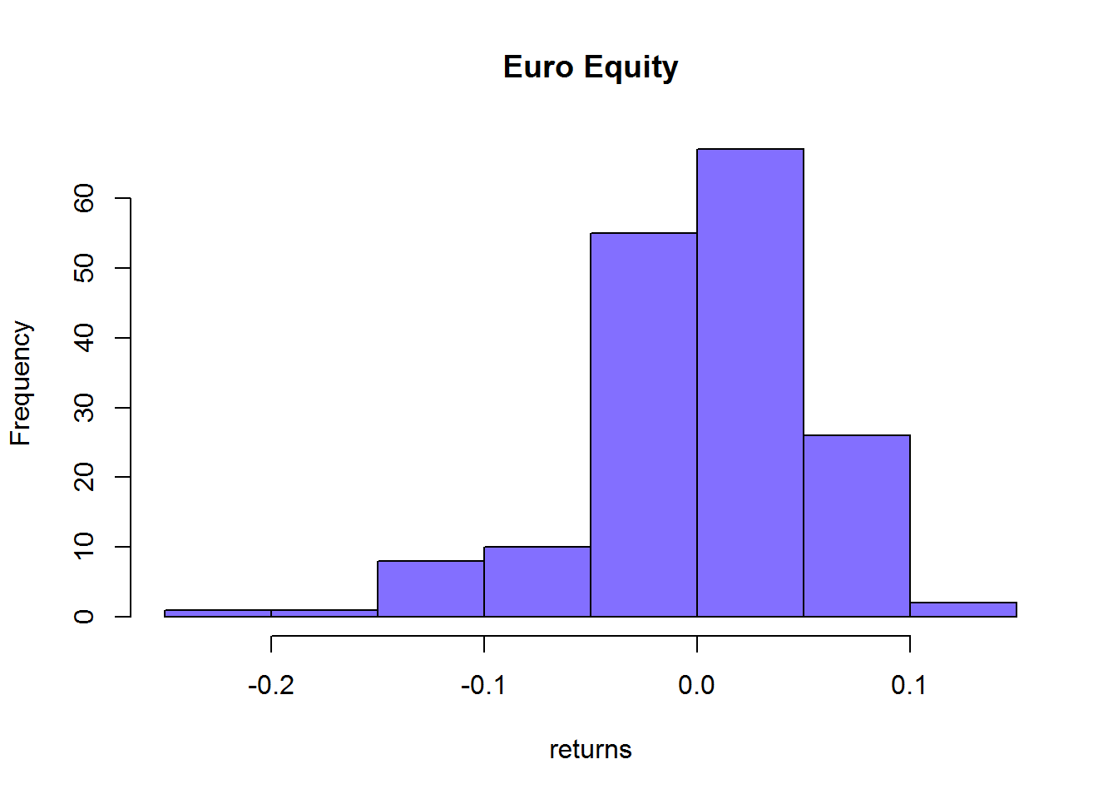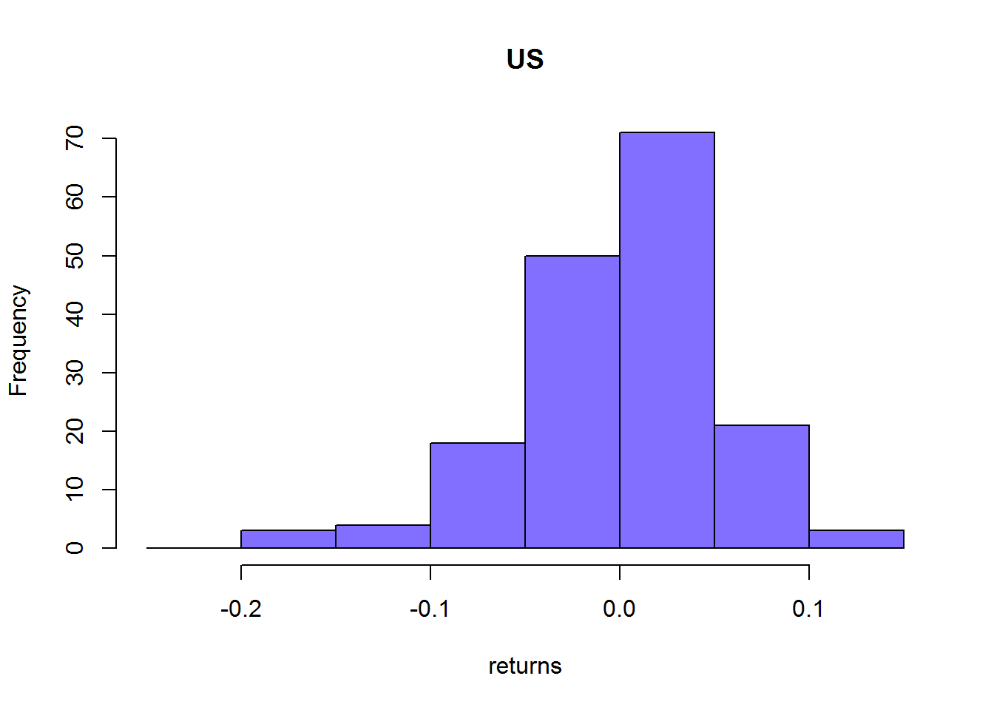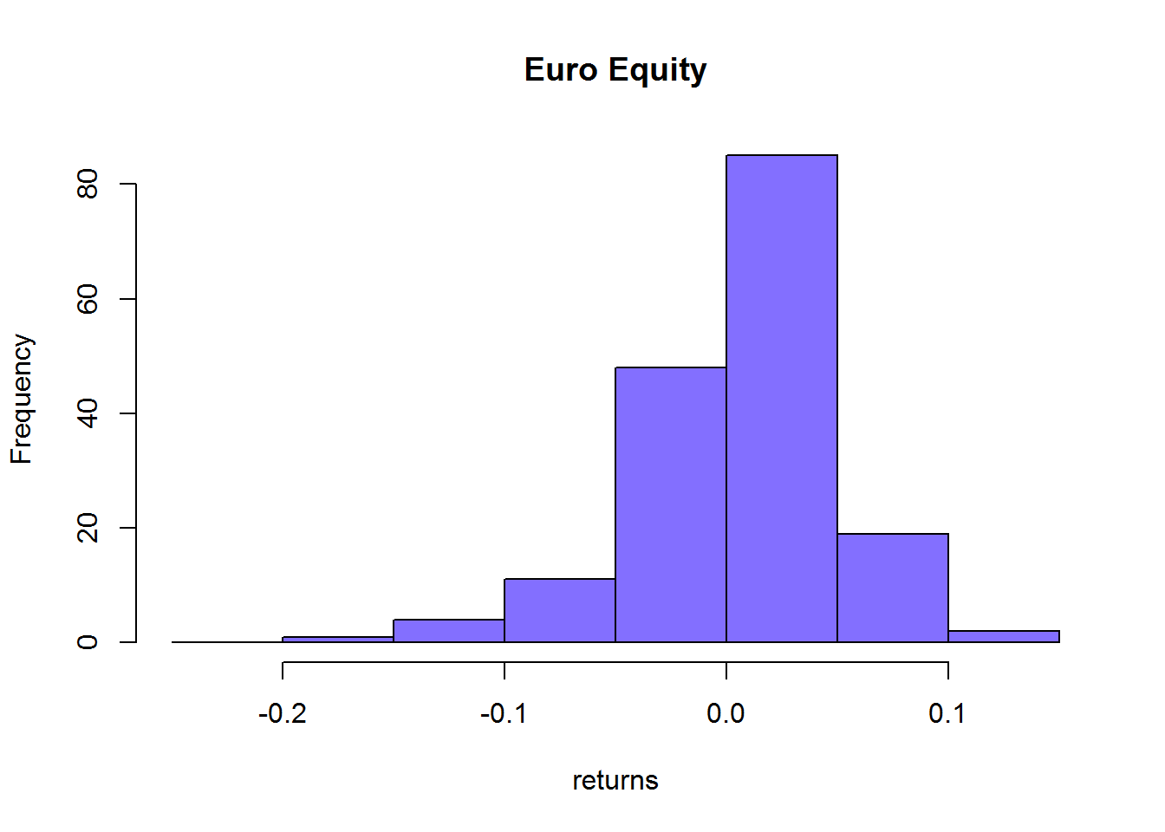

Descriptive Statistics for Each Market
US Equity
hist(m.m,main="US Equity", col="slateblue1",
probability=T, ylim=c(0,18))
market.density = density(m.m[-1])
points(market.density,type="l", col="orange", lwd=2)
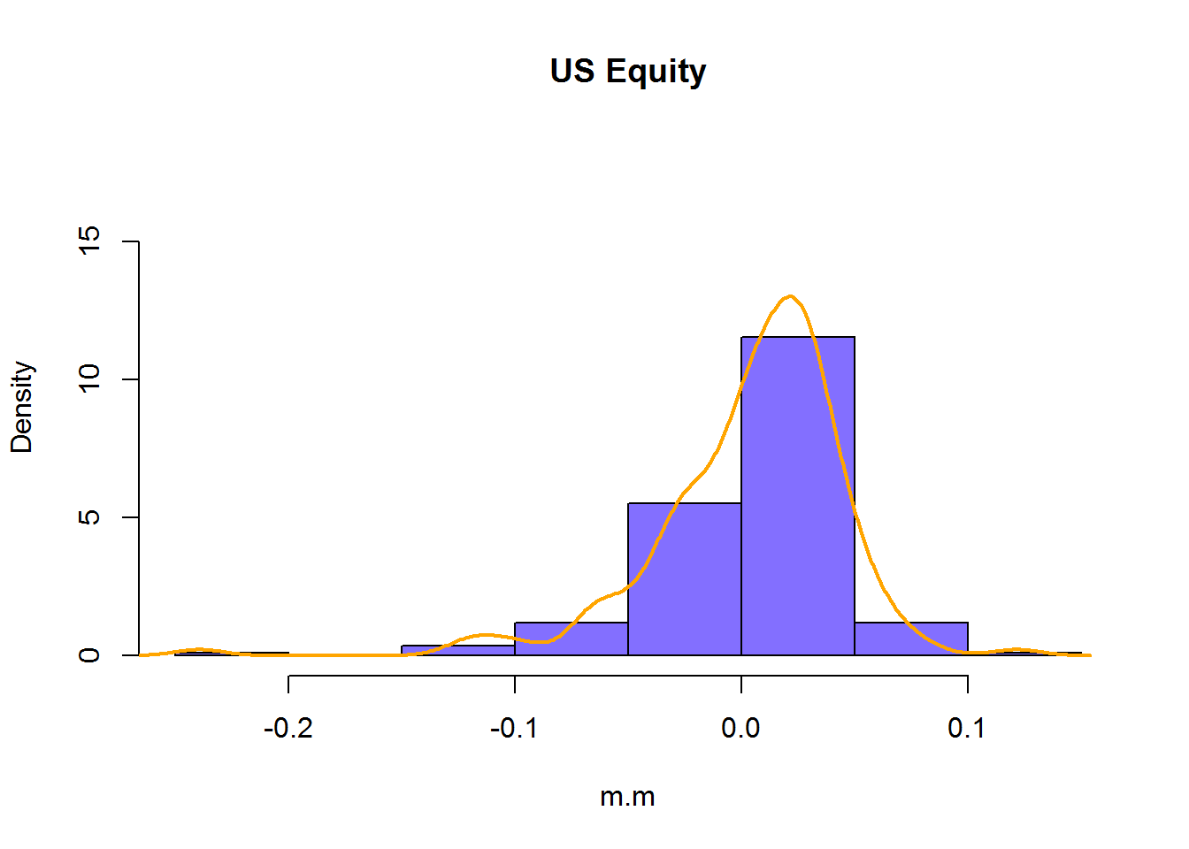
median(m.m)
## [1] 0.01196
quantile(m.m,probs=0.75) - quantile(m.m,probs=0.25)
## 75%
## 0.04457
mean(m.m)
## [1] 0.003923
var(m.m)
## mc.z
## mc.z 0.001768
sd(m.m)
## [1] 0.04205
skewness(m.m)
## [1] -1.64
## attr(,"method")
## [1] "moment"
kurtosis(m.m)
## [1] 6.445
## attr(,"method")
## [1] "excess"
min(m.m)
## [1] -0.2394
max(m.m)
## [1] 0.1215
Euro Equity
hist(e.m,main="Europe Equity", col="slateblue1",
probability=T, ylim=c(0,18))
market.density = density(e.m[-1])
points(market.density,type="l", col="orange", lwd=2)
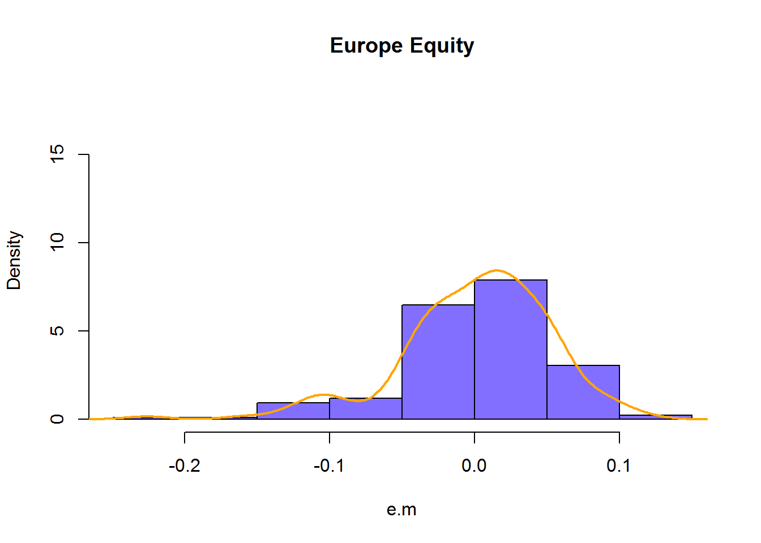
median(e.m)
## [1] 0.007262
quantile(e.m,probs=0.75) - quantile(e.m,probs=0.25)
## 75%
## 0.06186
mean(e.m)
## [1] 0.001048
var(e.m)
## ec.z
## ec.z 0.002699
sd(e.m)
## [1] 0.05195
skewness(e.m)
## [1] -0.9227
## attr(,"method")
## [1] "moment"
kurtosis(e.m)
## [1] 1.906
## attr(,"method")
## [1] "excess"
min(e.m)
## [1] -0.2261
max(e.m)
## [1] 0.1157

Box Plots and Scatter Plots
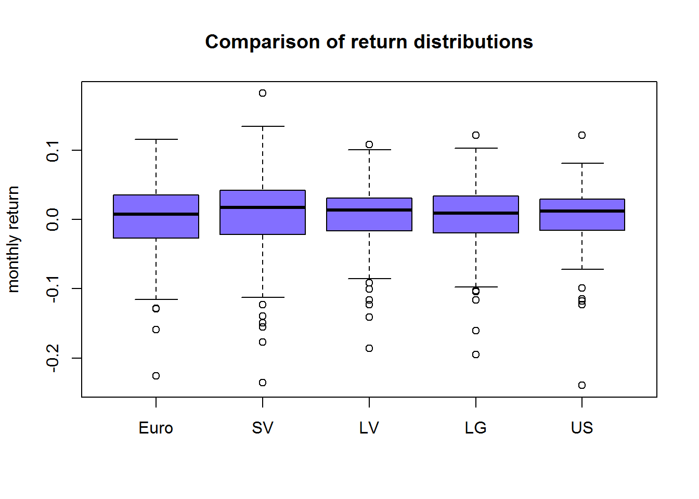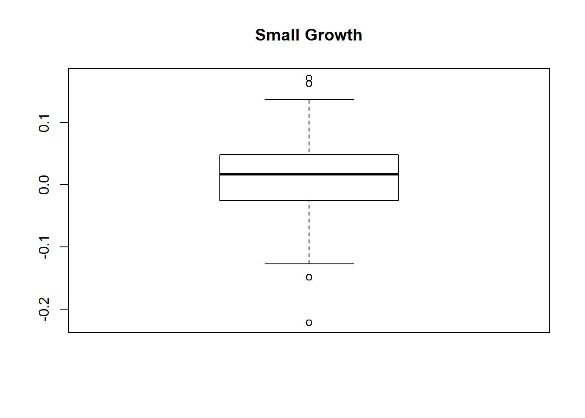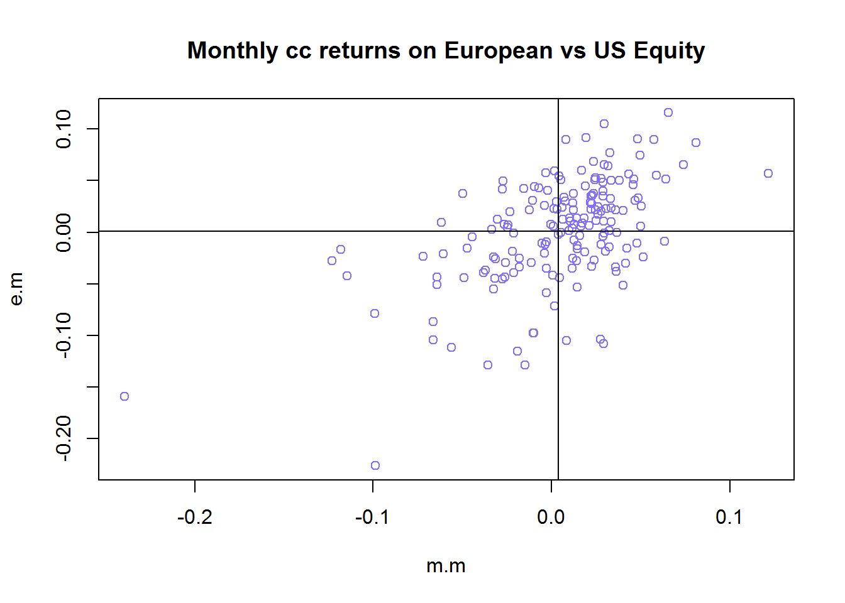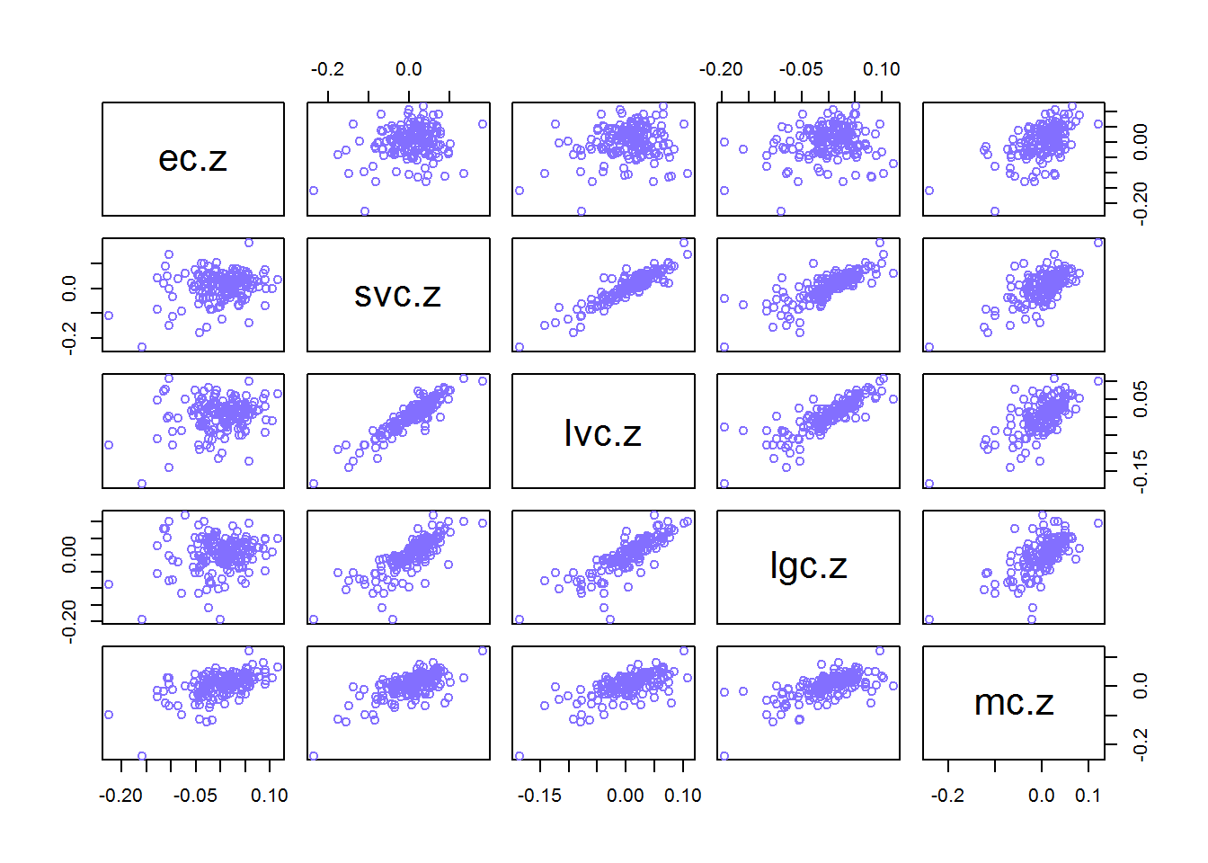
correlations look stronger between small and growth and value stocks and between large growth and value stocks. The MSCI has poor correlation with all, suggesting less integration.

Comparing the Market Return with that of an IDD Gaussian Distribution with the same Mean and SD as US Equity
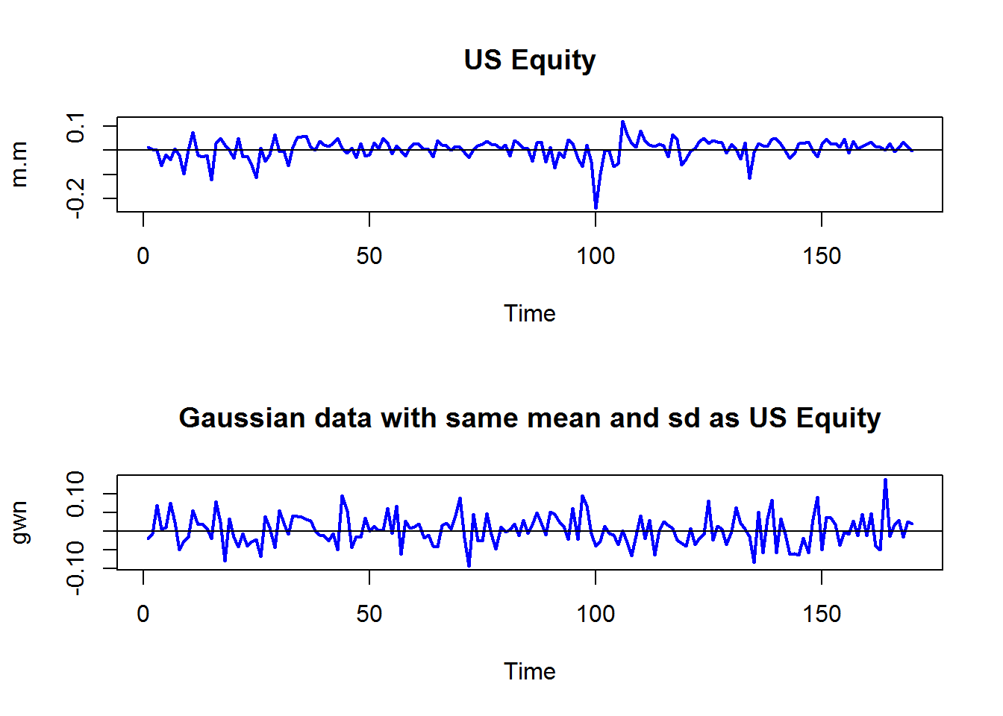
US data seems more clustered around the mean with large infrequent outliers

Comparing the Cumulative Distribution of the standardized US data with a normal distribution
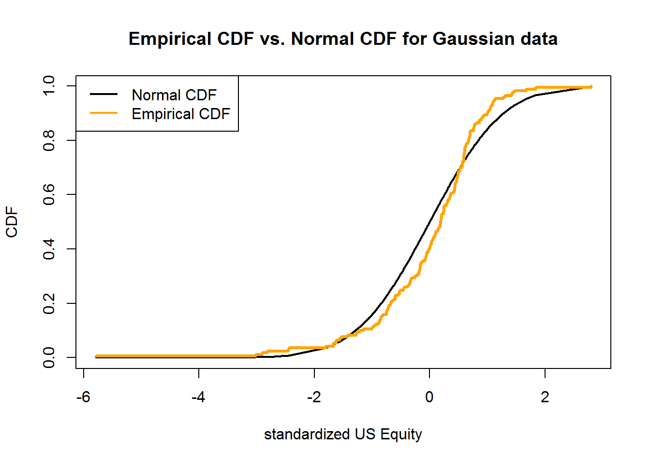
the CDF comparison suggests thicker tails for the market
## 1% 5%
## -0.11958 -0.06528
## [1] -0.09389 -0.06524
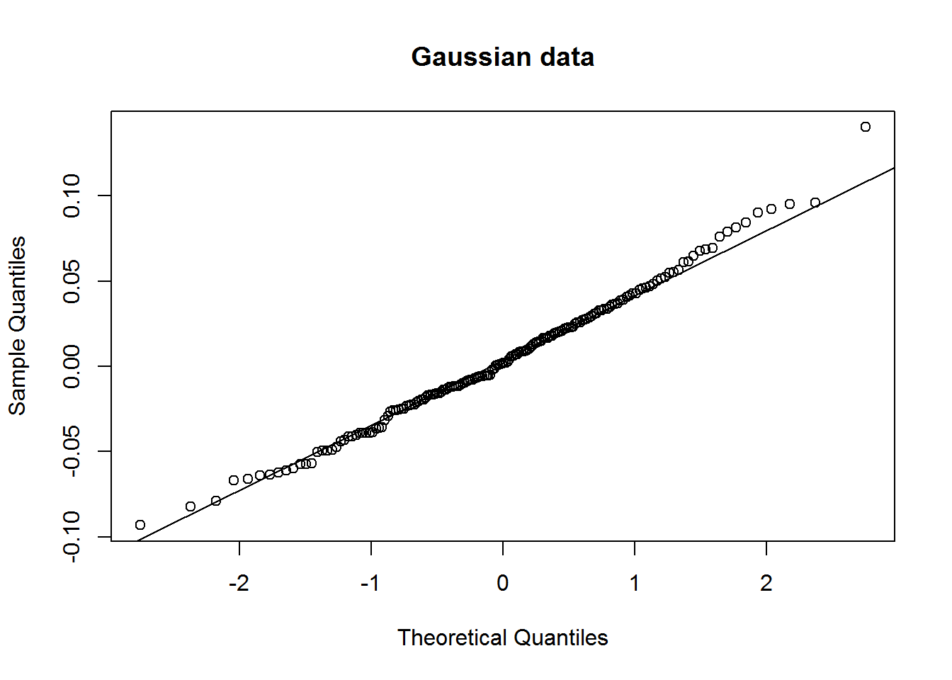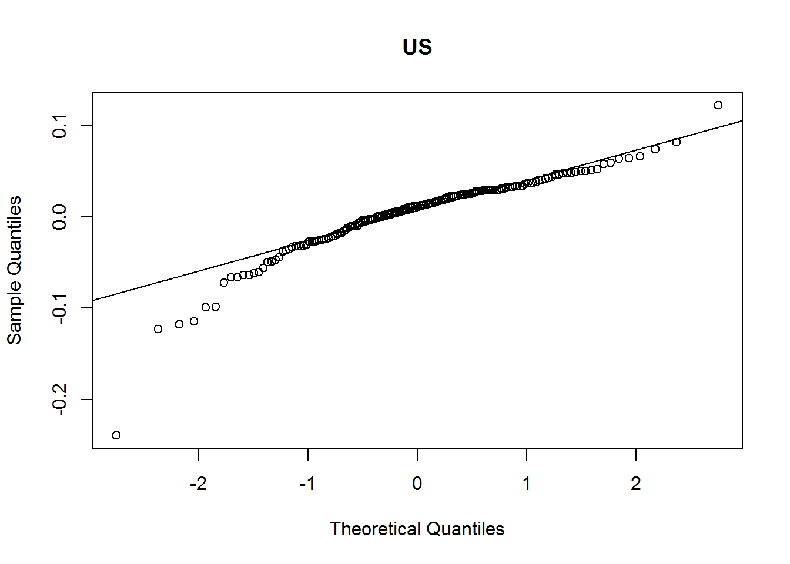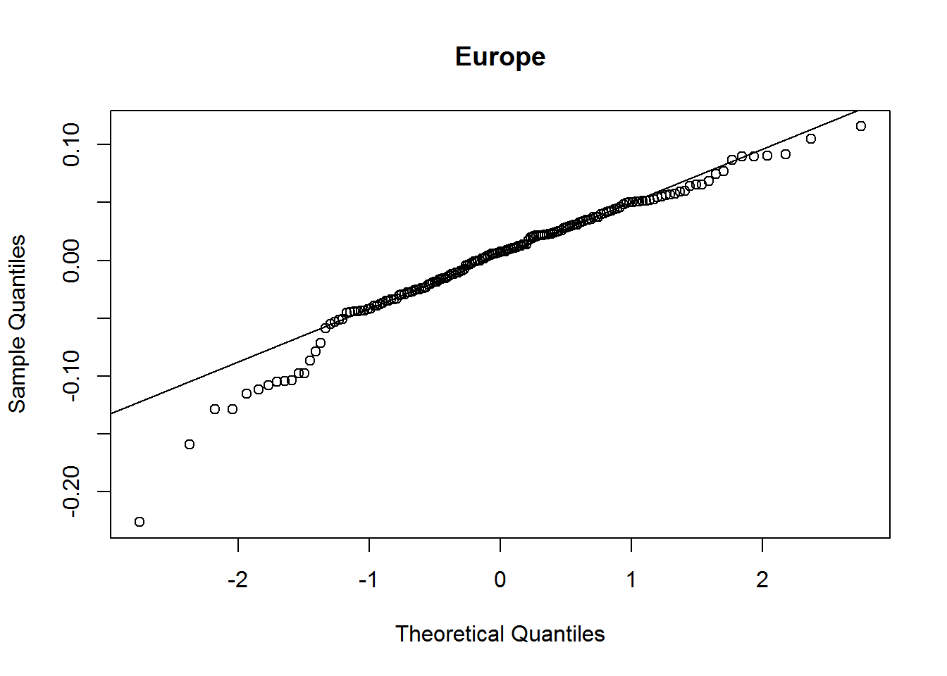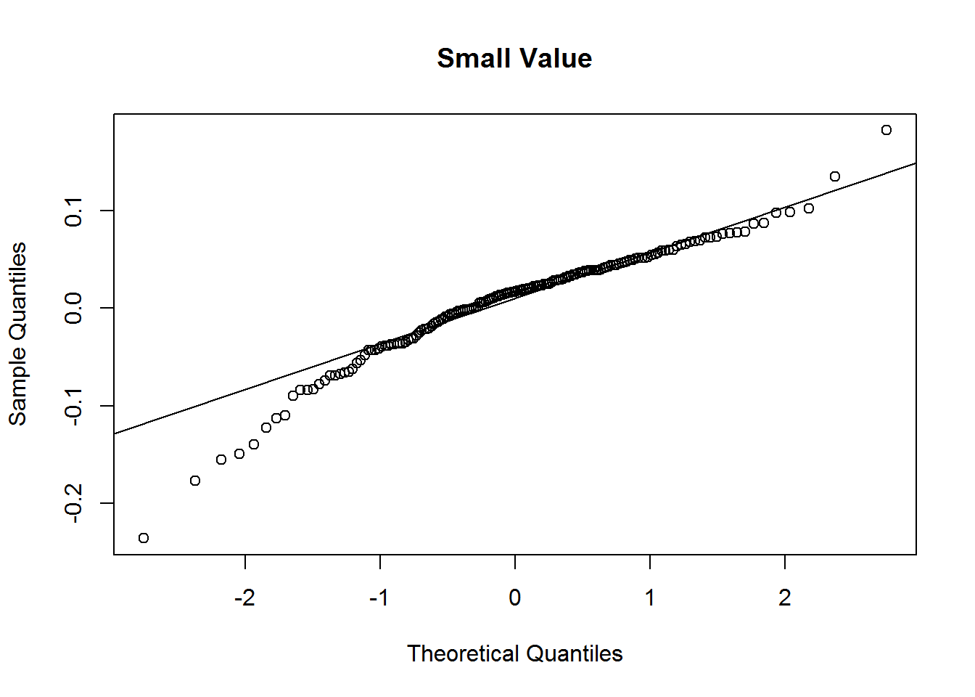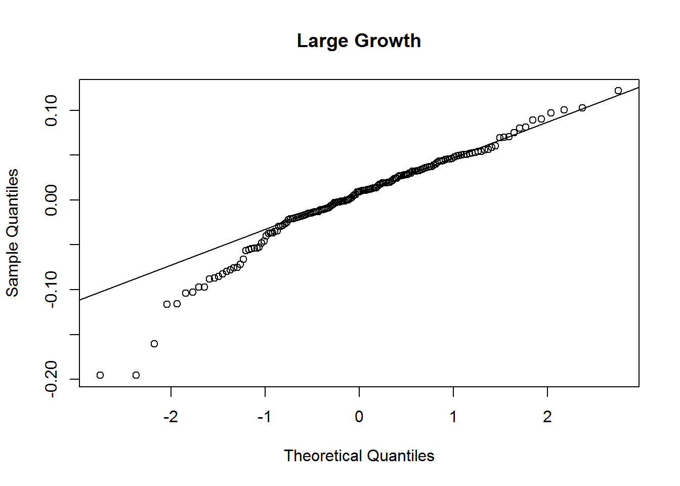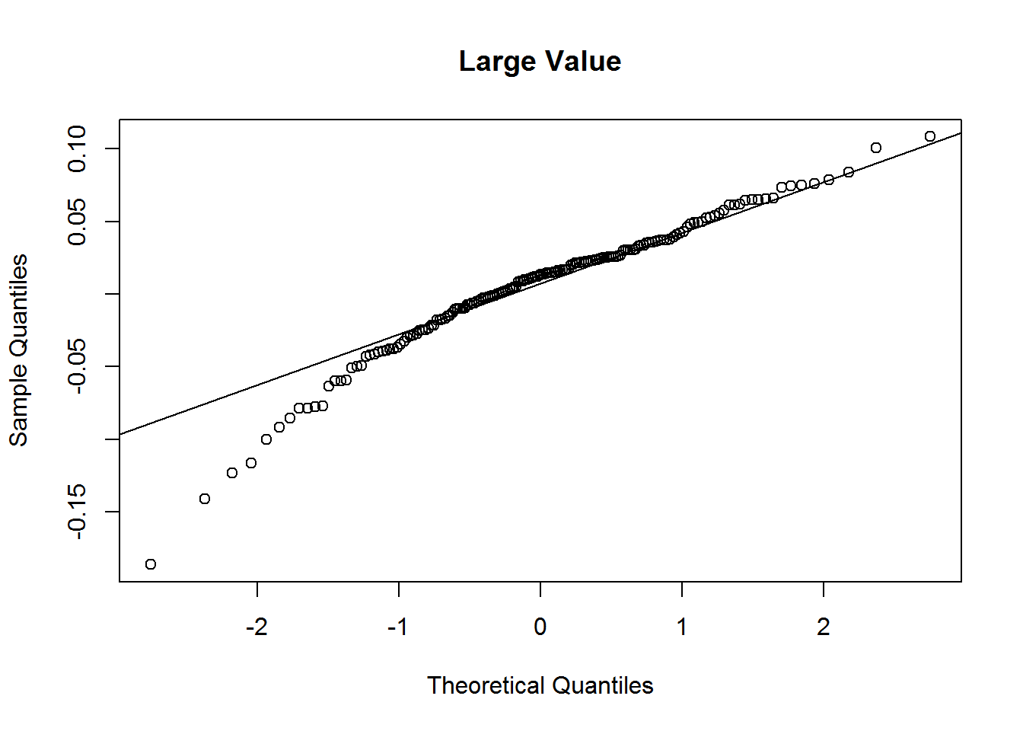

Constant Expected Return (CER) Model Calibrated to monthly market return
mu = mean(m.m)
sd.e = sd(m.m)
nobs = 170
set.seed(114)
sim.e = rnorm(nobs, mean=0, sd=sd.e)
sim.ret = mu + sim.e
boxplot(cbind(m.m,sim.ret,gwn), names=c("US","CER","GWN"))
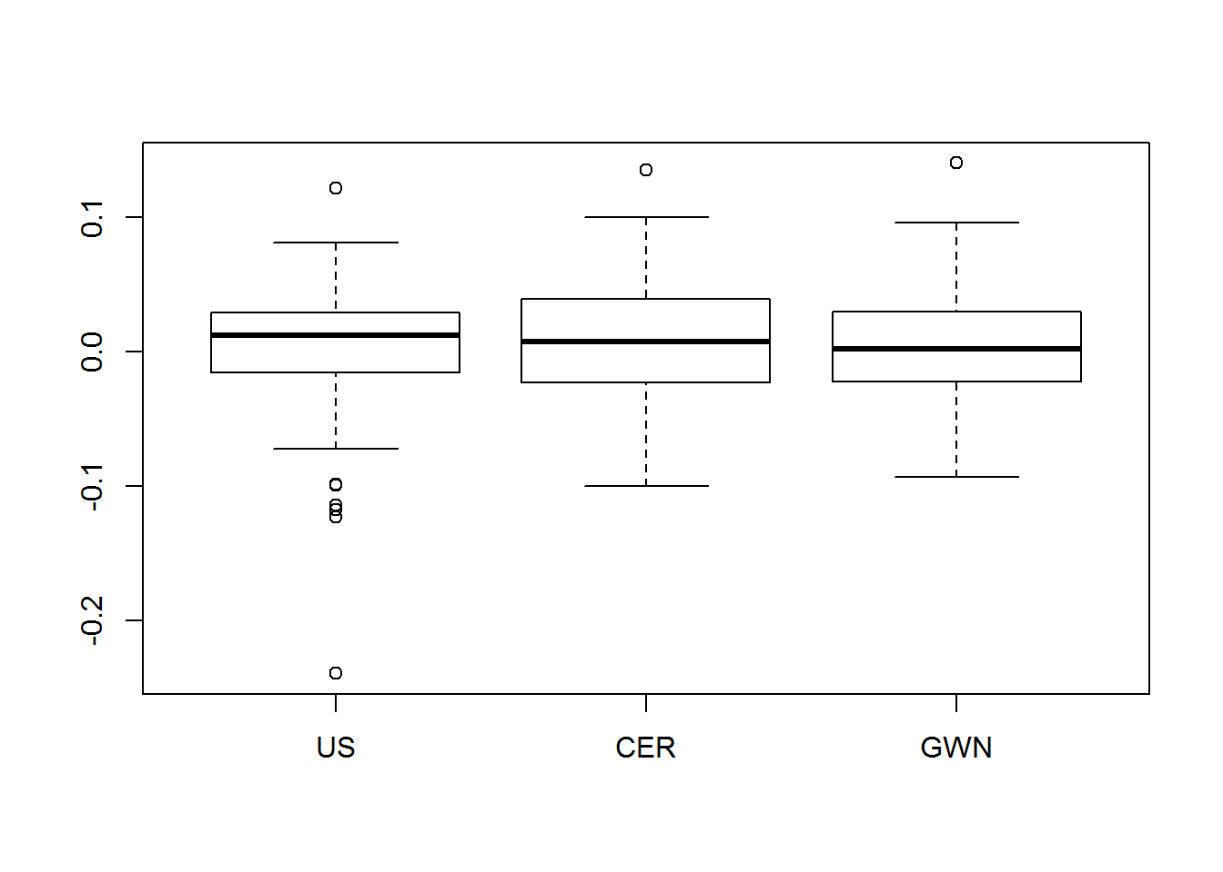

Comparing Market Return with the Random Walk Model, controlling for SD of errors and Mean of return
mu = mean(m.m)
sd.e = sd(m.m)
nobs = 170
set.seed(132)
sim.e = rnorm(nobs, mean=0, sd=sd.e)
sim.p = 1 + mu*seq(nobs) + cumsum(sim.e)
sim.P = exp(sim.p)
par(mfrow=c(2,1),mar=rep(2,4))
ts.plot(sim.p, col="blue",lwd=2,
ylim=c(-1, 2.5), ylab="log price")
lines( (1+mu*seq(nobs)), lty="dotted", col="black", lwd=2)
lines(cumsum(sim.e), col="orange", lty="dashed", lwd=2)
abline(h=0)
legend(x="topleft",legend=c("p(t)","E[p(t)]","p(t)-E[p(t)]"),
lty=c("solid","dotted","dashed"), col=c("blue","black","orange"),
lwd=2, cex=c(0.75,0.75,0.75))
ts.plot(sim.P, lwd=2, col="blue", ylab="price")
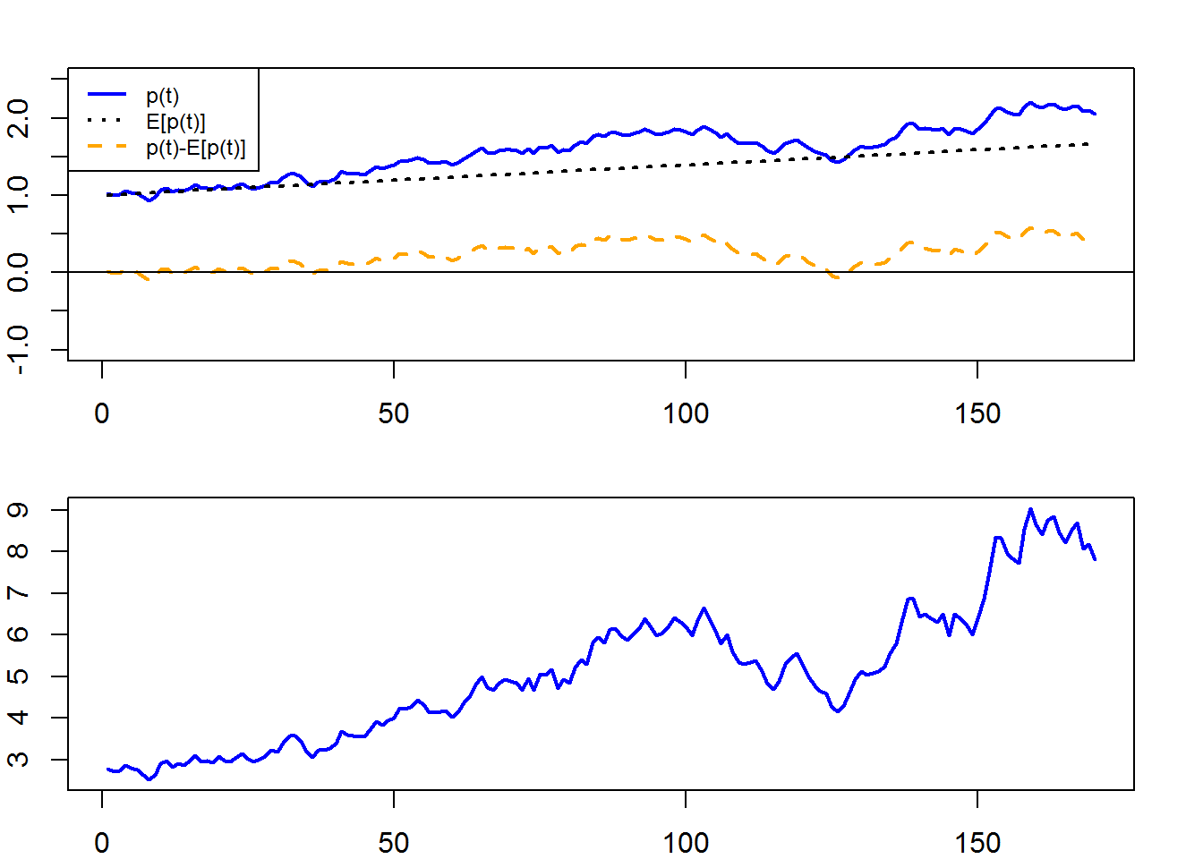
boxplot(cbind(sim.e,m.m), lwd=2, col=c("green","yellow"), names=c("random walk","market"),ylab="price")
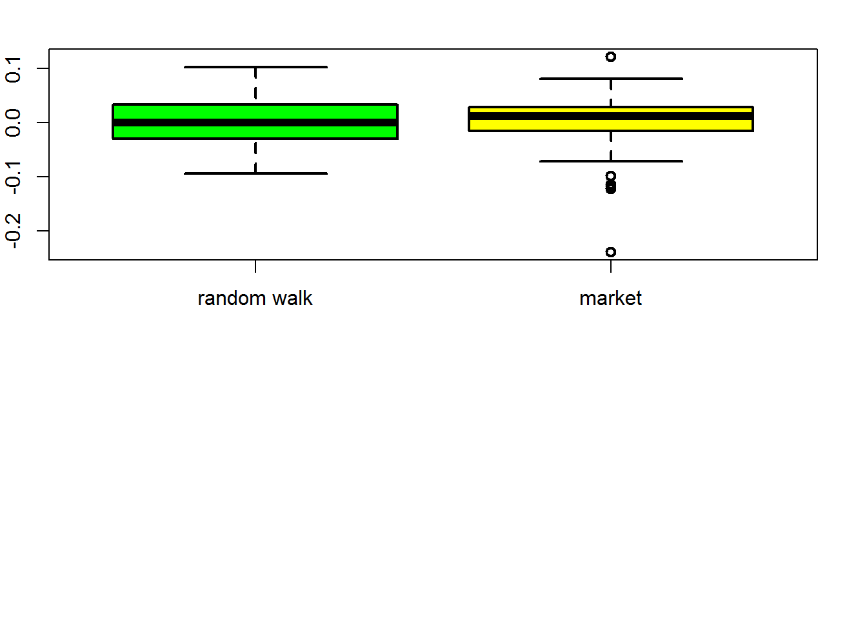

Computing means, variances and covariances
Mean
## ec.z svc.z lvc.z lgc.z mc.z
## 0.001048 0.006850 0.005546 0.001375 0.003923
Variance
## ec.z svc.z lvc.z lgc.z mc.z
## 0.002699 0.003253 0.002001 0.002699 0.001768
Standard Deviation
## ec.z svc.z lvc.z lgc.z mc.z
## 0.05195 0.05704 0.04474 0.05195 0.04205
Covariance Matrix
## ec.z svc.z lvc.z lgc.z mc.z
## ec.z 0.0026986 0.0006631 0.0004645 0.0004704 0.001199
## svc.z 0.0006631 0.0032531 0.0023290 0.0023509 0.001652
## lvc.z 0.0004645 0.0023290 0.0020015 0.0019258 0.001274
## lgc.z 0.0004704 0.0023509 0.0019258 0.0026992 0.001442
## mc.z 0.0011989 0.0016523 0.0012743 0.0014422 0.001768
Correlation Matrix
## ec.z svc.z lvc.z lgc.z mc.z
## ec.z 1.0000 0.2238 0.1999 0.1743 0.5489
## svc.z 0.2238 1.0000 0.9128 0.7934 0.6890
## lvc.z 0.1999 0.9128 1.0000 0.8286 0.6775
## lgc.z 0.1743 0.7934 0.8286 1.0000 0.6602
## mc.z 0.5489 0.6890 0.6775 0.6602 1.0000

Estimated standard error for mean and Confidence Intervals for the mean
## muhat.vals se.muhat tratios
## ec.z 0.001048 0.003984 0.2632
## svc.z 0.006850 0.004374 1.5660
## lvc.z 0.005546 0.003431 1.6164
## lgc.z 0.001375 0.003985 0.3451
## mc.z 0.003923 0.003225 1.2165
in some cases the se of the mean is even bigger than the mean itself! (in large growth)

compute exact 95% confidence intervals
t.975 = qt(0.975, df=99)
mu.lower = muhat.vals - t.975*se.muhat
mu.upper = muhat.vals + t.975*se.muhat
mu.width = mu.upper - mu.lower
cbind(mu.lower,mu.upper,mu.width)
## mu.lower mu.upper mu.width
## ec.z -0.006857 0.008954 0.01581
## svc.z -0.001829 0.015530 0.01736
## lvc.z -0.001262 0.012354 0.01362
## lgc.z -0.006531 0.009282 0.01581
## mc.z -0.002476 0.010322 0.01280
The Standard Error for the mean values are very big when compared to the mean values, indicating very low estimation precision

compute estimated standard error for Variance and Standard Deviation
se.sigma2hat = sigma2hat.vals/sqrt(nobs/2)
se.sigmahat = sigmahat.vals/sqrt(2*nobs)
cbind(sigma2hat.vals,se.sigma2hat)
## sigma2hat.vals se.sigma2hat
## ec.z 0.002699 0.0002927
## svc.z 0.003253 0.0003528
## lvc.z 0.002001 0.0002171
## lgc.z 0.002699 0.0002928
## mc.z 0.001768 0.0001918
cbind(sigmahat.vals,se.sigmahat)
## sigmahat.vals se.sigmahat
## ec.z 0.05195 0.002817
## svc.z 0.05704 0.003093
## lvc.z 0.04474 0.002426
## lgc.z 0.05195 0.002818
## mc.z 0.04205 0.002280
# compute approx 95% confidence intervals
sigma2.lower = sigma2hat.vals - 2*se.sigma2hat
sigma2.upper = sigma2hat.vals + 2*se.sigma2hat
sigma2.width = sigma2.upper - sigma2.lower
cbind(sigma2.lower,sigma2.upper,sigma2.width)
## sigma2.lower sigma2.upper sigma2.width
## ec.z 0.002113 0.003284 0.0011708
## svc.z 0.002547 0.003959 0.0014114
## lvc.z 0.001567 0.002436 0.0008684
## lgc.z 0.002114 0.003285 0.0011711
## mc.z 0.001384 0.002151 0.0007670
sigma.lower = sigmahat.vals - 2*se.sigmahat
sigma.upper = sigmahat.vals + 2*se.sigmahat
sigma.width = sigma.upper - sigma.lower
cbind(sigma.lower,sigma.upper,sigma.width)
## sigma.lower sigma.upper sigma.width
## ec.z 0.04631 0.05758 0.011269
## svc.z 0.05085 0.06322 0.012373
## lvc.z 0.03989 0.04959 0.009705
## lgc.z 0.04632 0.05759 0.011270
## mc.z 0.03749 0.04661 0.009121

compute estimated standard error for Correlation
se.rhohat = (1-rhohat.vals^2)/sqrt(nobs)
cbind(rhohat.vals,se.rhohat)
## rhohat.vals se.rhohat
## sve 0.2238 0.07286
## lve 0.1999 0.07363
## lge 0.1743 0.07437
## me 0.5489 0.05359
## lvsv 0.9128 0.01280
## lgsv 0.7934 0.02842
## msv 0.6890 0.04029
## lvlg 0.8286 0.02404
## lvm 0.6775 0.04150
## lgm 0.6602 0.04327
# compute approx 95% confidence intervals
rho.lower = rhohat.vals - 2*se.rhohat
rho.upper = rhohat.vals + 2*se.rhohat
rho.width = rho.upper - rho.lower
cbind(rho.lower,rho.upper,rho.width)
## rho.lower rho.upper rho.width
## sve 0.07809 0.3695 0.29142
## lve 0.05262 0.3471 0.29453
## lge 0.02557 0.3230 0.29747
## me 0.44173 0.6561 0.21435
## lvsv 0.88715 0.9384 0.05120
## lgsv 0.73651 0.8502 0.11369
## msv 0.60844 0.7696 0.16114
## lvlg 0.78048 0.8766 0.09617
## lvm 0.59446 0.7604 0.16599
## lgm 0.57367 0.7467 0.17307
SE for Variance, Standard Deviation and correlation are much lower, indicating higher precision

show risk return tradeoffs
cex.val = 1
plot(sigmahat.vals, muhat.vals, ylim=c(0, 0.04), xlim=c(0, 0.20), ylab=expression(mu[p]),
xlab=expression(sigma[p]), pch=16, col="blue", cex=2.5, cex.lab=1.75)
text(sigmahat.vals, muhat.vals, labels=names(muhat.vals), pos=4, cex = cex.val)
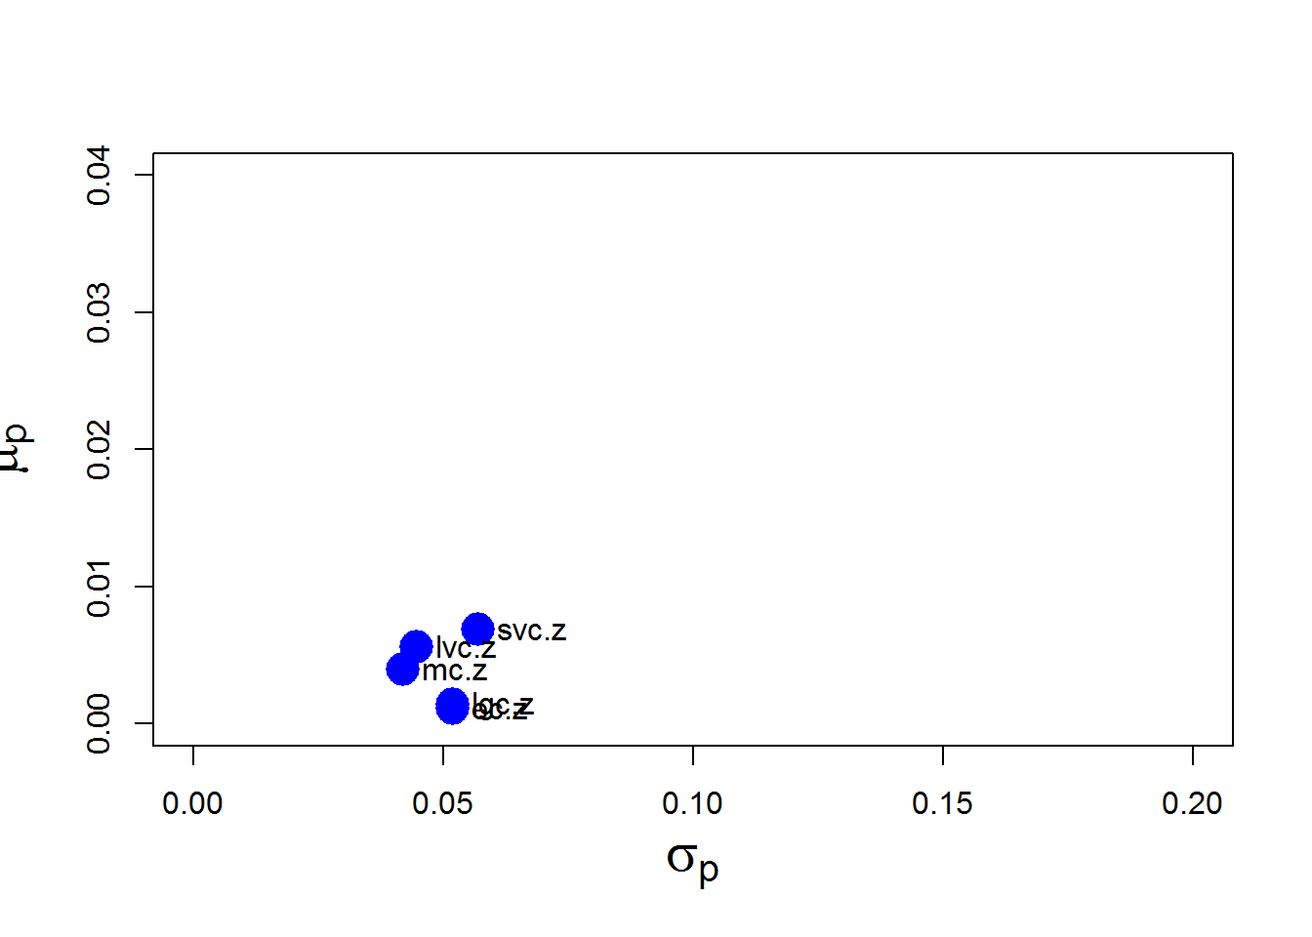 A clear tradeoff between risk and return is unclear for the period. The Will 5000 index is inferior to all other choices

Portfolio Construction and Optimization

compute equally weighted portfolio of four asset classes
## Call:
## getPortfolio(er = er, cov.mat = ecov, weights = ew)
##
## Portfolio expected return: 0.009189
## Portfolio standard deviation: 0.03622
## Portfolio weights:
## ec.z svc.z lvc.z lgc.z
## 0.25 0.25 0.25 0.25
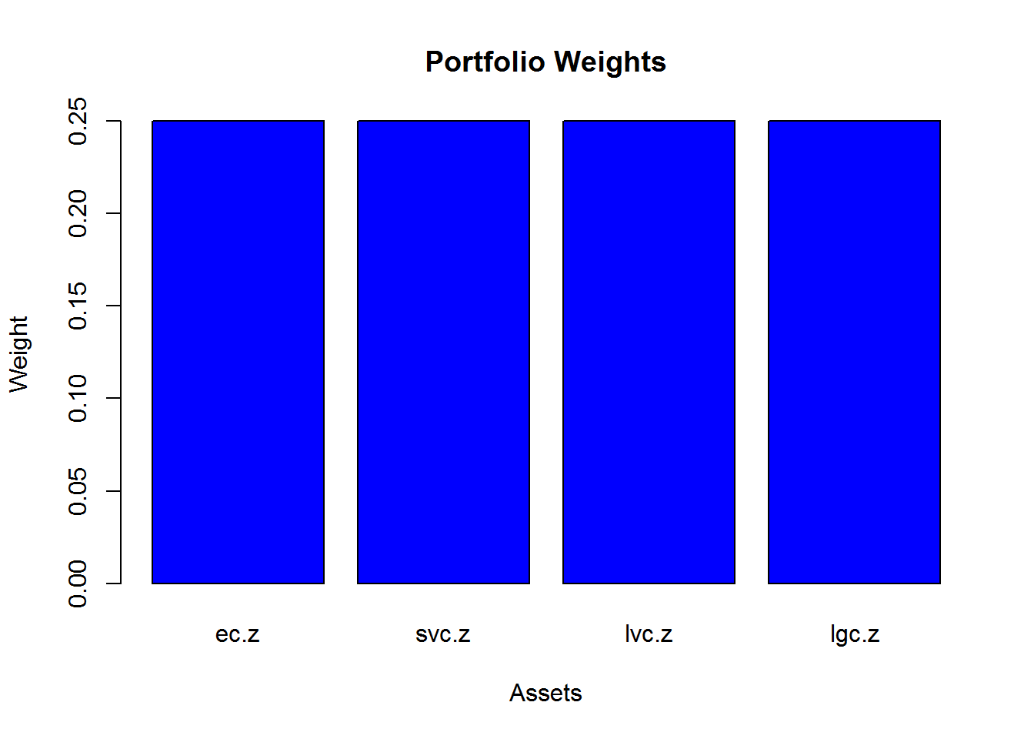

compute global minimum variance portfolio with shorts allowed
## Call:
## globalMin.portfolio(er = er, cov.mat = ecov)
##
## Portfolio expected return: 0.007515
## Portfolio standard deviation: 0.03061
## Portfolio Sharpe Ratio: 0.2095
## Portfolio weights:
## ec.z svc.z lvc.z lgc.z
## 0.3483 -0.6508 1.0566 0.2459
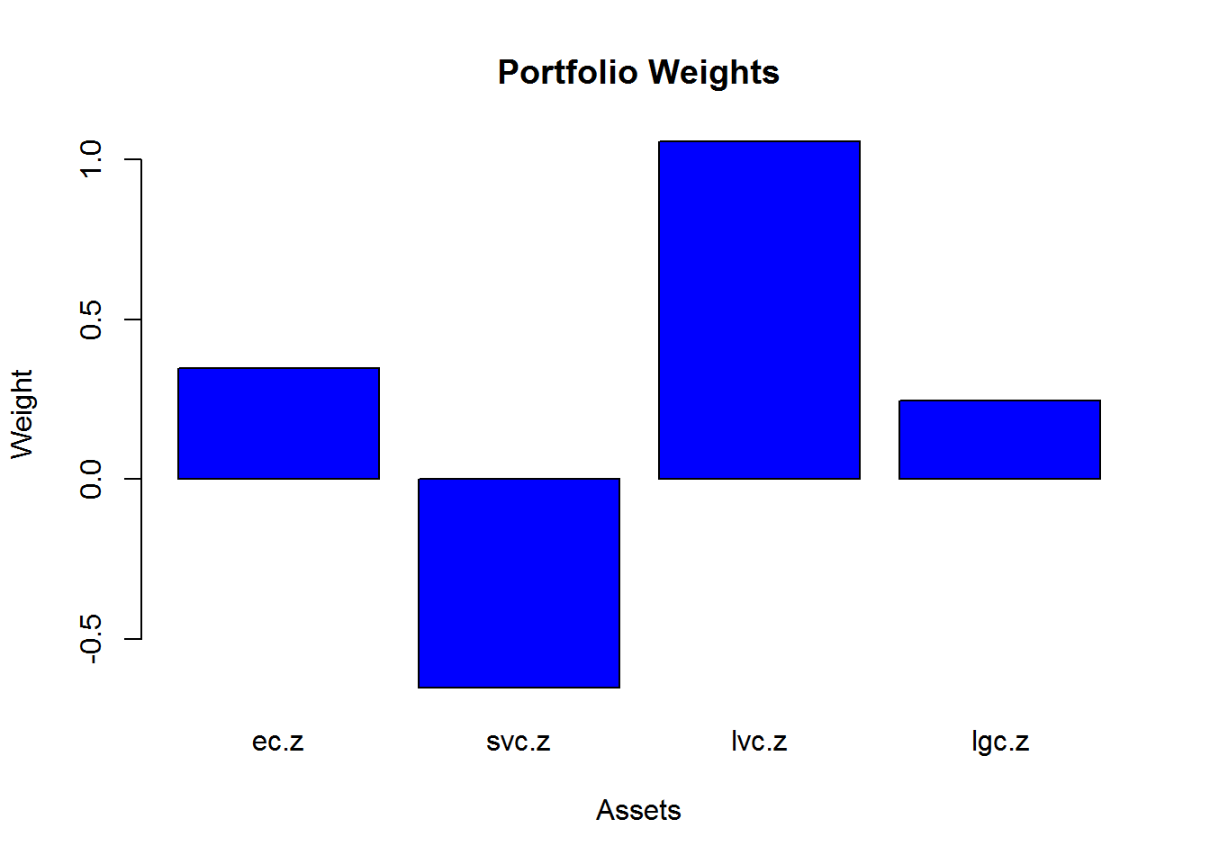

compute global minimum variance portfolio with shorts not allowed
## Call:
## globalMin.portfolio(er = er, cov.mat = ecov, shorts = FALSE)
##
## Portfolio expected return: 0.008166
## Portfolio standard deviation: 0.03291
## Portfolio Sharpe Ratio: 0.2147
## Portfolio weights:
## ec.z svc.z lvc.z lgc.z
## 0.3875 0.0000 0.4575 0.1550
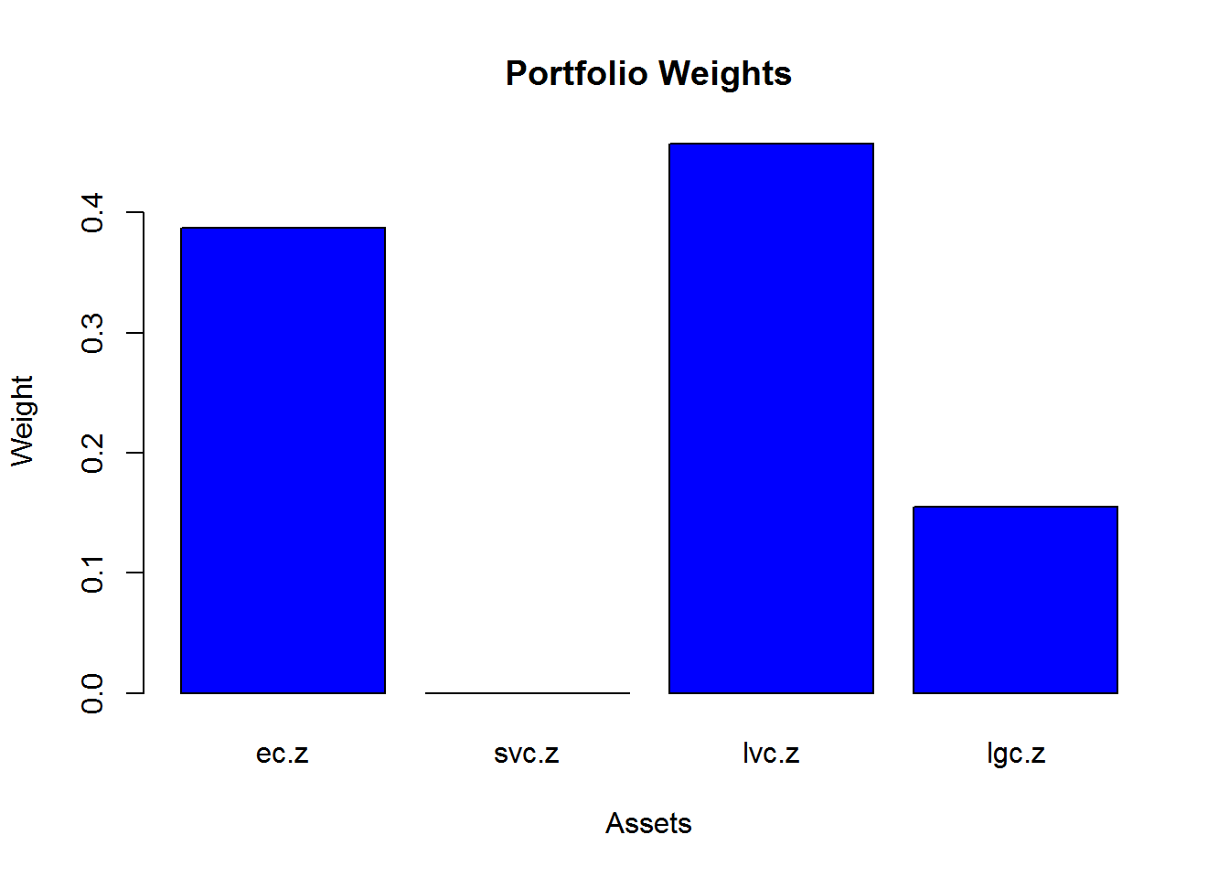

compute efficient portfolio subject to target return equal to mean return of the Small Value Asset Class
## Call:
## efficient.portfolio(er = er, cov.mat = ecov, target.return = target.return)
##
## Portfolio expected return: 0.01191
## Portfolio standard deviation: 0.04727
## Portfolio Sharpe Ratio: 0.2287
## Portfolio weights:
## ec.z svc.z lvc.z lgc.z
## -0.0365 0.2044 1.4469 -0.6148
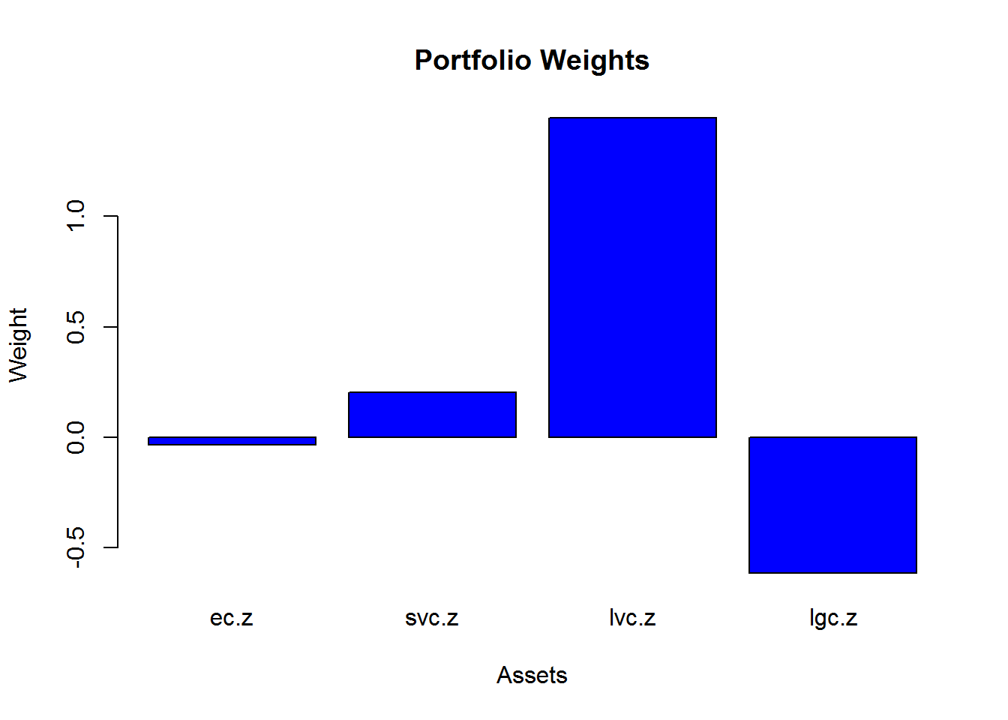

compute efficient portfolio subject to target return with no short sales
## Call:
## efficient.portfolio(er = er, cov.mat = ecov, target.return = target.return,
## shorts = FALSE)
##
## Portfolio expected return: 0.01191
## Portfolio standard deviation: 0.05167
## Portfolio Sharpe Ratio: 0.2092
## Portfolio weights:
## ec.z svc.z lvc.z lgc.z
## 0 1 0 0
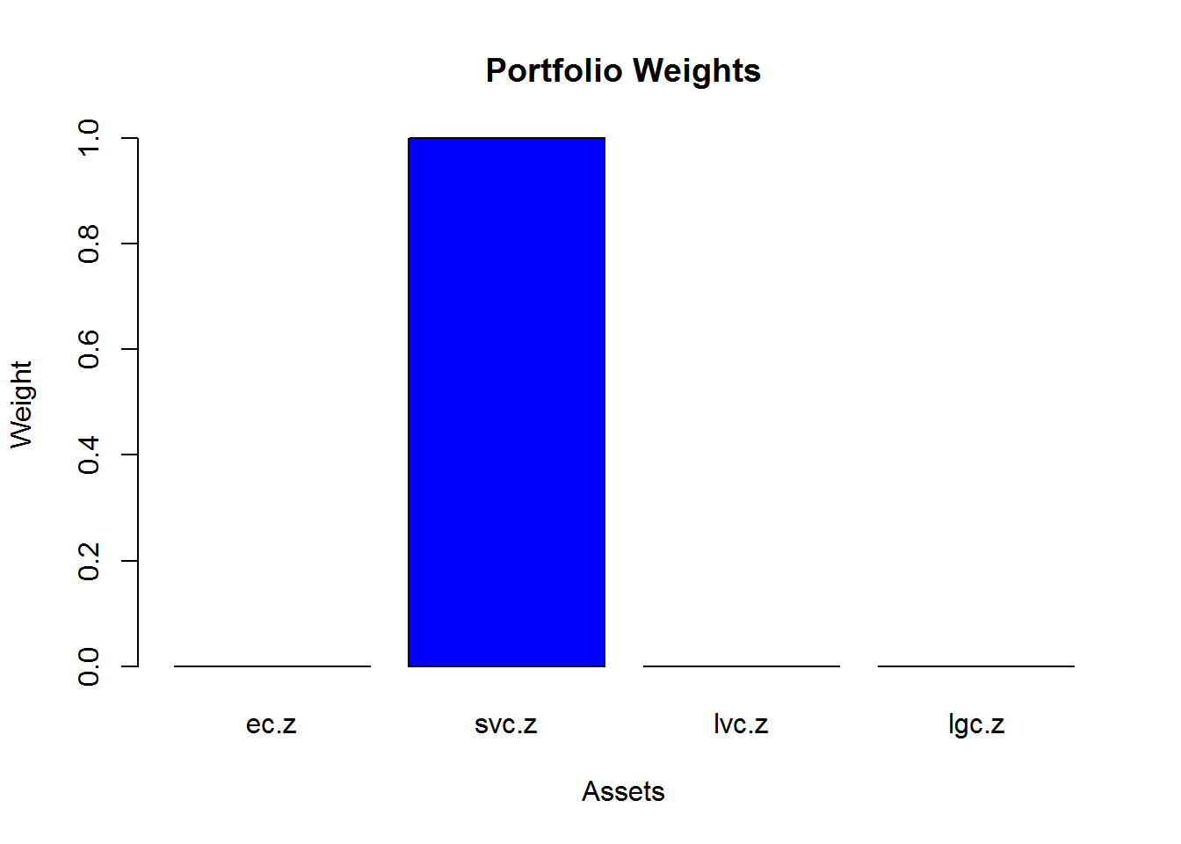

compute tangency portfolio
## Call:
## tangency.portfolio(er = er, cov.mat = ecov, risk.free = r.free)
##
## Portfolio expected return: 0.009689
## Portfolio standard deviation: 0.03542
## Portfolio weights:
## ec.z svc.z lvc.z lgc.z
## 0.1579 -0.2276 1.2498 -0.1800
## Call:
## tangency.portfolio(er = er, cov.mat = ecov, risk.free = r.free)
##
## Portfolio expected return: 0.009689
## Portfolio standard deviation: 0.03542
## Portfolio Sharpe Ratio: 0.2425
## Portfolio weights:
## ec.z svc.z lvc.z lgc.z
## 0.1579 -0.2276 1.2498 -0.1800
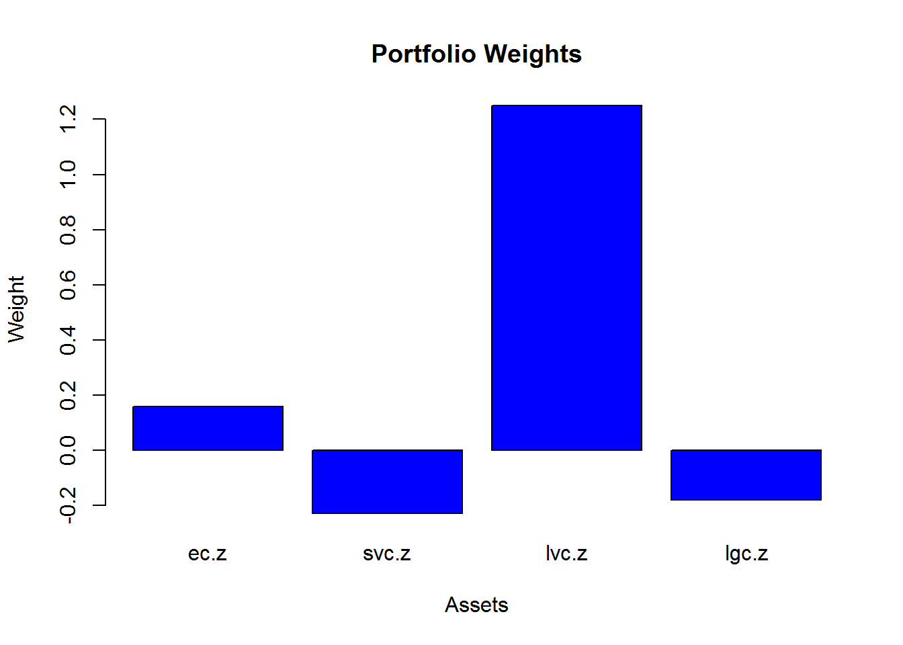

compute tangency portfolio with no short sales
## Call:
## tangency.portfolio(er = er, cov.mat = ecov, risk.free = r.free,
## shorts = FALSE)
##
## Portfolio expected return: 0.009747
## Portfolio standard deviation: 0.03617
## Portfolio Sharpe Ratio: 0.2391
## Portfolio weights:
## ec.z svc.z lvc.z lgc.z
## 0.158 0.000 0.842 0.000
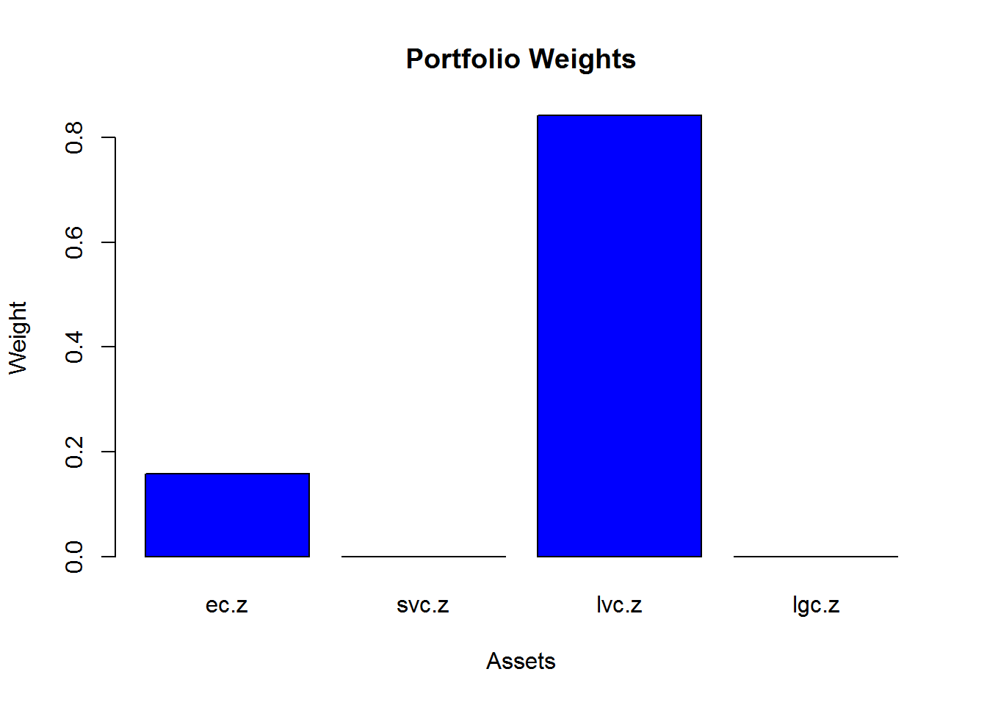

compute efficient frontier
## $names
## [1] "call" "er" "sd" "weights"
##
## $class
## [1] "Markowitz"
## Call:
## efficient.frontier(er = er, cov.mat = ecov, nport = 20, alpha.min = -2,
## alpha.max = 1.5)
##
## Frontier portfolios' expected returns and standard deviations
## port 1 port 2 port 3 port 4 port 5 port 6 port 7 port 8 port 9 port 10
## ER 0.0207 0.0199 0.0191 0.0183 0.0175 0.0166 0.0158 0.0150 0.0142 0.0134
## SD 0.1123 0.1059 0.0996 0.0933 0.0871 0.0809 0.0748 0.0688 0.0629 0.0572
## port 11 port 12 port 13 port 14 port 15 port 16 port 17 port 18 port 19
## ER 0.0126 0.0118 0.0110 0.0102 0.0094 0.0086 0.0077 0.0069 0.0061
## SD 0.0517 0.0465 0.0418 0.0376 0.0342 0.0318 0.0307 0.0310 0.0327
## port 20
## ER 0.0053
## SD 0.0355
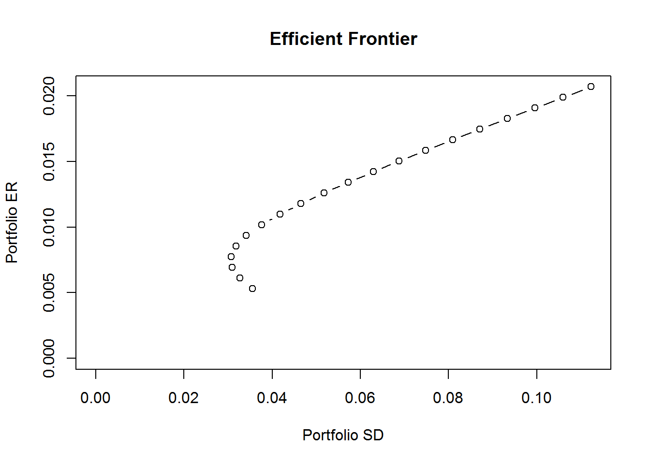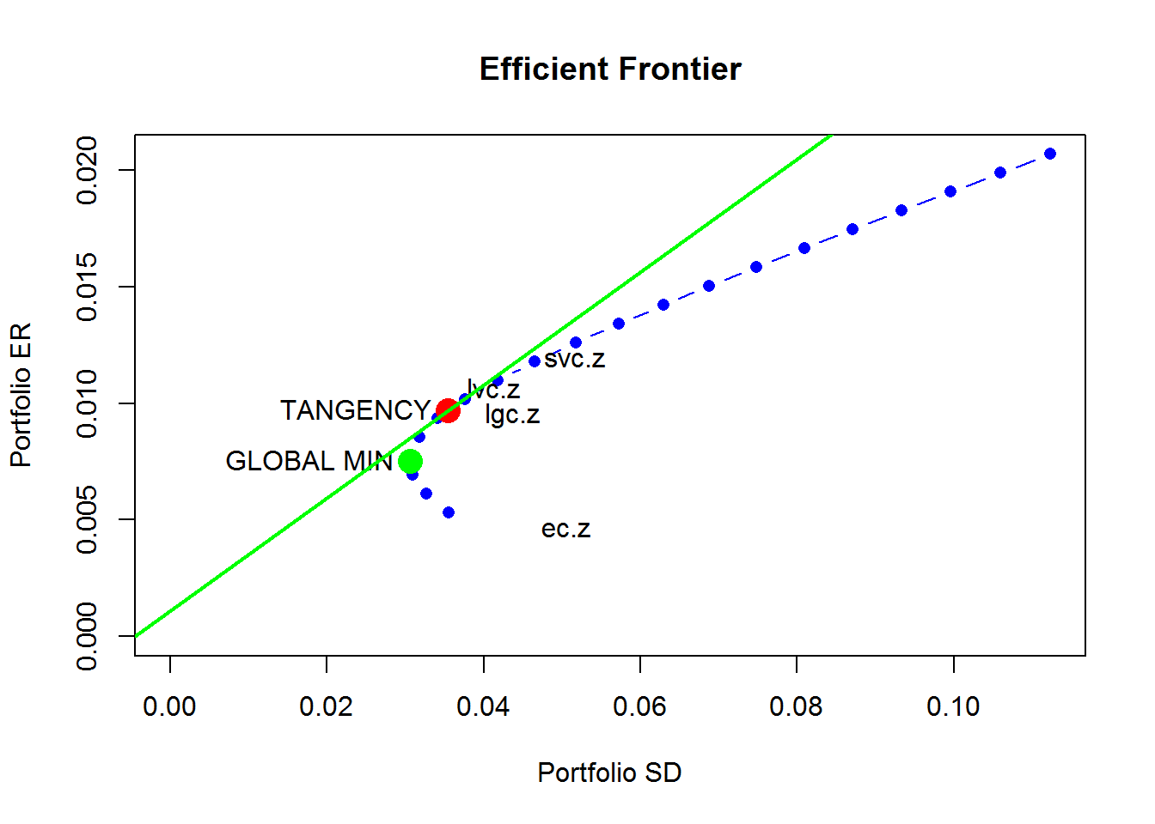

plot portfolio frontier with tangency portfolio
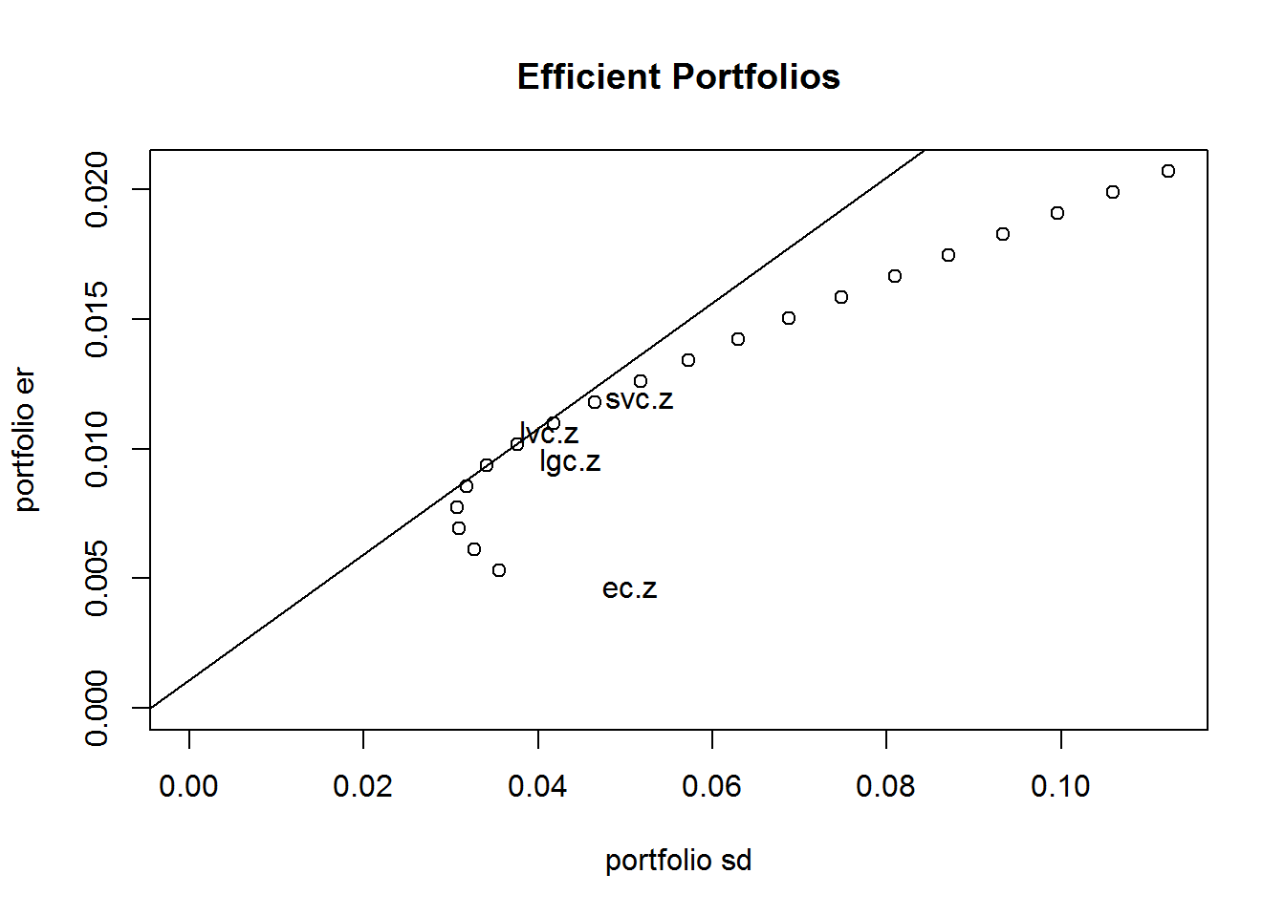

compute portfolio frontier with no short sales
## Frontier portfolios' expected returns and standard deviations
## port 1 port 2 port 3 port 4 port 5 port 6 port 7 port 8 port 9 port 10
## ER 0.0082 0.0084 0.0086 0.0088 0.0090 0.0092 0.0093 0.0095 0.0097 0.0099
## SD 0.0329 0.0330 0.0331 0.0334 0.0337 0.0341 0.0347 0.0354 0.0361 0.0370
## port 11 port 12 port 13 port 14 port 15 port 16 port 17 port 18 port 19
## ER 0.0101 0.0103 0.0105 0.0107 0.0109 0.0111 0.0113 0.0115 0.0117
## SD 0.0380 0.0390 0.0401 0.0413 0.0426 0.0441 0.0458 0.0476 0.0496
## port 20
## ER 0.0119
## SD 0.0517
##
## Portfolio weights:
## ec.z svc.z lvc.z lgc.z
## port 1 0.3875 0.0000 0.4575 0.1550
## port 2 0.3632 0.0000 0.5230 0.1138
## port 3 0.3389 0.0000 0.5886 0.0725
## port 4 0.3146 0.0000 0.6542 0.0312
## port 5 0.2884 0.0000 0.7116 0.0000
## port 6 0.2560 0.0000 0.7440 0.0000
## port 7 0.2236 0.0000 0.7764 0.0000
## port 8 0.1913 0.0000 0.8087 0.0000
## port 9 0.1589 0.0000 0.8411 0.0000
## port 10 0.1265 0.0000 0.8735 0.0000
## port 11 0.0941 0.0000 0.9059 0.0000
## port 12 0.0618 0.0000 0.9382 0.0000
## port 13 0.0294 0.0000 0.9706 0.0000
## port 14 0.0000 0.0151 0.9849 0.0000
## port 15 0.0000 0.1792 0.8208 0.0000
## port 16 0.0000 0.3434 0.6566 0.0000
## port 17 0.0000 0.5075 0.4925 0.0000
## port 18 0.0000 0.6717 0.3283 0.0000
## port 19 0.0000 0.8358 0.1642 0.0000
## port 20 0.0000 1.0000 0.0000 0.0000
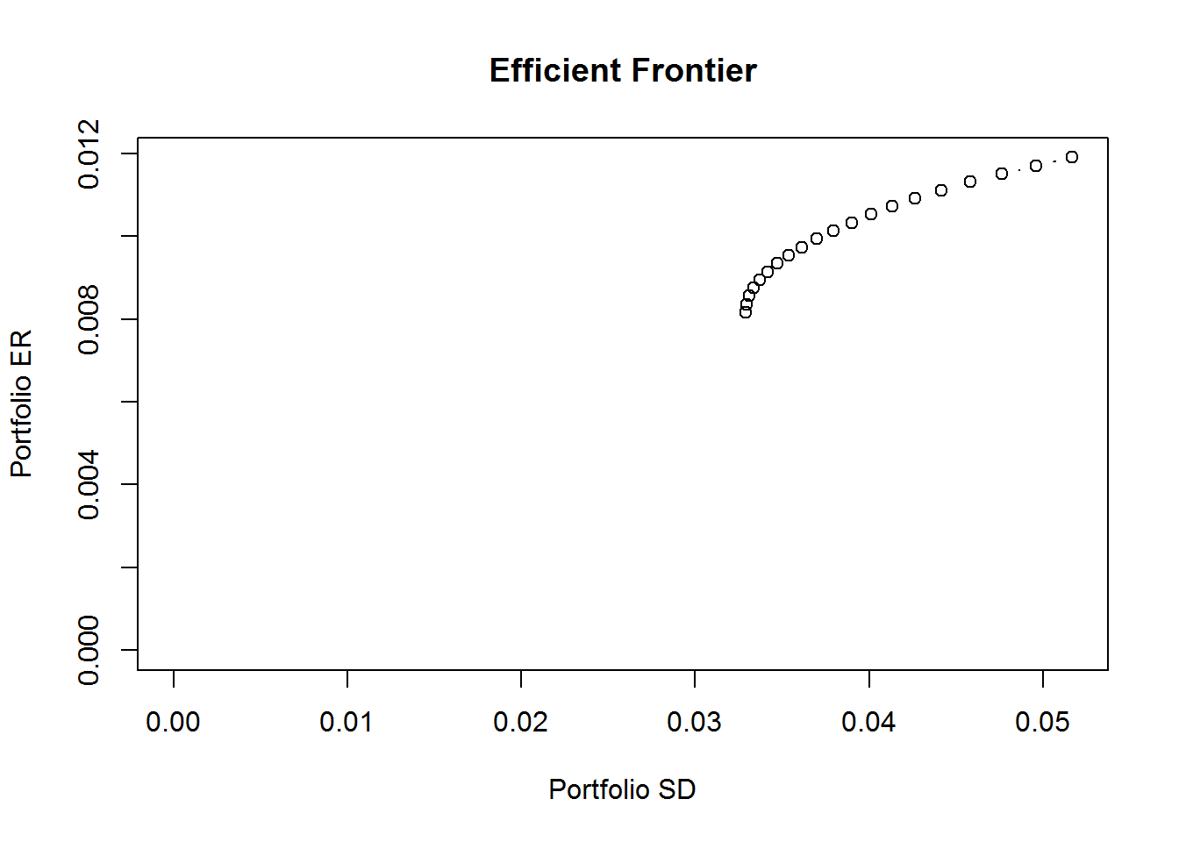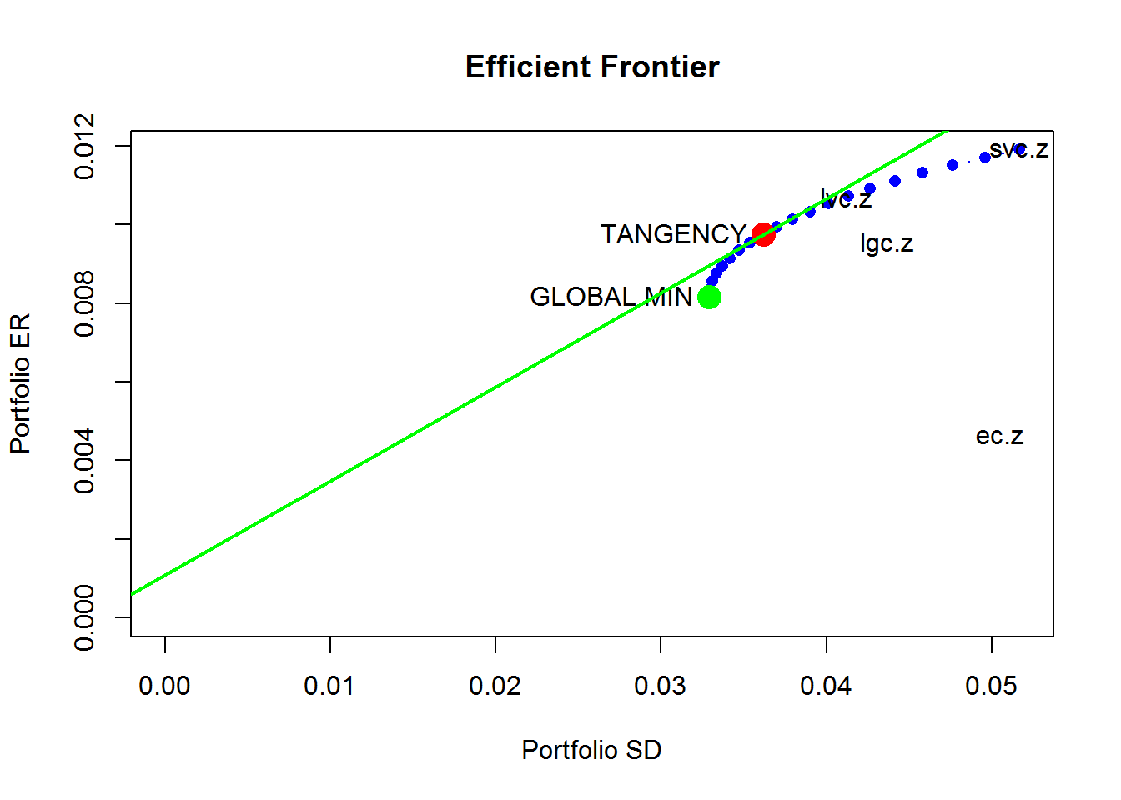

plot portfolio frontier with tangency portfolio
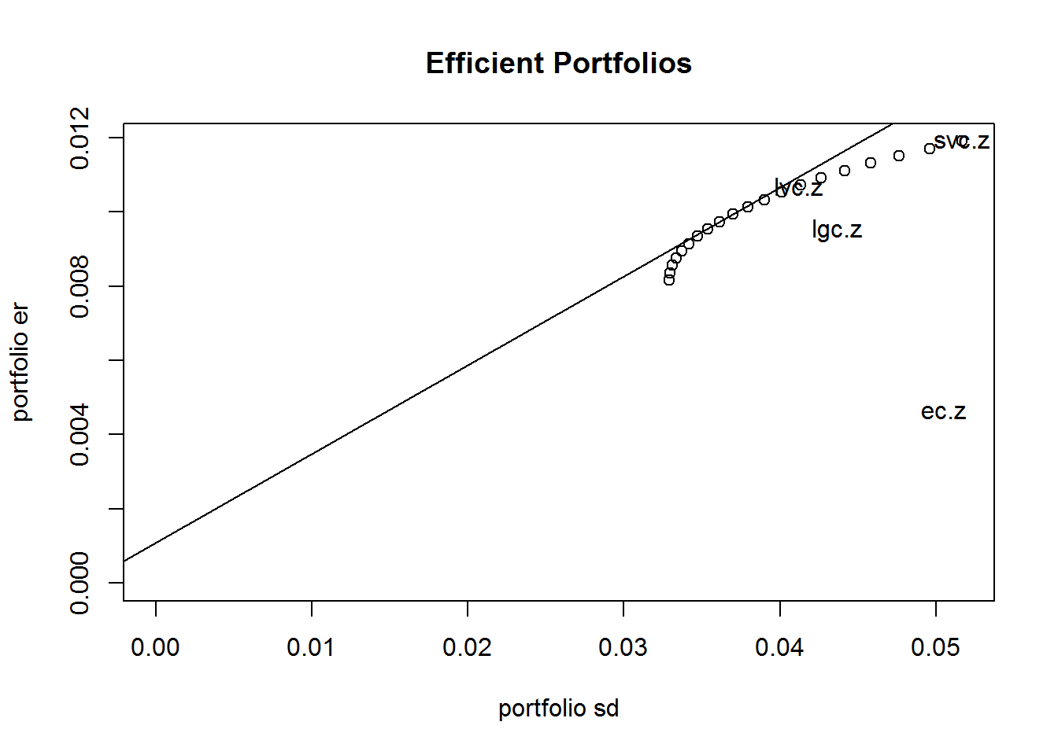

BOOTSTRAPPING
plot of bootstrapped asset values and volatilities
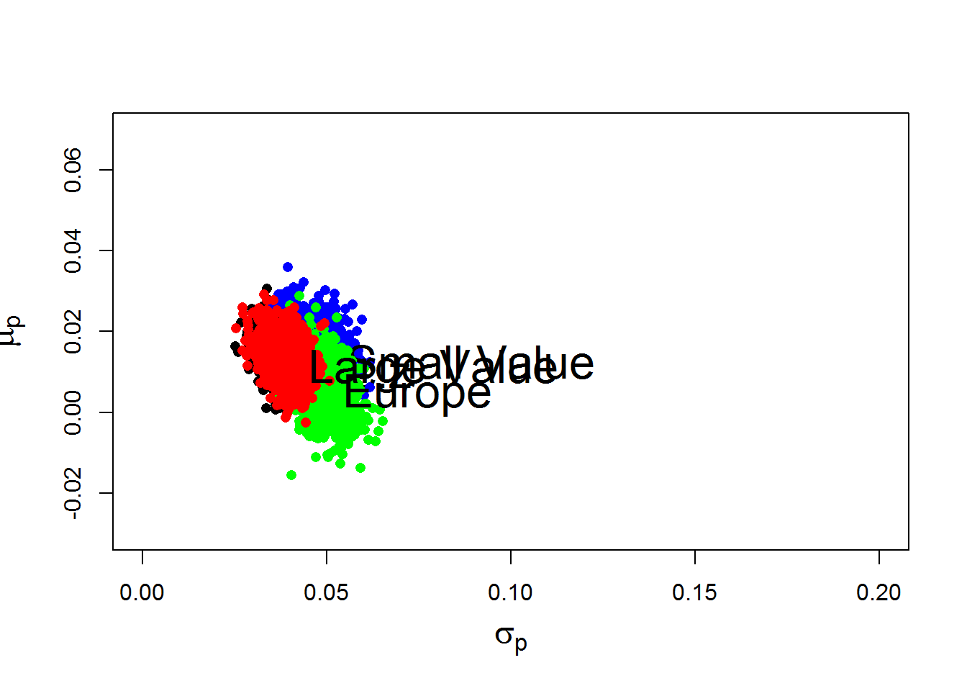

original global minimum variance portfolio
## Call:
## globalMin.portfolio(er = mu.vals, cov.mat = ecov)
##
## Portfolio expected return: 0.007515
## Portfolio standard deviation: 0.03061
## Portfolio weights:
## ec.z svc.z lvc.z lgc.z
## 0.3483 -0.6508 1.0566 0.2459
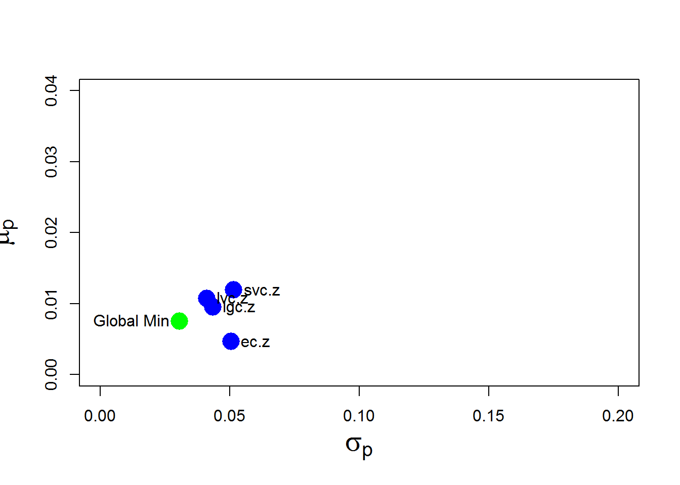

bootstrapped global min portfolio
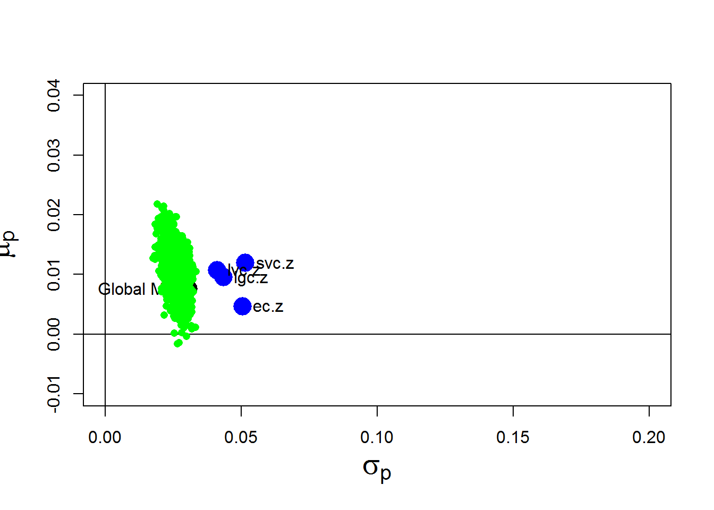

Exploring the Bootstrap Distribution
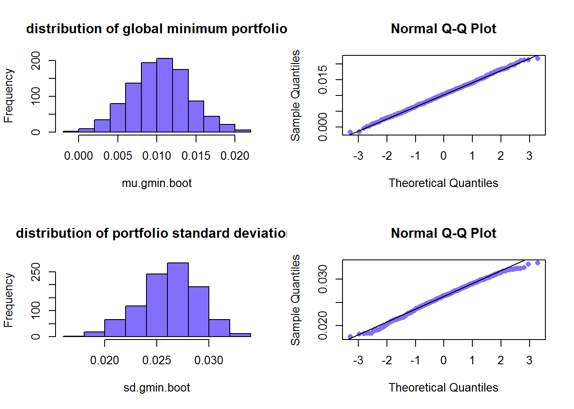
confidence interval for Global Minimum Portfolio
bias.mu.gmin
## [1] 0.002853
se.mu.gmin
## [1] 0.00383
ci.mu.gmin.95
## [1] -0.0001451 0.0151745
confidence interval for Global Minimum Volatility
bias.sd.gmin
## [1] -0.004387
se.sd.gmin
## [1] 0.002768
ci.sd.gmin.95
## [1] 0.02508 0.03615
Minimum variance portfolio asset weights
par(mfrow=c(2,2))
hist(w.gmin.boot[, "lvc.z"], main="Large Value", xlab="Weight", col="slateblue1")
hist(w.gmin.boot[, "svc.z"], main="Small Value", xlab="Weight", col="slateblue1")
hist(w.gmin.boot[, "lgc.z"], main="Large Growth", xlab="Weight", col="slateblue1")
hist(w.gmin.boot[, "ec.z"], main="Europe", xlab="Weight", col="slateblue1")
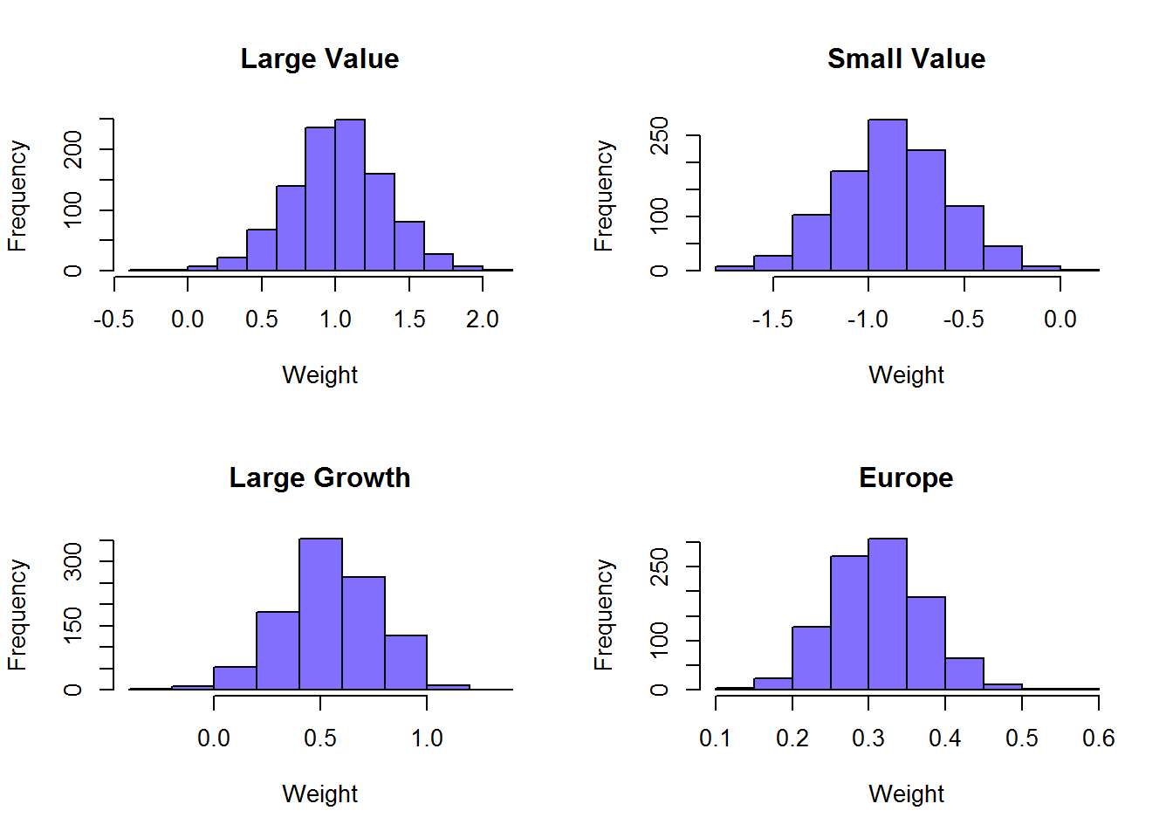
par(mfrow=c(1,1))
confidence interval for Global Minimum Asset Weights
bias.w.gmin
## ec.z svc.z lvc.z lgc.z
## -0.03627 -0.22107 -0.03985 0.29720
se.w.gmin
## ec.z svc.z lvc.z lgc.z
## 0.06216 0.29354 0.32590 0.22588
ci.w.gmin.95
## ec.z svc.z lvc.z lgc.z
## lower 0.2240 -1.23791 0.4048 -0.2058
## upper 0.4726 -0.06374 1.7084 0.6977
a look at a sample of portfolio weights in stacked bar charts
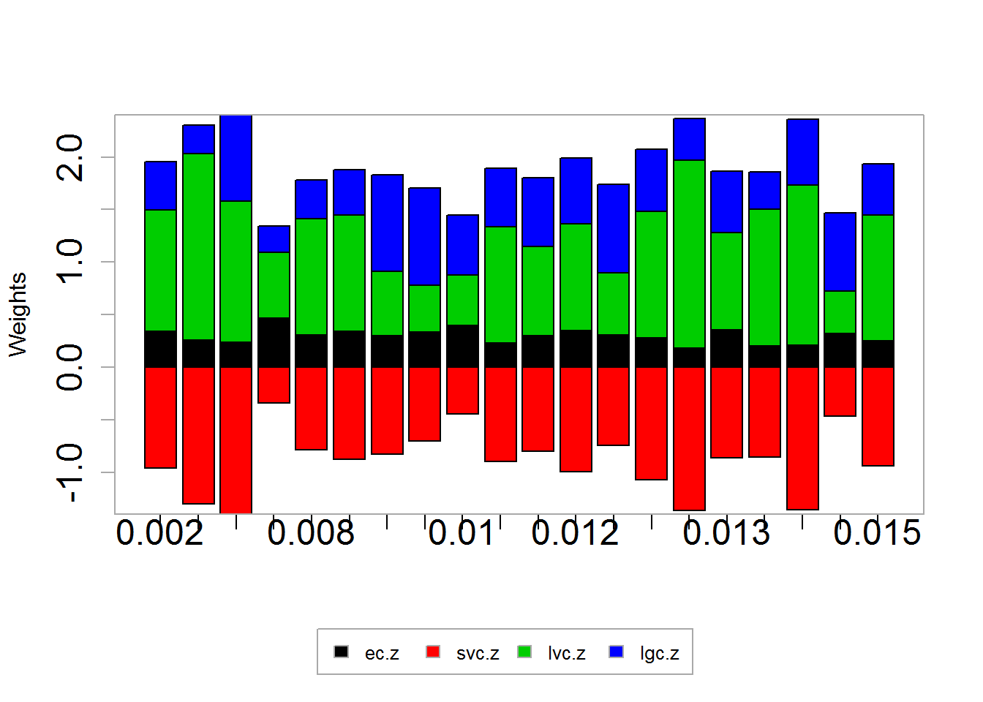
- a look at correlation between min var weights*
cor(w.gmin.boot)
## ec.z svc.z lvc.z lgc.z
## ec.z 1.0000 0.5775 -0.5572 -0.2217
## svc.z 0.5775 1.0000 -0.7512 -0.3747
## lvc.z -0.5572 -0.7512 1.0000 -0.3133
## lgc.z -0.2217 -0.3747 -0.3133 1.0000
pairs(w.gmin.boot)
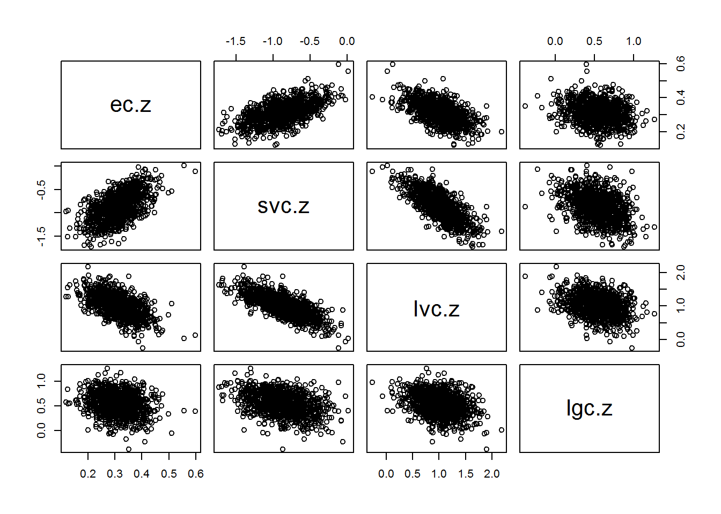
qqnorm(w.gmin.boot[, "svc.z"], col="slateblue1", pch=16)
qqline(w.gmin.boot[, "svc.z"])
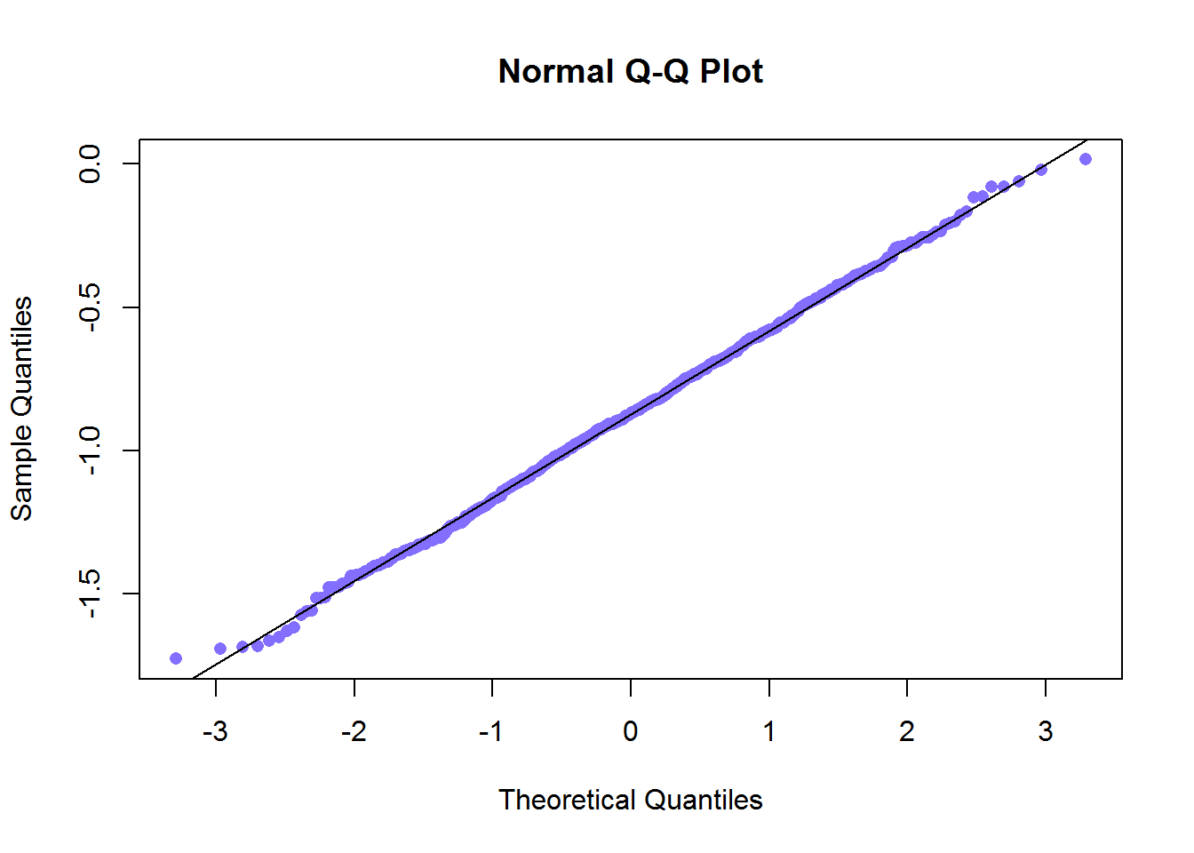

Bootstrapping the Efficient Frontier
Original Efficient Frontier
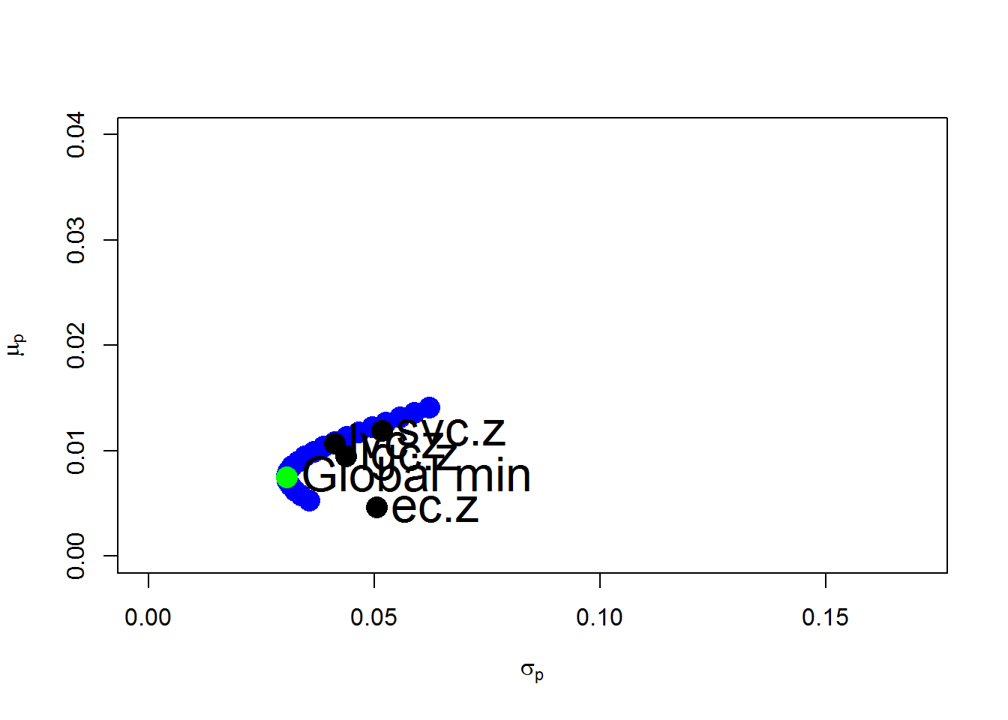

The bootstrapped efficient frontiers
a plot of the first 20 bootstraps
