Sarah Tsai

Yanni Loukissas

LMC 2700

November 7th, 2018

Project 4: Twitter Bot (<https://twitter.com/poke_translator>)

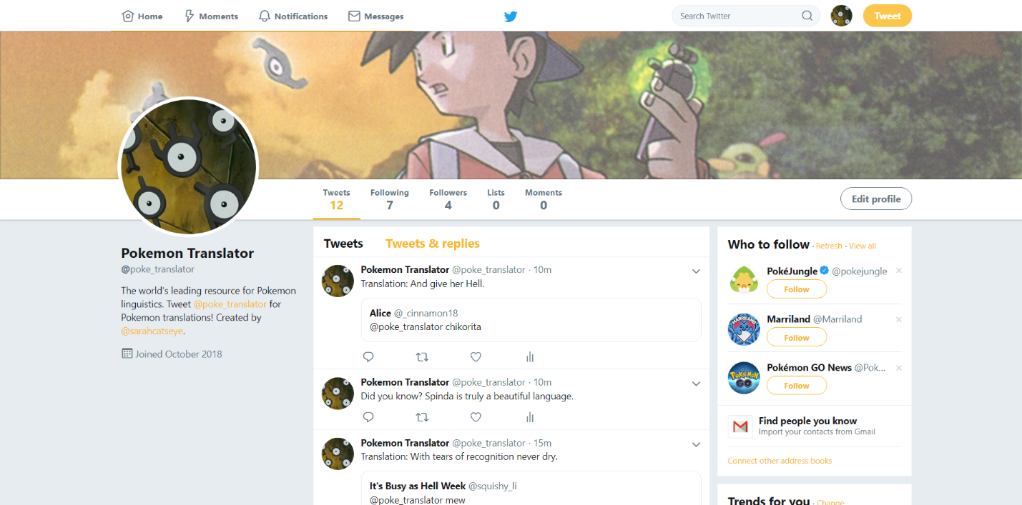

In the Pokemon TV show universe, most Pokemon communicate by saying their name over and over again. As a result of this unintelligible language, the Pokemon community cannot understand what most Pokemon are saying, and what Pokemon are communicating has often been a mystery. My Twitter bot attempts to engage with the Pokemon community by offering the answers to such mysteries. By connecting to the Twitter API, the Wordnik API, the PokeAPI, and the PoetryDB API, the poke_translator bot can complete four different actions. First, it can retweet posts with the #pokemon hashtag in order to draw in the Pokemon community. Second, it can retweet posts from those it is following, who are important figures in the Pokemon community like the official Pokemon Twitter account or Bulbapedia, a well-known wiki resource on Pokemon data. Third, it tweets out pre-generated text combined with a random Pokemon name from the PokeAPI and random nouns from the WordnikAPI. Fourth, it “translates” mentions in the Pokemon language by quote tweeting the last line from a well-known poem from a well-known poet.

The four different actions taken by the poke_translator bot offer knowledge and hilarity in equal measure. By retweeting posts from #pokemon and from those it is following, my bot offers the community knowledge about content created about Pokemon and from the Pokemon creators. The randomly generated tweets pretend to offer fun facts, but the Pokemon name and randomly generated words make the facts humorous. While the quote tweets do offer information about poetry to the Pokemon community, they also hilariously juxtapose the pop gibberish of the Pokemon language with the refined, dramatic poetry of the most famous poets. The bot’s character is a similar mixture of knowledgeability and humor. It attempts to pose as a serious and self-important source for a topic no one finds serious. It describes itself as “The world’s leading resource for Pokemon linguistics” and tweets out information parodying the Pokemon TV show and Dictionary.com’s tweets.

While the bot has only been up for a few hours, it has already provoked some engagement from the Pokemon community. Beyond my own Tweets at the Twitter bot, three other people have already attempted to engage with the bot and have tweeted Pokemon at the bot. These people have also liked tweets from the bot. The bot has also gained over ten followers despite only following the official accounts. To engage with the community further, I could alter the Twitter bot to follow those it retweets. I could also tweet a message of thanks to anyone who follows the bot, and I could ask them for mentions to be translated by the bot.