SIMULATING BIODIVERSITY PATTERNS: NEUTRAL, COMPETITIVE, & INVASION MODELS

2022-11-30

**Introduction**

Hubbell’s neutral theory of biodiversity and biogeography highlights the importance of unifying ecological processes–birth, death, and immigration–and offers a null model that can provide insight into current and future species-abundance distributions. Neutral theory is commonly used in ecology to describe and understand biodiversity and evolution patterns, and although its applications are expanding, it primarily supports theoretical exploration (Rosindell et al., 2011). Although neutral theory had been applied in the marine context (see Alzate et al., 2019, Dolan et al., 2007, Wootton, 2005, among others), it is not commonly used in marine ecosystems or for species that are targeted by marine fisheries.

Biodiversity indices have been developed over the years to help us compare and measure biodiversity across scales, taxa, trophic levels or regions. Species richness is perhaps the simplest of the diversity metrics, representing the total number of species represented in a population without taking species abundance or relative abundance into consideration (Whittaker 1972). Both the Shannon-Weiner index (Shannon & Weaver 1949) and the Simpson’s Index take into account species richness and abundance distribution of a species. The Shannon-Weiner index measures the amount of uncertainty of picking the same species twice from a random draw from all of the species in a community. Therefore, a high level of uncertainty indicates a higher species diversity. The Simpson’s Index measures probability that two individuals randomly sampled belong to different species. Again, the higher the Simpson index, the higher the diversity.

In this study, we seek to explore how neutral theory can be used to understand biodiversity patterns in intertidal marine ecosystems, with a focus on commercially important shellfish species. Using classical biodiversity indices, will compare the neutral theory model to a competitive model and assess how well each model represents biodiversity patterns in a marine ecosystem. Specifically, we will model the biodiversity patterns that occur under immigration pulses from rare species. This approach aims to model recent species introductions observed in many of Maine’s intertidal marine ecosystems, namely the introduction of wild American oysters and increases in invasive green crab populations. This study will inform future analyses and help to identify potential forces driving biodiversity patterns in these systems.

**Study System**

The Damariscotta River estuary, located in midcoast Maine, hosts a diversity of coastal marine habitats ranging from rocky shores to soft sediment intertidal areas and eelgrass beds. The estuary is home to extensive human activity, including recreational boating, commercial fishing, and shellfish aquaculture. The Damariscotta has more than a dozen marine aquaculture operations that total 0.93 km², where farmers grow American oysters, mussels, scallops, and kelp (Maine DMR, 2022). The biodiversity in the Damariscotta is similar to other estuaries in the Gulf of Maine and varies along habitat type and physical and biological gradients (Britsch, 2021).

The intertidal mudflat is the focus of this study. This habitat hosts a diversity of shellfish, marine worm, and arthropod species. Of commercial interest are soft-shell clams (*Mya arenara*), quahogs (*Mercenaria mercenaria*), razor clams (*Ensis directus*), blood worms (*Glycera dibranchiata*), and sand worms (*Nereis virens*). Within the past 20 years commercial shellfish harvesters have observed the appearance of wild American oyster (*Crassostrea virginica*), a previously extirpated species now reappearing ostensibly as a result of aquaculture activity (Delago, 2021; Risley, 2022). Green crabs (*Carcinus maenas*), an invasive species originally from the Mediterranean, have also experienced a recent growth in population abundance, likely linked to warming ocean temperatures. Green crabs prey on shellfish species, particularly the delicate soft-shell clam, and have resulted in declines in clam populations as their number grow (Tan and Beal, 2015).

Therefore, the Damariscotta has two ‘rare’ species whose growth and expansion could affect the biodiversity of the whole system. This study seeks two explore how increases in rare species, like the wild American oyster and the green crab, can influence biodiversity within the ecosystem.

**Methods** (PJ - updated 1800 12/7)

For this project we will use R Studio to simulate both a neutral theory model and a competitive model for the system. We utilized the “roleLite” R package (xversion 0.1.0, Rominger) and then utilized the untbSim function to run a neutral simulation for a null model evaluation with the following parameters: neut <- untbSim(J = 1000, # number of individuals in local community + Sm = 50, # number of species in meta community + Jm = 10000, # number of individuals in meta community + nu = 0, # speciation probability + m = 0.1, # immigration probability + niter = 10000) # number of iteration to run

Additionally, we ran a competitive simulation model using the compSim function. This simulation used a competitive matrix with intraspecies competition removed in order to increase average niche differentiation. Both models were visualized using the final time step of a species abundance distribution (SAD) and biodiversity indices (Simpsons, Shannons, Richness) were calculated for each model.

An invasion model was generated to simulate the amplification of a rare species. This model consisted of a pre-invasion simulation merged with a post-invasion simulation in order to evaluate the effects of this amplification. We visualized SAD’s for the invasion model at three timesteps -10,000, 13,000, and 20,000 iterations - in order to visualize biodiersity patterns immediately before an invasion (through 10,000 iterations), shortly after the invasion (from 10,000 to 13,000 iterations), and long after the invasion (up to 20,000 iterations). Biodiversity indices were calculated for each of these timesteps, respectively. The metacommunity was modified in the post-simulation to amplify the rare species by a factor of two (the rare species were twice as common). Both pre- and post-simulations used the untbSim package with the same parameters used in the previously-mentioned neutral and competitive models.

Finally, measures for Simpsons and Shannons Diversity Indices and Species Richness, were calculated to compare and contrast neutral, competitive and merged models for resulting biodiversity impacts.

**Results** (PJ)

(NEUTRAL SAD) 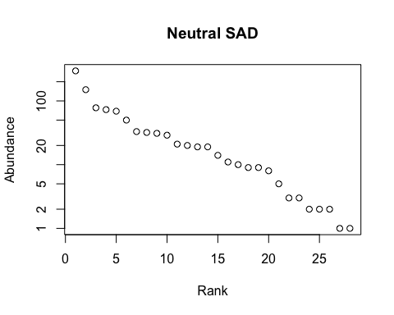

-Max abund = 277

(COMP SAD) 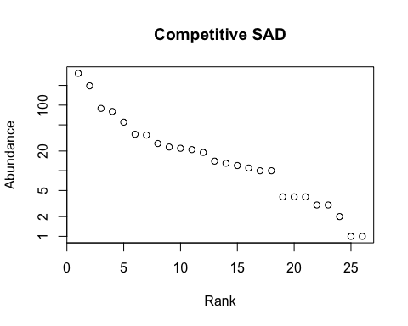 -Max abund = 262 -More species with lower abundances -Overall, graphs look similar -Linear slope

(INVASION SADs)

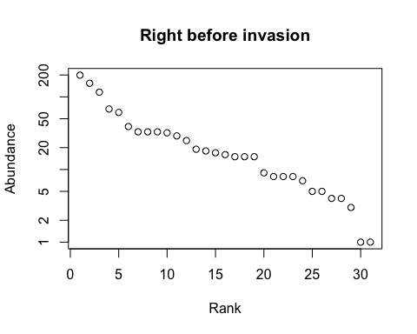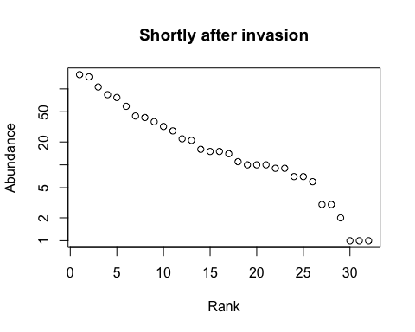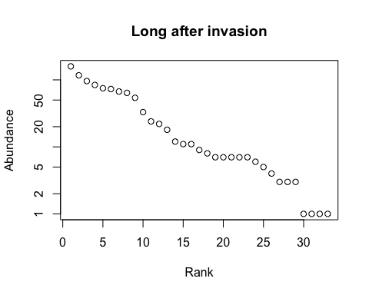

-Pre and shortly after look very similar -Steep drop from max abundances species across all time steps -Appears to be two curves in graphs with break between rank 10-15 for short- and long-term after invasion, but not pre-invasion

pre:431 post short-term: 409 post long-term: 354

TABLE

## Simpsons Index Species Richness Shannons Index  
## Neutral Model 7.41 28.00 12.23  
## Competitive Model 6.45 26.00 10.55  
## Pre-Invasion 10.56 31.00 16.04  
## Post-Invasion 12.25 32.00 17.08  
## After Invasion 12.34 33.00 16.46

* Simpson’s: relative abundances, how evenly the abundances are distributed -Greatest diversity of species in competative model -Followed by Neutral -Long term after invasion, then post invasion, then pre-invasion is lowest -Relatively invasion model is much lower than both neutral and competitive

-Species richness: count of species in community -Neutral model has greatest richness -Competitive and pre-invasion are the same -Richness declines post invasion, with lowest at long term after invasion time step -So fewer species in post-invasion model, but greater evenness regarding abundances across species

-Shannon’s: species richness -Neutral and competitive similar and most diverse -Invasion model on the whole is lower -Lowest pre, then after invasion, with short-term post-invasion having the highest of the three

the importance of rare species decreases in order species richness > Shannon index > Simpson index

**Discussion**

-Neutral and competitive are very similar, give similar predictions -Competitive model is more diverse -Niche differentiation increases in competitive model, therefore more likely to be diverse than neutral -

*Things to Consider* - Discussion around special considerations for marine systems (Chust et al., 2016) -Refutes NTB (Dornela et al., 2006) -What about different dispersal rates? (Srisvastava and Pavel, 2013) - How does the scale of observation influence model results? (Chisholm and Lichstein, 2009) -What about harvesting activity? How does that play into the NTB model? -How does genetic manipulation from AQ influence biodiversity? -Connolly et al., 2014 -What worked and didn’t work

**ADD CODE BELOW SO FIGURES CAN BE IN SINGLE DOC** *look at old spatial analysis Rmd for how to hide code in knit*

**References**

Alzate, A., Janzen, T., Bonte, D., Rosindell, J., & Etienne, R. S. (2019). A simple spatially explicit neutral model explains the range size distribution of reef fishes. Global Ecology and Biogeography, 28(7), 875–890. <https://doi.org/10.1111/geb.12899>

Britsch, M. L. (2021). Marine Aquaculture in Maine: Understanding Diverse Perspectives and Interactions at Multiple Scales. University of Maine.

Delago, D. F. (2021). Investigating Larval Spillover From Oyster Aquaculture Through Geospatial Habitat Suitability Index Modeling: A Damariscotta River Estuary Case Study. University of New England.

Dolan, J. R., Ritchie, M. E., & Ras, J. (2007). The “neutral” community structure of planktonic herbivores, tintinnid ciliates of the microzooplankton, across the SE Tropical Pacific Ocean. Biogeosciences, 4(3), 297–310. <https://doi.org/10.5194/bg-4-297-2007>

Maine DMR. (2022). Aquaculture Map: Maine Department of Marine Resources. <https://www.maine.gov/dmr/aquaculture/leases/aquaculturemap.html>

Risley, S. (2022). Linking Local Knowledge & Community Science in Support of Coastal Marine Stewardship (3564) [The University of Maine]. Electronic Theses and Dissertations. <https://digitalcommons.library.umaine.edu/etd/3564>

Rosindell, J., Hubbell, S. P., & Etienne, R. S. (2011). The Unified Neutral Theory of Biodiversity and Biogeography at Age Ten. Trends in Ecology & Evolution, 26(7), 340–348. <https://doi.org/10.1016/j.tree.2011.03.024>

Shannon, C.E. & Weaver, W. (1949) The Mathematical Theory of Communication. University of Illinois Press, Urbana.

Tan, E. B. P., & Beal, B. F. (2015). Interactions between the invasive European green crab, Carcinus maenas (L.), and juveniles of the soft-shell clam, Mya arenaria L., in eastern Maine, USA. Journal of Experimental Marine Biology and Ecology, 462, 62–73. <https://doi.org/10.1016/j.jembe.2014.10.021>

Whittaker, R. H. 1972. Evolution and measurement of species diversity. Taxon 21:213–251.

Wootton, J. T. (2005). Field parameterization and experimental test of the neutral theory of biodiversity—Nature. Nature, 433(7023), 309–312. <https://doi.org/10.1038/nature03211>