PROPOSAL

**Abstract:**

# House Price Prediction

the House Price Prediction Challenge, you will test your regression skills by designing an algorithm to accurately predict the house prices in India. Accurately predicting house prices can be a daunting task. The buyers are just not concerned about the size(square feet) of the house and there are various other factors that play a key role to decide the price of a house/property. It can be extremely difficult to figure out the right set of attributes that are contributing to understanding the buyer's behavior as such. This dataset has been collected across various property aggregators across India. In this competition, provided the 12 influencing factors your role as a data scientist is to predict the prices

**Design:**

**how many house is under construction?**

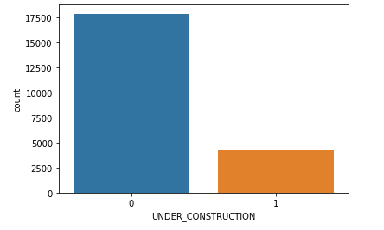

**how many person on the house READY_TO_MOVE?**

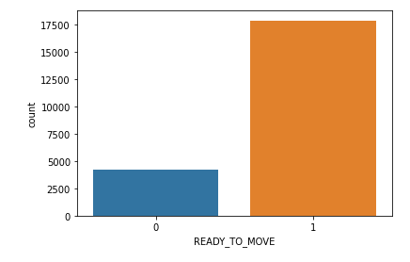

*#* **How many house get RESALE efore?**

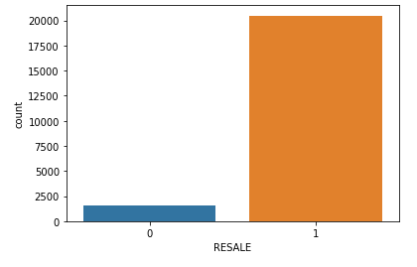

## **Attributes Description:**

Column | Description

POSTED_BY | Category marking who has listed the property

UNDER_CONSTRUCTION | Under Construction or Not

RERA | Rera approved or Not

BHK_NO | Number of Rooms

BHKORRK | Type of property

SQUARE_FT | Total area of the house in square feet

READYTOMOVE | Category marking Ready to move or Not

RESALE | Category marking Resale or not

ADDRESS | Address of the property

LONGITUDE | Longitude of the property

LATITUDE | Latitude of the property

## **libraries**

pandas

numpy

matplotlib

seaborn

sk linear

**Models :**

**Linear regression**

**Decision Tree Regressor**

**Random Forest Regressor**