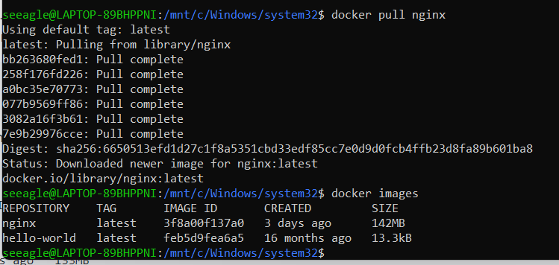

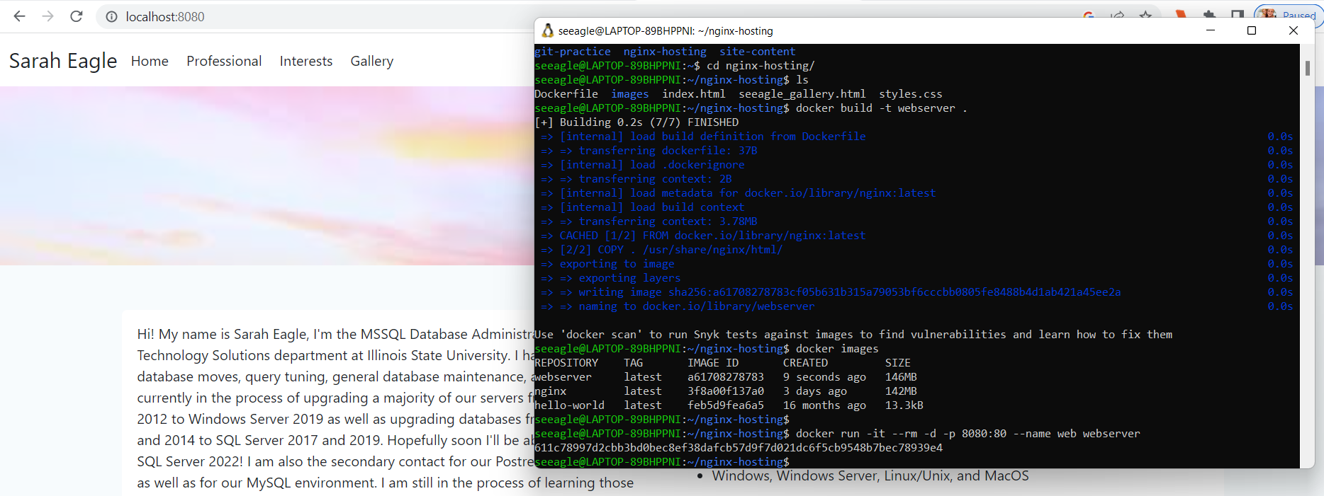

QUESTION:

A docker file contains a list of commands that the docker daemon calls while creating an image (Section 2.2). It is supposed to help automate the process. You’d want to use this to save time when creating a new image because of the added commands.