Headlines
Beware: The Italian Joker, Danny Russo, Plots His Next Grand Scheme
Tam Electric’s master of mischief, Danny Russo, was recently spotted concocting his next major prank on a job site in Cobourg. Rumor has it that this caper may outshine all previous antics, potentially featuring Bombay chicken and chopsticks from Blue Sky.


Warning: Danny Russo Strikes Again, Posing as a Plumber
Tam Electric’s master of disguise, Danny Russo, recently took on the role of a plumber again, assisting a homeowner with plumbing problems. However, his plumbing escapade ended in disaster as pipes burst, leaving behind a chaotic scene. The homeowner was devastated to realize that Danny was the fake plumber from a viral TikTok video.


Danny Strikes a Deal with Josh to Test a Joke-Free Day
Danny Russo made a pact with Josh to attempt a day without cracking jokes. Just one hour into his shift, the struggle becomes evident, and the weird side effects of holding in jokes are beginning to surface.

Poor Witch Marries Danny Believing He’s a Skeleton
In a bewitching turn of events, Danny Russo, masquerading as a skeleton, successfully weds a witch who remains blissfully unaware of his true identity. Curious to know whether the witch would accept him for who he truly is, he once asked her if she’d ever marry a joker. This inquiry led to a full-blown tantrum, with cats being flung out the window, as she furiously expressed her hatred for them, declaring that she would turn them into soup if she ever encountered one. She explained that her hatred for jokers stemmed from her father being one himself. He had abandoned her and her mother for his psychiatrist, Harley Quinn, for whom his mother paid for to get him help. Fearing the possibility of losing her, Danny has chosen to fully identify as a skeleton and intends to conceal his true identity from her for the rest of his life, petrified that she’ll turn him into soup if she ever finds out.
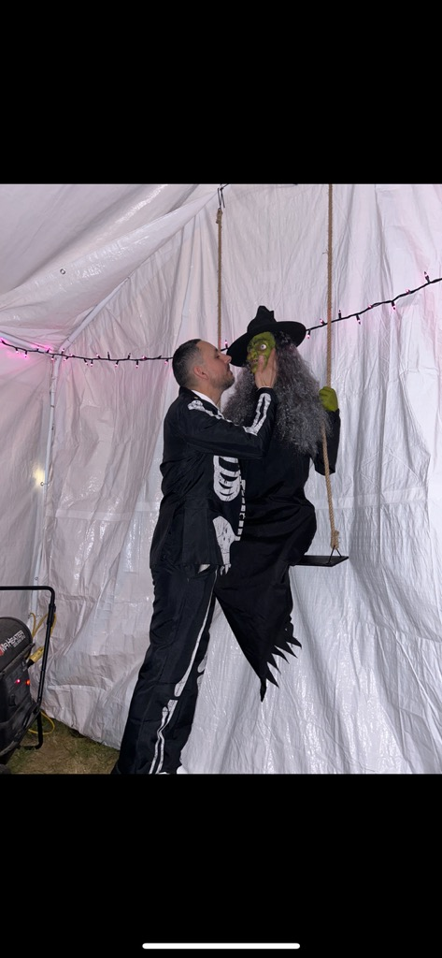
In The Name of Romance: Danny Russo Declares Joke-Free Truce for Love’s Sake
Danny Russo, the fierce joker of Tam Electric, declares a truce for the sake of his romantic relationship. Now fully identifying as a skeleton, Danny vows to lay his jokes to rest to ensure harmony and safety in his love life. This unexpected decision stems from his deep fear of losing his witch wife, who remains unaware of his true identity.


