Tab 1

Multi-Agent Academic Research Online System: Design and Implementation Proposal

Insight Analytics Ltd.

Executive Summary 2
Introduction 3
Theoretical Background 4
System Requirements 4
Design Decisions & Methodology 5
Challenges, Limitations & Future Work 9
Conclusion 9
References 11

Executive Summary
Insight Analytics Ltd requires an automated solution to identify, evaluate, and structure academic research to support internal knowledge development and client reporting, since manual literature review processes are time-intensive and difficult to scale.

This proposal outlines a blackboard-coordinated, Belief–Desire–Intention (BDI) multi-agent architecture. The system autonomously retrieves research data from the ArXiv API, evaluates the quality of the results, and generates structured JSON outputs for analysis and client reporting. The architecture prioritises modularity, scalability, and transparency of reasoning, ensuring operational efficiency and long-term maintainability.

Introduction
Intelligent agents are autonomous software entities capable of perceiving their environment, reasoning about goals and acting to achieve defined outcomes (Wooldridge, 2009). Within the Academic Research Online domain, agents must identify relevant online content, process retrieved information and store structured outputs for analysis.

This report proposes a multi-agent architecture based on the Belief–Desire–Intention (BDI) model to address these domain requirements. The following sections outline the theoretical foundations, system requirements, architectural design decisions, graphical representations, and anticipated challenges of the proposed system.

Theoretical Background
In the Academic Research Online domain, the system design is informed by the tension between autonomy, reactivity and explainability in web-facing agents. The proposed system adopts a Belief–Desire–Intention (BDI) architecture (Rao and Georgeff, 1995), in which agents maintain beliefs about their environment, pursue goal-directed desires, and commit to intentions through a structured reasoning cycle.
Within this framework, agents repeatedly execute a perceive–deliberate–act loop over a shared environment. This enables them to respond to changes in query parameters, API responses, and intermediate results while maintaining interpretable decision-making. Information-gathering behaviour follows patterns described by Maes (1994) and Jennings and Wooldridge (1996), combining goal-directed behaviour with simple rules to manage noisy and dynamic web content.
The design also addresses the trade-off between reactive and deliberative agent architectures. BDI supports structured deliberation and intention reconsideration (Bratman, 1987; Rao and Georgeff, 1995), while reactive behaviour enables agents to respond to timeouts or unexpected API behaviour (Brooks, 1991). This hybrid approach reflects contemporary agent design practices (Qu et al., 2025). Compared with a simple scripted pipeline, the BDI model provides explicit goal management, adaptability and transparent reasoning (Wooldridge, 2009).

System Requirements
The proposed agent-based system supports academic research in online environments and is developed in Python due to its strong capabilities for web interaction and data manipulation (Wooldridge, 2009). The system retrieves research data through integration with the ArXiv API, which provides structured access to academic metadata through a standardised interface. It then processes retrieved records using native Python data structures, transforming raw metadata into structured formats that support downstream agent reasoning and filtering decisions, prior to storage.
The system stores processed outputs offline using lightweight formats such as JSON and plain-text files, allowing results to be easily inspected, reused and traced without introducing unnecessary infrastructural complexity. During implementation, testing frameworks such as unittest or pytest can support systematic validation of agent behaviour and system functionality.
Data sources are restricted to the publicly accessible ArXiv repository, ensuring ethical data access in line with responsible data use principles (Floridi et al., 2018). Networking considerations include request rate limiting and avoidance of personal data storage, while domain-specific requirements include keyword-driven retrieval, structured metadata extraction, and traceable result storage.

Design Decisions & Methodology
The system is implemented in Python 3.9+ using a modular architecture that separates core BDI components, agent logic, and coordination mechanisms. The design operationalises the BDI paradigm through an abstract base class that enforces the perceive–deliberate–act cycle, with selective reconsideration of intentions when outcomes are uncertain (Wooldridge, 2009).
The architecture comprises four specialised agents: a SearchAgent for metadata retrieval via the ArXiv API, an ExtractionAgent for record standardisation, a ProcessingAgent for adaptive filtering, and a StorageAgent for structured persistence. This separation of responsibilities supports modularity and future extensibility. The overall component structure is illustrated in Figure 1, while the internal decision flow of the ProcessingAgent is shown in Figure 2. Adaptive filtering allows behaviour to respond to observed data quality rather than static rules, consistent with information-gathering agent models (Giles, Bollacker and Lawrence, 1998).
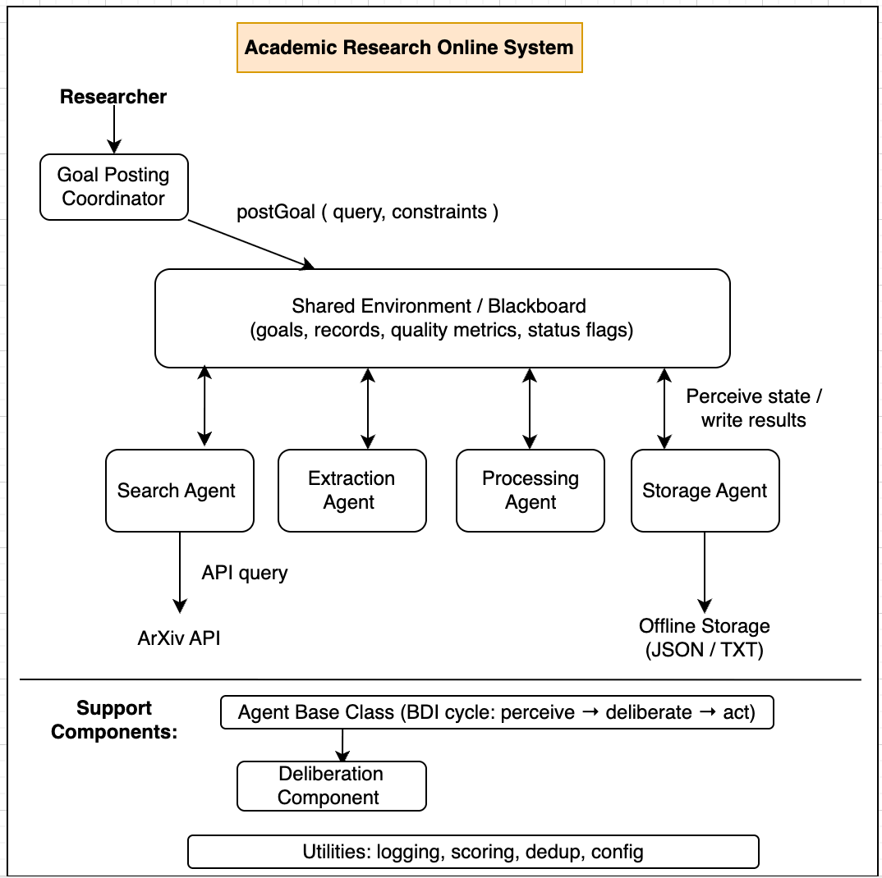
Figure 1: Component architecture of the BDI multi-agent academic research system (blackboard coordination).
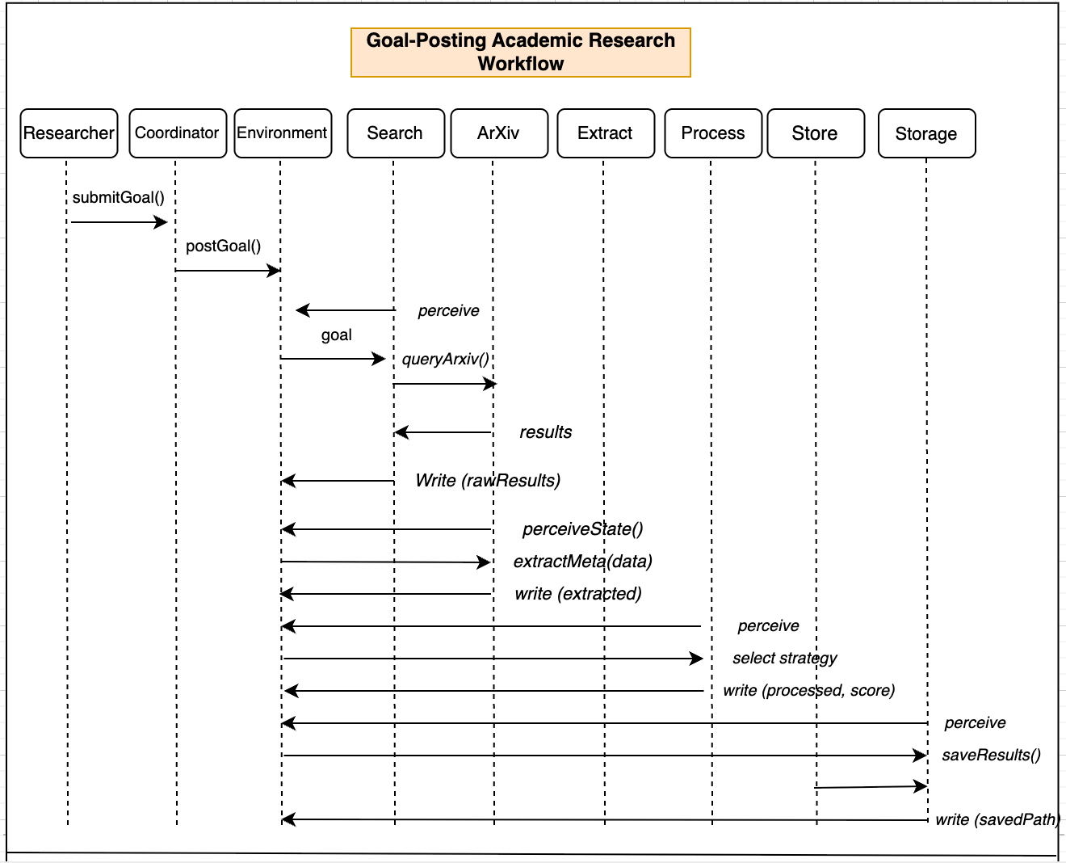
Figure 2: Activity diagram for ProcessingAgent

Agents coordinate through a shared environment inspired by the blackboard architecture (Nii, 1986). Task progression emerges from the environment rather than a fixed pipeline, enabling flexible interaction and transparent reasoning among agents. The resulting interaction sequence is illustrated in Figure 3.
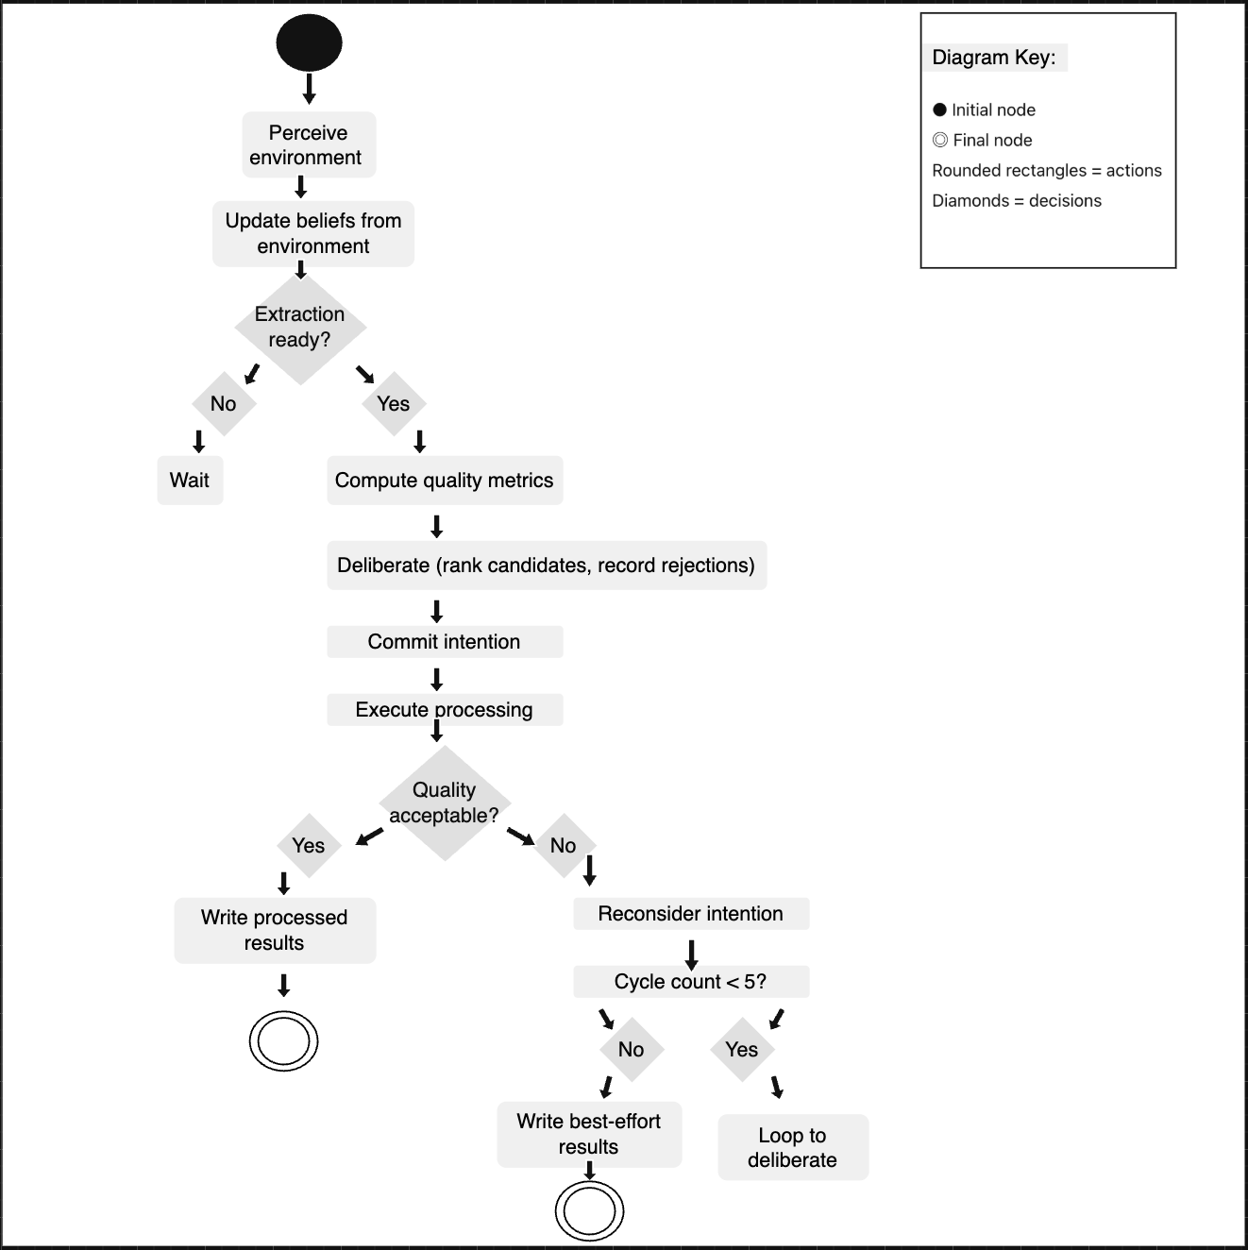
Figure 3: Sequence Diagram illustrating how agents interact via the shared environment.
The multi-agent design improves modularity and interpretability. Although a monolithic pipeline would simplify coordination, it would reduce extensibility; the blackboard model instead provides greater flexibility and observability.

Challenges, Limitations & Future Work
The proposed system faces several challenges common to agent-based web information retrieval. Reliance on other services, e.g., the ArXiv API, creates risks related to network connectivity, rate limiting, and schema, necessitating robust error recovery and handling in the shared environment. The reliance on rule-based quality heuristics reflects a broader trade-off between robustness and sophistication, highlighting the tension between reactive behaviour and deliberative BDI reasoning.
The prototype operates more like a coordinated multi-agent pipeline than a decentralised agent society, despite the fact that traceable JSON/text outputs increase transparency. While focusing on rule-based BDI agents guarantees predictable, testable behaviour, it delays the integration of learning-based techniques that have been found crucial in recent surveys (da Silva et al., 2020; Qu et al., 2025).
In the future, these underpinnings will facilitate development beyond the prototype. Preference learning, adaptive query refinement, and source prioritisation are possible future iterations that go toward learning-enhanced BDI agents. Scalable, accountable, and provenance-aware coordination in line with responsible AI principles will be made possible by the shared environment and explicit belief representation (Floridi et al., 2018).

Conclusion
This design proposal outlines a BDI-based multi-agent system for academic research in online environments, grounded in established agent theory and informed by contemporary discussions on autonomy, reactivity, and explainability. By combining structured deliberation with behaviour-based responsiveness, the proposed architecture seeks to balance goal-directed reasoning with practical robustness when interacting with dynamic web resources, such as the ArXiv API. The adoption of a blackboard-style coordination model further supports loose coupling among agents while preserving transparency in decision-making. Although the system is initially constrained to rule-based behaviour and a single data source, these limitations are explicitly acknowledged as part of a staged development strategy. Overall, the proposal demonstrates how theoretical principles from intelligent agent research can be translated into a coherent, extensible and ethically grounded system design, suitable for academic research support.

References
Bratman, M. E. (1987). Intention, plans, and practical reason. Harvard University Press.​
Brooks, R. A. (1991). Intelligence without representation. Artificial Intelligence, 47(1–3), 139–159. https://people.csail.mit.edu/brooks/papers/representation.pdf
Da Silva, L., Meneguzzi, F., & Logan, B. (2020). BDI agent architectures: A survey. In Proceedings of the Twenty-Ninth International Joint Conference on Artificial Intelligence (IJCAI-20) (pp. 4776–4784). https://www.ijcai.org/proceedings/2020/0684.pdf
Floridi, L., Cowls, J., Beltrametti, M., et al. (2018) ‘AI4People—An ethical framework for a good AI society’, *Minds and Machines*, 28(4), pp. 689–707.
Giles, C. L., Bollacker, K. D., & Lawrence, S. (1998). CiteSeer: An automatic citation indexing system. In Proceedings of the Third ACM Conference on Digital Libraries (pp. 89–98). https://doi.org/10.1145/276675.276685
Jennings, N. R., & Wooldridge, M. (1996). Software agents. IEEE Review, 42(1), 17–20. http://www.cs.ox.ac.uk/people/michael.wooldridge/pubs/iee-review96.pdf
Maes, P. (1994). Agents that reduce work and information overload. Communications of the ACM, 37(7), 30–40. https://doi.org/10.1145/176789.176792
Nii, H. P. (1986). Blackboard systems: The blackboard model of problem solving and the evolution of blackboard architectures. AI Magazine, 7(2), 38–53. https://doi.org/10.1609/aimag.v7i2.543
​Qu, X., et al. (2025). A comprehensive review of AI agents: Transforming possibilities in technology and beyond. arXiv. https://doi.org/10.48550/arXiv.2508.11957
Rao, A. S., & Georgeff, M. P. (1995). BDI agents: From theory to practice. In Proceedings of the First International Conference on Multiagent Systems (ICMAS-95) (pp. 312–319).​
Wooldridge, M. J. (2009). An introduction to multiagent systems (2nd ed.). John Wiley & Sons.

