**SQL Company HR Database**

1. All locations.

SELECT locations.street_address AS Street, locations.postal_code AS Zip,

locations.city AS City, locations.state_province AS State,

countries.country_name AS Country, regions.region_name AS Region

FROM countries

JOIN regions ON countries.region_id = regions.region_id

JOIN locations ON countries.country_id = locations.country_id;

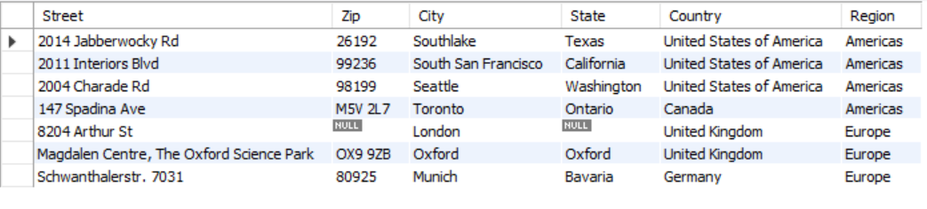

1. Number of locations in each region

SELECT COUNT(*) AS 'Number of Locations'

FROM countries

JOIN regions ON countries.region_id = regions.region_id

JOIN locations ON countries.country_id = locations.country_id;

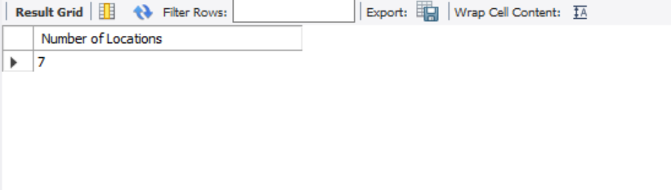

1. Departments and the locations

SELECT d.department_name AS Department, l.city AS City

FROM departments as d

JOIN locations as l ON d.location_id = l.location_id;

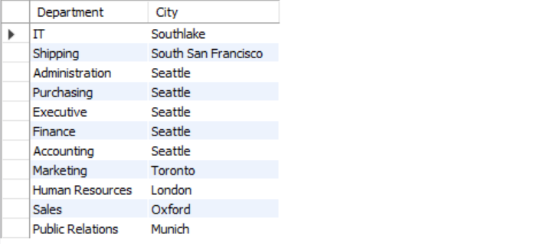

1. Employee with the highest salary

SELECT e.first_name AS 'First Name', e.last_name AS 'Last Nmae', j.job_title AS 'Job Title'

FROM employees AS e

JOIN jobs AS j ON e.job_id = j.job_id

ORDER BY e.salary DESC

LIMIT 1;

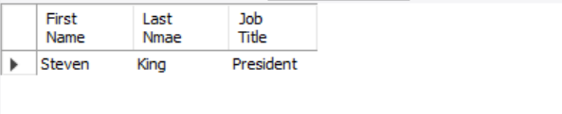

1. Employees who have children

SELECT CONCAT(e.first_name, ' ', e.last_name) AS 'Parent Name',

CONCAT(d.first_name, ' ', d.last_name) AS 'Child Name'

FROM employees AS e

INNER JOIN dependents AS d ON e.employee_id = d.employee_id;



1. Managers in each department

SELECT CONCAT(e.first_name, ' ', e.last_name) AS 'Name', j.job_title AS 'Title'

FROM employees AS e

JOIN ( SELECT job_id, job_title

FROM jobs

WHERE lower(job_title) LIKE '%manager') AS j

ON e.job_id = j.job_id;



1. Employees who make the most salary in each job title

SELECT CONCAT(e.first_name, ' ', e.last_name) AS 'Name',

j.job_title AS 'Job Title',

e.salary AS 'Salary'

FROM ( SELECT employee_id, first_name, last_name, MAX(salary) AS 'salary', job_id

FROM employees

GROUP BY job_id ) AS e

JOIN jobs AS J ON e.job_id = j.job_id

ORDER BY e.salary DESC;



1. Average years of employment

SELECT ROUND(AVG(2020 - e.Year), 0) AS 'Average Employment Years'

FROM ( SELECT employee_id, YEAR(STR_TO_DATE(hire_date, "%Y-%m-%d")) AS Year

FROM employees ) AS e

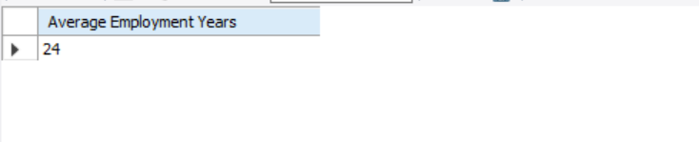

1. Average years of employment in each department

SELECT d.department_name AS 'Department', ROUND(AVG(2020 - e.Year), 0) AS 'Average Employment Years'

FROM ( SELECT employee_id, department_id, YEAR(STR_TO_DATE(hire_date, "%Y-%m-%d")) AS Year

FROM employees ) AS e

JOIN departments AS d ON e.department_id = d.department_id

GROUP BY d.department_name

ORDER BY d.department_name;

