Sarah Wood

Agile Programming

P2 A2-1

Why are we here:

We are here for a high school. We are here to simplify basic record-keeping and attendance tracking. We need this because paper records are tedious and problematic.

Elevator Pitch:

Easy. Easy interface, easy records, easy archives, easy storage.

NOT list:

We want to: accept "clock-ins" from students, track hours in class per day, archive daily records, archive "history" and "contact" fields, generate reports, allow "admin" access (create student, modify student record fields)

NOT a grading warehouse.

NOT a dump for random data.

NOT media-centric (console application only).

NOT a location-tracking system.

NOT a calendaring system.

NOT a future planning system.

Show the solution: (2 UML diagrams)

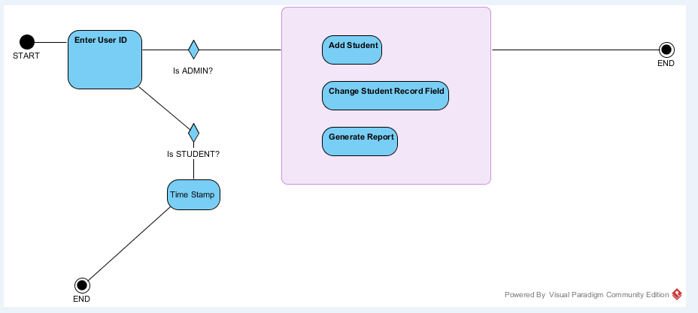

Activity Diagram

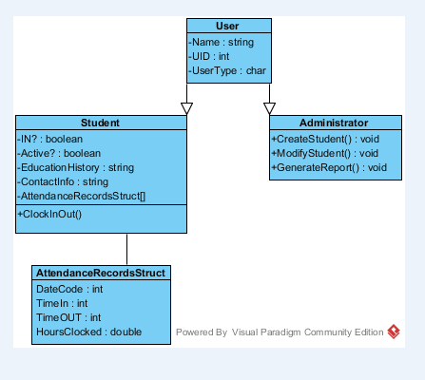

Class Diagram