Sarah Wood

Agile Programming

P2-A4-1

Analysis & Design Flow Chart:

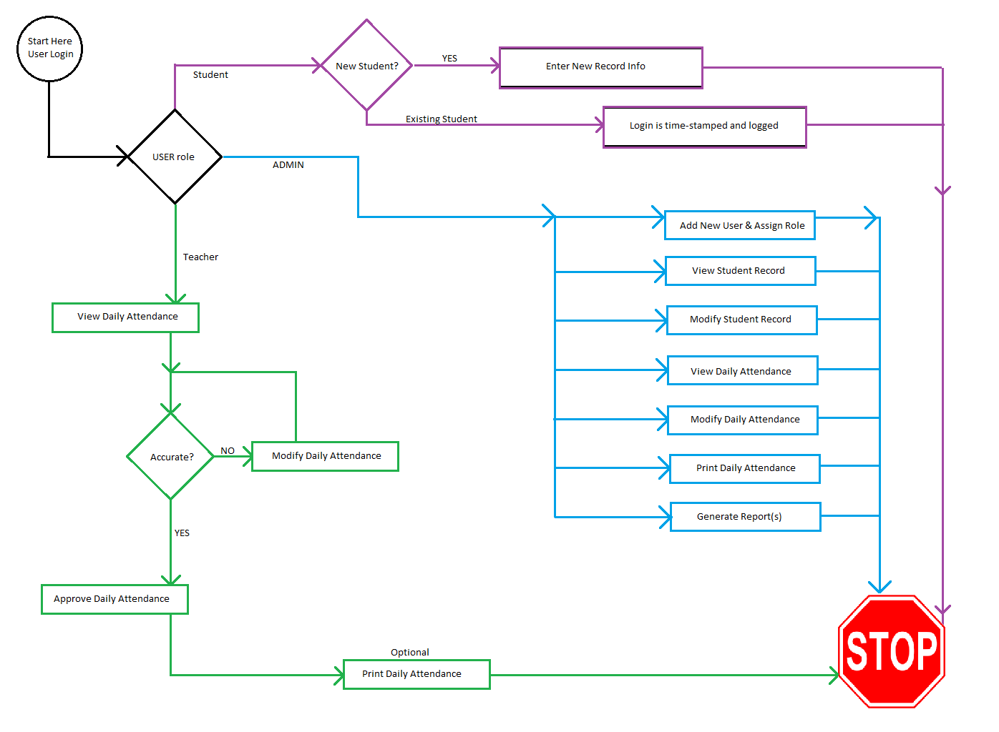

Student View:

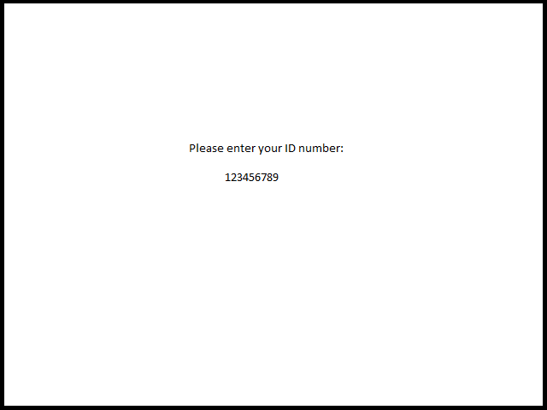

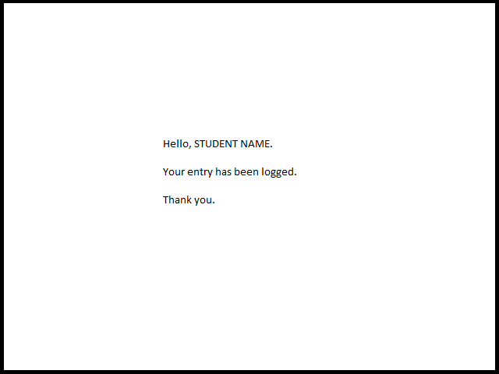

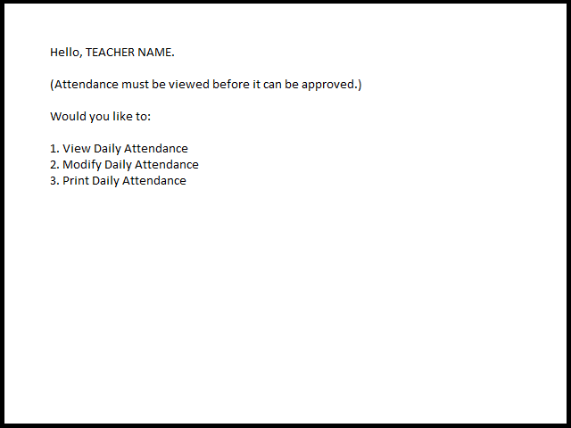

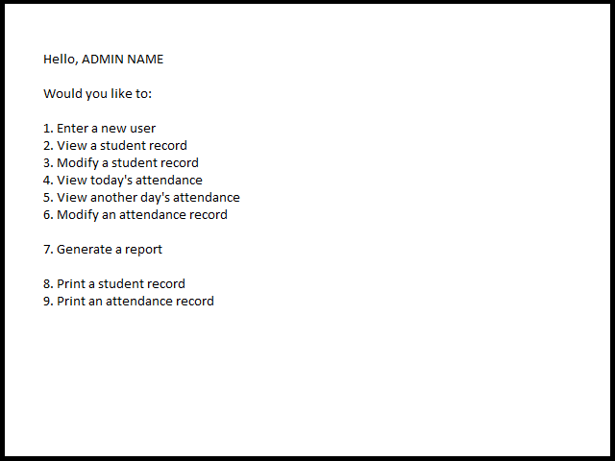

There aren’t many options for interface design in a console. I could split into different sub-menus, but things tend to get forgotten that way. “Out of sight, out of mind.”

User Personae

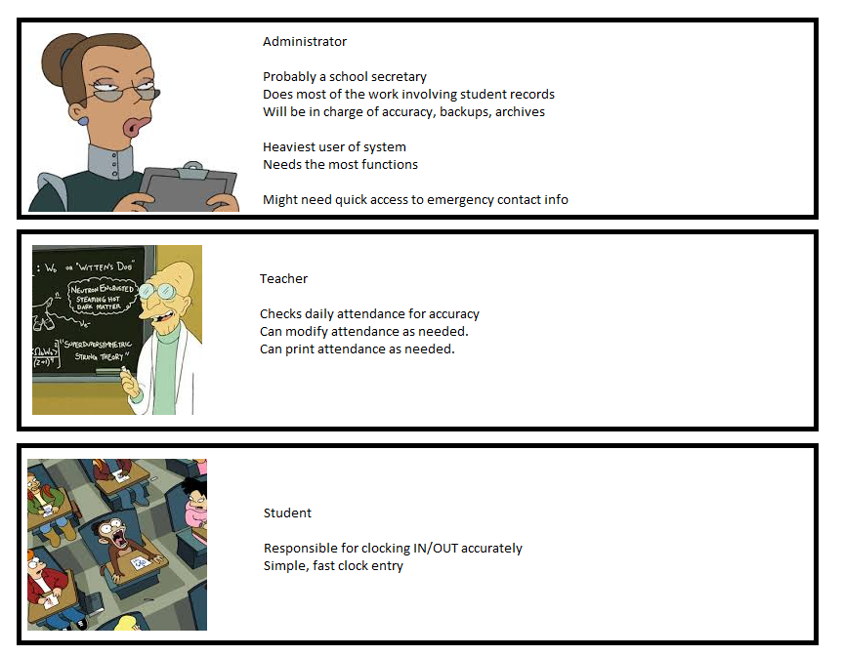

Agile Communication Plan

Our Story Planning meeting

Have we done our homework?

We have a pretty good idea forming in our heads of what the source code will look like.

We are itching to get a bare-bones implementation going.

Is our first iteration good to go?

We have a deck of story cards in order of attack.

We have our environment prepared for serious battle.

We have scheduled time for this project.

Geez, just let us kill this iteration already.

Are we ready to **RUMBLE**?!?!????

ATTACK!!

AAAAAAAAAAAAAAAAAAAAGGGGGGGGGGGGGGGGHHHHHHHHHHHHHHHHHHHHHHHHHHHH!!! 

Iteration Planning Meeting

The Showcase

Ok, team. We’ve delivered a bare-bones iteration. It doesn’t do everything YET, but it works, and is ROBUST, almost bulletproof. The client can USE IT. If we all dropped dead tomorrow, it could be DEPLOYED and USEFUL.

The Next Iteration

So far, so good. The client is happy, but it’s still very early on. Next week, we’ll start getting into some hairy stuff. The PERSON class needs to be nailed right the first time. Member functions are going to be critical. Bare-bones was lean and mean; if we can keep that elegance into the next iteration, we’ll kill it.

The Mini-Retrospective

What did we do well?

We delivered a USEABLE, USEFUL bare-bones first iteration.

How can we improve?

We wasted some time by mis-interpreting a story. We need to stop, take a deep breath, read it again, and make sure we’re pointed in the right direction before we get going.