Sarah Wood

Agile Programming

P2-A4-2

My Story Wall /My Release Wall

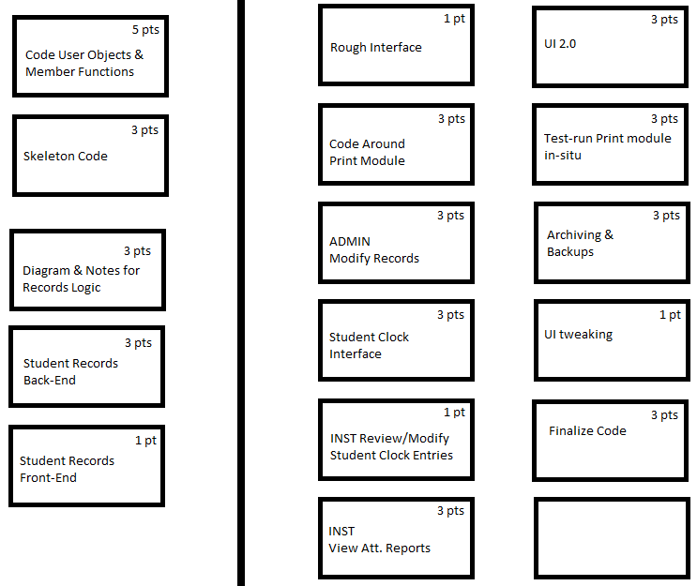

My Story Board for the current iteration

