Sarah Wood

Agile Programming

P2-A5-1

Unit Testing

I added a function to output Person records. Different person types are formatted in a similar fashion, so errors should be glaring.

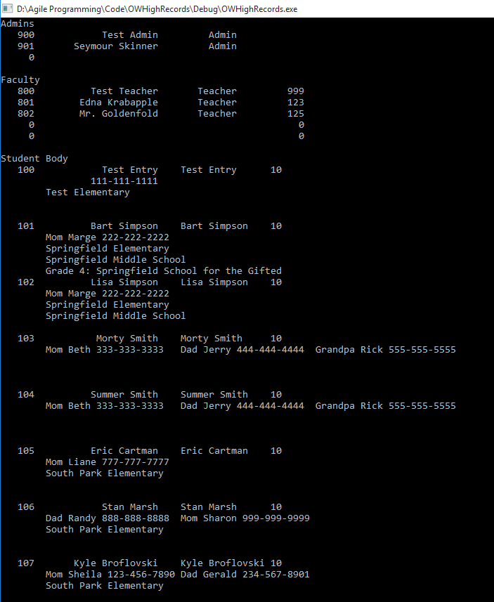

You get the idea.

Refactoring

I refactored some of the output logic for the attendance reports. If the student had no attendance, rather than no entry, they will have a zero entered to make an absence more apparent. It will be especially apparent in their individual attendance reports.

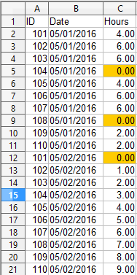

It also makes it very simple to conditionally format absences in a spreadsheet. If there was simply no entry, there would be nothing to flag, and you’d have to count each student for each date. What a pain!

Test-Driven Development

“start with a failed test” The first bit of interface code is entry validation. I.e., you can ONLY have an integer PersonID, and it can’t be already in use. That kills the “hard part” of making a new record right away. Then we visually test the input, and ask the user if the new record look correct. If NOT, we fix the incorrect record, and repeat until the record “looks right”.

Here is the first bit: asking for the new person’s “Role”, so we make the right kind of person-object

