Sarah Wood
Chapter 13
Assignment 11
“Payroll”

Screen Caps

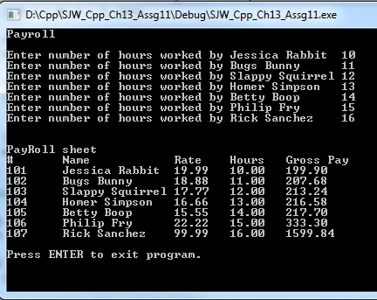

Look like “normal”
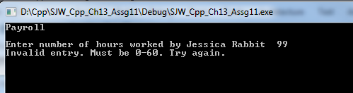

Validation works.

Source Code

$$$$$$$$$$$$$$$$$$$$$$$$$$$$$$$$$$$$$$$$$$$$$$$$$$$$$$$$$$$$$$$$$$$$$$$$$$$$
PayRoll.h
&&&&&&&&&&&&&&&&&&&&&&&&&&&&&&&&&&&&&&&&&&&&&&&&&&&&&&&&&&&&&&&&&&&&&&&&&&&&&

#include <iostream>
#include <iomanip>
#include <string>
using namespace std;

class PayRoll
{

private:
int employeeNumber;
string empName;
double rateOfPay;
double hoursWorked;
double weeklyPay;

public:
PayRoll(int id, string name, double rate)
{
employeeNumber = id;
empName = name;
rateOfPay = rate;
}
void setEmployeeNumber(int);
void setEmpName(string);
void setRate(double);
void setHours(double);

int getEmployeeNumber();
string getEmpName();
double getRate();
double getHours();
double getWeeklyPay();

PayRoll() : employeeNumber(0), empName("John Doe"), rateOfPay(18), hoursWorked(0), weeklyPay(0) {}; //default values
};

$$$$$$$$$$$$$$$$$$$$$$$$$$$$$$$$$$$$$$$$$$$$$$$$$$$$$$$$$$$$$$$$$$$$$$$$$$$$
PayRoll.cpp
&&&&&&&&&&&&&&&&&&&&&&&&&&&&&&&&&&&&&&&&&&&&&&&&&&&&&&&&&&&&&&&&&&&&&&&&&&&&&
#include <iostream>
#include <iomanip>
#include <string>
#include "PayRoll.h"

using namespace std;

//SET function definitions

void PayRoll::setEmployeeNumber(int num)
{
employeeNumber = num;
}

void PayRoll::setEmpName(string name)
{
empName = name;
}

void PayRoll::setRate(double rate)
{
rateOfPay = rate;
}

void PayRoll::setHours(double hrs)
{
hoursWorked = hrs;
}

//GET function definitions

int PayRoll::getEmployeeNumber()
{
return employeeNumber;
}

string PayRoll::getEmpName()
{
return empName;
}

double PayRoll::getRate()
{
return rateOfPay;
}

double PayRoll::getHours()
{
return hoursWorked;
}

double PayRoll::getWeeklyPay()
{
weeklyPay = (hoursWorked * rateOfPay);
return weeklyPay;
}
$$$$$$$$$$$$$$$$$$$$$$$$$$$$$$$$$$$$$$$$$$$$$$$$$$$$$$$$$$$$$$$$$$$$$$$$$$$$
source.cpp
&&&&&&&&&&&&&&&&&&&&&&&&&&&&&&&&&&&&&&&&&&&&&&&&&&&&&&&&&&&&&&&&&&&&&&&&&&&&&
/*
Payroll
Design a PayRoll class that has data members for an employee’s hourly pay rate,
number of hours worked, and total pay for the week. Write a program with an array of
seven PayRoll objects. The program should ask the user for the number of hours each
employee has worked and will then display the amount of gross pay each has earned.
Input Validation: Do not accept values greater than 60 for the number of hours
worked.
*/

#include <iostream>
#include <iomanip>
#include <string>
#include "PayRoll.h"

using namespace std;

int main()
{
//init console
cout << "Payroll" << '\n' << '\n';

//make a variable to hold temp input

double hoursThisWeek;

//create an instance
PayRoll thisWorker;
int num;
string name;
double rate;
double hrs;
double grossPay;

//make seven employees
const int SIZE = 7;
PayRoll workers[SIZE] = {
PayRoll(101, "Jessica Rabbit", 19.99),
PayRoll(102, "Bugs Bunny", 18.88),
PayRoll(103, "Slappy Squirrel", 17.77),
PayRoll(104, "Homer Simpson", 16.66),
PayRoll(105, "Betty Boop", 15.55),
PayRoll(106, "Philip Fry", 22.22),
PayRoll(107, "Rick Sanchez", 99.99),
};

//get user input for hours worked
for (int i = 0; i < 7; i++)
{
cout << "Enter number of hours worked by " << workers[i].getEmpName() <<'\t' ;
cin >> hoursThisWeek;

while (hoursThisWeek < 0 || hoursThisWeek>60)
{
cout << "Invalid entry. Must be 0-60. Try again.";
cin >> hoursThisWeek;
}
workers[i].setHours(hoursThisWeek);
}

//Display figures for each employee

cout <<'\n'<<'\n'<< "PayRoll sheet" << '\n';
cout << "#" << '\t' << "Name" << '\t' << '\t' << "Rate" << '\t' << "Hours" << '\t' << "Gross Pay" << '\n';

cout << fixed << showpoint << setprecision(2);
for (int i = 0; i < 7; i++)
{
cout << workers[i].getEmployeeNumber() << '\t' << workers[i].getEmpName() << '\t' << workers[i].getRate();
cout << '\t' << workers[i].getHours() << '\t' << workers[i].getWeeklyPay() << '\n';

}

//keep window open

cout << '\n' << "Press ENTER to exit program."; //advise user of correct keypress to exit
cin.ignore(256, '\n'); //ignore up to 256 characters, stop ignoring at any instance of '\n'
cin.get();
return 0;
}

