Sarah Wood
Chapter 17
Assignment 8
“List Template”

Screen Caps

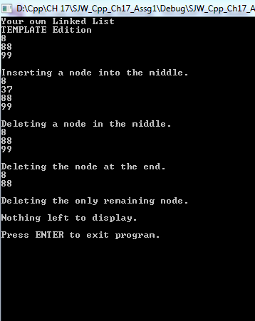
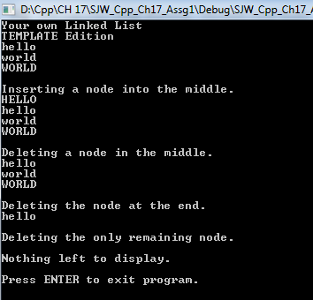
It also works with strings, so long as I instantiate the list with a <string> type.

Source Code

&&&&&&&&&&&&&&&&&&&&&&&&&&&&&&&&&&&&&&&&&&&&&&&&&&&&&&&&&&&&&&&&&
Classes.h
*******************************************************************
#pragma once

#ifndef NUMBERLIST_H
#define NUMBERLIST_H

#include <iostream>
#include <cstddef>

using namespace std;

template <class T>
class NumberList
{
private:

struct ListNode
{
T value;
struct ListNode *next;
};

ListNode *head;

public:
//contructor, head pts to NULL
NumberList()
{
head = nullptr;
}

//destructor

~NumberList();

//operations

void appendNode(T);
void insertNode(T);
void deleteNode(T);
void displayList();

};

//&&&&&&&&&&&&&&&&&&&&&&&&&&&&&&&&&&&&&&&&&&&&&&&&&&&&&&&&&&
template <class T>
NumberList<T>::~NumberList()
{
ListNode *nodePtr; // To traverse the list
ListNode *nextNode; // To point to the next node

// Position nodePtr at the head of the list.
nodePtr = head;

// While nodePtr is not at the end of the list...
while (nodePtr != nullptr)
{
// Save a pointer to the next node.
nextNode = nodePtr->next;

// Delete the current node.
delete nodePtr;

// Position nodePtr at the next node.
nodePtr = nextNode;
}
}

template <class T>
void NumberList<T>::appendNode(T num)
{
ListNode *newNode;
ListNode *nodePtr;

//make a new node and store "num"

newNode = new ListNode;
newNode->value = num;
newNode->next = nullptr;

//make newNode the first node if we have none.

if (!head)
head = newNode;
else //else, is end of list
{
//nodePtr to head of list
nodePtr = head;

//traverse to last in list

while (nodePtr->next)
{
nodePtr = nodePtr->next;
}

//insert newNode as last node

nodePtr->next = newNode;
} //close "else"
} //close "append"

template <class T>
void NumberList<T>::insertNode(T num)
{

ListNode *newNode; // A new node
ListNode *nodePtr; // To traverse the list
ListNode *previousNode = nullptr; // The previous node

// Allocate a new node and store num there.
newNode = new ListNode;
newNode->value = num;

// If there are no nodes in the list
// make newNode the first node
if (!head)
{
head = newNode;
newNode->next = nullptr;
}
else // Otherwise, insert newNode
{
// Position nodePtr at the head of list.
nodePtr = head;

// Initialize previousNode to nullptr.
previousNode = nullptr;

// Skip all nodes whose pointer value is less than num.
while (nodePtr != nullptr && nodePtr->value < num)
{
previousNode = nodePtr;
nodePtr = nodePtr->next;
}

// If the new node is to be the 1st in the list,
// insert it before all other nodes.
if (previousNode == nullptr)
{
head = newNode;
newNode->next = nodePtr;
}
else // Otherwise insert after the previous node.
{
previousNode->next = newNode;
newNode->next = nodePtr;
}
}
}

template <class T>
void NumberList<T>::deleteNode(T num)
{
ListNode *nodePtr; //traverse-r
ListNode *previousNode; //point to previous node
previousNode = head; //make the "previous" node point to something to start with

//if list empty, do nothing

if (!head)
return;

//is the first node the one we need to delete?
if (head->value == num)
{
nodePtr = head->next;
delete head;
head = nodePtr;
}
else
{
//let's look for the node we want
nodePtr = head;

//skip the ones we don't want
while (nodePtr != nullptr && nodePtr->value != num)
{
previousNode = nodePtr;
nodePtr = nodePtr->next;
}

//if nodePtr is not end of list, link previous to node after "this one", then delete "this one"

if (nodePtr)
{
previousNode->next = nodePtr->next;
delete nodePtr;
}

} //close else
}

template <class T>
void NumberList<T>::displayList()
{

ListNode *nodePtr; // move through the list

//NodePtr at the head of the list.
nodePtr = head;

// traverse the list.
while (nodePtr)
{
// Display the value in this node.
cout << nodePtr->value << endl;

// Move to the next node.
nodePtr = nodePtr->next;
}
}
#endif // !NUMBERLIST_H

&&&&&&&&&&&&&&&&&&&&&&&&&&&&&&&&&&&&&&&&&&&&&&&&&&&&&&&&&&&&&&&&&
Source.cpp
*******************************************************************
/*
1. Your Own Linked List
Design your own linked list class to hold a series of integers. The class should have
member functions for appending, inserting, and deleting nodes. Don’t forget to add a
destructor that destroys the list. Demonstrate the class with a driver program.
*/

#include <iostream>
#include "Classes.h"

using namespace std;

void main()
{
cout << "Your own Linked List" << '\n';
cout<<"TEMPLATE Edition"<< '\n';

//make a NumberList object
NumberList<int> list;

//add some values to the list
list.appendNode(8);
list.appendNode(88);
list.appendNode(99);

//display current list
list.displayList();

//insert a node into the middle
list.insertNode(37);
cout << '\n' << "Inserting a node into the middle." << '\n';

//display current list
list.displayList();

//delete a node in the middle
list.deleteNode(37);
cout << '\n' << "Deleting a node in the middle." << '\n';

//display current list
list.displayList();

//delete last nodes
list.deleteNode(99);
list.deleteNode(88);
cout << '\n' << "Deleting the node at the end." << '\n';

//display current list
list.displayList();

//delete the remaining node
list.deleteNode(8);
cout << '\n' << "Deleting the only remaining node." << '\n';

//nothing to display now.
cout << '\n' << "Nothing left to display." << '\n';

//keep window open

cout << '\n' << "Press ENTER to exit program."; //advise user of correct keypress to exit
cin.ignore(256, '\n'); //ignore up to 256 characters, stop ignoring at any instance of '\n'
cin.get();

}

