Sarah Wood
Chapter 19
Assignment 5
“Recursive Multiplication”

Screen Caps

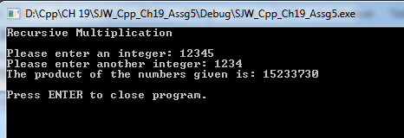

Source Code

/*

Recursive Multiplication
Write a recursive function that accepts two arguments into the parameters x and y .
The function should return the value of x times y.Remember, multiplication can be
performed as repeated addition :
7 * 4 = 4 + 4 + 4 + 4 + 4 + 4 + 4

*/

#include <iostream>

//I've learned that in larger &/or legacy code, "using namespace std" can cause headaches with custom name spaces. I'm going to see if I can live without it.

// Follow-up: it wasn't bad to go without it, and I could understand if I had a "custom function names", that I wouldn't want to confuse anything. I probably won't be using custom name spaces in the scope of this class, but it's good to know.

long int multiplyNumbers(long int, long int);
long int tempVariable = 0;

void main()
{
//init console
std::cout << "Recursive Multiplication" << '\n' << '\n';

//make variables and get user entry for their values
long int numberX, numberY;
std::cout << "Please enter an integer: ";
std::cin >> numberX;
std::cout << "Please enter another integer: ";
std::cin >> numberY;
std::cout << "The product of the numbers given is: "<<multiplyNumbers(numberX, numberY) << '\n'<<'\n';

//keep window open
std::cout << "Press ENTER to close program." << std::endl;
std::cin.ignore(256, '\n');
std::cin.get();

}

long int multiplyNumbers(long int numX, long int numY)
{
if (numX == 0 || numY==0)
return 0; //Multiplying by zero makes zero

else
{
return (numX + multiplyNumbers(numX, numY - 1)); //recursive case
//return X + X a decreasing number of times -- until we run out
}

}

