C#, part 2, ASP.Net

Sarah Wood

Chapter 16, “Try It Out”

Initial Configuration for Personalization

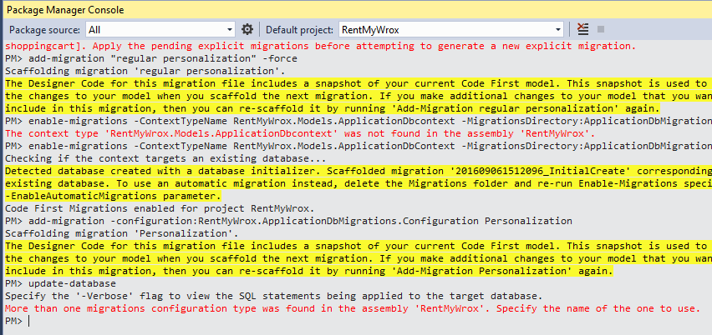

Package Manager kak. “Update-database” failed as it should.

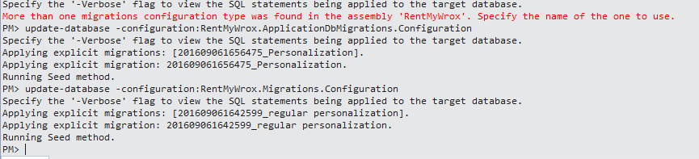

Ran two updates with configuration specs.

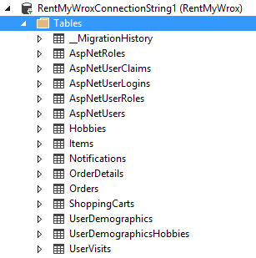

New table: UserVisits created successfully. AspNetUsers has many new columns that are difficult to show here.

**Capturing and Applying Data**

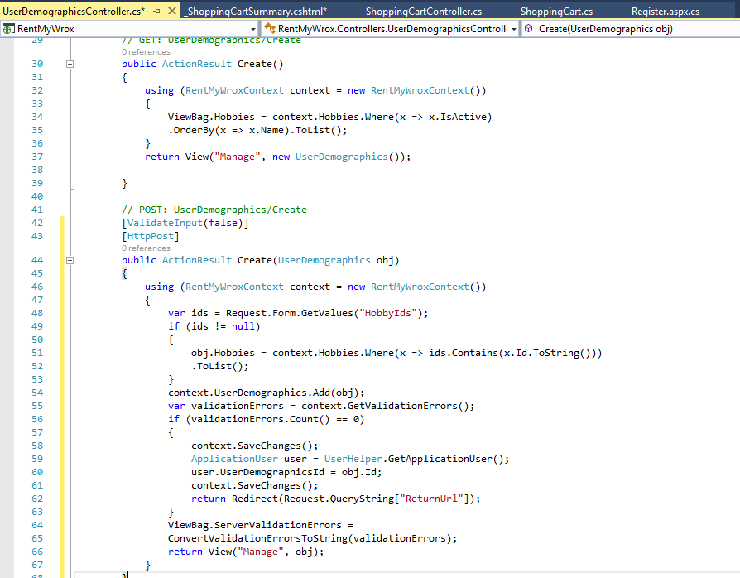

Modified Register, ShoppingCart, ShoppingCartController, ShoppingCartSummary, and UserDemographicsController.

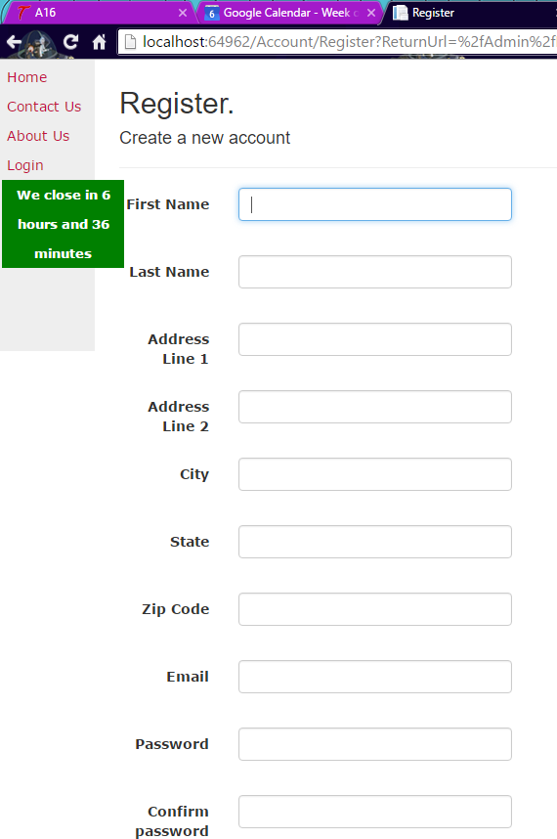

Looks like it works.

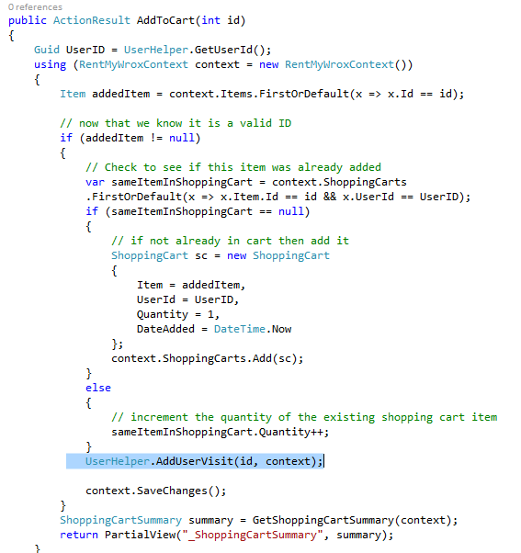

NOTE: IN #12, figure 16-10 does NOT look like what the code should look like at this point. It should look like the above, note the highlighted text. (Author used a picture that belongs further along in the text)

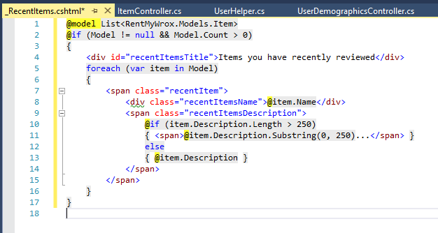

Updated controller and created RecentItems.

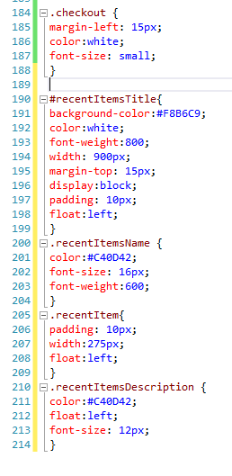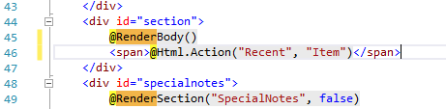

More CSS, and Addition to Render Body.

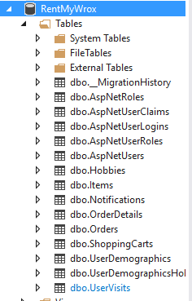

Looks like the database updates worked. I have several new tables.