C#, part 2, ASP.Net

Sarah Wood

Chapter 17, “Try It Out”

Adding Error Pages

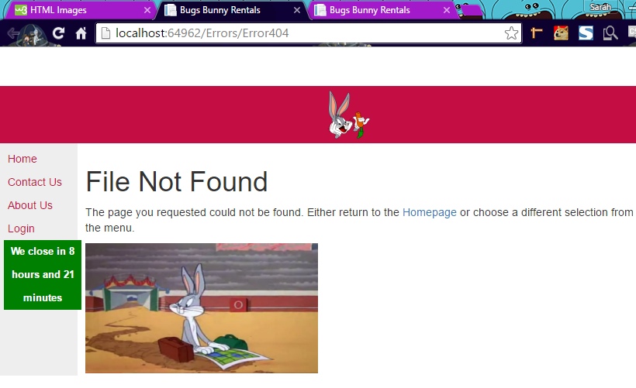

404 works. I knew I shoulda taken that left turn at Albuquerque.

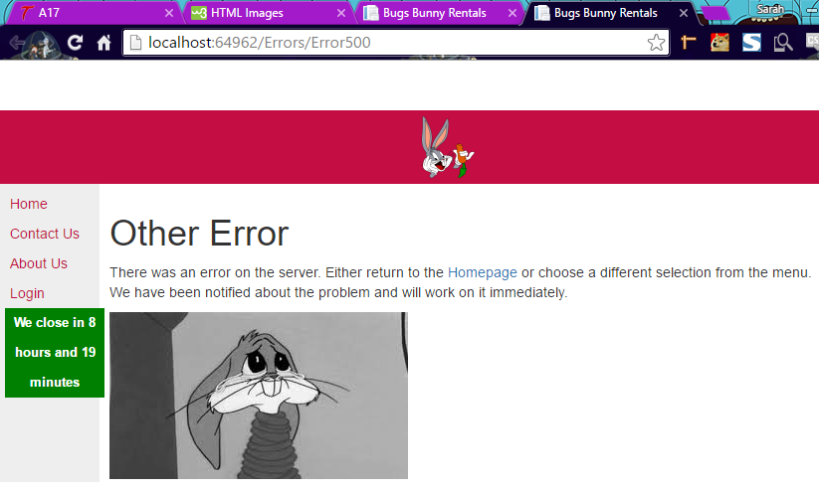

500 also works. I also installed a header image in the Site Master.

Debugging Faulty Code

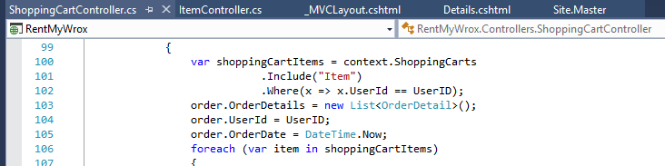

Updating buggy code for ShoppingCartController. Have built details and Address views.

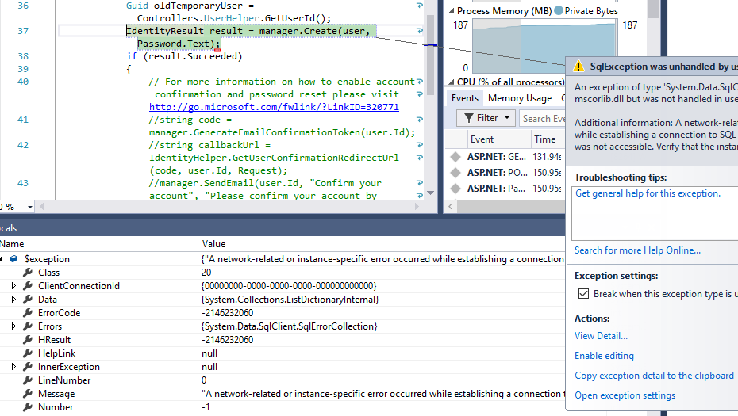

I got a different error first. Time to troubleshoot the database connection.

Nothing I do seems to help. Time for a Hail Mary. I deleted the database, rebuilt, reconnected, re-scaffolded and re-seeded it. Not the greatest field solution, but it seems to working OK so far. Entering test data…

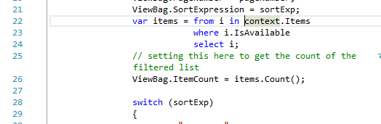

I kept getting a weird error that wouldn’t let my items populate. Turns out in my enthusiasm I omitted “Provider Name” in my connection strings in Web.Config . I fixed that and…

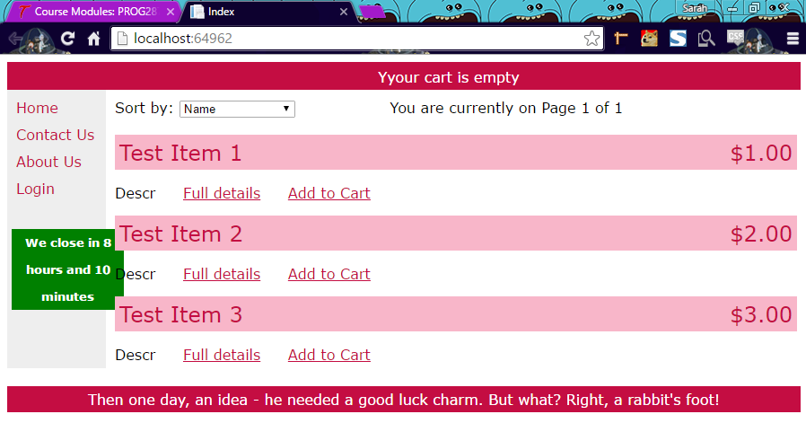

Population. Other stuff to fix, but I have an item list.

Repeated add-migration and update database for both migrations. Now I can’t add new users. Looks like a database design script didn’t or couldn’t execute to add name and address data to the AspNetUsers table.

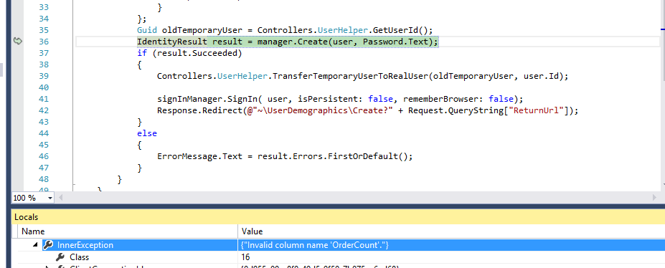

Do not forget to add a column for “OrderCount”. Also, make sure your “UserDemographicsId” column is set to INTEGER!

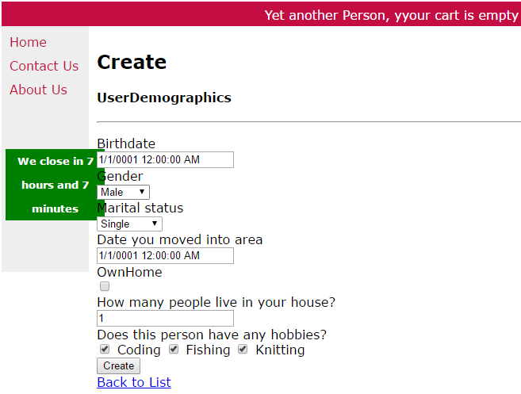

Registering a new person didn’t throw any errors, and took me to Demographics. Demographics threw an error: something to do with the Redirect request (UserDemographicsController.cs , ~ line 62 ). I can log in just fine with the new credentials, though.

Now that I’ve had the advanced course in troubleshooting, I’m going to see if I can complete this part of the assignment.

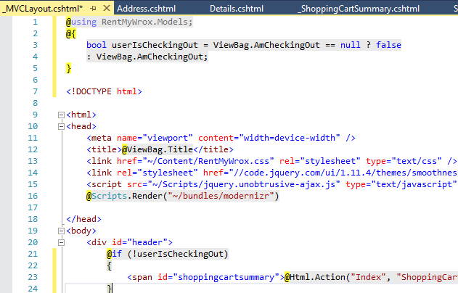

Now that I’ve done steps 1-8 as per the book, let’s see if we can break it—but in a predictable way.

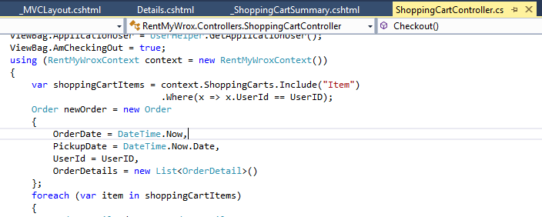

Broke it in a predictable way, and updated context as per #11.

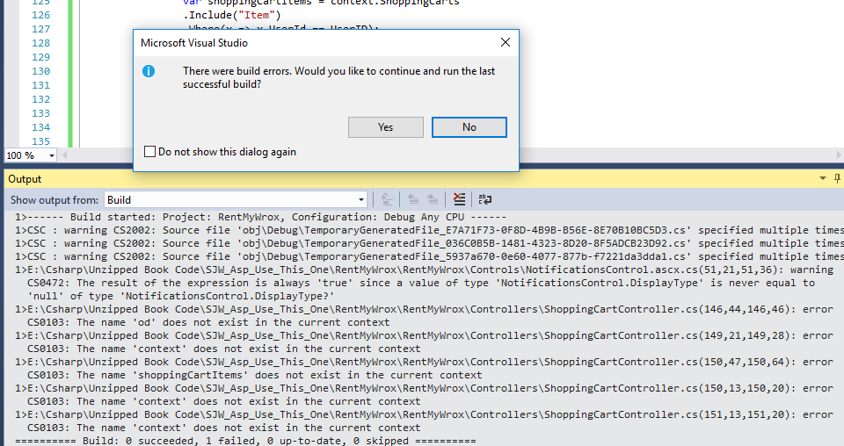

Now I’m getting errors in “UserDisplayName”. The inner exception says “Invalid column name : UserDisplayName” It’s just two name strings fetched from the database and assigned to a few places. It looks like it should work, but it doesn’t.

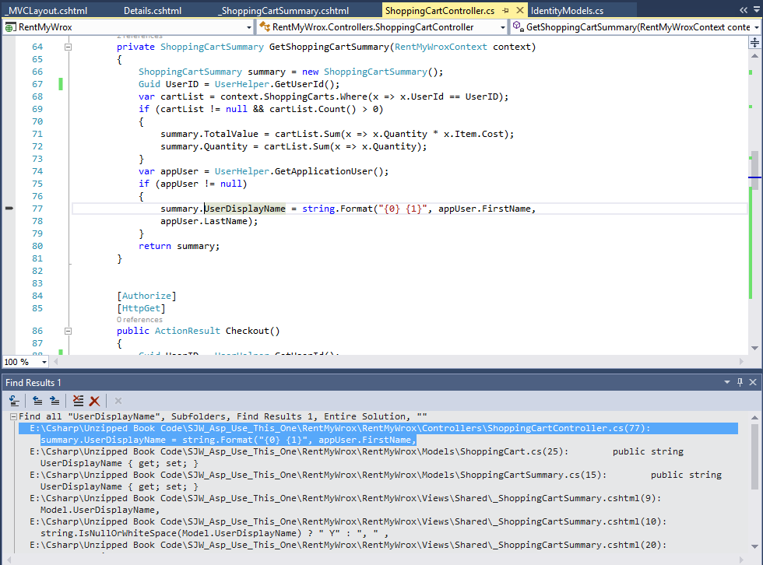

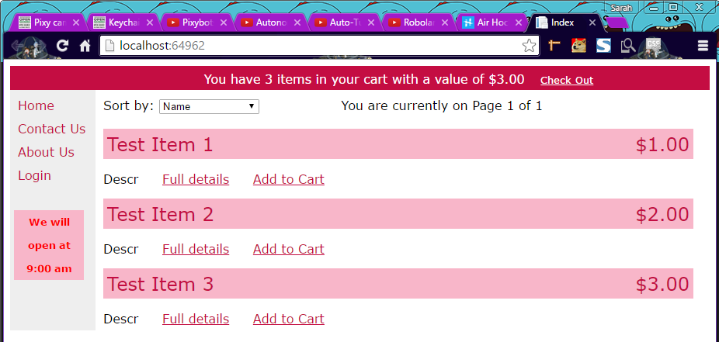

I commented out anything that used “UserDisplayName” and it will at least build now. Can I check out?!?

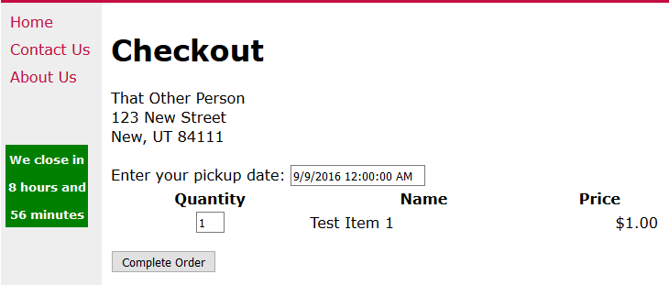

So far, so good. Let’s add the checkout method as per #14

Hooray, it runs to the breakpoint. Adjust the parse statement to actually work, and…

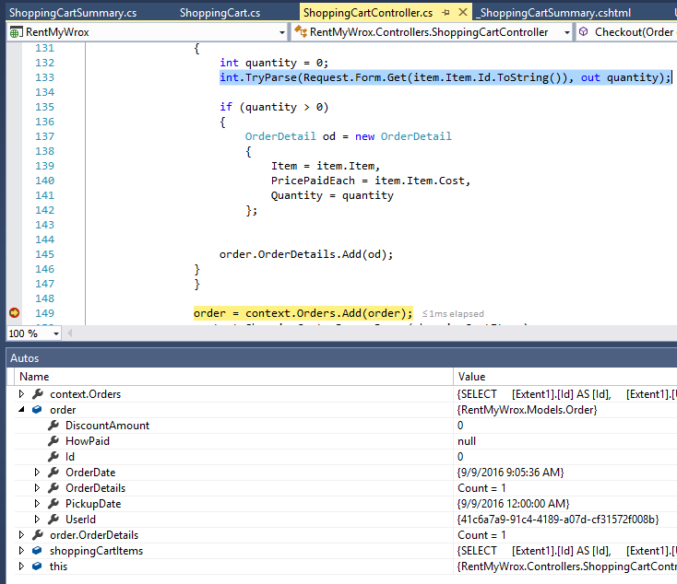

Order Details! Now to add an Order Controller. This is a long assignment. You still with me?

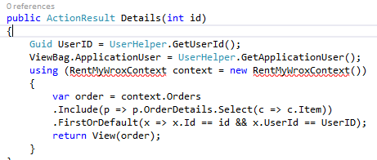

For #25, I get a context error. The easiest way to fix that is to include “using RentMyWrox.Models”, but then I get this:

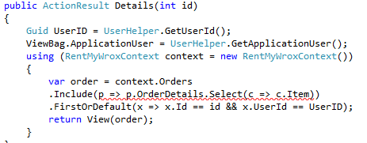

Include is new, but the paragraph on page 647 is less than helpful. Let’s do some sleuthing.

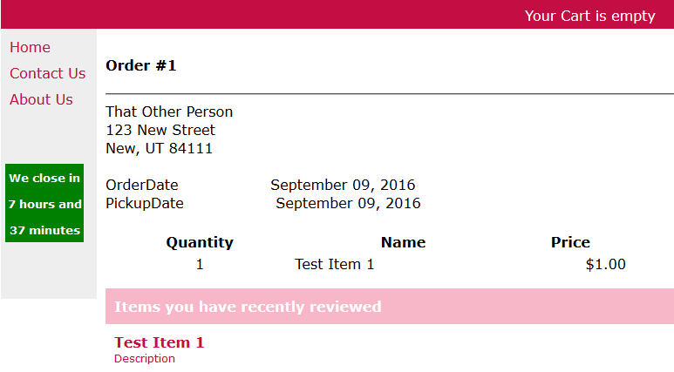

Adding the directives “using RentMyWrox.Models” and “using System.Data.Entity” fixed my difficulty.

Configuring Tracing

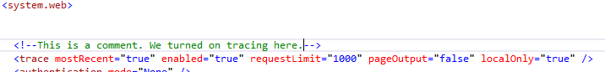

Tracing ON. Let’s see what it does.

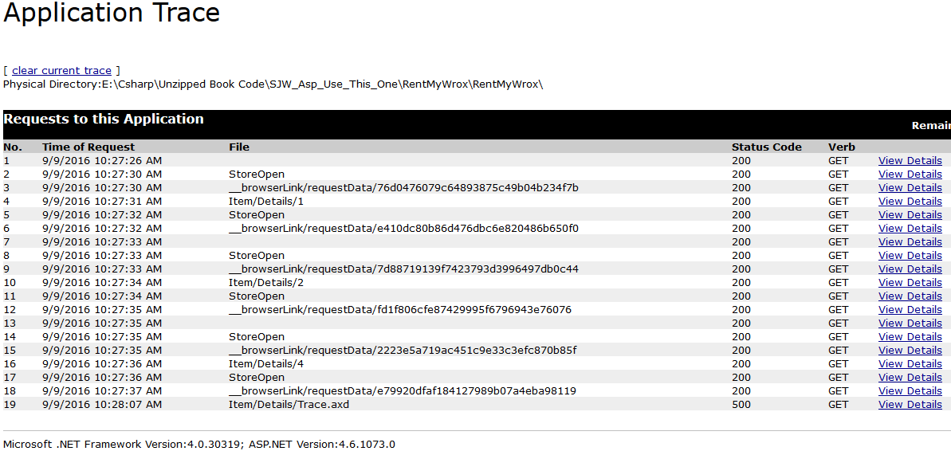

It works! (It helps to realize that “trace.axd” is NOT in the Solution Explorer. It is a web page you view in browser. D’oh!)

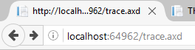

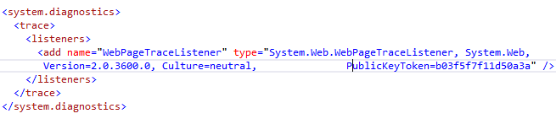

Added TraceListener.

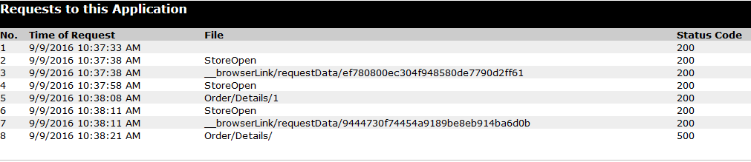

Hey, code 500 is an error. Let’s see more details.

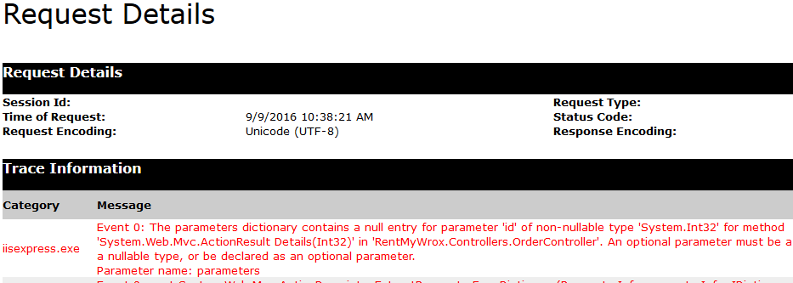

OK, in order to show something, it has to point to something to show. It can’t show nothing without a “nothing” error.

Adding nLog

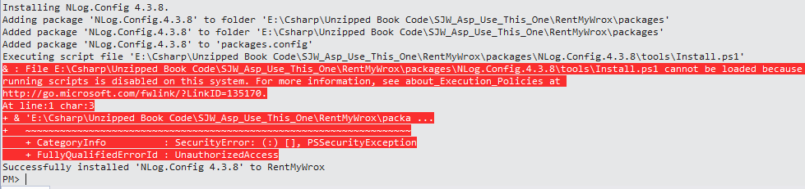



This helped. I’ll roll it back after Nlog installs.

OTHER STUDENTS will want to Bypass Execution policy FIRST. (I had to uninstall Nlog and re-install.)

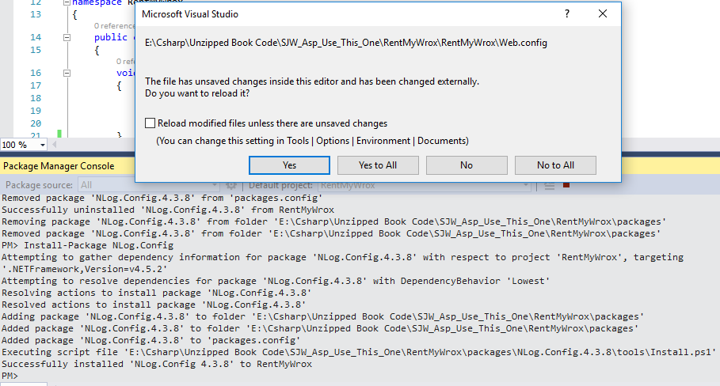

Click YES.

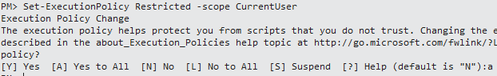

Important step. Roll the Execution policy back to Restricted.

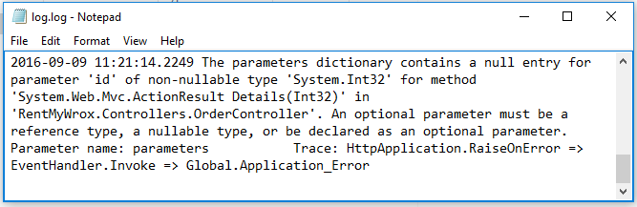

<CueMedia: Ren&Stimpy> It’s LOG! It’s LOG! It’s big, it’s heavy, it’s Wood!

LOG, LOG,



We survived. This looks like the hairiest chapter. Time to celebrate. Happy happy joy joy!



</Ren&Stimpy>