C#, part 2, ASP.Net

Sarah Wood

Chapter 14, “Try It Out”

Bundling JavaScript Files

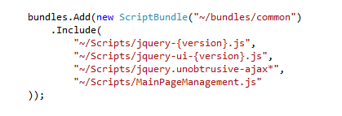

I adjusted _MVCLayout & BundleConfig. Let’s see what it does.

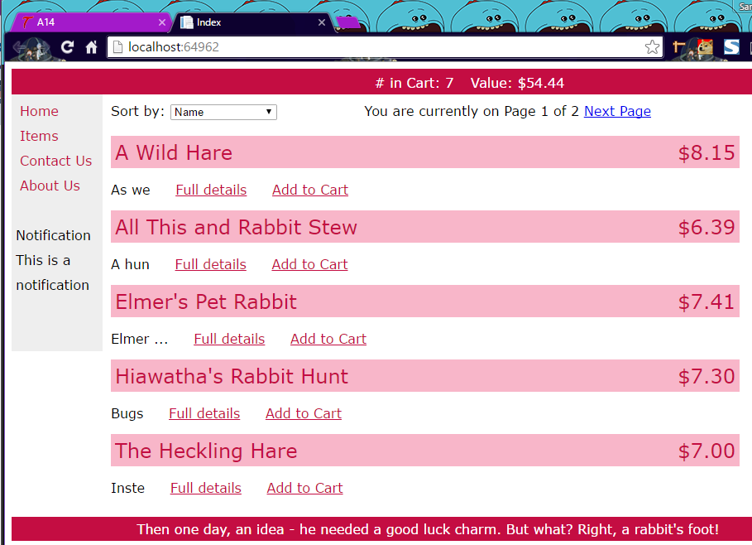

Everything looks OK, EXCEPT Store Hours! ☹

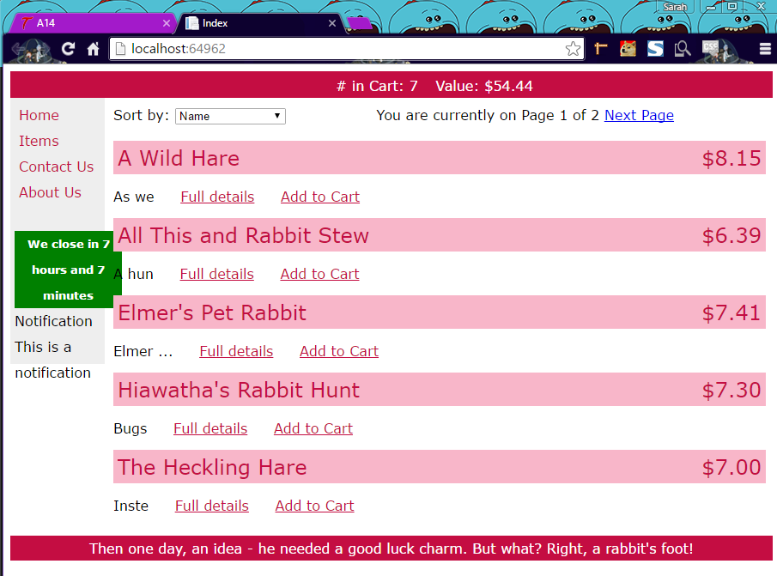

There are my Store Hours. Poorly aligned, but functional. (I build MainPageManagement.js in the WebForms directory, but referenced it in the Scripts directory. D’oh!)

Adding jQuery to Our Application

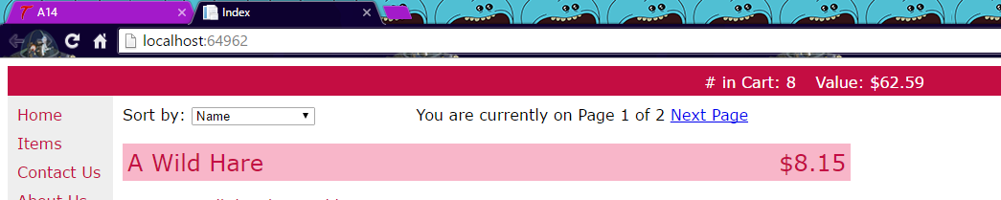

It did a fancy fade when the update executed.

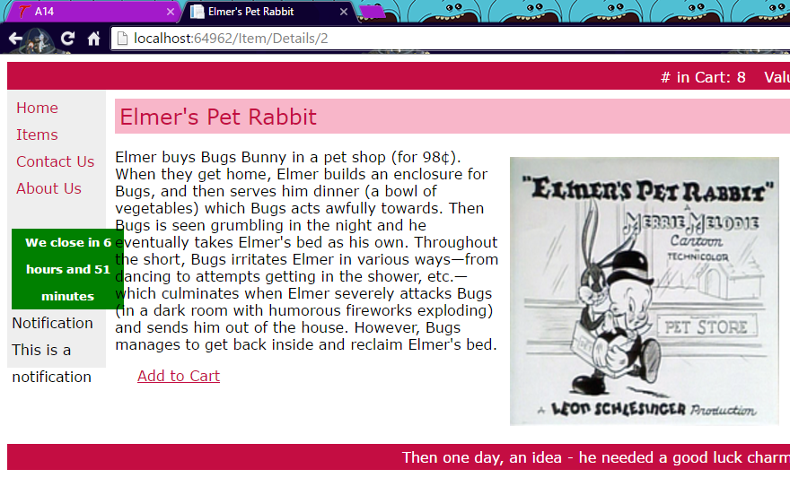

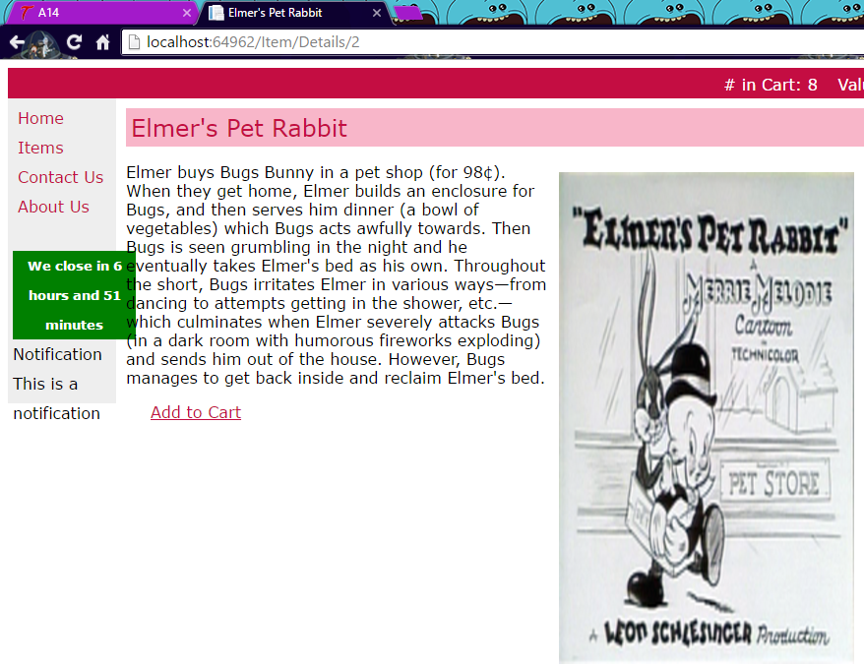

It stretches the height of the image upon image click.

It looks like everything except “List Item Hover” works. Troubleshooting time! (I missed step 6: adding the <div class = “listitem”>) Let’s check it now.

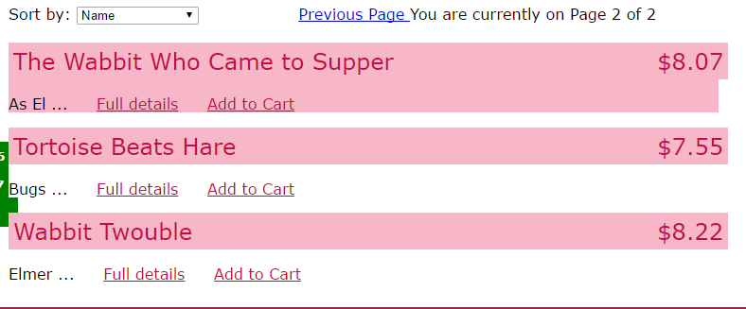

Hovering on “The Wabbit Who Came to Supper” highlights the whole item entry.

Debugging JavaScript Code

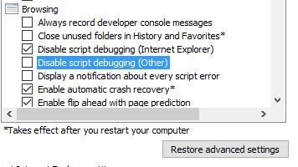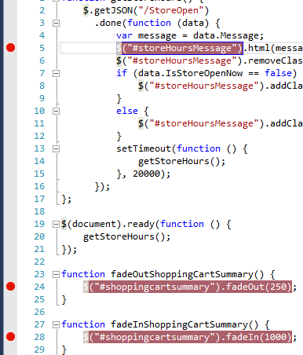

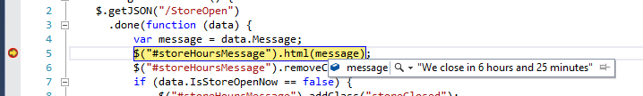

Breakpoints work.

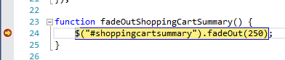

Second breakpoint works.

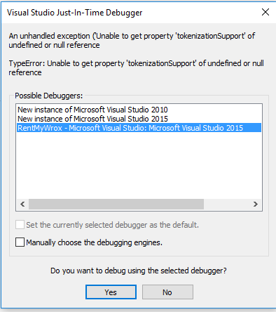

IE Threw this JIT debugger window at me. Since the exercise is to use the IE debugger, I will not debug now.

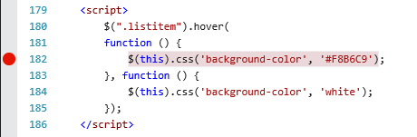

Breakpoint inserted.

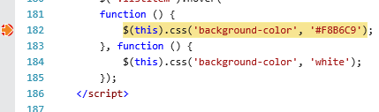

When I start the application running again, it runs until my mouse touches a list item, then it hits breakpoint. It is rather difficult to show in a Word document.

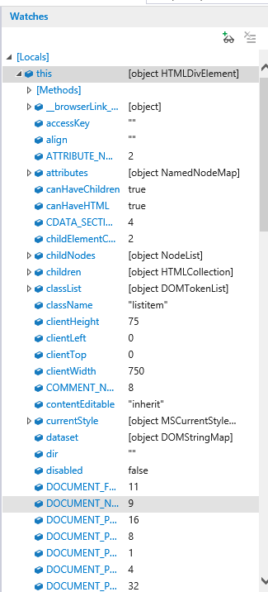

There is a lot of information in the Watches window.