C#, part 2, ASP.Net

Sarah Wood

Chapter 19, “Try It Out”

Adding Configuration

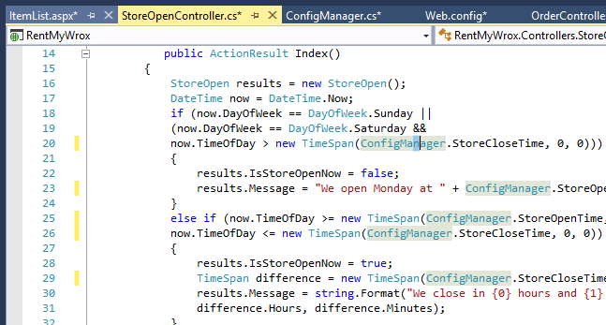

Abstracted Shop hours to a configuration manager and an hours controller. Did we kill it?

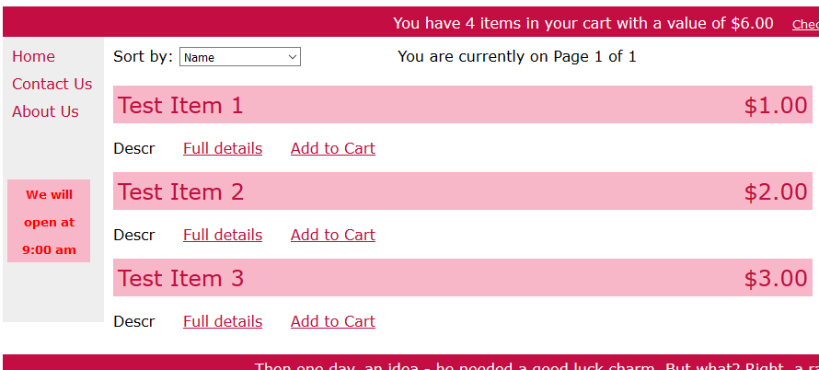

No, we got a bunch of new warnings, but no showstoppers. (they were left over from Nlog)

Registering for Microsoft Azure

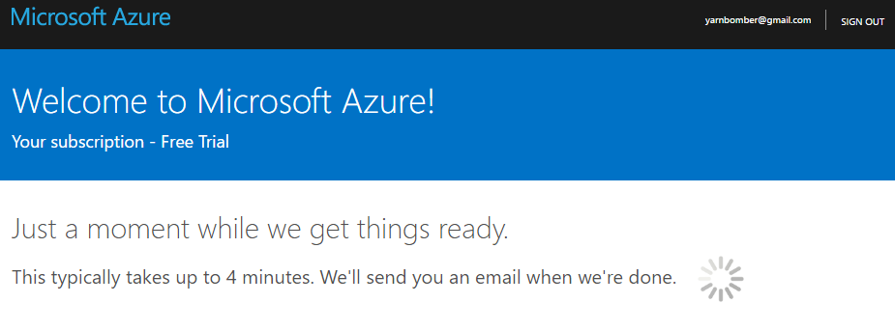

Nothing too difficult.

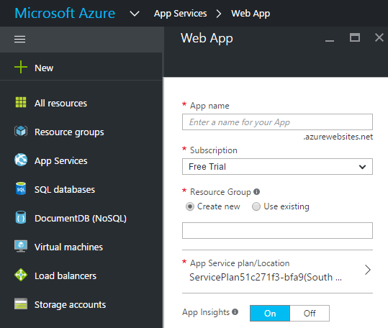

This part was a little different from the book. You have to have an active App Service to connect to. The above image was snipped from my browser while I was logged into Azure.

Publishing Your Site

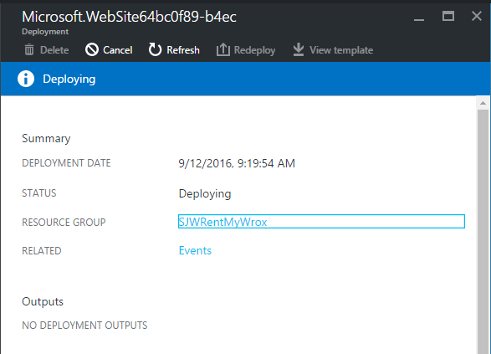

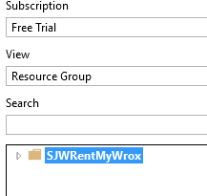

And there it is.

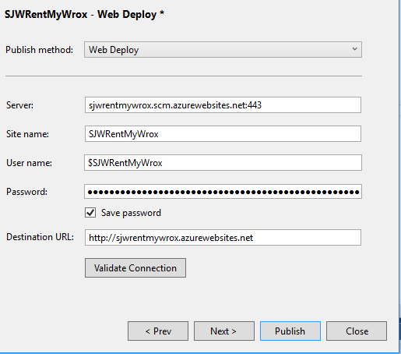

A URL! I’ll be able to find it out in the wild.

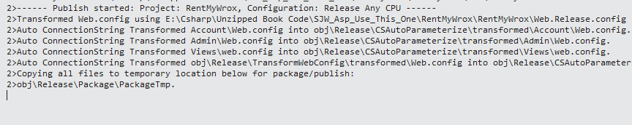

…Add a bunch of files…

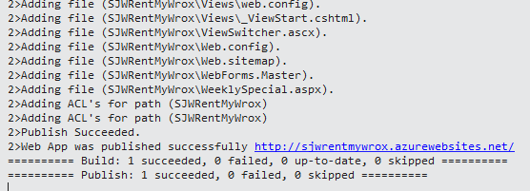

Looks like the publish went well.

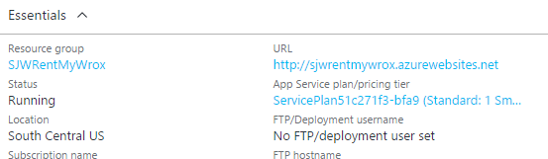

This is the Azure window.

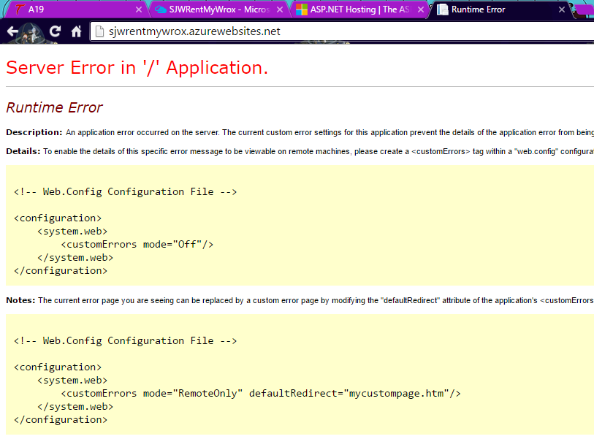

Hooray! Our first error after going live.

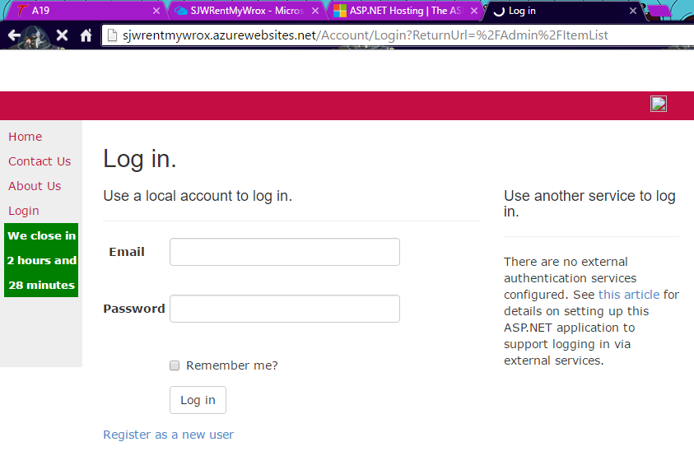

I can get to login, but home is still broken, as I haven’t linked to the database yet.

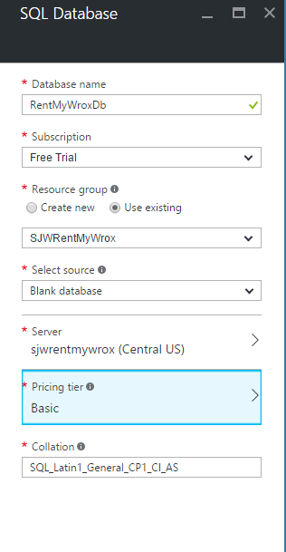

Inside Azure, I added a database.

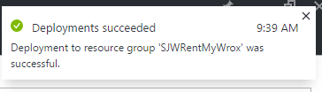

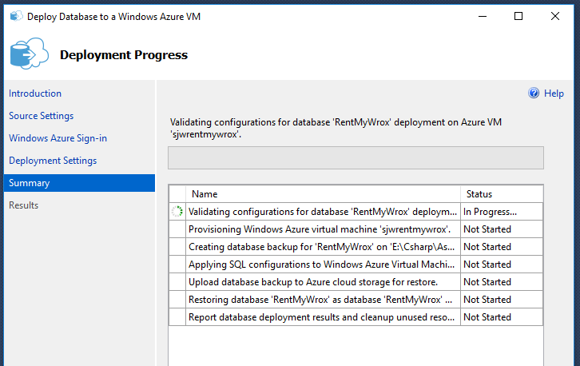

Now that there’s a place for it in Azure, I’m in SQL Server Management, where there is a “deploy to Azure” wizard. This took a while. At this point, I can access certain pages from their URL, but I hope this connects the current version of my database. That would be nearing full functionality.

I’m going to let it percolate while I work on the rest of the assignment.

Adding Transformations to Your Application

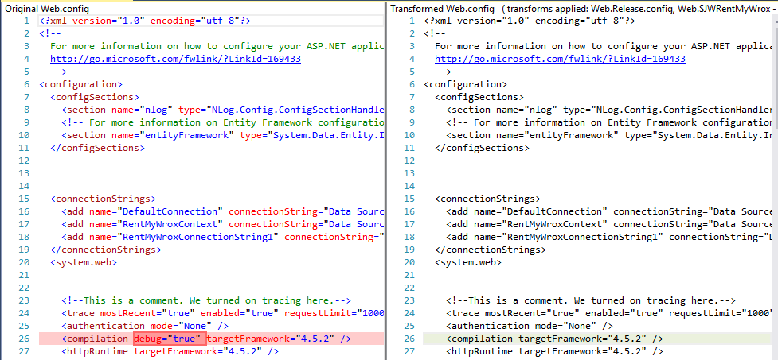

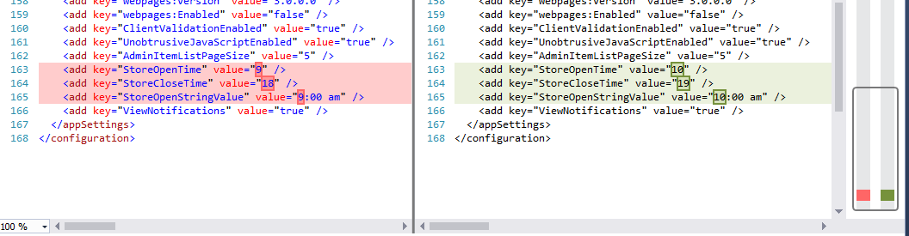

Copying Data to the Remote Server

I’m getting hung up on #7. It won’t import my tables due to a versioning problem.

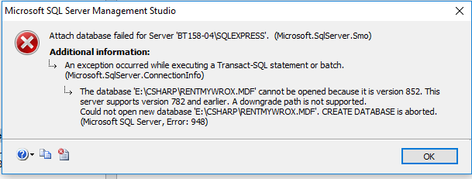

No matter which workaround I use, it won’t import my tables. I can’t “backdoor” it in File Manager, because I don’t have admin privileges in that directory.

I repeated the Publish, and was able to upload the database. One tricky part is

Smoke Testing Your Application

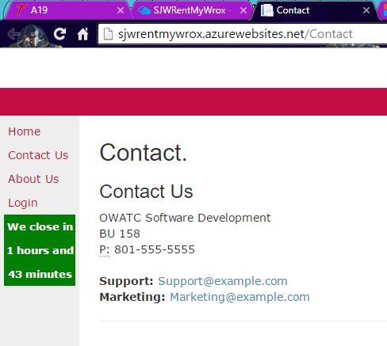

I can get to pages that don’t access the database, but I cannot get the database to upload.