C#, part 2, ASP.Net

Sarah Wood

Chapter 15, “Try It Out”

Adding Registration Capability

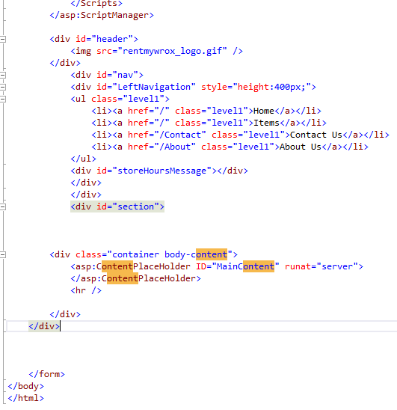

Modified Site Master

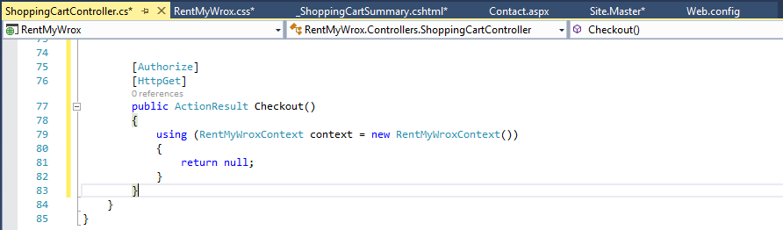

Modified Cart Controller, CSS, Summary code-behind, and Webconfig.

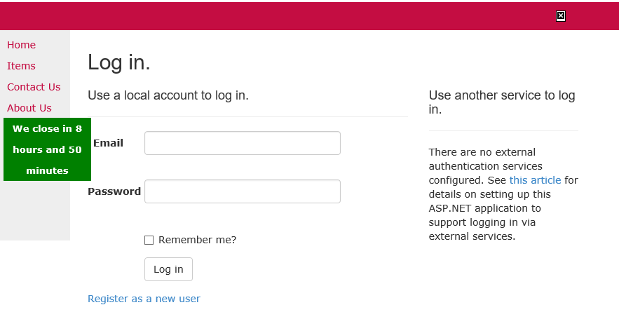

It builds and “Check Out” asks for registration.

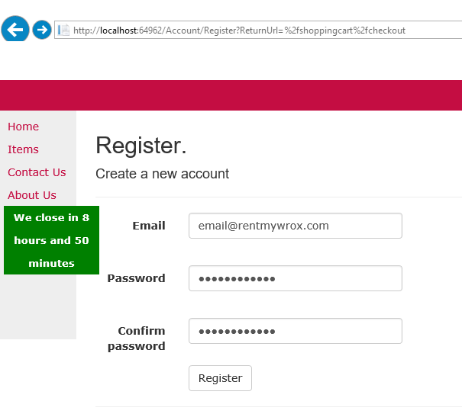

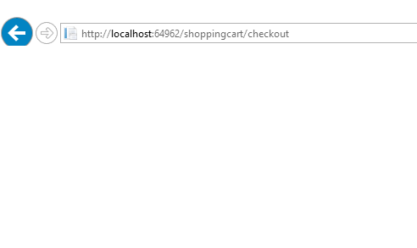

I get the indicated blank page at checkout. Registration seemed to work fine. Let’s see what’s in the tables.

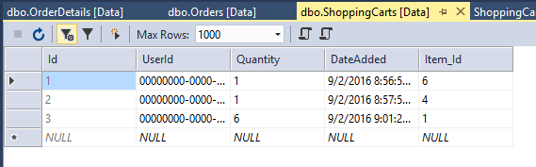

No order data yet (I haven’t built that part), but cart data is generating nicely.

Update Shopping Cart Based on Real User

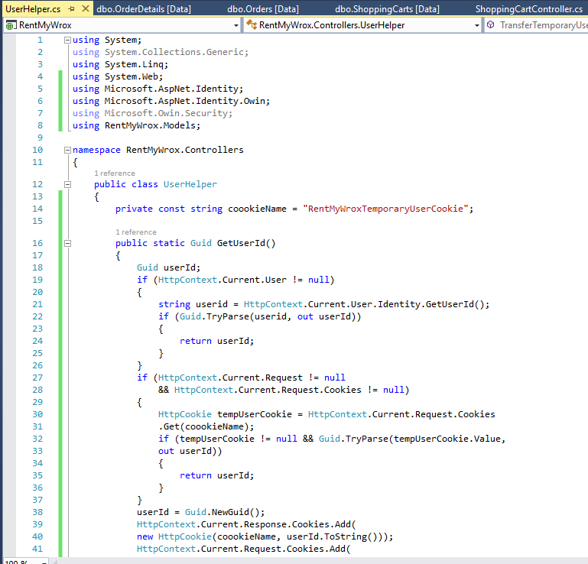

New Class “UserHelper” created and Cart Controller updated

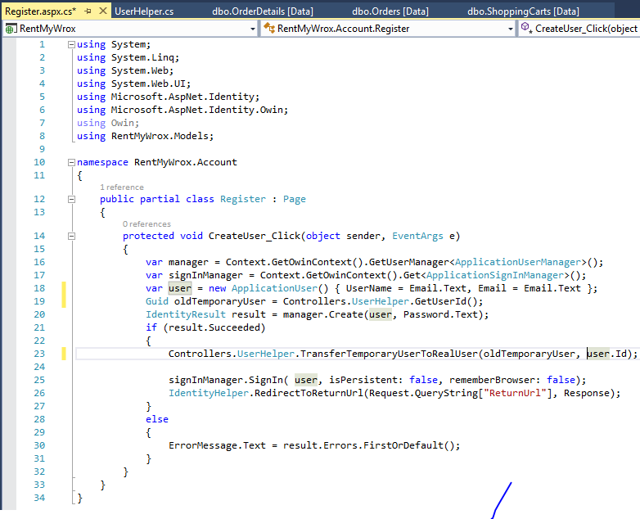

Register Account Code-behind updated. (Please ignore the random blue mark.)

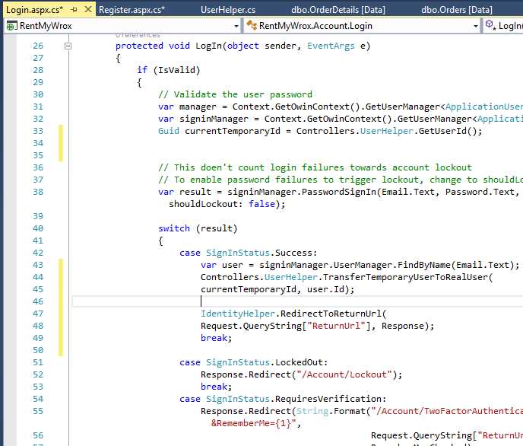

Updated Login code-behind. Let’s run it and see what happens.

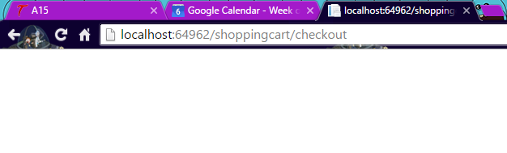

I was able to log in and get to the blank checkout page.



The cart was not altered by logging in.

Adding Roles

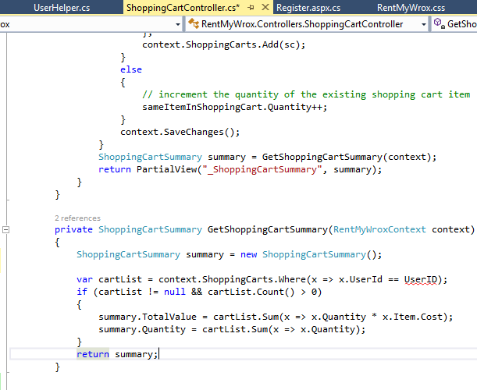

I got an error. It looks like this function/method can’t see the UserHelper field.

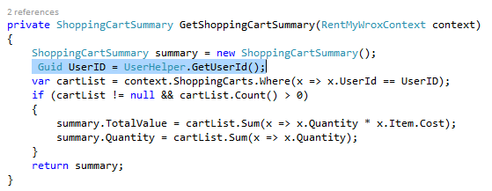

Adding the highlighted line seems to have fixed it.

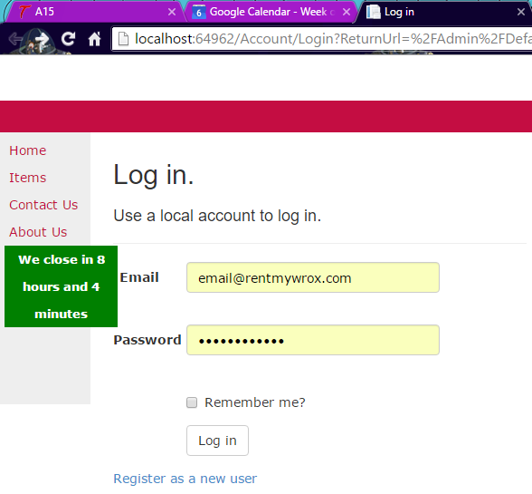

I have to log in to get to admin stuff.



If I do log in, I don’t get an error, just redirected back to the login page.

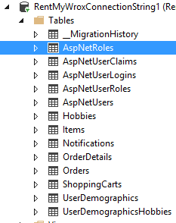

New tables. Let’s investigate.

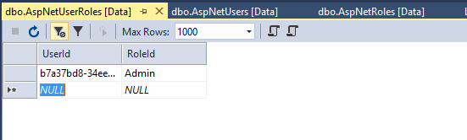

I filled in my Test User’s ID, from dbo.AspNetUsers and assigned it to the newly created Admin role in dbo.AspNetRoles.

(This process is starting to make sense.)

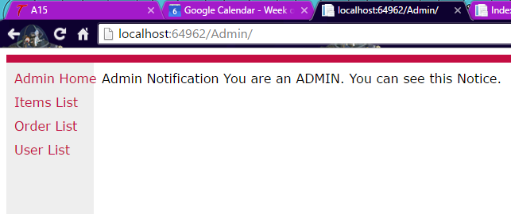

Sweet. It let me log in to my Admin stuff.

Changing Menu Options Based on Role

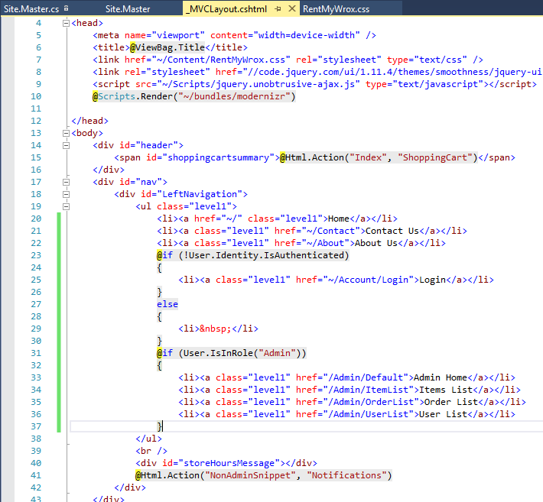

Added code to SiteMaster and MVCLayout

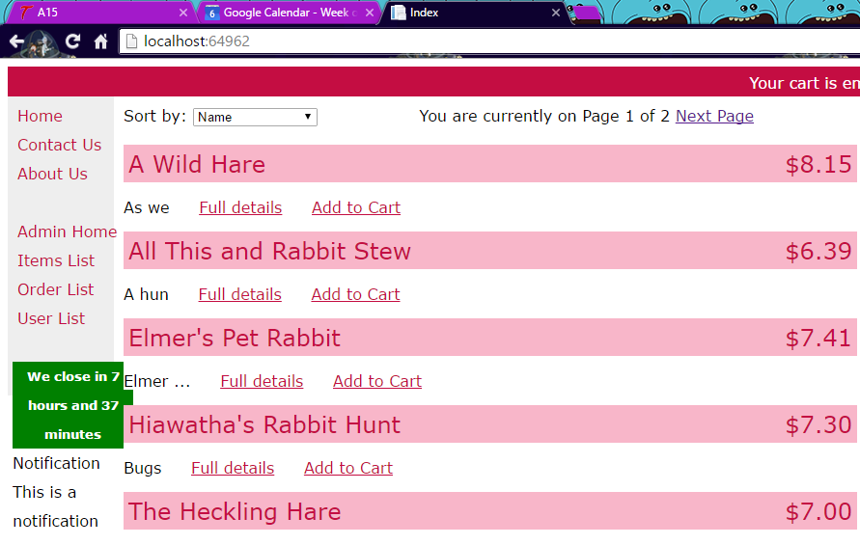

Admin brings me more items in the left nav menu.

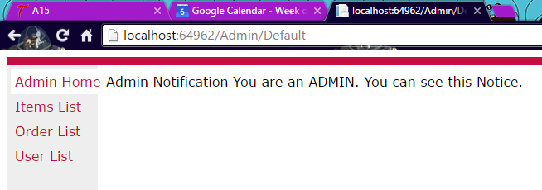

This includes Admin functions.